- preparation:
The oldest player shares all the ‘planets tickets’.
These planets are now in the possession of the player.
Now, each player takes a ‘mission card’.
Each player gets 20 aliens. And divides these over his planets.
The player who finishes as first his/her mission wins the game.

- During the game:

You have to accomplish your mission.
How to do this?
Example:
Player 1 (blue) has to conquer whole the planet Sun and Mars.
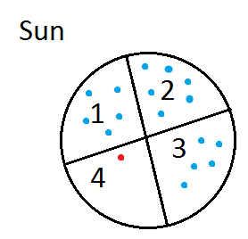
The player has already as 3/4 of the planet, he only needs to kill 1 alien of Player 2 (red).

Player 1: "I want Sun 4"
P1 throws first with the dice. He throws 4. P2 throws second
and throws 6.

P1: P2:

6 wins of 4. (The highest number)
So P1 (blue) loses 1 alien. P1 wants to do that again and throws 4 P2 -> 1
now P1 can put his aliens on that.
Now his turn is over because he has moved an alien.
You only can move only 7 aliens each turn.

- Extra Aliens
If you want to you can skip a turn to and get extra aliens.
Then you have to count all your planets :3, that's the number of aliens you get.
example:
6 planets, 6:3= +2 aliens
13 planets, 13:3= +4 aliens
x planets, x:3= +y aliens

if you captured an entire planet will get 1 extra alien per turn (You should think about it yourself!!!)

Sun 1 | Sun 2 | Sun 3 | Mercury 1
Mercury 2 | Mercury 3 | Venus 1 | Venus 2
Earth 1 | Earth 2 | Earth 3 | Mars 1
Mars 2 | Mars 3 | Jupiter 1 | Jupiter 2
Jupiter 3 | Jupiter 4 | Jupiter 5 | Neptune 2
Saturn 1 | Saturn 2 | Saturn 3 | Uranus 1
Uranus 2 | Uranus 3 | Neptune 1

Mission  Conquer:  Sun and Earth | Mission  Conquer:  Mars, Neptune and a telescope cart | Mission  Conquer:  Saturn and Venus and a telescope cart | Mission  Conquer:  3 X telescope cart
Mission  Conquer:  Uranus, Saturn and a telescope cart | Mission  Conquer:  Mercury and Venus | Mission  Conquer:  Sun and Neptune | Mission  Conquer:  Saturn and a telescope cart
Name 3 places where lights burn at night:  highways  streets  buildings  decorative Lighting  sports fields  outdoor lighting  ... | What are the consequences of light pollution on animals, plants and people?  Animals -> disturb biological -day and night rhythm  Plants -> influencing their growth mode  People -> disturb biological -day and night rhythm | What is light pollution exactly?  Light pollution is the increased brightness of the nocturnal environment by excessive use of artificial light. | You can only see ?/3 of the stars at heaven  1
100 million of these are killed annually because of collisions with man-made structures  - Birds  - Fish  - Snail  It is estimated that at least 100 million birds are killed annually due to collisions with man-made structures, including wind turbines, power lines, glass and towers. One third of collisions are due to urban light. 90,000 birds are killed flying into buildings in New York City | Give 3 examples what causes light pollution:  wrong placement of light sources  To high power of light sources which honors a very strong reflection to the atmosphere is too much light sources  long burning light sources | which of the two lamp posts, are the best against light pollution?  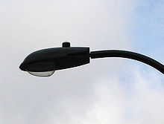  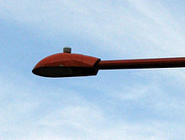  the Red Lantern

