ESTEP Project Trainee’s Guide
Supporting effective parental engagement through social media
Birmingham City University
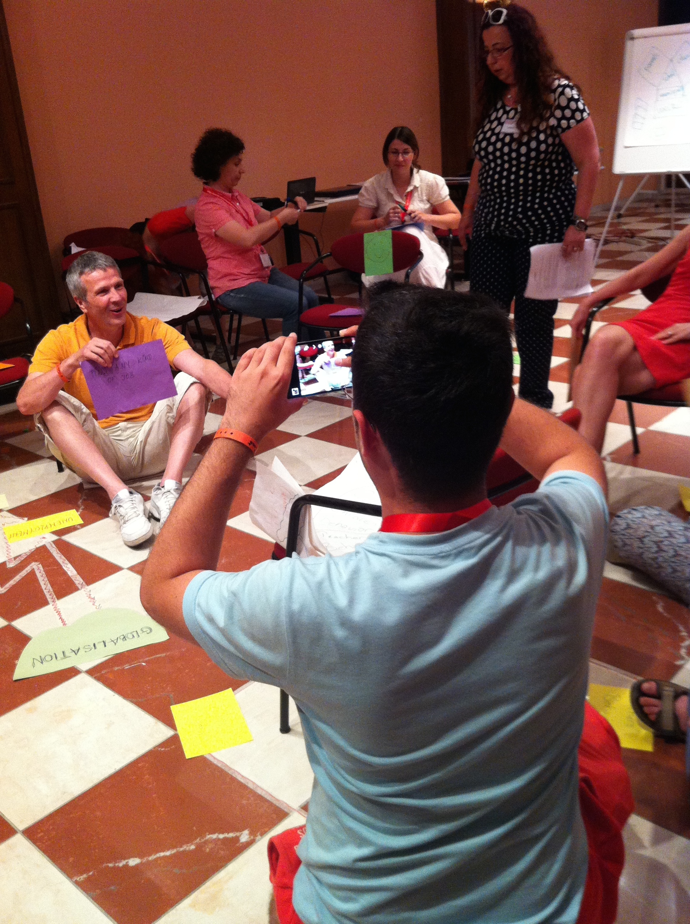

SECTION A:

OVERVIEW

- Introduction


This guide accompanies the ESTEP training framework and is supported by a teacher’s guide and a suite of learning activities. Together these resources will support you to develop, implement and evaluate strategies to engage parents more actively and effectively in the work of your school through use of social networking technologies. As you work through the three modules of the framework you will

- explore key issues and debates in parental engagement;
- engage with the wider school community to better understand parental engagement and the existing and potential roles of social media in their own context;
- create new meanings, identities and roles in relation to parental engagement;
- experiment with social media as a tool to support effective parental engagement;
- collaborate with parents, teachers and the wider school community;
- drive innovation and implement change.

- What is the ESTEP Framework?

The ESTEP framework is a learning programme that aims to support reflective approaches to parental engagement that draw on effective use of social media. ESTEP draws on an evidence base that includes secondary analysis of large-scale studies of parental engagement and new technologies across five EU countries (Austria, Bulgaria, Greece, Ireland, England) and primary analysis of teachers needs in twenty-five settings, five from each country. The framework is underpinned by a number of key principles about meanings, contexts, values and forms of parental engagement that have emerged from this work.

Meanings and value of parental engagement

- ‘Parental engagement’ is a contested concept;
- Conceptualisations of the meanings of school, learning and childhood are implicit in all forms of PE;
- PE that engages parents in their children’s learning has been shown to contribute to beneficial outcomes (social, developmental, academic) for young people.

Contexts for parental engagement:
- Many parents value opportunities to engage with schools and teachers although needs and wants may evolve and change as the child progresses through their school career;
- Schools and colleges work with diverse communities of young people and parents and a parental engagement strategy must be responsive to the complexity and plurality of the particular local context;
- The engagement of senior leaders is crucial to effective forms of PE;
- Highly valued parental engagement is characterised by a range of interactions for a variety of purposes and is likely to make use of a range of communication modes including social media.
Forms of Parental Engagement
- Participation in social media is a social practice and requires digital literacy knowledge, expertise and confidence from all participant;
- Teachers’ and parents’ (and young peoples’) knowledge, awareness, understanding and experiences of social media (and other forms of ICT) vary substantially and impact on their attitudes to social media use in school;
- Teachers and parents attitudes towards social media are informed by wider discourses and these might be especially influential where individuals lack direct experience;
- Initial teacher education does not necessarily teach either PE or digital literacy, teachers knowledge and expertise is likely to be tacit and gained through experience and participation;
- The use of technology to support PE is in its infancy and the body of evidence that might inform practice is very much emergent;
- Communication between parents and schools that is mediated by technology will be framed by the existing attitudes, values and cultures of the school or institution;
- Attitudes and values of leaders, teachers, parents and children are crucial in determining the success or otherwise of both a parental engagement strategy and implementation of a work in digital modes.

- Who is the ESTEP framework for?

The ESTEP framework has been designed for use by any member of the school’s professional community including school leaders, teachers and ICT coordinators. The generative nature of the framework means that the framework user, and their local, strategic priorities, is always the starting point for ESTEP actions. As such the framework is useful to a wide range of users and can be flexed to achieve a broad spectrum of purposes from micro-interventions at the level of a single class teacher working with their own class and a discrete group of parents to a whole school focus led by the senior leadership team or across school ICT co-ordinator.

- How can the ESTEP framework work for your school?

Building on the principles outlined above the ESTEP framework recognises that because no two school or college contexts are the same parental engagement strategies that make use of social media must be must be tailored to the specific needs of the school community if they are to be successful. As such the framework encourages you to take an enquiry-based, or action research, approach that will put you and your school at the centre of learning enabling you to: build grounded knowledge about your parent community; articulate local vision and aspirations for parent engagement; and work collaboratively towards implementation of a ‘road map’ for development and transformation. The ESTEP framework also accepts that individual teachers, parents and school communities are at different stages in their adoption and use of social media. Throughout the learning process you will explore social media in two ways; as a context for stimulating and sharing your own thinking and learning and collaborating; and as potential tools to support and facilitate new ways of working and interacting with parents.

The framework comprises three modules that, taken together, will enable you to work through three key stages of a participatory action research process, that is to say a process in which you are both the enquirer and an active ‘participant’ in the context being explored. This will involve:

- documenting and contextualising your current situation in relation to parental engagement and use of social media;
- identifying how you want to develop and working towards change;
- and understanding impact, affect and influence.

It is hoped that working through the modules will not only support development of your parental engagement work but also enable you, and colleagues, to work competently and confidently within an action research cycle, and build research expertise and capacity within your school that can be put to work in other aspects of school development.

Module one, ‘Understanding Parental Engagement in Context’, will introduce action research methodologies, modes and strategies and open up exploration of key concepts and definitions. You will be encouraged to experiment with social media (for example using MyODS communities) and engage in reflexive evaluation of existing practice, cultures, attitudes and values. These will involve you in collection of pre-existing empirical material as well as generation of new data through implementation of more creative, experimental approaches such as story-telling and artefact production. A range of conceptual lenses will then be used to critique, analyse and make sense of this material so as to establish starting points for working towards change.

Module two, ‘Working towards change: planning and implementing context specific parental engagement’, will facilitate a series of interventions derived directly from the close examination of the school/college context undertaken in module one. You will identify strategic priorities for your institution alongside a bespoke, context specific, ‘road map’ for change that will identify the key actions and dependencies (resources, roles, responsibilities, training needs) that will be required to realise the aspirations articulated in module one.

Module three, ‘Parental Engagement in practice: understanding outcomes, impact and influence’, will explore a range of strategies for documenting, describing and evaluating the outcomes of parental engagement in practice. It will support design, development and implementation of robust and rigorous evaluation tools that draw on a range of qualitative and quantitative traditions. This will your institution, and the communities of parents you work with, to understand the outcomes, impact and influence of your parental engagement work through a range of lenses and to pay attention to anticipated, as well as contingent and serendipitous, change and or development. This module will also explore strategies for sustaining momentum and enthusiasm for ongoing collaborative development in this key area of work.

- How long will the training programme take?

The learning you do with the ESTEP framework can paced to suit your own timeframe for the work you want to undertake. You can choose which areas of work you want to spend most or least time on according to what you want to your aims and aspirations. You are advised to work through each of the modules however so that you complete the action research cycle and ensure that your aims have been met, that you understand the impact of your ESTEP intervention and that your success criteria have been met. Completing the cycle will also help you to plan the ‘what next’ so that you can continue to develop and improve over the longer term.

- Where can I see examples of the training programme in action?

You can find examples of the training programme in action at https://www.facebook.com/estepproject/videos?ref=page_internal

You can click on the following links to show evidence of the impact of factors external to school on attainment (estimated at 70%+), which shows the potential benefits of working with parents.
Here's a US example:
http://ezproxy.bcu.ac.uk:2055/science/article/pii/S027656241200042X?via=ihub.

The BBC reported on it here - Parents not schools boost exam success, study suggests:
http://www.bbc.co.uk/news/education-19923891

SECTION B:
MODULES

Module 1: Understanding Parental Engagement in Context

Module Aims
This module will facilitate exploration and analysis of parental engagement and use of social media in your context. You will discuss key contemporary concepts, issues and debates in the field and develop a working definition of parental engagement for your institution. You will make use of enquiry orientated practitioner researcher approaches to explore existing attitudes, values and cultures to parental engagement in your setting and, to understand the role and potential role of social media in developing practice. You will begin to agree priorities and aspirations for the future development of practice.

Learning Objectives
Through participation in this module trainees will:
- describe and synthesise existing debates, concepts and research evidence in relation to parental engagement and social media;
- use participatory action research techniques to plan strategies for change;
- make effective use of a range of investigative tools to explore current practice and stake-holder perspectives (including their own) on parental engagement and use of social media;
- evaluate the potential value of social media to support and sustain parental engagement in your own context;

Module Content
Unit Code. | Unit Name | Description
M1U1 | Introduction – exploring definitions, values and attitudes | In this unit trainees will engage in a range of creative methods to explore and describe their personal attitudes, values to, and perceptions of, parental engagement. See suggested session plan MU1U  Introduction to and exploration of key theories and concepts in parental engagement for example Price-Mitchell, Epstein (see M1U1 sample session plans). Generate working definition relevant to own context  Review personal definitions and share a revised personal definition with wider group through appropriate social media tool (for example definition in 140 characters via Twitter) in the session.  Share a follow-up reflective ‘think piece’ for example through Storify post session.
M1U2 | Exploring own context | Introduction to modes of practitioner research and the action research cycle.  Plan an action research ‘audit’ to produce a baseline against which to measure development.  Determine what data already exists to inform the review and what new data will need to be collected.  Explore a range of techniques and strategies collecting data e.g. map, box etc  Consider ethical issues and e-security  Review a range of social media tools and select an appropriate social platform through which to document and share the review process e.g. Facebook or Storify.
M1U3 | Analysis and Review | Produce baseline analysis – ‘where are we now’ in relation to parental engagement and social media and make available for dissemination.  Identify key priorities of a ‘road map’ for change – what does the school want to do differently?

Module Outcomes
At the end of this module trainees will have:
- agreed a working definition for parental engagement that is meaningful in their own context;
- designed and planned a participatory action research process to implement in their school/college;
- engaged the wider school community in a study of current practice;
- used social media to support and facilitate the above.

Module 2: Working towards change: planning and implementing context specific parental engagement

Module Aims
This module will provide a step-by-step approach to planning for change using a range of modes and mediums. You will generate a context specific ‘road map’ that responds to the strategic priorities identified in module one and define targets, milestones, key dependencies and success criteria.

Learning Objectives
Through participation in this module trainees will:
- analyse existing school development processes and cycles and potential spaces and places for embedding development work on parental engagement;
- re-conceptualise boundaries between home, school, community and identities of key stake-holders including young people, teachers, leaders and parents;
- identify the key components necessary to facilitate cultural change within the local context;
- identify, describe and attribute key roles and responsibilities in cultural change processes for different groups of stake-holders within the community;
- plan the stages and processes of a parental engagement intervention/s within their local context and the evidence base that will help to document the communities experience of participating in the intervention;
- explore strategies for winning support and commitment from the wider school community for new ways of working in relation to parental engagement.

Skills Development
Through participation in this module trainees will develop, expand and practice their skills:
- as communicators - influencers, persuaders, brokers of change;
- as analysts of qualitative and quantitative data.

Module Content

Unit Code | Unit Name | Description
M2U1 | Understanding and agreeing purpose | Reviewing existing school development processes and understanding how this work will complement. Key questions:  - How does my school develop?  - What existing cycles and processes could this work fit in to?  Identifying actions for change  Identifying stake-holders. Key questions:  - Who needs to be involved in the process? How? and why?  Agreeing time-frame for implementation of Road Map
M2U2 | Building stories of success | Agreeing what the school wants to achieve through the intervention and describing in detail what success might look like for different groups of stakeholders and beneficiaries.  Identifying interim milestones – what will the stepping stones towards success look like?
M2U3 | Designing and planning change | Construction and dissemination of plan.  Key activities:  - Agreeing deadlines  - Identifying dependencies and resources.  - Clarifying roles, responsibility and expectations.

Module Outcomes
At the end of this module participants will have:
- clearly articulated strategic priorities and aspirations for both parental engagement and the use of digitally mediated environments to support parental engagement in their context;
- constructed a co-produced and community owned ‘road map’ for change.

Module 3: Parental Engagement in practice: understanding outcomes, impact and influence

Module Aims
This module will provide a step-by-step approach to evaluating the processes, experience and impacts (planned and unexpected) of the ‘road-map’ proposed in module 2. It will explore approaches to designing impact and strategies for effective sharing, dissemination and sustainability of outcomes.

Learning Objectives
Through participation in this module trainees will:
- Explore and evaluate a range of pathways for achieving maximum impact and determine what most preferred approach in their context;
- Plan how they will track and monitor the progression of their intervention and document and share, via social media, ‘change in action’;
- Construct a dissemination plan that makes effective use of social media to ensure that the process and outcomes of change are shared with local, regional audiences as well as those further afield;
- Determine how change will be sustained over the longer term.

Module Content
Unit Code | Title | Description
M3U1 | Understanding & Maximizing Impact | Explore a range of potential approaches to achieving maximum impact for a wide range of stake-holders and beneficiaries.  Ensure that strategies for achieving high impact are ‘designed-in’ to Road Map from the outset.
M3U2 | Build an evidence base | Evaluate a range of ways of capturing and evaluating outcomes (both planned and serendipitous) using social media.  Determine:  - Where to look  - Who to ask  - What to collect  - How to collect it  - How best to share with other  - Who you want to share with
M3U3 | Dissemination and Sustainability | Create a social media dissemination plan that identifies:  - key stories  - audiences  - best social media platforms and tools to utilize  Review whole action research cycle and determine Where next?

Module Outcomes
At the end of this module participants will produce:
- An impact strategy
- a plan for generating evidence (pictures, stories, case studies as well as more traditional forms of data) to document the process of implementing a change ‘road map’
- A dissemination and sustainability strategy.

SECTION C:
ACTION (B)LOG

The ESTEP Action Tool is can be completed in any format that supports your learning and development. It is suggested that you choose an appropriate social media platform (your trainer/teacher will be on hand to advise) and experiment with a ‘live’ blog that documents progress through the ESTEP programme. This blog will then have a dual function of enabling you to capture and reflect on your learning and helping you to communicate with and engage your wider school community.

The ESTEP Action Tool offers a process orientated approach to supporting the development of a community of practice focused on building effective parental engagement through social media and other strategies and approaches. The tool provides prompts in the forms of questions and is intended to offer generative opportunities for discussion and action-planning underpinned by a secure evidence base.

The tool can be used by a variety of stake-holders:

- School leaders can use the ESTEP Action Tool to: identify personal, professional and institutional parental engagement needs; prioritise and plan actions and to meet identified needs; guide the monitoring and evaluation of parental engagement impact in meeting the needs of young people, the school and the wider community.
- Teachers can use the ESTEP Action Tool to: explore their own experiences of and attitudes towards parental engagement; be involved in decision-making and planning for parental engagement within their own institutions; identify and plan for their own professional development in relation to parental engagement

Part 1 CONTEXTS FOR PARENTAL ENGAGEMENT

1.1 VISION AND VALUES
Aspect | Key Questions | Response and Action
Establishing core principles | Why is parental engagement important in your school?  Why do you want to make changes at this particular time? What are the key drivers for change?  What are the risks if you make no change at all?  Reflect on your responses to the above questions, how might these frame your action planning?
Establishing your baseline – parental engagement | How would you describe current practice, attitudes and values towards parental engagement in your institution?  What images and metaphors would you draw on?  To what extent do different members of the community (leaders, teachers, parents, pupils) have a shared or different views? How engaged are different groups?  How do you work with the community beyond pupils and parents?  What are you doing well? What do you need to develop?  How far are you from the vision and your aspirations?
Establishing your baseline – social media | What platforms and tools are you currently using?  If you are not yet using social media – what would you like to use? Why?  If you are already using social media, what works well? What works less well?  How are you evaluating current practice?  How skilled are teachers in the use of social media?  What do you know about your parent group as users of social media?
Establishing your parental engagement goals | What are the end goals of your parental engagement work? For teachers? For pupils? For parents? For the wider community?  How do think social media might help you to achieve these goals?
Establishing your definition of parental engagement | How would you define parental engagement in 140 characters?  Choose an appropriate social media tool to share this with your community – how does your definition compare and contrast with those of others?

1.2 REVIEWING PARENTAL ENGAGEMENT IN YOUR CONTEXT
Aspect | Key Questions | Response and Action
Exploring the key drivers for your review | What you want to achieve as an outcome of the review process and why?  What do you want to know more about in relation to attitudes, values and experience of parental engagement across the wider school community?  What do you want to know more about in terms of social media and parental engagement?
Exploring partnerships and stakeholder groups | Who do you want to involve in your review?  Who can help you to find out more?
Involving others in the review process | How will you involve diverse groups of parents?  How will you involve young people too?  How will you involve members of your wider community? Could they contribute? In what ways?  In what ways will different groups be involved? What will they be doing? What will you be doing?
Working ethically and responsibly | What ethical frameworks do you currently work with in school?  How familiar are you of the European Educational Research Association’s guidelines for Ethical Practice (see http://www.eera-ecer.de/about/ethical-guidelines/)?  How might you use these guidelines to help you to plan your work?
Collecting evidence | What data already exists?  What other data might be useful? Where are the gaps in your evidence base?  What new data/evidence will you need to generate? What kind of evidence?  How will communicate and share the process of data review? Using social media?  What tools will you need to use?  (E)Surveys? Group discussions? Social media?  What events will you need to organize?  Where and who will your new data come from?  How will you store it appropriately?  How will you share it with others?

1.3 DESIGNING YOUR ‘ROAD MAP’ FOR CHANGE
Aspect | Key Questions | Response and Action
Key issues arising from your review | What are the key issues:  - For children and young people?  - For the school?  - For teachers?  - For parents?  - For the community?
Priorities and actions for change | What works well and what do you want to do more of?  What doesn’t work so that you could do better?  What new areas of activity do you want to develop? Your key priorities?  What actions will you need to take?  How will you judge progression and development?
Timeframe for change | What are the internal and external factors driving your timeframe?  How will you prioritise your actions?  What do you want to achieve in the short, medium and longer term?
Roles, responsibilities and resources | What roles and responsibilities will you need to allocate to achieve your actions?  What new resources will you need to support your road map?  What support will you need to be successful? For what, and from whom? How will you go about this?
Benefits, impact and indicators of success | What will be the benefits and impact of your action plan?  Who will be the beneficiaries?  How will you judge ‘effectiveness’, ‘progress’ and ‘improvement’?  How will you monitor progress against your targets?  Who will be involved in this process? How will different groups in your community be represented in this process?
Managing your time and team | How will you combine your practitioner enquiry role with your teacher/ professional role?  What do you see as the possible problems and how will you address them?  How will you manage each of the following:  - time management?  - public engagement?  - the need to persuade and build support?  - the need to deal with resistance and reluctance?  - change management?

Part 2 MANAGING PARENTAL ENGAGEMENT – INDIVIDUALS

Aspect | Key Questions | Response and Action
Reflecting on your current practice – parental engagement | How do you currently work with parents?  In what ways does your work with parents impact on your learners?  How do you work with the community beyond pupils and parents?  What are you doing well? What do you need to develop?
Reflecting on your current practice – social media | What platforms and tools are you currently using?  If you are not yet using social media – what would you like to use? Why?  If you are already using social media, what works well? What works less well?
Establishing your parental engagement goals | What are the end goals of your parental engagement work?  How do think social media might help you to achieve these goals?
Establishing your definition of parental engagement | How would you define parental engagement in 140 characters?  Choose an appropriate social media tool to share this with your community – how does your definition compare and contrast with those of others?
Contributing to the review process | What role can/will you play in reviewing parental engagement in your school?  What evidence already exists?  What evidence can/will you collect?
Contributing to change | What role can/will you play in developing parental engagement in your school?  What actions will you need to take?  What support will you need to be successful?
Managing your own time | How will you combine your practitioner enquiry role with your teacher/ professional role?  What do you see as the possible problems and how will you address them?  How will you contribute to team working?

