Introduction
Designing a space telescope is an incredibly complex job, with many requirements that must be met. Some of these are because of the scientific discoveries that the astronomers would like the make, while others are due to limits that the engineers put on the spacecraft. Beginning in the 1990s, astronomers and engineers around the world were busy designing the Herschel Space Observatory. This project will help you explore the kinds of decisions they had to make.
Your task is to design a space observatory for the UK Space Agency. You will have to make a number of decisions about what your space telescope will look like. If you are in a group, you could use a number of roles, but you will need to work together for a final solution:

Rocket Engineer
The role of the engineer is to ensure that the mass and size of the structure does not surpass the limits of the launcher. The engineer must also select the appropriate launch site, and the orbit from which the satellite will observe.

Project Manager
The role of the accountant is to ensure that the mission does not go over budget, and to ensure that the risk of overrunning in terms of time or budget is as low as possible.

Instrument Scientist
The instrument scientist is in charge of making sure the instruments on-board are appropriate for meeting the science goals, and to ensure that they will be able to meet the scientific requirements.

Mission Scientist
The mission scientist will ensure that the satellite's mirror and cooling system are suitable for the mission to succeed.

Once you have selected your mission, fill in the details on the draft proposal at the end of this document.

Case Studies
Problems for groups (or individuals to solve) are (loosely) based on real life space observatory missions, from past, present and future.
- A private organization has funded your group to research into the birth and evolution of stars the distant and nearby Universe, with full analysis of the spectra of the event. The budget of your mission is £2 billion. You will need the appropriate instruments on board your satellite in order to observe such objects.

- A government research grant has come through to take images of the sky in ultraviolet, visible and nearby wavelengths from a satellite in space, in order to map stars, galaxies and other yet to be discovered phenomena. The budget of your mission is £400 million.

- A university has approached your group to design a mission for satellite telescope in order to analyse the spectra of interstellar dust in nearby galaxies. The budget of your mission is £9 billion. You will need the appropriate instruments on board the telescope in order to carry out the mission.

- A private rocket company, SpaceX, has approached your group to launch a telescope into space in order to study the formation of planets and their chemical composition. The resolution must be at least four times better than previous equivalent missions, and you must use their rocket. The budget for your mission is £4 billion.

- A funding agency is providing funding to perform an all-sky survey from near infrared to far infrared. The budget of your mission is £1 billion. The satellite should launch within 10 years.

- Your group has received funding to send a telescope on board a satellite into space with the main objective of analysing stars in a nearby galaxy at very high resolution. You should aim to capture both the spectra and image data. The budget of your mission is £15 billion. Your group will need to use the appropriate instruments in order to collect data if it is to be analysed.

- The government has asked you to design a satellite to take images of near-Earth asteroids. The mission should last for as long as possible, but the £700 million funding for the development of the satellite will expire in eight years. The European Space Agency will provide the launch and operations cost, also up to a total of £700 million, but only providing their launch site is used.

Project Manager


Previous missions
Any satellite has to make scientific discoveries that are better than those that previous satellites have made. There have been a number of previous space telescopes launched to observe in a range of wavelengths, and some of the details are given below
Infrared Astronomy Satellite (IRAS) | Infrared Space Observatory (ISO)
Launched: 1983  Mission operators: NASA  Mission duration: 10 months  Instruments: Mid-IR (Camera), Mid-IR (Spectrometer)  Cooling: Passive + Cryogenic  Operating Temperature: 2 K  Coolant: 600 litres liquid helium  Mirror diameter: 0.7m  Total satellite mass: 800 kg  Launch site: Vandenberg Airforce Base, California, USA  Launch vehicle: Delta rocket  Orbit: Low-Earth orbit (900km altitude)  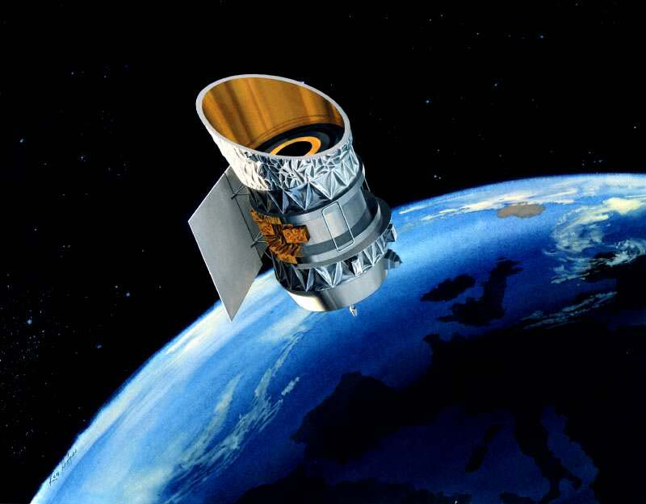  Approximate cost: £400 million | Launched: 1995  Mission operators: ESA  Mission duration: 2.5 years  Instruments: Near-IR (Camera), Mid-IR (Camera) Mid-IR (Spectrometer)  Cooling: Passive & Cryogenic  Operating Temperature: 2K  Coolant: 2300 litres of liquid helium  Mirror diameter: 0.6m  Satellite mass: 2400kg  Launch site: Korou, French Guiana  Launch vehicle: Ariane 4  Orbit: High-Earth orbit (elliptical, ranging from 1000 – 70,000 km)  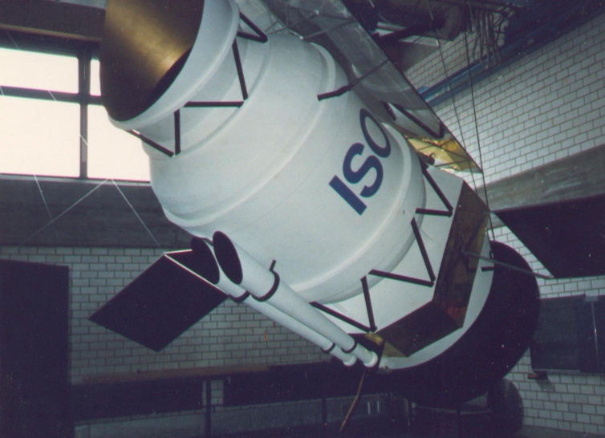  Approximate cost: £300 million

Spitzer Space Telescope | Akari
Launched: 2003  Mission operators: NASA  Mission duration: 5.5 years*  Instruments: Near-IR (Camera), Mid-IR (Spectrometer), Mid-IR (Camera)  Cooling: Passive & Cryogenic  Operating Temperature: 5 K  Coolant: 340 litres of liquid helium  Mirror diameter: 0.85m  Satellite mass: 860 kg  Launch site: Cape Canaveral, Florida, USA  Launch vehicle: Delta II rocket  Orbit: Earth-trailing orbit  Approximate cost: £800 million  Notes: *Since the cryogenic cooling is only required by the Mid-IR instruments, the Near-IR instruments continued to operate after the end of the nominal mission. | Launched: 2006  Mission operators: JAXA (Japan)  Mission duration: 1.5 years  Instruments: Near-IR (Camera), Mid-IR (Camera), Far-IR (Camera)  Cooling: Passive & Cryogenic  Operating Temperature: 2 K  Coolant: 170 litres of liquid helium  Mirror diameter: 0.7m  Maximum resolution: 44 arcseconds at 140 microns  Satellite mass: 950 kg  Launch site: Uchinoura Space Center, Japan  Launch vehicle: M-V rocket  Orbit: Low-Earth orbit (700 km altitude)  Approximate cost: £200 million (exc. launch cost)
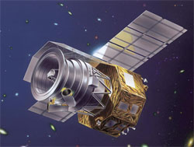
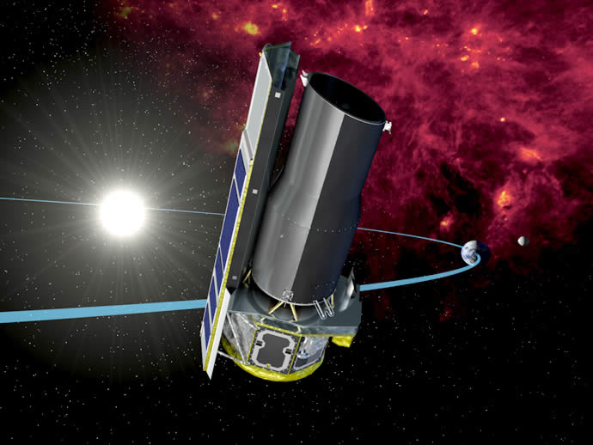

Herschel Space Observatory | Hubble Space Telescope
Launched: 2009  Mission operators: ESA  Mission duration: 3.5 years  Instruments: Far-IR (Camera & Spectrometer), Sub-mm (Camera &  Spectrometer), Far-IR & Sub-mm (Spectrometer)  Cooling: Passive & Cryogenic & Active  Operating Temperature: 0.3 K  Coolant: 2300 litres of liquid helium  Mirror diameter: 3.5m  Satellite mass: 4000 kg  Launch site: Korou, French Guiana  Launch vehicle: Ariane 5  Orbit: Earth-Sun L2 point  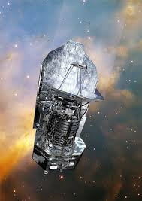  Approximate cost: £1 billion | Launched: 1990  Mission operators: NASA, ESA  Mission duration: >20 years  Instruments: Near-IR (Camera & Spectrometer), Optical (Camera), UV  (Spectrometer), Optical (Camera & Spectrometer)  Cooling: Passive  Operating Temperature: 300 K  Mirror diameter: 2.4m  Satellite mass: 11,000 kg  Launch site: Kennedy Space Centre  Launch vehicle: Space Shuttle Discovery  Orbit: Low-Earth orbit (600 km altitude)  Approximate cost: £2 billion
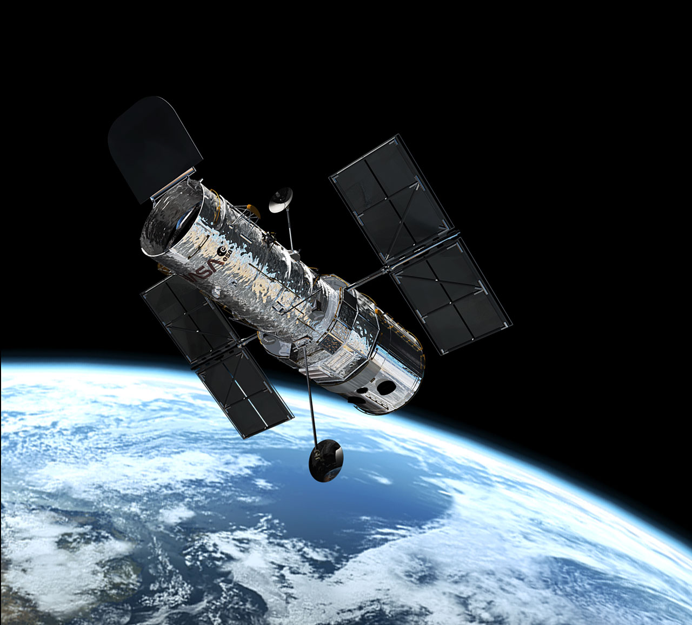

GALEX | WISE
Launched: 2003  Mission operators: NASA  Mission duration: 10 years  Instruments: UV (Camera)  Cooling: Passive  Operating Temperature: 300 K  Mirror diameter: 0.5m  Satellite mass: 280 kg  Launch site: Carrier Aircraft  Launch vehicle: Pegasus Rocket  Orbit: Low-Earth orbit (700 km altitude)  Approximate cost: £150 million (exc. launch cost)  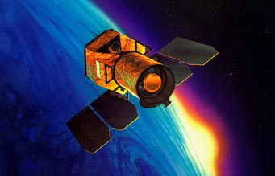 | Launched: 2010  Mission operators: NASA  Mission duration: 1 years  Instruments: Near-IR (Camera), Mid-IR (Camera)  Cooling: Passive  Operating Temperature: 300 K  Mirror diameter: 0.4m  Satellite mass: 400 kg  Launch site: Vandenberg  Launch vehicle: Delta II rocket  Orbit: Sun-synchronous orbit (500 km altitude)  Approximate cost: £300 million (exc. launch cost)  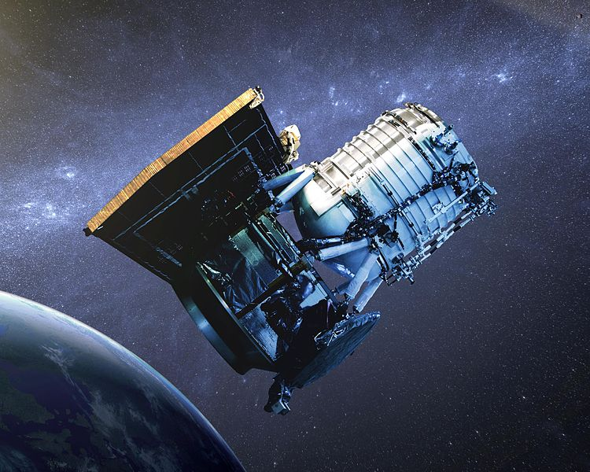


Questions

- What factors made the Hubble telescope so expensive to launch and maintain?

- What factors made the Akari telescope so much cheaper than Hubble to launch and maintain?

- What is the dominant factor in the cost of a satellite mission?

Satellite structure
Your colleagues are in the process of selecting various aspects of the mission design. Each of these will have an effect on the cost, size, mass and development time of the whole project. Your task is to keep track of the cost, mass, and development time of all the components, and ensure that they meet the requirements.
Linking all of the other parts together is the main satellite structure. This structure, sometimes referred to as the “service module” or “satellite bus” also carries the power, propulsion and communication systems. The cost, size and mass of this structure will primarily depend on the mirror selected by the mission scientist, as shown in the table below. The development time of the satellite structure is 5 years. A deployable mirror also requires a much more complex satellite structure, which will be twice as expensive and twice as massive. However, it will also be half the diameter.
Mirror diameter | Structure diameter | Structure cost | Structure mass
0.5 m | 0.8 m | £100 million | 50 kg
1 m | 1.4 m | £200 million | 100 kg
2 m | 2.4 m | £500 million | 200 kg
4 m | 4.4 m | £1 billion | 300 kg
8 m | 10 m | £2 billion | 400 kg
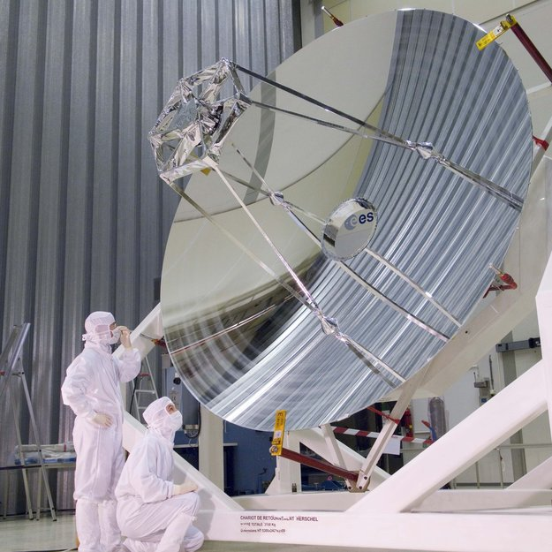
Mirror of the Herschel Space Telescope, during construction

Mission timeline, budget and mass
A satellite often takes much longer to develop than it is up in space.

Development time
The individual components all require development times, which is the time it takes to integrate them with the main satellite and prepare for launch. Use the table below to keep track of the development time.
Development time
Satellite Structure:
Mirror:
Cooling System:
Instruments:
Total Development time:
Mission lifetime:
Total project duration:

Satellite mass
Every part of the satellite has a mass. Use the table below to keep track of the mass of the satellite.
Mass
Satellite Structure:
Mirror:
Cooling System:
Instruments:
Total Satellite mass:


Check with the Rocket Engineer that the satellite mass is compatible with the capability of the rocket.

Budget
Every part of the mission costs money. Use the table below to keep track of the total cost:
Cost
Satellite Structure:
Mirror:
Cooling System:
Instruments:
Development cost:
Launch cost:
Ground control cost:
Operations cost:
Total mission cost:

Mission Scientist

Telescope Mirror
Telescopes work by focusing light using either lenses or mirrors, or sometimes a combination of the two. Mirrors tend to be much lighter and easier to manufacture, and so almost all space telescopes – and large ground-based telescopes - use them instead of lenses
The mirror of a telescope is one of the most important parts. It collects the light and focuses it onto the scientific instruments. Bigger mirrors are able to collect more light, and therefore see fainter objects more easily. They also have a higher resolution, and so can see finer detail.
The maximum possible resolution of a telescope is given by:
$$R≈1.22\frac{λ}{D}$$where λ is the wavelength of the light, D is the diameter of the telescope. The value of R is in radians. You can convert to other units using the following relations:
1 radian = ${180}/π$ degrees 1 degree = 60 arcminutes 1 arcminute = 60 arcseconds
This gives the maximum possible resolution that a telescope mirror can provide, and is called the “diffraction limit”. Note that it is different for different wavelengths. On previous satellites, not all instruments have taken advantage of this maximum resolution.
Example calculation using the Hubble Space Telescope

The Hubble Space Telescope has a main mirror that is 2.4m across, so $D=2.4 \text{m}$. It observes visible light, which has a wavelength of around 600 nm, so $λ=600 \text{nm}=6×{10}^{-7}\text{m}$. The resolution of the Hubble Space Telescope is:
$$\begin{aligned}R≈1.22\frac{λ}{D} \\ \begin{matrix}1.22\frac{6×{10}^{-7}}{2.4} & 3.05×{10}^{-7}\text{radians} \\ & 0.06 \text{arcseconds}.\end{matrix}\end{aligned}$$

Questions

- Calculate the resolution of the Lovell Telescope at Jodrell Bank. The main dish is 76 m across, and it typically works at a wavelength of around 21 cm.

- How does that compare to the Hubble Space Telescope?

- If a telescope were to have the same resolution as the Hubble Space Telescope, but observe wavelengths of 100 microns, what diameter mirror would it need? [1 micron = 1 millionth of a metre]


Your choices
The specifications of the selected mirror will affect the quality of the light collected by the telescope. Budget, mass and size constraints apply to these selections.

Diameter
A larger mirror will collect more light, however a smaller mirror will collect light at a faster rate. The size of the mirror is also a factor in the resolution of the detected light
Mirror Diameter | Mass | Cost | Development Time
0.5 m | 3 kg | £12 million | 0.5 year
1 m | 10 kg | £25 million | 1 year
2 m | 30 kg | £50 million | 1 year
4 m | 100 kg | £200 million | 2 years
8 m | 300 kg | £1 billion | 2 years

Deployable
A deployable mirror will mean a smaller structure can be used to support the mirror, and also a smaller rocket. However, this does not mean a lighter structure, a deployable mirror will have double the mass and 4 times the cost of a non-deployable mirror. It also takes twice as long for development, and carries a higher risk of failure or delay.

UV Quality
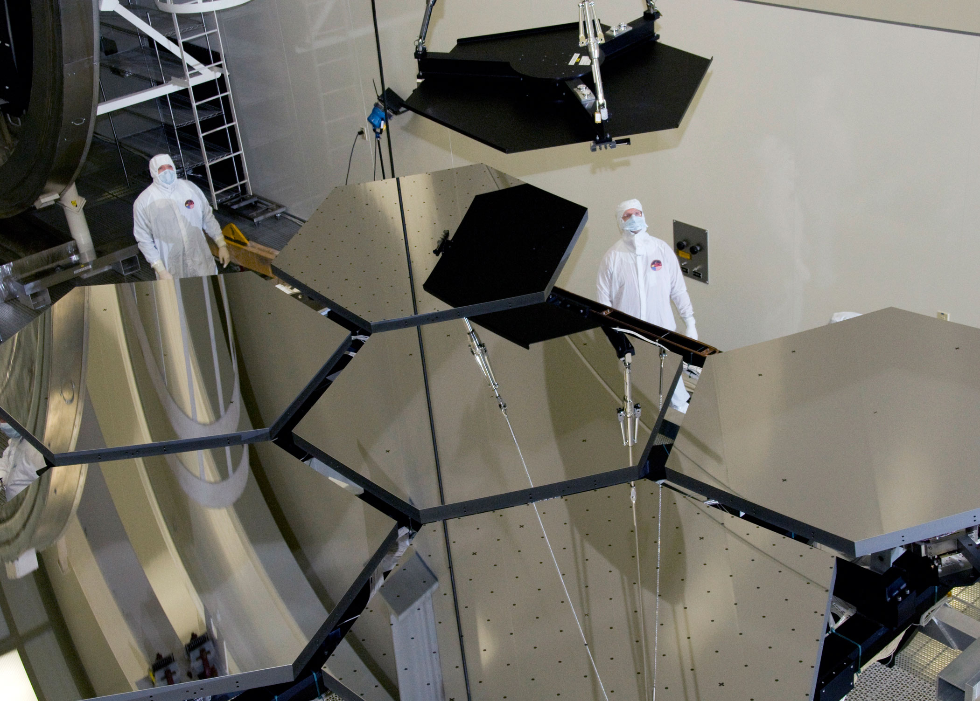
A mirror used for observing at ultraviolet wavelengths will need to be far more highly polished than a mirror used for longer wavelengths. As a result, a UV quality mirror is twice as expensive to build.

Cooling System
The Deployable mirror that will be aboard the James Webb Space Telescope, constructed from hexagonal segments
A cooling system may be required for your satellite, particularly for instruments observing longer wavelengths. A number of cooling options are available, all as effective as each other. More than one cooling system may be needed to reach the required temperature. The possibility of failure or delays with the cooling means that more complex systems carry a higher risk.
Check with the Instrument Scientist what the temperature requirements of the instruments are

Check with the Rocket Engineer that the chose orbit is appropriate for the cooling system(s) you have chosen.

Your choices

Passive Cooling
The most basic method of the three options, which cools the instruments by 90%. This method is also the cheapest, lightest and most enduring of the three possible cooling systems.
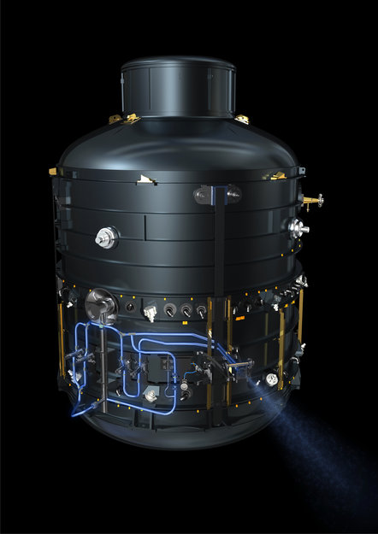

The cryogenic cooling system on-board the Herschel Space Telescope

Cryogenic Lifetime
Cryogenics (super-cold liquids and gases) can be used to cool the instruments a further 90%. Such technologies cost much more than passive cooling, and have a limited lifetime because the cryogenics gradually disappear into space. Each 2 years of lifetime requires more cryogenic liquid and so will add mass to the satellite. A longer mission also means a greater risk of encountering problems. The development time is 1 year, regardless of the expected lifetime.
Lifetime | Cost | Mass
2 years | £20 million | 500kg
4 years | £50 million | 1,000kg
8 years | £250 million | 2,000kg

Active Cooling
The most complex, and expensive method to cool the instruments, and achieves an additional factor of 90% cooling. This method is much more expensive in the short term in comparison with a cryogenic system, costing £200million to design and build, but may be cost-effective in the long term. It is much lighter, weighing only 100 kg. Although an active cooling system does not consume liquids or gases, the complex nature of the equipment means that it only has an expected lifetime of 10 years.
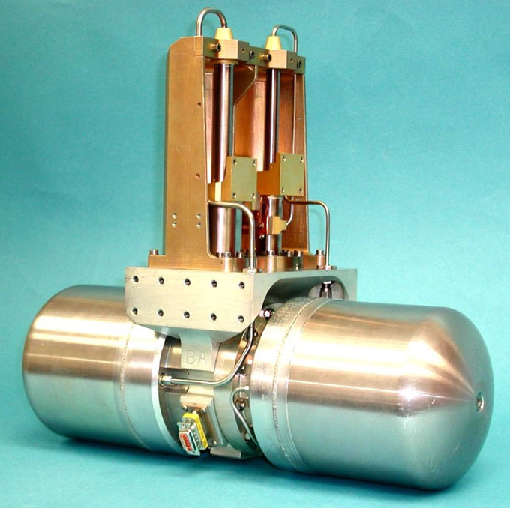
The active cooling that will be on-board the James Webb Space Telescope

Instrument Scientist

Instrument selection
The instruments on board the satellite will dictate the type of science that can be carried out by the telescope. Different wavelengths will observe different objects in the universe, as shown in the table below. The light from objects in the distant Universe is stretched by a phenomenon called redshift. This means that a given wavelength is sensitive to different objects in the nearby and distant Universe.
Type | Wavelength | Our Galaxy and nearby galaxies | Distant Universe
Sub-mm | 300–1000 μm | Birth of stars  Very cold dust | Birth of stars  Cool dust
Far-IR | 30–300 μm | Cool dust  Birth of stars  Outermost regions of the solar system (Uranus, Neptune, Kuiper Belt, comets) | Birth of stars  Warm dust around young stars
Mid-IR | 3–30 μm | Warm dust around young stars  Formation of planets  Inner Solar System (Mars, Jupiter, Saturn, Asteroids) | The first stars (100 million years after Big Bang)
Near-IR | 0.8 – 3 μm | Cool stars (red dwarfs, red giants)  Near-Earth objects | The first galaxies in the Universe (400 million years after the Big Bang)
Optical | 0.4–0.8 μm | Most Stars  Nearby galaxies | Hot, young stars
UV | 0.1–0.4 μm | Hot, young stars | Very hot regions

The variation of objects studied at different wavelengths is largely due to their different temperatures. An object of a given temperature will typically emit light at a broad range of frequencies, but the strongest emission will be at a wavelength given by Wen’s Displacement Law:
$$λ_{peak}×T=w$$where $λ_{peak}$ is the wavelength (in metres) at which the emission is brightest, T is the object temperature in Kelvin, and w is Wein’s displacement constant, which has a value of 0.0029 m.K.
The Kelvin temperature scale is similar to the Celsius temperature scale, but begins at –273ºC. This is known as absolute zero, and is the coldest temperature it is physically possible for an object to achieve. To convert from Celsius to Kelvin, simply add 273.
There are two general types of instruments in astronomy. One is a “camera”, which takes pictures of objects. The other is a “spectrometer”, which splits the light into a range of wavelengths in order to look for the signatures of specific atoms and molecules.

Example using the Sun
The surface of the Sun is around 5800 K. If we wanted to convert from Kelvin to Celsius we would subtract 273, so the surface of the Sun is at a temperature of just over 5500ºC.
From Wein’s displacement law, the wavelength at which the Sun is brightest is given by:
$$λ_{peak}=\frac{0.0029 \text{m.K}}{5800 \text{K}}=5×{10}^{-7}\text{m}=500 \text{nm}$$
That means that the Sun is brightest in the visible part of the spectrum.
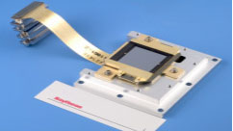
An infrared detector chip

Questions

- Convert the following temperatures from degrees Celsius to Kelvin:
a) 20ºC, b) 75ºC, c) –50ºC

- Using Wein’s displacement law, do colder objects typically emit at longer or shorter wavelengths.

- Given the temperature of the following 3 objects, calculate the wavelength at which they are brightest using Wien’s law: a) A Person (37ºC), b) Jupiter (160K), c) a hot young star (10,000ºC)

- The light from very distant objects is stretched to longer wavelengths. Does this make them appear warmer or cooler?

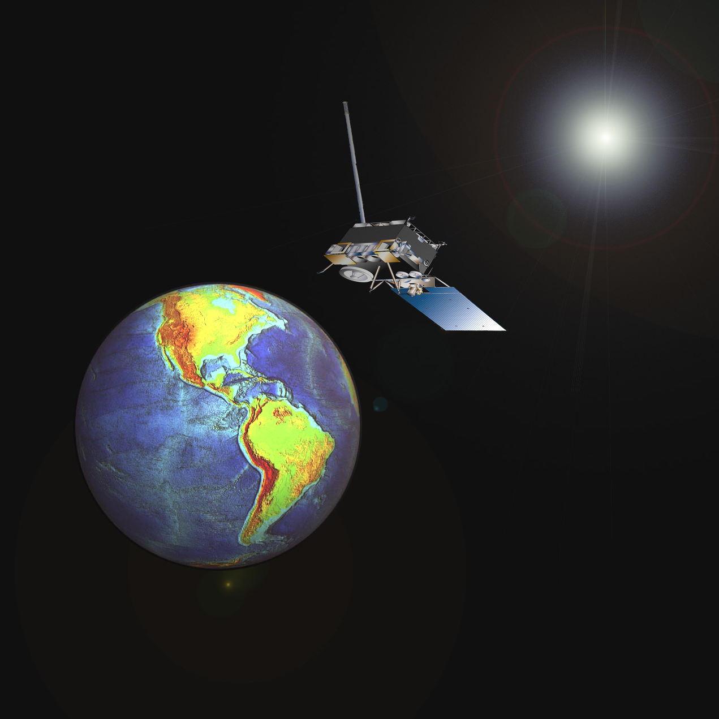

Your choices
Some instruments need to operate at low temperatures. In general, the instrument must be cooler than the objects it is looking at. The temperature requirements of the different instruments are given below.
Instrument wavelength | Temperature requirement
Sub-mm | 0.4 K
Far-infrared | 0.4 K
Mid-infrared | 4 K
Near-infrared | 40 K
Optical | 300 K
Ultraviolet | 400 K

Check with the Mission Scientist that any cooling systems are adequate for the instruments you have chosen.

There are three options for each instrument, a camera, a spectrometer or both. A camera will give you an image of the observed light, whereas a spectrometer will give a spectra-analysis of the light detected, giving the chemical composition of the observed objects, amongst other types of information. A camera and a spectrometer both cost and have the same mass, however to have both will be more expensive in both cost and mass.
Instrument type | Mass | Cost | Development time
Camera | 50 kg | £50 million | 0.5 years
Spectrometer | 50 kg | £50 million | 0.5 years
Both | 75 kg | £75 million | 1 year
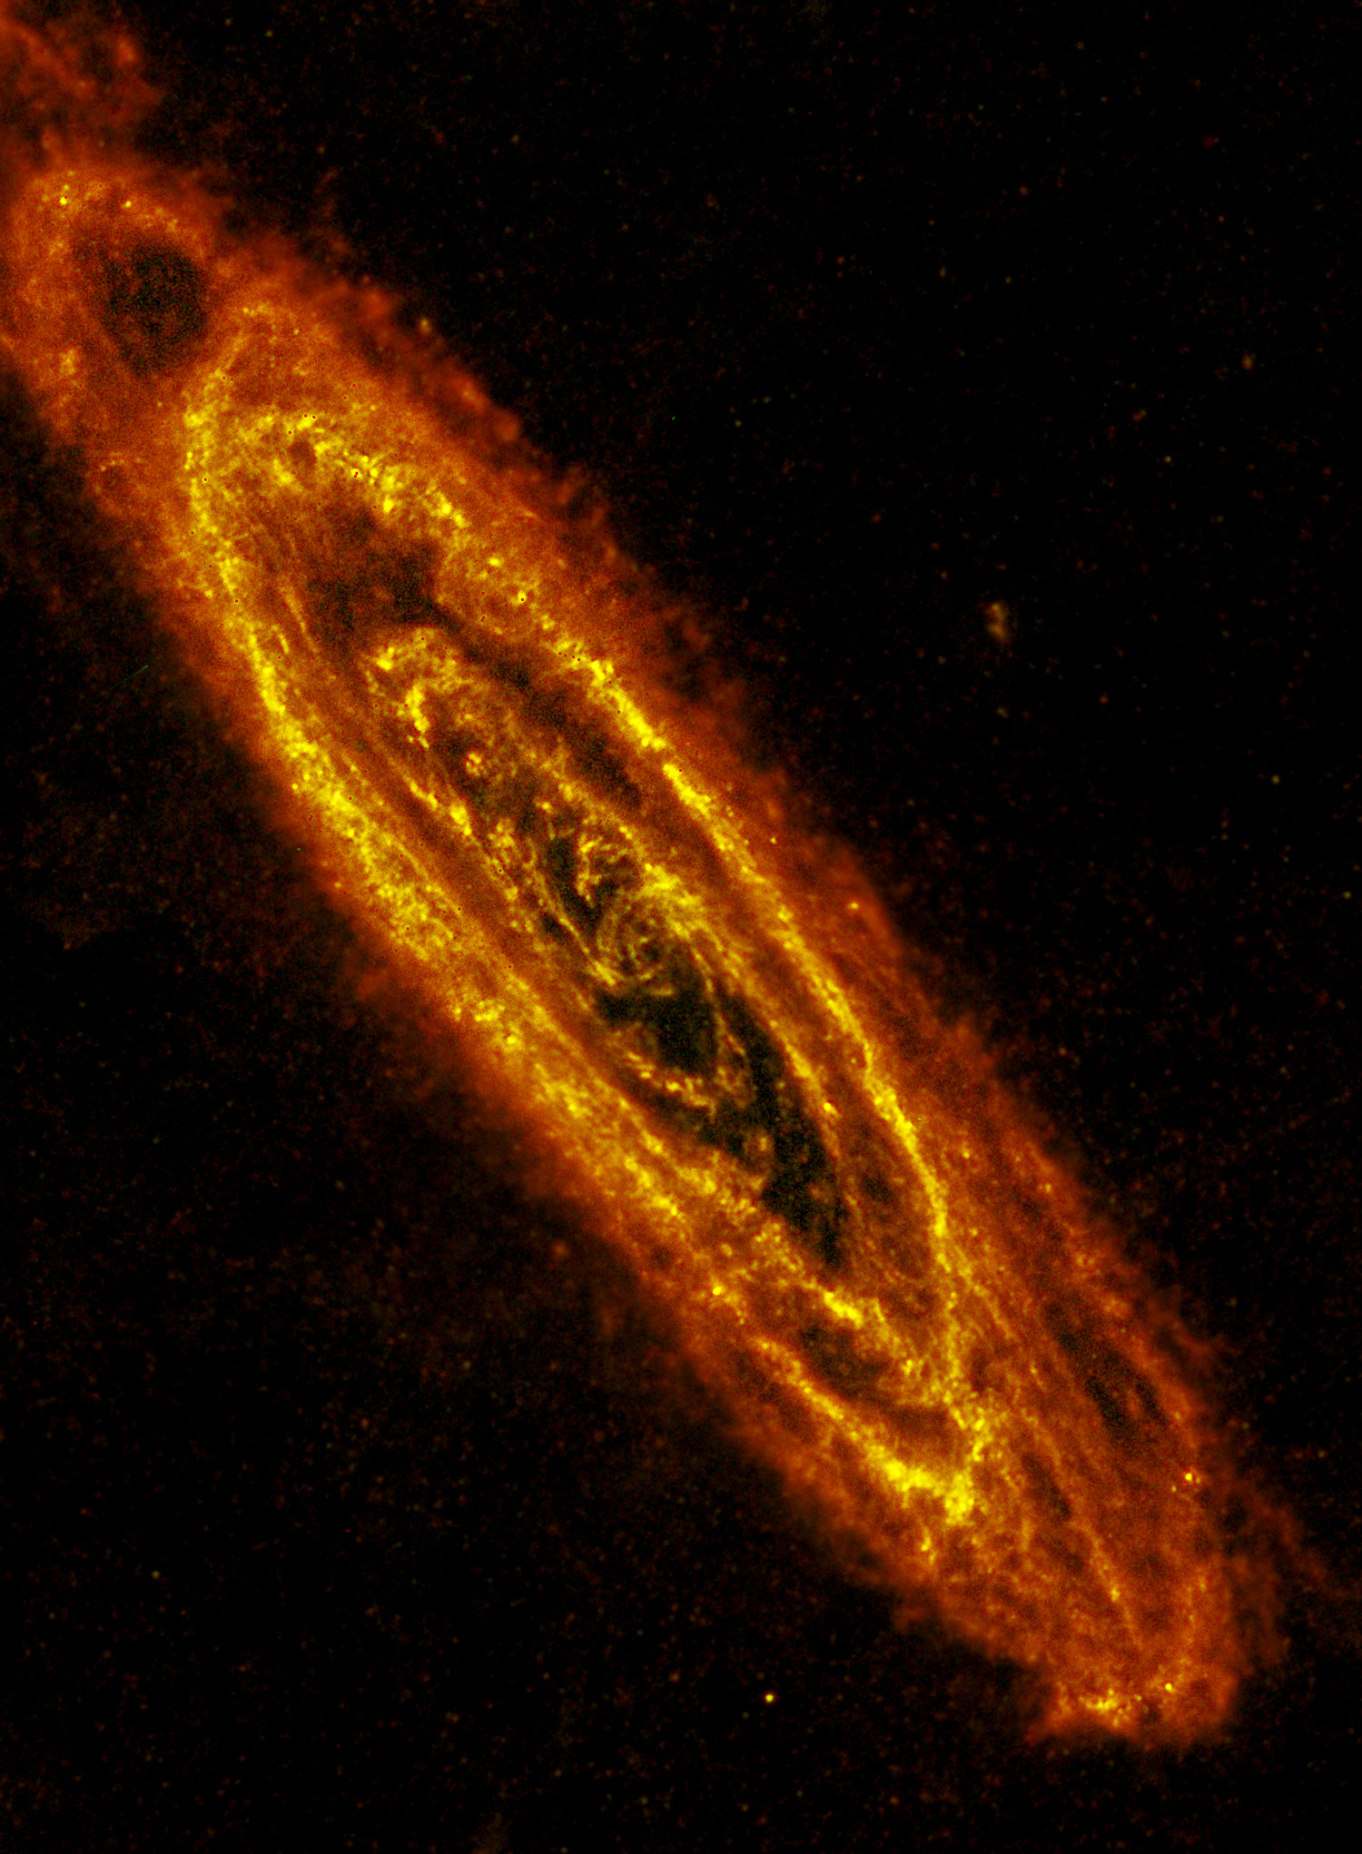
The Andromeda galaxy, seen by the Herschel Space Observatory in the far-infrared

Rocket Engineer

Satellite orbit
The orbit selected will take into account many different factors. From an observing point of view, an appropriate Observing Fraction is needed. In terms of cost, a higher altitude will mean a more expensive Ground Control cost. Some orbits have additional requirements, such as a relay satellite or the ability to safely de-orbit the mission.

Orbit Selection | Orbit Altitude | Orbit Period | Observing Fraction | Ambient Temperature
Low Earth Orbit | <1000km | 90 minutes | 50% | 400K
High Earth Orbit | >1000km | 100 minutes | 50% | 300K
Sun-Synchronous Orbit | <1000km | 90 minutes | 100% | 400K
Geostationary Orbit | 36,000km | 24 hours | 50% | 300K
Earth-Trailing | 10,000,000 km | 370 days | 100% | 300K
Earth-Moon L2 | 400,000 km | 27 days | 50% | 300K
Earth-Sun L2 | 1,500,000 km | 365 days | 100% | 300K

The period of an orbit depends on the mass of the body it is orbiting and the distance from its centre.
The gravitational pull from the central object is given by Newton’s law of gravity:
$$F=\frac{GMm}{r^{2}}$$
Where G is Newton’s gravitational constant (6.67x10^{–11} N m² kg⁻²), M is the mass of the central object (e.g. the Earth, m is the mass of the orbiting object (e.g. the satellite), and r is the distance from the centre of each.
Assuming the orbit is circular, this gravitational force acts as a centripetal force, which is related to the velocity, v, of the orbiting object by:
$$F=\frac{mv^{2}}{r}$$

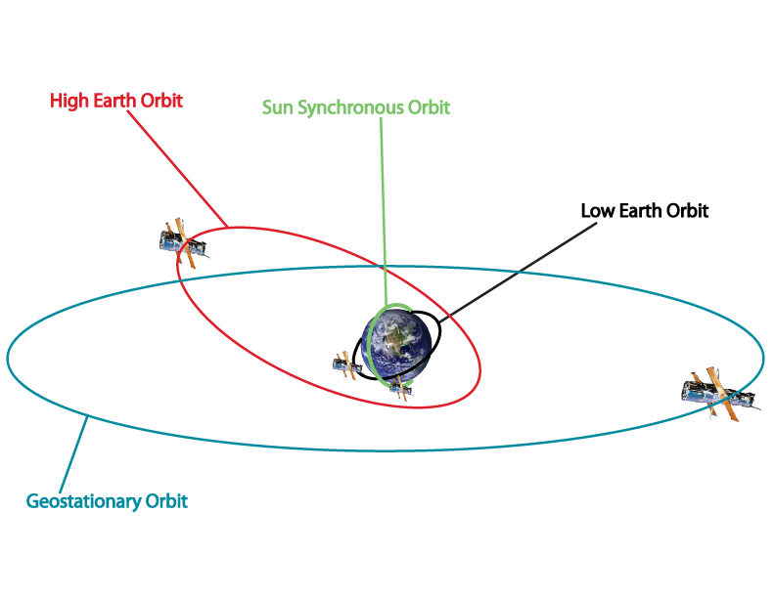

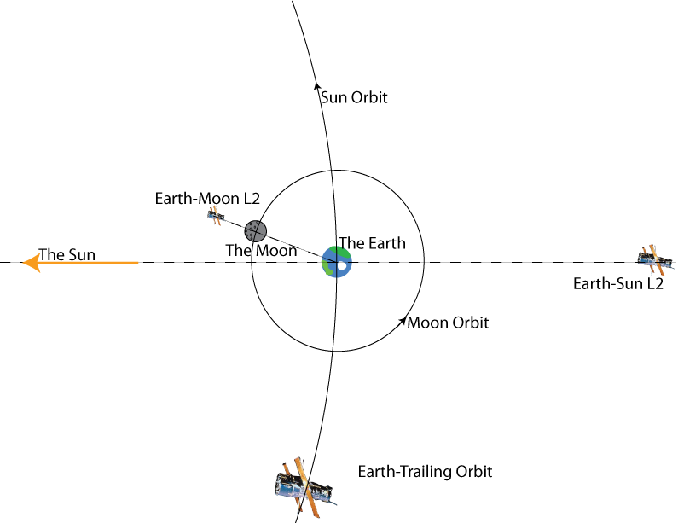
Schematic diagrams of the available orbit selections

Questions

- A satellite in low Earth orbit is typically 300 km above the surface. Use the equations above to calculate its speed
[The radius of the Earth is approximately 6500 km. The mass of the Earth is approximately 6x10²⁴ kg]

- Use the two equations above to show that the relationship between the period and radius of a satellite’s orbit around the Earth is given by the following equation
$$T=\frac{2πr^{3/2}}{\sqrt{GM}}$$

- What altitude would a geostationary satellite orbit at?

- Calculate the velocity of the Earth’s surface at the equator as it spins on its axis. Is this faster or slower than a satellite in low-Earth orbit?

- In which direction does the Earth’s surface move as it rotates?

Your Choices

Low Earth-orbit
These are satellites in orbit around the Earth, typically less than 1000 km above the surface and with an orbital period of 90-100 minutes. To reduce space debris in the future, a satellite in low-Earth orbit must be fitted with the ability to de-orbit safely at the end of the mission, which increases the launch cost by 20%. For half of each orbit, the satellite is between the Earth and the Sun, and so can only observe for around 50% of the time. The small amount of drag from the Earth’s atmosphere means that the fuel lifetime is 10 years. This orbit is suitable for all types of cooling systems, though the proximity of the Earth reduces the cryogenic lifetime by 30%. Ground control costs are £20 million per year.

High-Earth orbit
Satellites in high-Earth orbit are typically more than 1000 km from the surface. They are often in highly elliptical orbits, which allows them to observe for 75% of the time. Since the satellite is higher than one in low-Earth orbit, the fuel will last 20 years. This orbit is suitable for all types of cooling systems. Ground control costs are £30 million per year.

Sun-synchronous orbit
A sun-synchronous orbit is a particular type of low-Earth orbit which allows the satellite to remain in sunlight the entire time. This increases the ambient temperature, but means that the satellite can observe 100% of the time. As with a normal low-Earth orbits, the satellite must be fitted with the ability to de-orbit safely at the end of the mission, which increases the launch cost by 20%. The small amount of drag from the Earth’s atmosphere means that the fuel lifetime is 10 years. This orbit is suitable for all types of cooling systems. Ground control costs are £30 million per year.

Geostationary orbit
A satellite in geostationary orbit remains above the same place on the Earth’s surface at all times, since it orbits roughly once every 24 hours. This requires it to be at an altitude of around 36,000 km. Since it spends half its time between the Earth and the Sun a satellite in geostationary orbit can typically only observe for around 50% of the time. Such long periods in the Sun make such an orbit unsuitable for passive or cryogenic cooling. Since the satellite is in a high orbit the fuel lifetime is 20 years. Ground control costs are £40 million per year.

Earth-trailing orbit
Some satellites can be put into orbit around the Sun rather than the Earth. They orbit the Sun slightly more slowly than the Earth does, and so gradually trail behind, reaching a distance of around 10 million km after a year. Their distance from the Earth means that they can observe 100% of the time. Since such an orbit requires very few course adjustments the fuel lifetime is 20 years. This orbit is suitable for all types of cooling systems. Ground control costs are £60 million per year.

Earth Moon L2-point
The “L2” point, or 2nd Lagrangian point, is a position on the far side of the Moon which orbits the Earth at the same rate as the Moon. While the satellite is well away from the Earth, its position behind the Moon requires a relay satellite to be placed in orbit around the Moon, which increases the launch costs by 50%. Since the satellite spends half of each orbit between the Moon and the Sun, it can only observe 50% of the time. Since it spends long durations in sunlight, such an orbit is unsuitable for passive or cryogenic cooling. Relatively large amounts of fuel are required to maintain orbit at an L2 point, so the fuel lifetime is 10 years. Ground control costs are £80 million per year.

Earth-Sun L2 point.
The “L2” point of the Earth-Sun system is the position at which a satellite with orbit the Sun at the same rate as the Earth, despite being 1.5 million km further away. This is because of the slight increase in centripetal force due to the Earth’s gravitational pull. Since the Earth and the Sun are constantly in the same direction, the satellite can observe 100% of the time. Relatively large amounts of fuel are required to maintain orbit at an L2 point, so the fuel lifetime is 10 years. This orbit is suitable for all types of cooling systems. Ground control costs are £50 million per year.

Operational lifetime
The operational lifetime of the mission will add to the cost required to run the satellite. It may be limited by the fuel or coolant supply. A longer mission will also mean a higher risk of failure of delay.
Check with the Mission Scientist that the coolant will meet the lifetime requirements
Check with the Project Manager that the mission lifetime does not exceed the fuel lifetime
Check with the Mission Scientist that the orbit is suitable for the cooling systems chosen.

Launch Vehicle
There are numerous launch vehicles and launch sites to use for your satellite from. However, different launch vehicles are launched form different sites, and the two must be compatible.
Different launchers have different sizes and have different limits in terms of the mass they can carry. The mass carried depends the on the orbit chosen. It is advisable for the satellite mass to below 80% of maximum mass for the chosen launch vehicle. The maximum mass is lower for launches beyond low or high Earth orbit, and some launches are not able to achieve higher orbits. Some operators are a little more efficient than others in terms of cost in order to launch satellites, and other launchers also have varied Success Probabilities, which in turn affects the risk.

Your choices

Launch vehicle | Diameter | Maximum mass to LEO | Maximum mass beyond LEO | Launch cost | Operator | Success Rate
Ariane 5 | 5.5 m | 20 t | 9 t | £100 million | ESA (Europe) | 96 %
Soyuz | 3 m | 8 t | 4 t | £60 million | Roscosmos (Russia) | 98 %
Delta II | 3 m | 6 t | 2 t | £30 million | NASA (USA) | 99 %
Delta IV | 5 m | 23 t | 13 t | £200 million | NASA (USA) | 95 %
Proton-M | 4 m | 20 t | 5 t | £60 million | Roscosmos (Russia) | 88 %
H-2B | 5 m | 15 t | 8 t | £80 million | JAXA (Japan) | 95 %
Vega | 3 m | 2.3 t | -- | £23 million | ESA (Europe) | 98 %
Pegasus | 1.2 m | 0.4 t | -- | £15 million | Orbital (USA) | 92 %
Long March 3B | 3.5 m | 12 t | 5 t | £30 million | CNSA (China) | 75 %
Atlas V | 3.5 m | 19 t | 9 t | £150 million | NASA (USA) | 98 %
Falcon 9 | 3.5 m | 10 t | 7 t | £40 million | SpaceX (USA) | 97 %
Check with the Project Manager that the satellite mass and the rocket capacity are compatible.
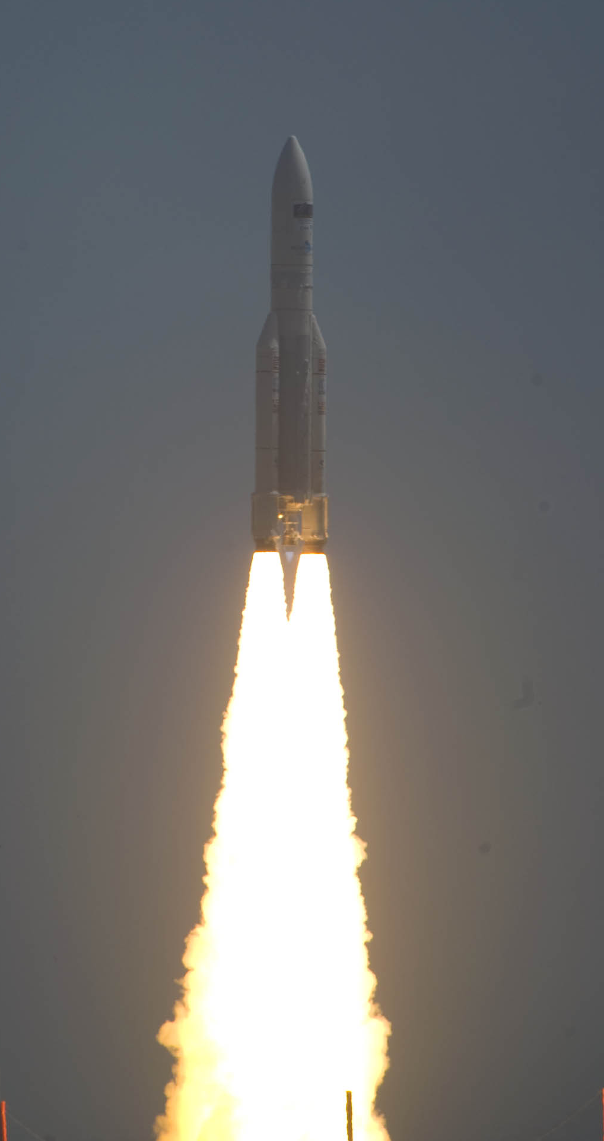
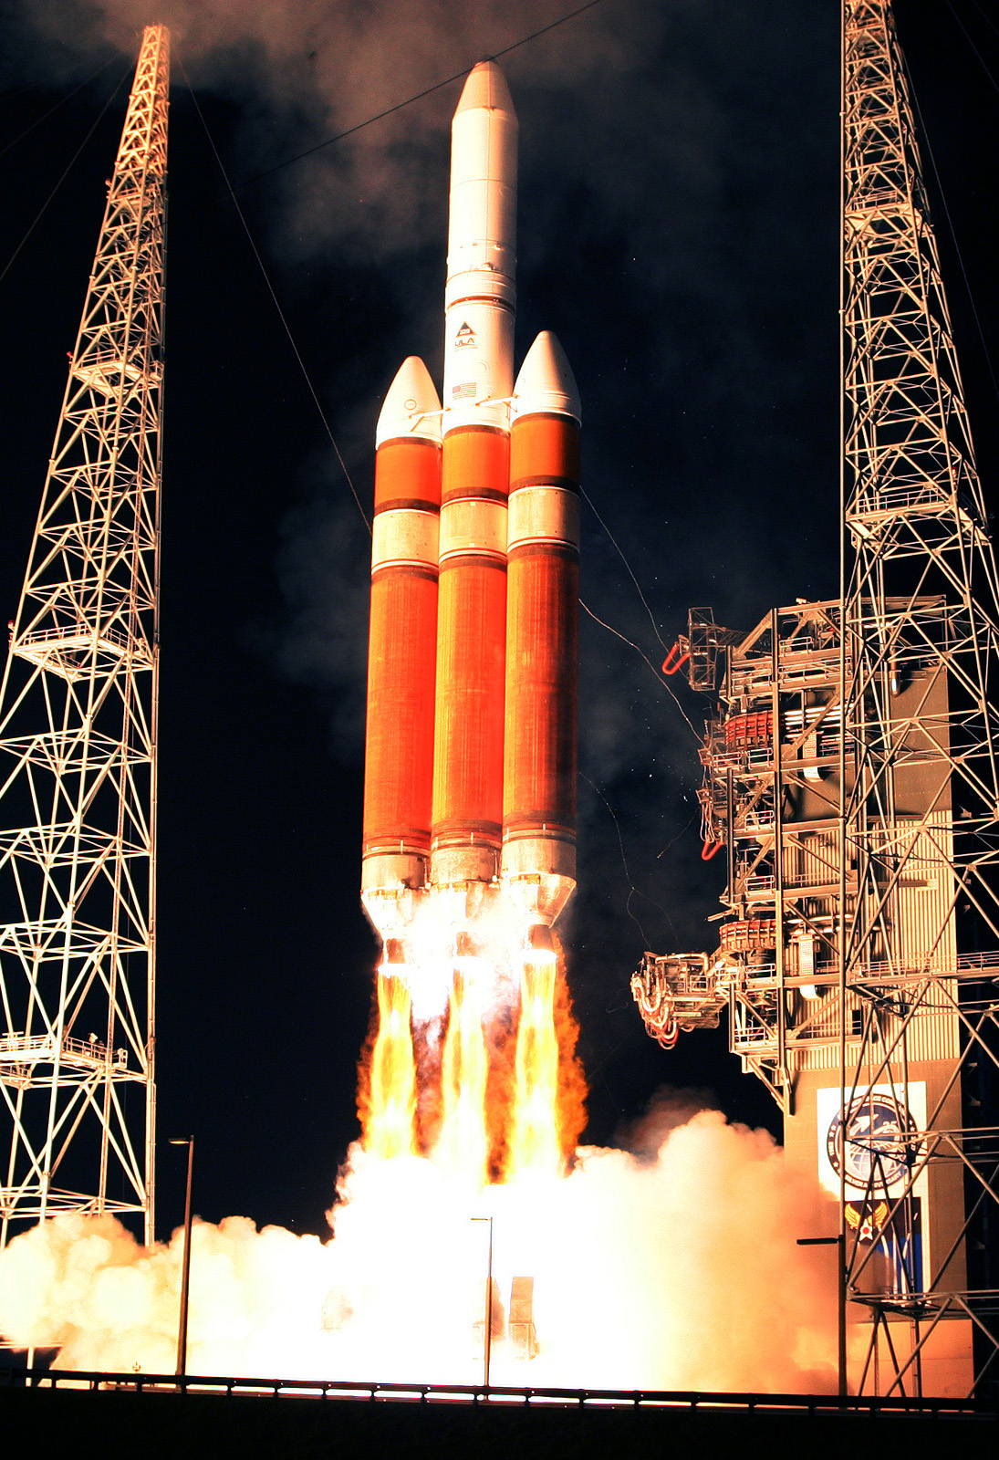
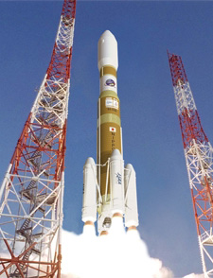
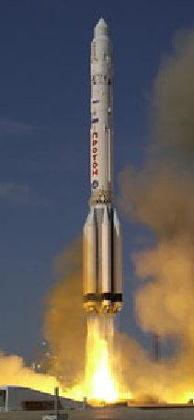
Ariane 5 Delta IV H-2B Proton-M

Launch Site
Different sites also effect the type of Orbit available, as a rocket cannot be launched and immediately fly over a highly populated regions. To reach orbits beyond low-Earth orbit, a rocket must be launched in the direction of the Earth’s rotation.

Your Choices

Launch site | Launch trajectories | Launch vehicles supported
Guiana Space Centre, French Guiana | North, East | Ariane 5, Soyuz, Vega
Baikonur, Russia | North, East | Soyuz, Proton-M
Plestesk, Russia | North | Soyuz, Proton-M
Kennedy Space Centre, Florida | East | Delta II, Delta IV, Atlas V, Falcon 9
Vandenberg, California | North | Delta II, Delta IV, Atlas V, Falcon 9
Xichang, China | North, East | Long March 3B
Tanegashima, Japan | South, East | H-2B
Carrier Aircraft | Any | Pegasus

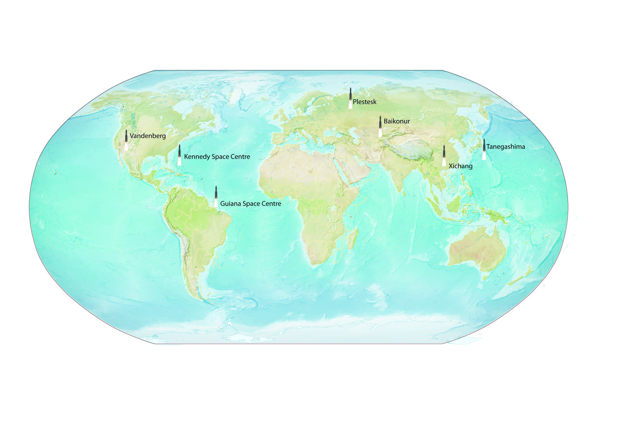

Locations of Launch sites around the world

Example Proposal Letter

Dear ________________,
We would like to propose a project to send a telescope into space on board a satellite. The aim of the mission is to ____________________________________________.
Previous similar missions are_____________________________. This mission will advance on these by _______________________________________________________

Instruments
The instruments on board will be ______________________________________ ___________________ . They will allow the science goals to be met by

Mirror
The main mirror of the telescope will be ____________________________ . This will allow the instruments to achieve resolutions from ____________________ to _____________________ .

Cooling System
The cooling systems on board will be ___________________________________________________, to achieve a temperature of __________ Kelvin, the minimum operating temperature required by the instruments is __________ Kelvin.

Mass budget
The total mass of the satellite will be ____________ . The breakdown from the individual components is given below
Mass budget
Satellite Structure:
Mirror:
Cooling System:
Instruments:
Total Satellite mass:

Orbit Selection
The satellite will observe from ______________________________________ , at a distance of ____________ from Earth. The orbital period will be __________________________ , and the maximum fuel lifetime for maintaining such an orbit is ______________________________. The mission duration will be ______________ years

Launch vehicle and site
To reach orbit, the satellite will be launched on a __________________________ , operated by ________________ , from _______________________________ . The maximum capacity of this launch vehicle is __________ ,

Budget
The total cost of the mission will be ________________ .
Cost
Satellite Structure:
Mirror:
Cooling System:
Instruments:
Development cost:
Launch cost:
Ground control cost:
Operations cost:
Total mission cost:

Kind Regards,
____________________________

