Smile for light

Contents
- Buy cards
- Loan cards
- Mail cards
- 6 pawns
- Money
- 1 dice

Mail cards:
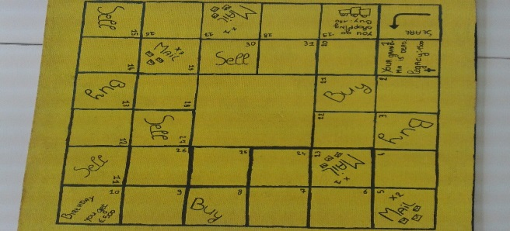
Mail cards are cards that you get when you're on a mail square. Sometimes it’s a letter or it is an invoice that you have to pay at the end of the month.
Buy cards:
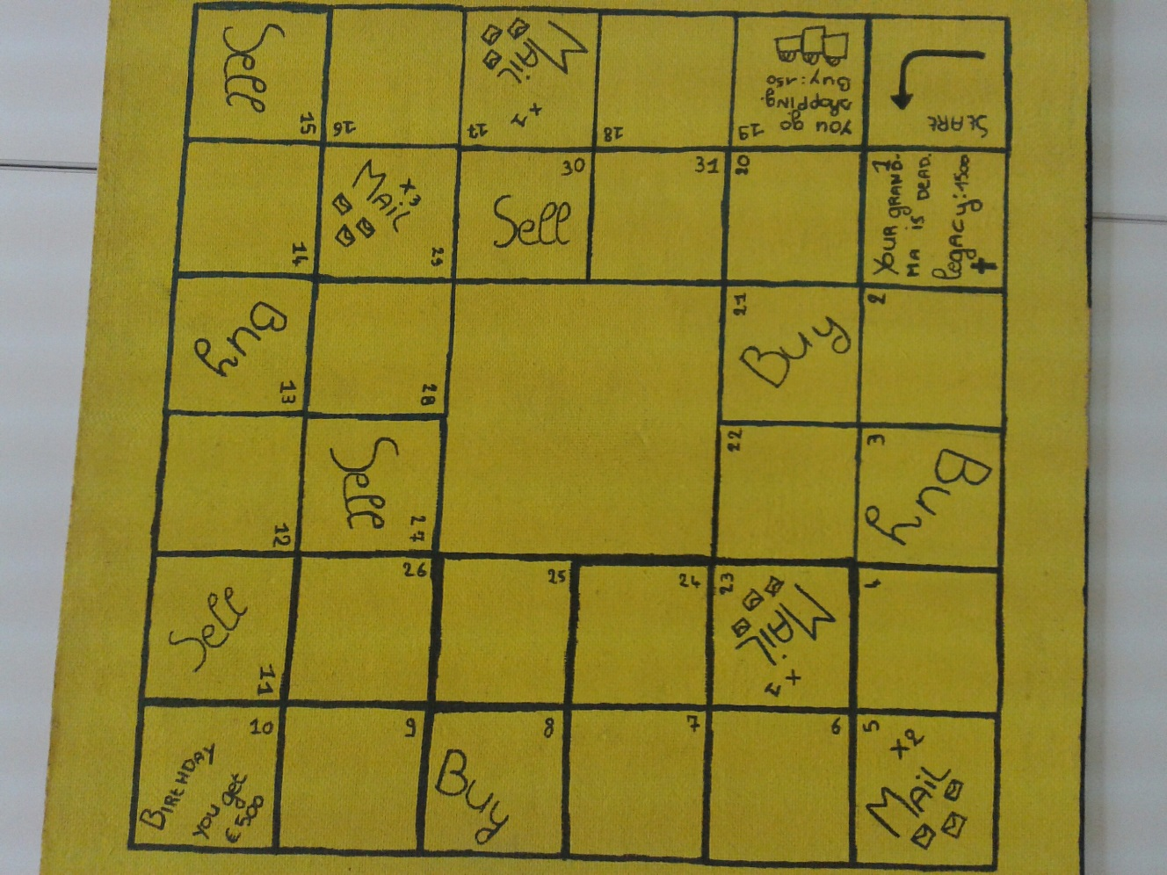
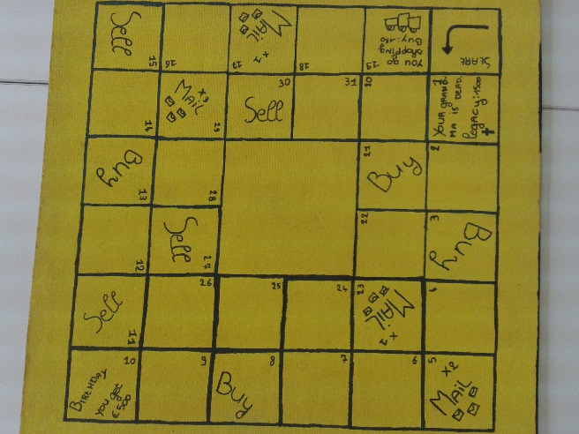
Buy cards are cards that you can earn extra money with. You buy something and a little later you can sell it. You can only buy something if you're on a buy square. You can only sell if you're on a sell square.

Loan cards:
loan cards You can borrow money if you want. But it must be paid back within one month. Failing that, you will have to pay €300 extra. Manage it within the month than you will need only pay 150 Euros on top of your loan. The loan comes from the bank. You pay the money back to the bank at the end from a month.

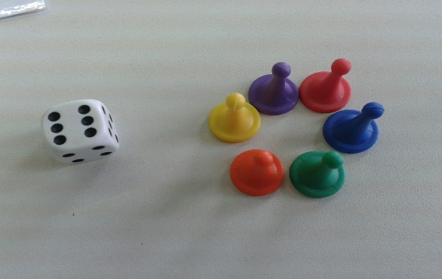
Game rules

Before:
- You begin whit €1500 (that’s your start capital)
- Choose a pawn
- Grab a dice
- Shake the cards and put the same card together ( for example: mail by mail and loan by loan)
- Let’s begin the game

The game:
- Throw a dice
- Put your pawn on the right square
- Try to make a lot of money

How to make a lot of money:
- Go to a square where you can buy
- Take a card and decide if you will buy
- If you come at the square sell you can sell ONE
buy card to the bank
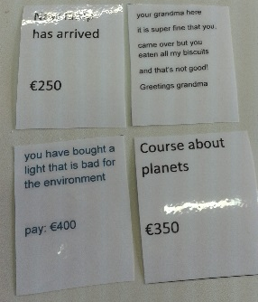
The cards:

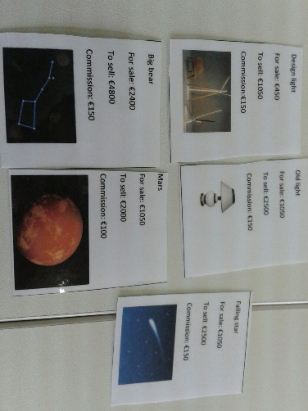
- Mail cards
- Buy cards
- Loans cards

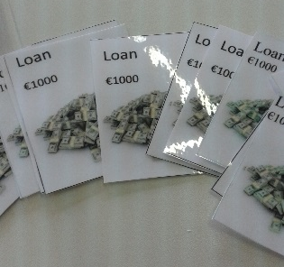
Mail cards: Mail cards are cards that you get when you're on a mail square. Sometimes it’s a letter or it is an invoice that you have to pay at the end of the month.
Buy cards: Buy cards are cards that you can earn extra money. You buy something and moments later you can sell it. You can only buy something if you're on a buy square. You can only sell if you're on a sell square.

Loans cards: loan cards You can borrow if you want. But it must be repaid within one month. Failing that, you will have to pay €300 extra. Manage it within the month than you will need only pay 150 Euros on top of your loan. The loan comes from the bank. You paid the money back to the bank.

More explanation:
- The game takes about half an hour to an hour.
- The game is per month
- You play three months
- At the end of the month, you pay all your post, your loans as well.
- The person the first time on the big box in the Middle gets all the money that‘s in the box.
- There are also boxes where you have to pay: put the money in the big box in the Middle.
- You may not borrow money from someone only with loan cards.

Savings account
You have a savings account where you can drop money. You don’t drop money in your savings account after the 23rd After a month, you get your money back, but you will also earn extra. The more money you put into it, the more you gain.
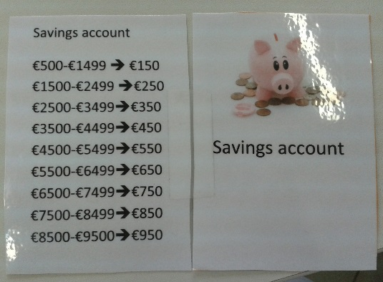
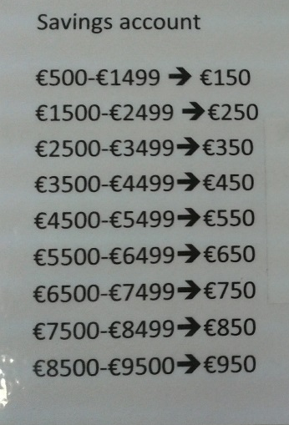

If you put between 500 and 1499 euros in your savings account you get 150 euros extra at the end of the month.

Pictures of the game
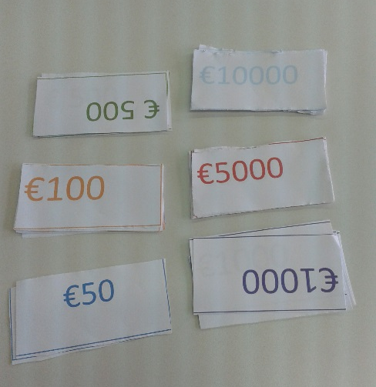
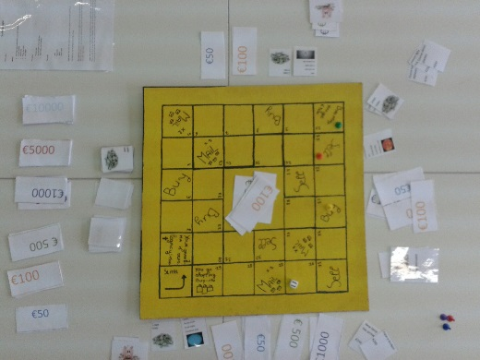

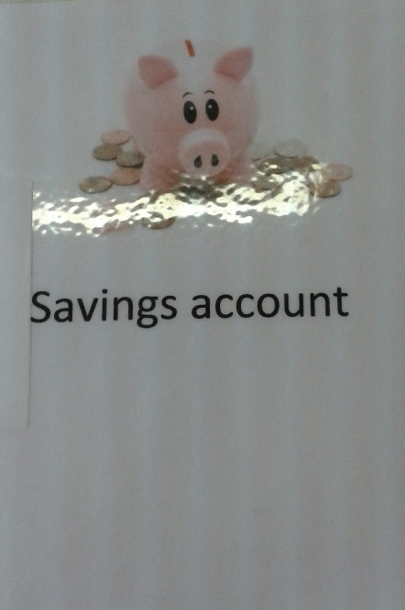
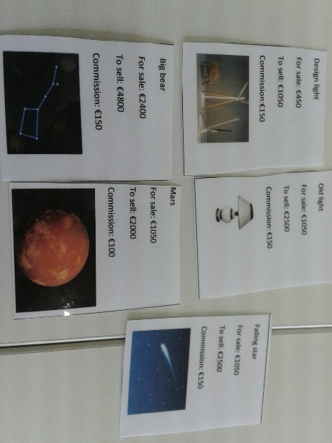
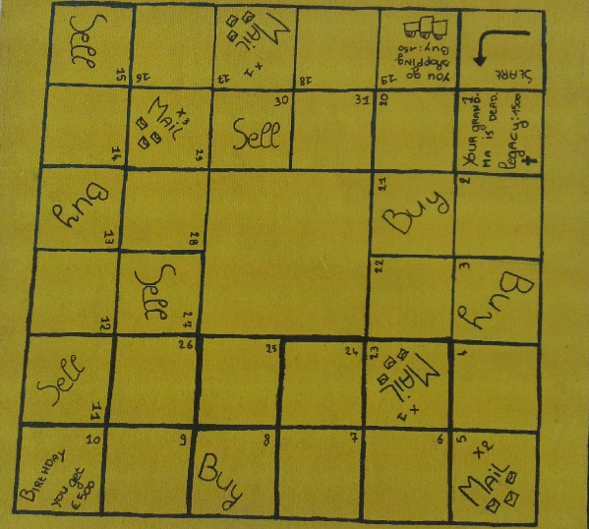
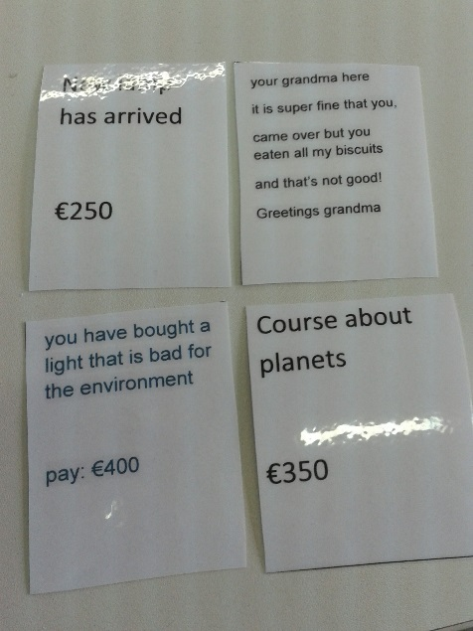
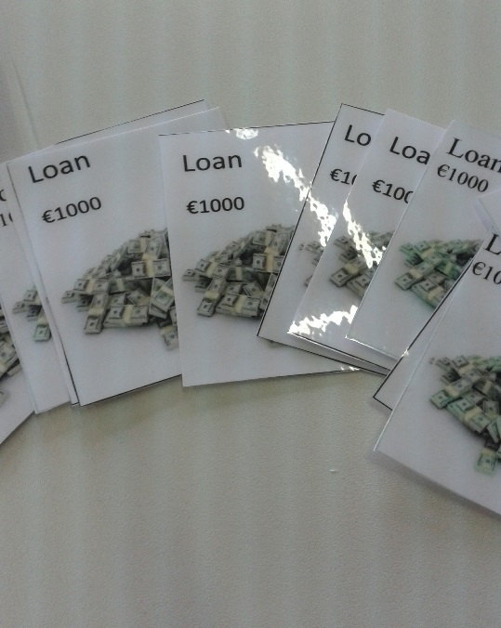
I made this game because I play this game with my best friend , she is like a sister for me. When I heard that we has to make a game , my first idea was a copy from ‘lach je rijk’ with the theme light and I managed it. My best friend helped me and gives hints.

