iMuSciCA educational Scenario Metdata

Title: | Scenario A: Investigating algorithms with iMuSciCA
Keywords: | Monochord, frequency, tension, length
Short Description: | Students will investigate algorithm. They will be able to see the pattern in many different fields such us music, receipe etc. they will invest also the repeat procedure and discover it in a pattern (partiture) . They will try to synthesize music by using a repeating pattern
Lesson Plans included: | Lesson Plan A1: Learning about algorithms  Lesson Plan A2: learning about loop statements in programming | Date: | 5/7/2018
Educational Objectives: | Learn how to find the repeat loop in real life problems and to write the appropriate algorithm. | Estimated Duration: | 5-6 hrs
Author(s): | Petrou Arg. | Age Group: | 13-17
Contributor(s): |  | Language: | English
Status: | Final | Difficulty Level: | Medium
Dissemination level: | Public | Special Needs Addressed:

iMuSciCA educational Scenario Synopsis

Scenario Title: Investigating a monochord
Scenario Description
E: Engineering/Technology, S: Science/Mathematics, M: Music
Phases | Field | Time | Description | Activity | Remarks
Engage | M,S | 1.5 hr |  |  | Lesson plan 1
Imagine | E,S | 1 hr |  |  | Lesson Plan 1
Create | E, S | 2 hrs |  |  | Lesson Plan 1
Analyze | M, E, S | 1.5 hr |  |  | Lesson Plan 1
Communicate/Reflect | M, E, S | 1.5 hrs |  |  | Lesson Plan 1

Lesson Plan 1: Learning about monochords
Description: In this lesson plan, students will be introduced to the algorithm and its characteristics. And they will work with repeat loop procedure. The lesson plan is addressed to High School Students (Age 13-17) with an estimated duration of 2.5 hrs and 2.5 hrs

Inquiry Phase: Engage

STEAM Field: M,S

Wonder, Ask Questions, Explore, Observe– Identify Problems, questions and chances
- Have you ever wondered if there is a similarity between a woman who cooks and a boy who play guitar?
- Write down some similarities?
- can you find other activities with the above similarities? Discuss.
So what is the common characteristic of the three below items;
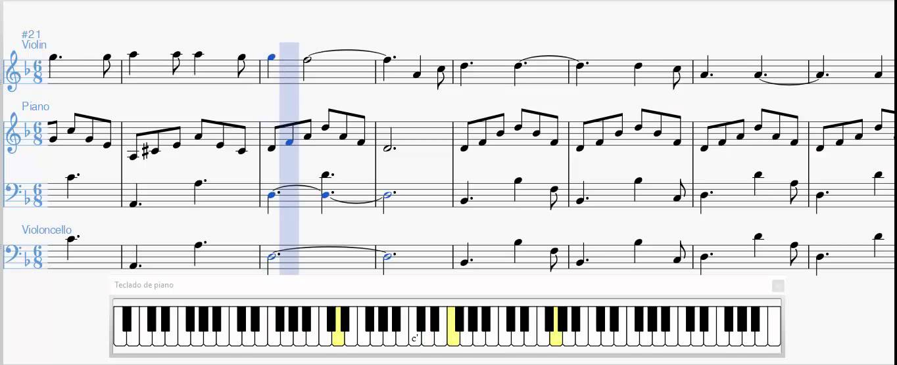
RECEIPE: Coffee Cured Ahi Tuna Salad With Turrialba Cheese and Lime Dressing
Have you ever made a Costa Rican sashimi salad at home? Probably not — but you definitely should.
So the recipe:
Marinate fresh tuna steak with coffee, brown sugar, and salt.
Then, slice it up and serve on a bed of greens with tangy cheese and salad dressing.

Figure 1:TRAVEL ASIA
Travel to ASIA
Apply for a Passport
Visit a Travel Clinic
Apply for Travel Visas
Book a Flight to Asia
Get Travel Insurance for Asia
Plan Your Asia Travel
Arrive Prepared

[Μαγνητίστε την προσοχή του αναγνώστη σας με μια εξαιρετική παράθεση από το έγγραφο ή χρησιμοποιήστε αυτόν το χώρο για να δώσετε έμφαση σε ένα κύριο σημείο. Για να τοποθετήσετε αυτό το πλαίσιο κειμένου οπουδήποτε στη σελίδα, απλώς σύρετέ το.]

Relate to Background Knowledge
What is the meaning of the word ALGORITHM? What is the key subject of it? Can you recognize it to three upper paradigms?
1. What are the fundamental properties of algorithm?
Let’s watch the following video and remember
https://www.youtube.com/watch?v=TfYCnOvNnFU
Discuss:
- Unambiguous − Algorithm should be clear and unambiguous. Each of its steps (or phases), and their input/outputs should be clear and must lead to only one meaning.
- Input − An algorithm should have 0 or more well defined inputs.
- Output − An algorithm should have 1 or more well defined outputs, and should match the desired output.
- Finiteness − Algorithms must terminate after a finite number of steps.
- Feasibility − Should be feasible with the available resources.
- Independent − An algorithm should have step-by-step directions which should be independent of any programming code.
- How are the Unambiguity, finiteness, the input and output of an algorithm are related?
-on what is the feasibility of an algorithm is depend?
- How do you understand the independent of an algorithm? Do you believe that is you “run” an algorithm to any programming language will have/must have the same results?
What happened with music? Are we getting the same results by playing the same melody to guitar and to monochord (try it to https://workbench.imuscica.eu/). discuss the result

2. Let’s remember some key features of algorithm:
https://www.youtube.com/watch?v=FbYzBWdhMb0
Discuss:
- What are the sources of algorithm? Can all the problems be solved?
- How does the mechanism of solving a problem is translated to an algorithm?
- how many ways can you use to present an algorithm?

Now that we have reviewed algorithm and its feature, let’s see how we can understand how can we code a melody by using an algorithm!
Can you imagine how will your name will be heard as a theme in classic music?
Do you think it is interesting?
There is a clever algorithm that convert any name to a melody.the algorithm is called Clarallel, and it produce the “musical equal” of a name. It has it history back to Robert Schumann and his wife Klara. Kai Konishi Dukes, a cellist and composer who lives in London took Schumman’s Technik and created and algorithm which produce classic music for any string is inserted in as an input to the algorithm
Try at first your name to the following link
http://www.clarallel.com/
Afterwards try two or more sentences from your favourite song (word by word)
Download the files and since you convert them to the appropriate form insert it to https://workbench.imuscica.eu/.
a)Use the tone synthesizer to synthesize a melody.
B) in the http://www.clarallel.com/ it provides you the pitches of each word try to synthesize a melody by using the DrawMe tool of https://workbench.imuscica.eu/. What do you have to say about the results.

Inquiry Phase: Imagine

STEAM Field: E, S

Repeat loop - Identify relevant variables to investigate – Identify Relevant Solutions to use

Your input was:
Roula Petrou
It led to the pitches:
GCDBA BEFGCD
Which led to the minor mode melody:
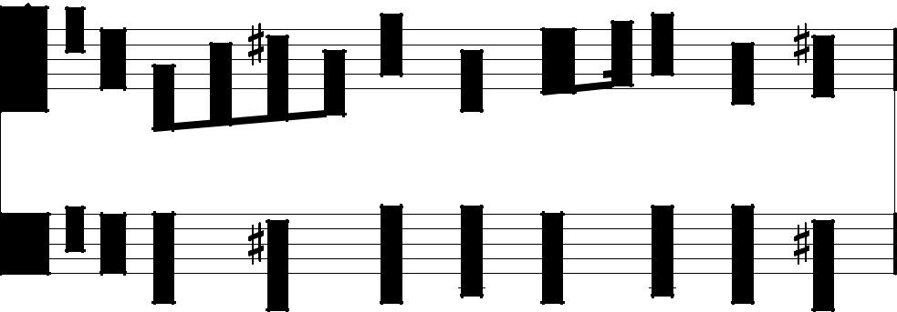

R o u l a P e t r o u

Do you see any repeat in the pitches or in the partiture?
See the following partitures also do you see any repeat loops in? Name them a-loop, b-loop etc in case there are more than one and write down how many times do they appear in the melody.
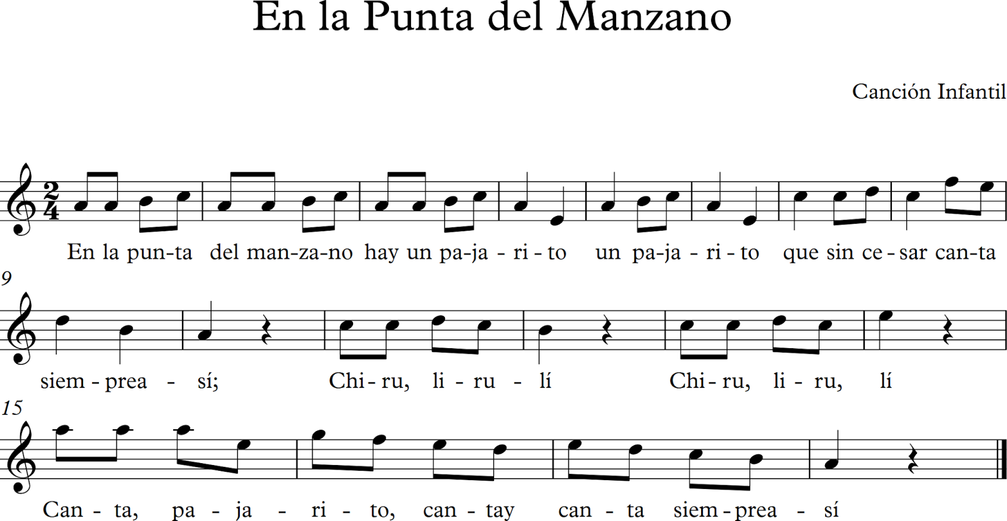
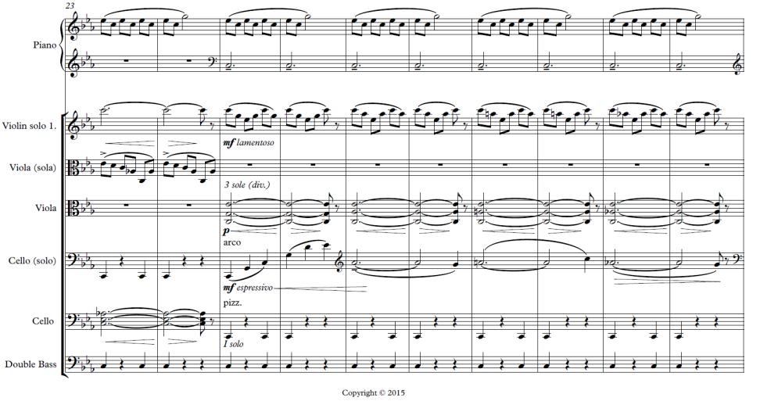
Assume that you are musical instrument manufacturers. You can divide in groups and “draw” an instrument in the https://workbench.imuscica.eu/ and try to play the melodies for the violin in https://workbench.imuscica.eu/. Do you hear the repentance of the music;
the repeat loop procedure is evaluated in the following way:
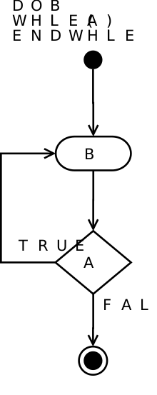
repeat
{statements}
Until contition(false)

Use your imagination and make hypothesis – Choose potential solution
Try to write a program that will produce one of the upper melodies using repeat until loop procedure or while loop procedure
Make small procedures for each repeating form in the pattern. And then write a program using these procedures. Try to use the graphic way to present at least one loop.
Which else loop procedures do you know?
Write them down. Can any of the upper melodies be evaluated by using any of the other forms of the loops? If yes try to write it down.
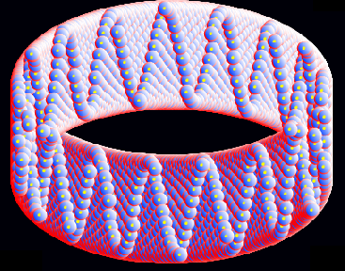
In the upper picture is any repeat loop or note, how many patterns do you recognize? How many repeats are shown? write them down on your notebook.
Assume that you are musical instrument manufacturers. You can divide in groups and “draw” your guitar https://workbench.imuscica.eu/ instrument tool maker.
Insert the popi’s orchestra that is made with Emerald algorithm and try to see if there is a loop. What do you know about emerald algorithm and algorithm DAC. Find some all the information you need from the links below and since you present them in the class discuss about them and their potetionals.
https://actu.epfl.ch/news/artificial-musician-builds-new-melodies-without-mu/
http://popaganda.gr/chrisimopiontas-algorithmous-stin-mousiki/

