Game rules
This game is very simple
you have to roll the dice seen
then you have many squares ahead
and run the command that is given
requisites
dice seen
questions
cards
game board
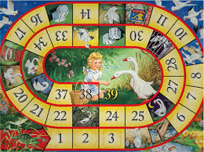
pions

