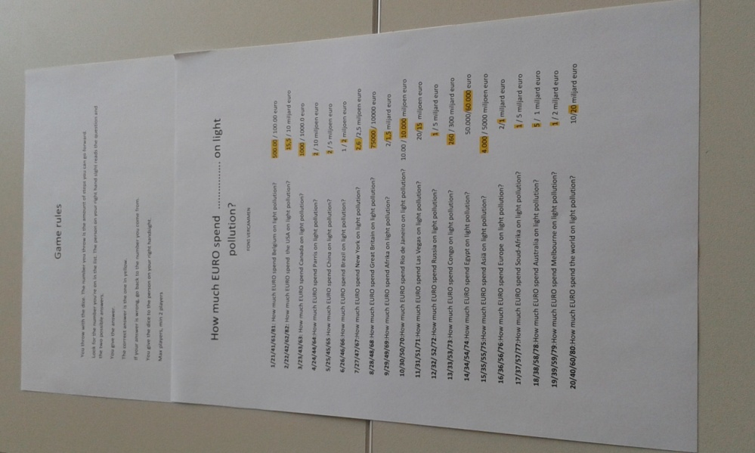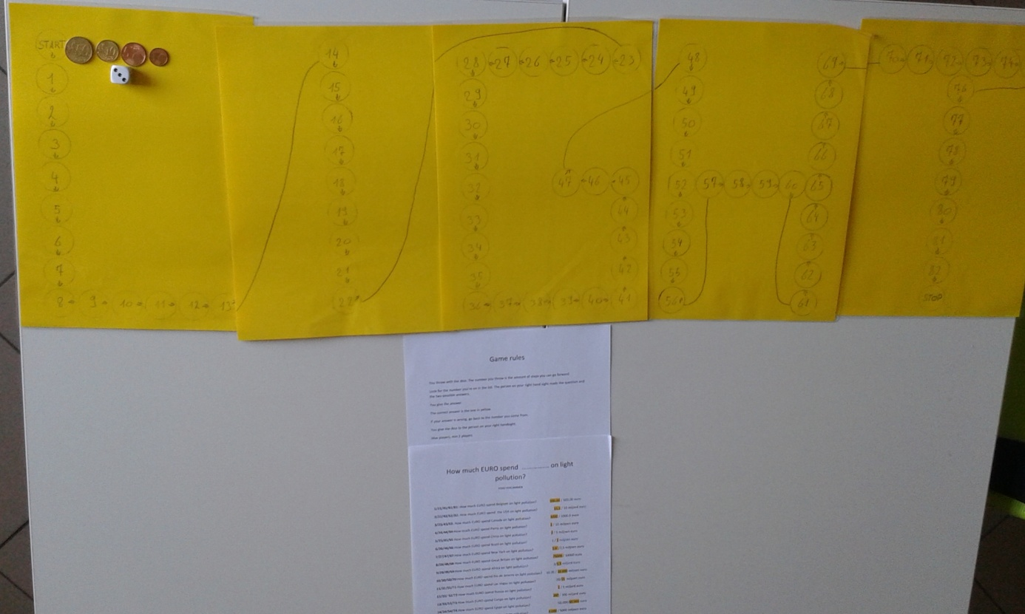
How much EURO spend ……………. on light pollution?
FONS VERCAMMEN

1/21/41/61/81: How much EURO spend Belgium on light pollution? 500.00 / 100.00 euro
2/22/42/62/82: How much EURO spend the USA on light pollution? 15,5 / 10 miljard euro
3/23/43/63: How much EURO spend Canada on light pollution? 1000 / 1000.0 euro
4/24/44/64:How much EURO spend Parris on light pollution? 2 / 10 miljoen euro
5/25/45/65:How much EURO spend China on light pollution? 2 / 5 miljoen euro
6/26/46/66:How much EURO spend Brazil on light pollution? 1 / 2 miljoen euro
7/27/47/67:How much EURO spend New York on light pollution? 2,6 /2,5 miljoen euro
8/28/48/68:How much EURO spend Great Britain on light pollution? 75000 / 10000 euro
9/29/49/69:How much EURO spend Afrika on light pollution? 2/1,5 miljard euro
10/30/50/70:How much EURO spend Rio de Janeiro on light pollution? 10.00 / 10.000 miljoen euro
11/31/51/71:How much EURO spend Las Vegas on light pollution? 20/15 miljoen euro
12/32/ 52/72:How much EURO spend Russia on light pollution? 1 / 5 miljard euro
13/33/53/73:How much EURO spend Congo on light pollution? 260 / 300 miljard euro
14/34/54/74:How much EURO spend Egypt on light pollution? 50.000/60.000 euro
15/35/55/75:How much EURO spend Asiä on light pollution? 4.000 / 5000 miljoen euro
16/36/56/76:How much EURO spend Europe on light pollution? 2/1 miljard euro
17/37/57/77:How much EURO spend Soud-Afrika on light pollution? 1 / 5 miljard euro
18/38/58/78:How much EURO spend Australia on light pollution? 5 / 1 miljard euro
19/39/59/79:How much EURO spend Melbourne on light pollution? 1 / 2 miljard euro
20/40/60/80:How much EURO spend the world on light pollution? 10/20 miljard euro

Game rules

You throw with the dice. The number you throw is the amount of steps you can go forward.
Look for the number you’re on in the list. The person on your right hand sight reads the question and the two possible answers.
You give the answer.
The correct answer is the one in yellow.
If your answer is wrong, go back to the number you come from.
You give the dice to the person on your right handsight.
Max players, min 2 players

