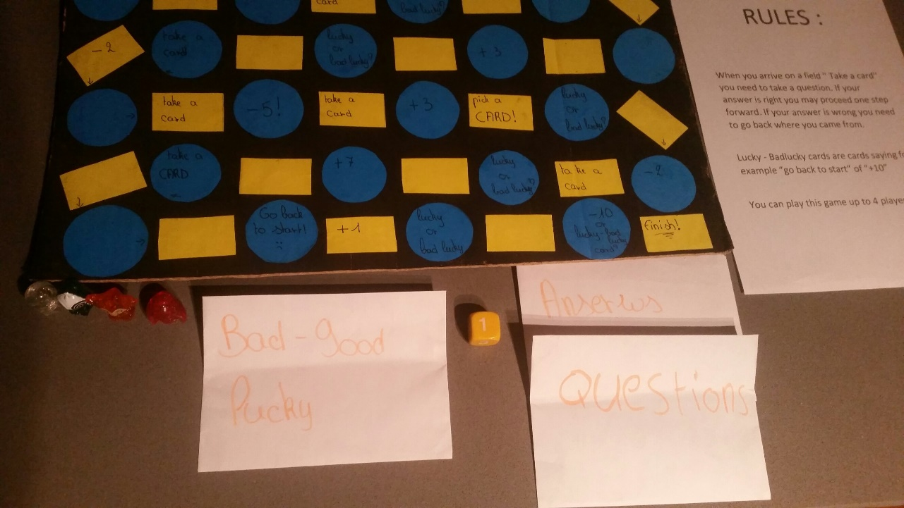

The rules :
When you arrive on a field ‘’ Take a cart ‘’ you need to take a question. If your answer is right you may proceed one step forward. If your answer is wrong you need to go back where you came from.

Lucky or Badlucky cards are cards saying for example ‘’ Change places with another player’’ of ‘’- 5’’
You can play this game up to 4 players. Have fun !!

