Sun 1 | Sun 2 | Sun 3 | Mercury 1
Mercury 2 | Mercury 3 | Venus 1 | Venus 2
Earth 1 | Earth 2 | Earth 3 | Mars 1
Mars 2 | Mars 3 | Jupiter 1 | Jupiter 2
Jupiter 3 | Jupiter 4 | Jupiter 5 | Neptune 2
Saturn 1 | Saturn 2 | Saturn 3 | Uranus 1
Uranus 2 | Uranus 3 | Neptune 1

Mission  Conquer:  Sun and Earth | Mission  Conquer:  Mars, Neptune and a telescope cart | Mission  Conquer:  Saturn and Venus and a telescope cart | Mission  Conquer:  3 X telescope cart
Mission  Conquer:  Uranus, Saturn and a telescope cart | Mission  Conquer:  Mercury and Venus | Mission  Conquer:  Sun and Neptune | Mission  Conquer:  Saturn and a telescope cart
Name 3 places where lights burn at night:  highways  streets  buildings  decorative Lighting  sports fields  outdoor lighting  ... | What are the consequences of light pollution on animals, plants and people?  Animals -> disturb biological -day and night rhythm  Plants -> influencing their growth mode  People -> disturb biological -day and night rhythm | What is light pollution exactly?  Light pollution is the increased brightness of the nocturnal environment by excessive use of artificial light. | You can only see ?/3 of the stars at heaven  1
100 million of these are killed annually because of collisions with man-made structures  - Birds  - Fish  - Snail  It is estimated that at least 100 million birds are killed annually due to collisions with man-made structures, including wind turbines, power lines, glass and towers. One third of collisions are due to urban light. 90,000 birds are killed flying into buildings in New York City | Give 3 examples what causes light pollution:  wrong placement of light sources  To high power of light sources which honors a very strong reflection to the atmosphere is too much light sources  long burning light sources | which of the two lamp posts, are the best against light pollution?  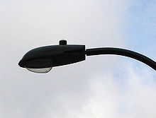  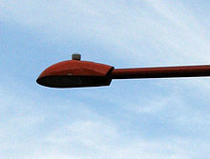  the Red Lantern

