iMuSciCA educational Scenario Metdata

Title: | Scenario A: Investigating a monochord
Keywords: | Monochord, frequency, tension, length
Short Description: | Students will investigate and verify Mersenne’s laws on the dependencies of the frequency of the sound produced by a virtual monochord on several parameters.
Lesson Plans included: | Lesson Plan A1: Learning about monochords  Lesson Plan A2: Design a monochord playing Note “A” | Date: | 30/9/2017
Educational Objectives: | Learn the relationship between frequency, tension and length of a monochord | Estimated Duration: | 7 hrs
Author(s): | E. Chaniotakis (EA) | Age Group: | 14-16
Contributor(s): | P. Stergiopoulos (EA), Renaat Frans (UCLL) | Language: | English
Status: | Final | Difficulty Level: | Medium
Dissemination level: | Public | Special Needs Addressed: | No

iMuSciCA educational Scenario Synopsis

Scenario Title: Investigating a monochord
Scenario Description: Students will investigate and verify Mersenne’s laws on the dependencies of the frequency of the sound produced by a virtual monochord on several parameters.
E: Engineering/Technology, S: Science/Mathematics, M: Music
Phases | Field | Time | Description | Activity | Remarks
Engage | M,S | 1.5 hr | Students wonder about monochords and learn the fundamental Physics related to them | https://lms.imuscica.eu/moodle/mod/assign/view.php?id=116 | Lesson plan 1
Imagine | E,S | 1 hr | Students imagine potential parameters that might affect the sound produced by a monochord | https://lms.imuscica.eu/moodle/mod/assign/view.php?id=116 | Lesson Plan 1
Create | E, S | 2 hrs | Students create their own virtual monochord and investigate its parameters | https://lms.imuscica.eu/moodle/mod/assign/view.php?id=116 | Lesson Plan 2
Analyze | M, E, S | 1.5 hr | Students analyze their data and produce quantitative relationships between fundamental frequency and string tension. | https://lms.imuscica.eu/moodle/mod/assign/view.php?id=116 | Lesson Plan 2
Communicate/Reflect | M, E, S | 1.5 hrs | Students communicate their results to their classroom and obtain feedback to refine their research. | https://lms.imuscica.eu/moodle/mod/assign/view.php?id=116 | Lesson Plan 2

Lesson Plan 1: Learning about monochords
Description: In this lesson plan, students will be introduced to the science behind the sound of the monochord. The lesson plan is addressed to High School Students (Age 14-16) with an estimated duration of 2.5 hrs.

Inquiry Phase: Engage

STEAM Field: M,S

Wonder, Ask Questions, Explore, Observe– Identify Problems, questions and chances
- Have you ever wondered how do musical instruments sound?
- Have you ever wondered why they produce the sounds they produce?
- Does the sound produced depend on parameters of the musical instruments? Discuss.
This is the image of the largest guitar ever manufactured and achieved the 2017 Guinness Record: It is almost 4m long!
Do you think it is playable? If we kept the tuning of a normal guitar, would it produce the same sounds? Assume that this guitar has strings similar to a normal guitar.

- Likewise, listen to the sound produced by a mini-guitar:
https://www.youtube.com/watch?v=cvfu5O1lqpU
Is the tuning the same with this of a normal guitar? Once again assume that the strings are similar to those of a normal guitar. Let’s investigate the science behind these instruments and perhaps we’ll break the World Guinness Record!

Relate to Background Knowledge
Let’s remember some things about sound:

1. What are the fundamental properties of waves?
Let’s watch the following video and remember
https://www.youtube.com/watch?v=TfYCnOvNnFU
Discuss:
- How are the wavelength, the frequency and the velocity of a wave related?
- What is the amplitude of a wave and how does it relate to its energy?
- On what does the velocity of a wave depend?
- On what does the frequency of a wave depend?
- What kinds of waves exist if we take into account the motion of a molecule of the medium compared to the direction of the propagation of the wave?
- What happens when two waves meet?

2. Let’s remember some key features of sound:
https://www.youtube.com/watch?v=qV4lR9EWGlY
Discuss:
- What are the sources of sound?
- What is pitch and what is loudness?
- Is sound a transverse or a longitudinal wave?
- Which are the frequencies that humans can hear?
- How does the mechanism of hearing compare to the mechanism of a microphone?
- Does the loudness of a sound depend on the distance from the source of it?

Now that we have reviewed our Physics of Waves and Sound, let’s see how we can understand the mystery of instrument making!

Inquiry Phase: Imagine

STEAM Field: E, S

Identify relevant variables to investigate – Identify Relevant Solutions to use

The monochord is a string plucked on both of its sides and can be considered as the progenitor of the guitar. It consists of two parts: the body and the string.
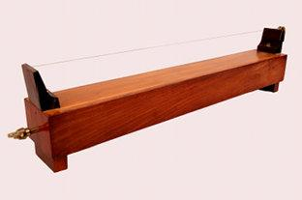
Picture 1
As happens with the guitar, likewise, when the monochord is triggered, the string oscillates and produces sound. The frequency of the sound produced is equal to the oscillation frequency of the string.
Different ways of triggering the string of the monochord will be available, for example, through a bow or a hammer, whereas, the parameters relevant to the interaction of the user with the monochord will be the interaction point, the distance of the interaction tool to the string etc.

Listen to the tuning frequencies of different instruments on the link below:
http://onlinetonegenerator.com/tuning.html
It seems that different instruments can be tuned to different frequencies. Why is that?

Use your imagination and make hypothesis – Choose potential solution

Brainstorm and discuss the parameters that you believe are important to determine the frequency of a sound produced by a stringed instrument. You can also perform a literature search. Among the parameters of interest, you should discuss: the length of the string, the string tension, the material of the string and the monochord and the thickness of the string.
After you narrow down the most important parameters, write them down on your notebook.

Create a hypothesis on how you could investigate the dependency of the sound produced by a simple monochord with the parameters you chose at the previous step of your investigation.
Assume that you are musical instrument manufacturers. You can divide in groups and “draw” your solution, highlighting the steps you wish to follow.

Present your solution in the classroom and discuss.

Lesson Plan 2: Design a monochord playing Note “A”
Description: In this lesson plan, students will use the iMuSciCA workbench to create a simple monochord which will be able to play note “A”. They will choose the parameters needed (string length, tension) to create a monochord that plays the requested note. The lesson plan is addressed to High School Students (Age 14-16) with an estimated duration of 4.5 hrs.

Inquiry Phase: CREATE (Investigate / Design)

STEAM Field: E, S

Plan the Investigation / Design the Prototype

In this activity, you will use the iMuSciCA workbench to try different string lengths and tensions in order to investigate the laws behind the sound produced by the monochord.
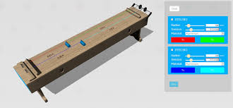
- Enter the iMuSciCA workbench and choose the 3D design environment https://workbench.imuscica.eu/release/v3
- Choose: “Monochord”
- Get Familiar with the different string parameters and the way to handle the monochord in the3D design environment.
- Choose the material of the string (e.g steel). - Ορίστε την τάση στα 60N.
- Fix the length of the monochord at a value of your liking.
- Write down the values of length, tension, material, string radius at your notebook.
- “Pluck” and listen to the sound produced by the monochord.
- Now choose the tuner tool. Pluck again and listen to the fundamental frequency of the sound. Can you find it out?

● Compare your result with the frequency of Note “A” (440Hz). How do these two numbers compare? Now, you will have to think which parameters affect the sound that you hear. Write them down in your notebook.

Carry out Investigation / Build the Prototype
- Keep tension constant at 60N and measure the frequency for different string lengths: 0.25 m, 0.5m, 0.75m, 1m, 1.25 m, 1.5m. Find the fundamental frequency for each value of length,
Table 1
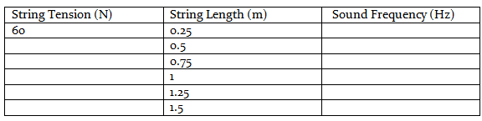
● Now reverse the procedure. Fix the length of the string at 1m and start altering tension. You can begin from the value of 20N and alter it by 20N in each step. Fill the next table in your notebook.

Table 2
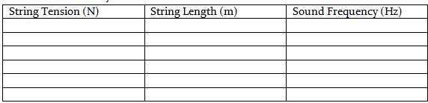

Inquiry Phase: Analyze

STEAM Field: S,E,M

Analyze Data from Investigations and Draw Conclusions/ Evaluate the Prototype.

- Using the data of the two tables you produced, plot the sound fundamental tone frequency with respect to: Tension and length of the string.
- Fit the data points with an appropriate function
- Make sure that your results are clearly noted and that the axes are appropriately labeled with the correct variable names and units.
- Write the dependency of the sound frequency to tension and string length.

Explain by Relating to Background Knowledge/ Optimize the prototype

Explain your results following the following points:
- First watch this video and consider the following questions
https://www.youtube.com/watch?v=XDsk6tZX55g
- What is a standing wave?
- How do musical notes correspond to the frequencies of standing waves?
- What are the three categories of musical instruments?
- What is the fundamental frequency and what are the upper harmonics?

- What is the connection between the sound frequency and the vibration frequency of the string?
(They are the same. The sound is a wave produced by a vibrating source: the string. The wave’s frequency is equal to the sounding body’s frequency).

- You see that sound frequency is inversely proportional to the length of the string. Why is that?
- You see that the sound frequency is proportional to the square root of tension of the string. Why is that?

In a stringed instrument like a monochord, both ends are plucked. Neither of them can move.
As a result, when the string is triggered, a standing wave will be produced.
The number of nodes on the string depends on the excitation energy.
The lowest energy configuration is this with no node between its ends.
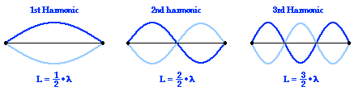
In this exercise, you investigated the parameters affecting the sound of a monochord.
The parameters of interest were: String Length “L” (m), String Tension “T” (N) , String linear density “μ” (kg/m).
For the first harmonic, L = λ/2. The equation connecting frequency, wavelength and wave velocity is:
f = u/2L (1)
The velocity of a wave propagating on a string is u =$\sqrt{T/μ}$ (2).
Thus, the frequency of the sound produced is: $f=\frac{1}{2L}\sqrt{T/μ}$ (3).
Equation (3) describes Mersenne’s law on the sound frequency produced by a monochord.

Let’s make a short exercise
Assume that you have a monochord with steel string (density equal to 7700 kg/m³ ). Its length is equal to L = 0.5m. Its string radius is R=0.235mm.
Find the value of the tension needed to produce note A (440 Hz) as a fundamental frequency solving equation (3).
Note! Linear density is not the same as volume density. To go from linear density μ to density ρ, you have to use the relationship:
$$μ=A.ρ \\ ($$Α: cross sectional area of the string).
You need to modify Mersenne’s law to display density and not linear density.
Are your results on par with Mersenne’s law?

Describe and explain the results in the different STEAM-fields and the connections between them.

- How would the monochord sound if you progressively increased the length of the string? Would the pitch increase or decrease?
- If your monochord had note A as a fundamental and you wanted to play note G, would you have to increase or decrease the length of the string while keeping the tension constant?
- Is the use of weights efficient in terms of a playable musical instrument?
- Propose other ways to vary the tension of the string.
- You are asked to create an orthogonal harp with 4 similar strings with equal length: the first string should have note A as fundamental, the second should be an octave higher, the third two octaves higher and the fourth five octaves higher. Which parameter would you vary and how?

Inquiry Phase: Communicate/Reflect

STEAM Field: E, S, M

Communicate Results and Conclusions/ Communicate the Product, perform

- Make a short power point presentation using screenshots of the instrument you designed, the waveforms produced and the frequency-tension and frequency-string length plots you created.
- Present your findings to your teacher and classmates. Accompany the plots with the saved records of the sounds you produced.

- Discuss with your classmates and ask for their feedback

Reflect on Feedback and incorporate in further process

-Reflect on the feedback you obtained.
- Watch this video of a monochord sonometer and compare with the process you followed: https://www.youtube.com/watch?v=IPH4W3n0t4o
- Run through your experiment again. Compare the procedure you followed with the procedure you designed during your “Imagine” phase. Determine the steps you need to take in order to create different monochords with the following frequencies as their fundamental harmonics:
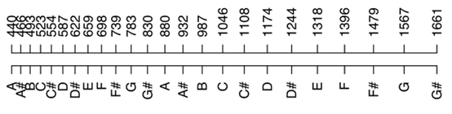
- What is more time consuming, changing the length or the tension of the strings? Relate your opinion to the real-world monochords and other stringed instruments.

