Title: | Scenario: Instruments of speech
Keywords: | Voice, musical scale, notes, monochord, timbre, power spectrum
Short Description: | Students will investigate the harmonic content of their voice and will try to emulate it using virtual musical instruments
Lesson Plans included: | Lesson Plan 1: Musical Scales and the human voice  Lesson Plan 2: Timbre and Power Spectra  Lesson Plan 3: Learning about monochords  Lesson Plan 4: Design a monochord playing note A  Lesson Plan 5: Investigating the frequency content of a monochord’s sound  Lesson Plan 6: Let’s emulate our voice | Date: | 29/3/2018
Educational Objectives: | Learn about musical scales and notes  Learn about the harmonic content of human voice  Learn how to use the waveform, the frequency spectrum and the spectrogram.  Learn about the design of a monochord  Learn about wave interference, timbre and power spectra | Estimated Duration: | 38 hrs
Author(s): | E. Chaniotakis (EA) | Age Group: | 14-16
Contributor(s): | P. Stergiopoulos (EA), Thomas Fisher (EA), Renaat Frans (UCLL), Erica Andreotti (UCLL) | Language: | English
Status: | Final | Difficulty Level: | Medium
Dissemination level: | Public | Special Needs Addressed: | No

LESSON PLANS

Title: Lesson Plan 1: Musical Scales and the human voice
Description:
In this lesson plan, students will be introduced to the aspects of human physiology related to human voice and then investigate musical notes and scales. They will be able to observe the notes prevalent in their voices. The proposed duration of this lesson plan is 5 hrs.
E: Engineering/Technology, S: Science/Mathematics, M: Music
Phases |  | Field |  | Time |  |  | Description |  |  |  | Activity |  | Remarks
Engage  Wonder, Ask Questions, Explore, Observe– Identify Problems, questions and chances |  | M |  | 1 hrs |  |  | The human voice is a dynamic instrument. It’s also the very first musical instrument that ever existed on Earth. Its ability to articulate, communicate ideas, create beautiful melodies, and translate human emotion into sounds is unmatched in the animal kingdom. Voices are as distinctive as our faces - no two are exactly alike. Some of the traits that make our voices unique can be formed into well-defined categories; pitch (high and low) and loudness (loud or soft), are examples.  Discuss: Do you think your voice has a low or a high pitch? You normally speak in high or low volume?  - Discuss the validity of this statement: “When two different people sing the same tone, the sound produced will be the same”. Is this true or false?  - Let’s try it ourselves:  Use a virtual tuning fork and try to emulate its sound with your voices. Compare your voices. Do they sound similar?  (enter the iMuSciCA workbench https://workbench.imuscica.eu/release/v3 and choose the “Tools” option).  You can record your voices using the iMuSciCA Recorder:  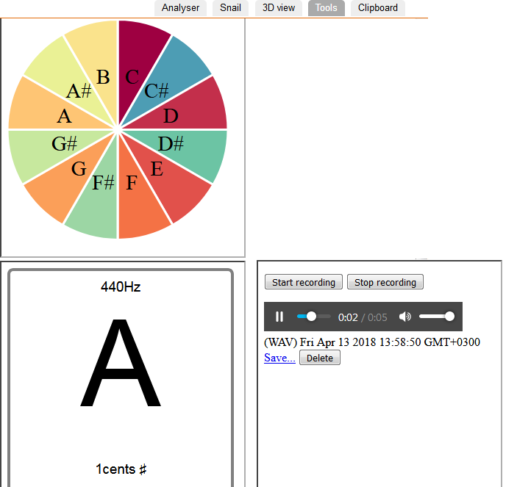  - If I had two similar tuning forks set at 440Hz, would the sound produced be the same? If so, why don’t your voices sound the same? What are the characteristics of the human body that define the properties of the sound we produce? Discuss with your classmates. |  |  |  |  |  | Before the beginning of this scenario, students should have an idea regarding  1. Sound:  https://www.youtube.com/watch?v=qV4lR9EWGlY  1.a Sound Pitch: http://hyperphysics.phy-astr.gsu.edu/hbase/Sound/pitch.html#c1  https://www.youtube.com/watch?v=yMLTF_0PAQw  1.b Sound Loudness:  http://hyperphysics.phy-astr.gsu.edu/hbase/Sound/loud.html#c1  https://www.youtube.com/watch?v=DztZDNDUaiQ
Relate to Background Knowledge |  | M, S |  | 1 hrs |  |  | In order to understand the differences between human voices, we need to understand the voice production mechanism  - Watch this video: https://www.youtube.com/watch?v=6XrqzzTWPl8  - Discuss: What are the characteristics of the human physiology that affect sound production beyond vocal chords? [1]  - Make a list of these characteristics.  Relating voice to our physiology  The sound of each individual's voice is entirely unique. Its uniqueness is due to the actual shape and size of an individual's vocal cords as well as the size and shape of the rest of that person's body, especially the chest and vocal tract. The manner in which the speech sounds are habitually formed and articulated adds another set of factors that determines vocal character. (It is this latter aspect of the sound of the voice that can be mimicked by skilled imitators.) Human spoken language makes use of the ability of the vocal cords to dynamically modulate themselves within certain parameters in a socially consistent manner. The most important communicative, or phonetic, parameters are the voice pitch (determined by the vibratory frequency of the vocal folds) and the degree of separation of the vocal folds.  Children learn to use all of these actions consistently during speech development. They learn to speak the difference between utterances by listening to and imitating the voices of the adults around them. They mimic these voices playfully because they are so much different from their own. Humans have vocal folds that can loosen, tighten, or change their thickness, and over which breath can be transferred at varying pressures. The shape of the chest and neck, the position of the tongue, and the tightness of otherwise unrelated muscles can be altered to give the voice a certain quality. Any one of these actions results in a change in pitch, volume, timbre, or tone of the sound produced. Sound also resonates within different parts of the body, and an individual's size and bone structure can affect to a certain degree the sound produced by an individual.  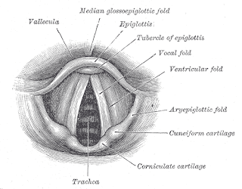  Adult men and women have different sizes of vocal fold which reflects the male-female differences in larynx size. Adult male voices are usually lower-pitched and have larger folds and the female vocal folds are smaller – between 12.5 mm and 17.5 mm in length. The folds in both sexes are within the larynx. As seen in the illustration above, the folds are located just above the vertebrate trachea (the windpipe, which travels from the lungs). The difference in vocal folds size between men and women vary as well because of genetics causing men and women's singing voices to being categorized into types.  As happens with musical instruments, the properties of human voice depend on the properties of the sounding body. For monochords it may be the string and the body. For humans it is the vocal chords and the vocal tract.  Now we need to ask ourselves the following question: How do we codify the sound of our voice? Using our voices we can speak and we can sing. In order to understand sound using the language of music, we need to understand musical notes and scales.  Musical Notes and Scales  From a musician’s point of view, sound can be characterized regarding its pitch and duration in different notes [2]:  In music, a note is the pitch and duration of a sound, and also its representation in musical notation (♪, ♩). A note can also represent a pitch class. Notes are the building blocks of much written music: discretizations of musical phenomena that facilitate performance, comprehension, and analysis.  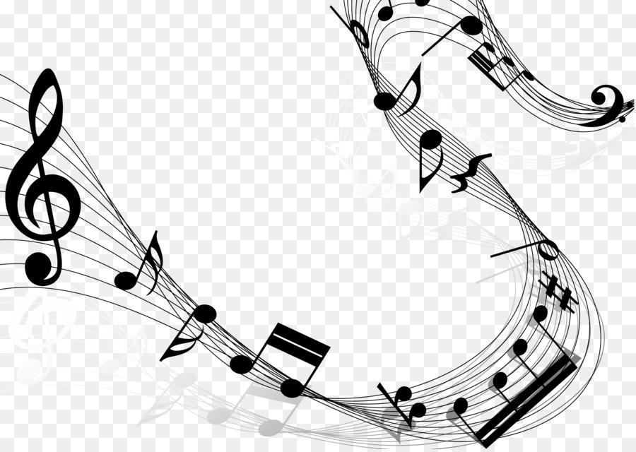  Check this video to find out more: https://www.youtube.com/watch?v=YjFIlLKjmkI  If we order the music notes by frequency we produce a scale [3]: In music theory, a scale is any set of musical notes ordered by fundamental frequency or pitch. A scale ordered by increasing pitch is an ascending scale, and a scale ordered by decreasing pitch is a descending scale. One of the most commonly used scales is the chromatic scale [4]: a musical scale with twelve pitches, each a semitone [5] above or below its adjacent pitches. As a result, in 12-tone equal temperament (the most common temperament in Western music), the chromatic scale covers all 12 of the available pitches. Thus, there is only one chromatic scale.  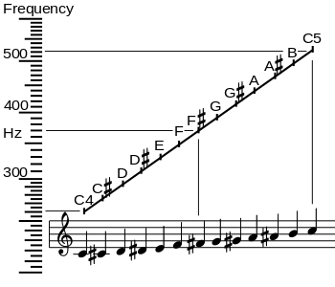  Find out more about the chromatic scale: https://www.youtube.com/watch?v=sr2rXc9Qu4A  In this table you can see the notes of the chromatic scale and the connection to sound frequencies:  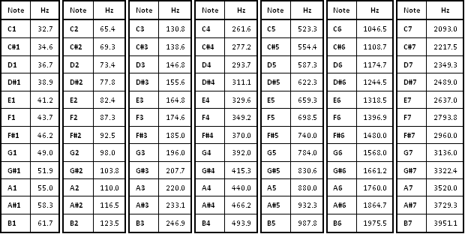  You will observe that the same note appears many times with different subscripts. For example, note C has variants from C₁ to C₇ in the table above.  - Can you observe any relationship between same notes with different subscripts?  We can see that C2 has twice the frequency of C1, C3 has 4 times the frequency of C1 and so one. In music, an octave (Latin: octavus: eighth) or perfect octave is the interval between one musical pitch and another with half or double its frequency. We say that C2 is an octave higher than C1. If we have C2 and C1 sound together, the sound produced will be pleasant and will consist of two harmonic waves, the one having twice the frequency of the other. |  |  |  |  |  | [1] Here we need to stress out the importance of our physiology in sound production: the vocal tract (meaning, the part between the voice chords and the mouth) and its relevant components are responsible about the different properties of the produced sound.  Resources for the Physics of Human voice:  http://hyperphysics.phy-astr.gsu.edu/hbase/Music/voicecon.html#c1  [2]: https://en.wikipedia.org/wiki/Musical_note  [3]:  https://en.wikipedia.org/wiki/Scale_(music)  [4]:  https://en.wikipedia.org/wiki/Chromatic_scale  [5]:  Semitone: the smallest interval used in classical Western music, equal to a twelfth of an octave or half a tone; a half step.
Imagine  Identify relevant variables to investigate – Identify Relevant Solutions to use  Use your imagination and make hypothesis – Choose potential solution |  | M, S |  | 1 hrs |  |  | We now understand the reason behind the voice differences among humans. Even if we sing the same song, or “tune” ourselves with the same tuning fork, the sound produced by each human will have the similarities but also differences.  We have also learnt about the music notes and scales. We know what an octave is and what musical notes represent.  It is now the time to bridge these two concepts and understand our voices in terms of musical notes. How would you do that?  Take the following points into account and formulate a working hypothesis:  - Human voices are different  - Even when we sing the same song, or tune ourselves to the same tuning fork, the sound produced would not be totally similar.  - Notes can codify sound in terms of music.  Experiment with the iMuSciCA Snail instrument which you will utilize in your further investigation:  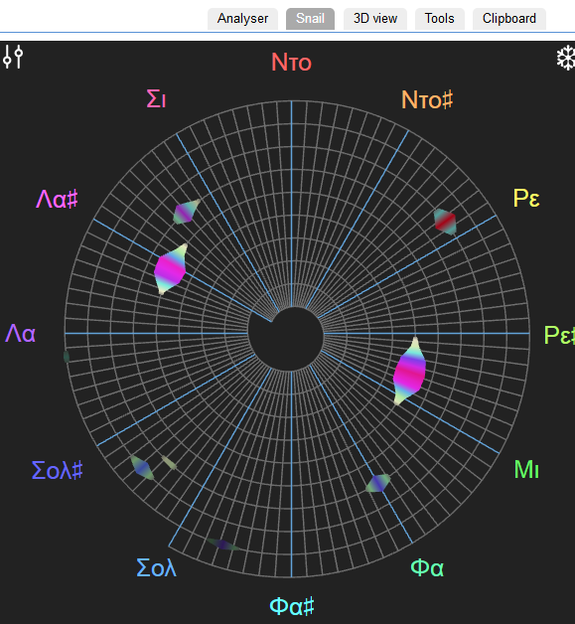
CREATE  (Investigate / Design)  Plan the Investigation / Design the Prototype |  |  | E, S |  |  | 2 hr |  |  | Divide in groups and do the following:  1. Use the virtual tuning fork (https://toolster.net/tuning_fork). Record (https://toolster.net/online_microphone) and download the sound produced.  2. Speak alongside the tuning fork record yourself speaking alongside it. Download the sound file.  3. Play the sound file produced by (1) the tuning fork and (2) yourselves. Use the iMuSciCA SNAIL environment to see the notes produced by your voice. The tuning fork was set to 440Hz corresponding to note A4. What do you observe in the SNAIL environment when you play the tuning fork sound? What do you observe when you play the sound produced by yourselves?  4. Compare the notes produced by the tuning fork with the notes produced by you and compare also the sound produced by different students speaking alongside the tuning fork. Are the student voices similar?  5. Take screenshots of the Snail during your investigation and use them to create a short presentation discussing what you did.  Discuss your results and conclusions with your classmates and your teacher.  Different humans may perform the same note but the sound produced will be different. The fundamental tone may be the same, but the overtones produced will be different. This difference can be observed in the note-content of one’s voice and directly depends on the physiology of the human voice tract. In the next lesson we will learn about the harmonic components of sound and will get the Physics point of view on this discussion. We will be able to understand the frequency component of a sound using the tools of the Power Spectrum and the Spectrogram and identify the harmonic component of our voices in terms of frequency. Finally, we will design virtual musical instruments and investigate if we can emulate the sound of our voices by producing similar power spectra with that of our voice.  Follow-up open activities:  - You can use the iMuSciCA drawing canvas to investigate the different notes and octaves  - You can record your voices saying the same words and use the snail to identify the prevalent notes in your speech. You can also record your voices narrating different texts.  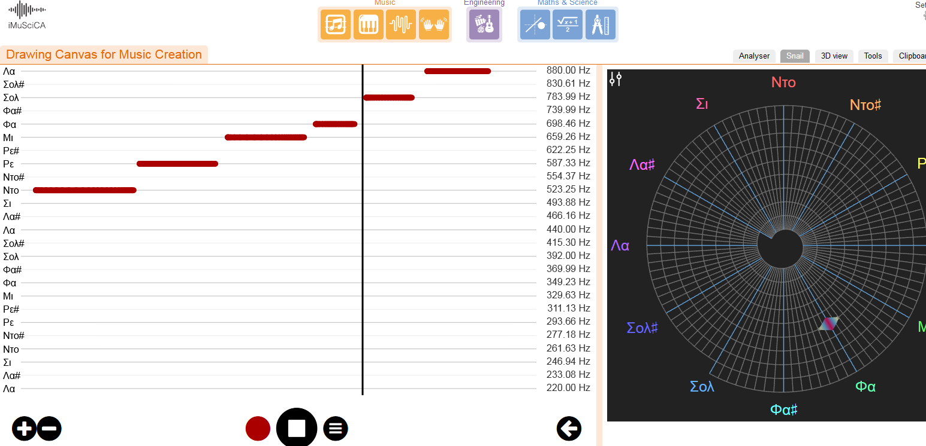
Title: Lesson Plan 2: Timbre and power spectra
Description: In this lesson plan, students will be introduced to the timbre of musical instruments and investigate the use of the waveform, the power spectrum and the spectrogram. The lesson plan is designed for High School students. The proposed duration of this lesson plan is 9hrs.
E: Engineering/ Technology, S: Science/Mathematics, M: Music
Phases | Field |  |  |  | Time |  |  | Description |  | Activity |  | Remarks
Engage  Wonder, Ask Questions, Explore, Observe– Identify Problems, questions and chances | M |  |  |  | 0.5 hrs |  |  | In our previous activity, we learnt about why human voices sound differently. We experimented with our voices and learnt which notes are most prevalent in our speech. The human voice chords and voice tract act as a musical instrument. The sound we produce depends on the properties of the “components” of this musical instrument. Likewise, the sound of musical instruments depends on the properties of the instrument itself. |  |  |  | Here, students will need an introduction to standing waves. They need prior knowledge about sine functions.
Relate to Background Knowledge | S, M |  |  |  | 0.5 hrs |  |  | Music is defined as vocal or instrumental sounds (or both) combined in such a way as to produce beauty of form, harmony, and expression of emotion. In music, timbre is the perceived sound quality of a musical note, sound or tone. The difference in the sound produced by a violin, a guitar and a cello can be identified as a difference in the timbre of the instruments. This difference derives from the different structure of the instruments and the different triggering mechanisms.  In order to understand the timbre of musical instruments in a scientific basis, we need to remember that music derives from sound and sound is a wave.  - Let us review the fundamental physics behind music:  https://www.youtube.com/watch?v=XDsk6tZX55g  Discuss the following questions  -How do musical notes correspond to the frequencies of standing waves?  -What is the fundamental frequency and what are the upper harmonics?  - How do the frequency and the wavelength of a sound wave relate?  -Compare the note G5 as it is produced by a tone generator and a violin:  https://workbench.imuscica.eu/release/v3 (use the tone generator for this investigation)  https://www.ee.columbia.edu/~dpwe/sounds/instruments/violin-G5.wav  Can you spot any difference?  The sound of the tone generator is “monochromatic”: it consists of a single frequency. Could you say the same for the sound produced by the violin: Is it monochromatic?
Imagine  Identify relevant variables to investigate – Identify Relevant Solutions to use | S |  |  |  | 2 hrs |  |  | In order to investigate the composition of the sound of a musical instrument and the correspondence of timbre to the harmonic structure of the sound waves produced, we need analysis tools which will facilitate our research.  The tools in question are:  - The waveform analyzer  See the picture below for the comparison of a longitudinal (a) and a transverse (b) wave with single frequency:  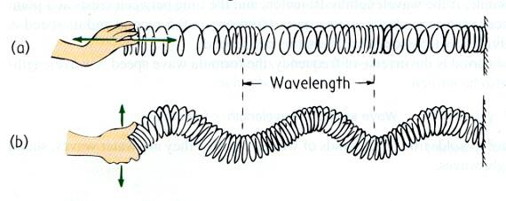  Picture 1  Sine waves of a single frequency, thus addressed as monochromatic, obey the equation:  y = Asin[2π(t/T-x/λ)] (1)  Α: amplitude of the wave ( measured in m)  T: period of the wave (measured in sec) is equal to 1/f  f: frequency of the wave (measured in Hz)  λ: wavelength of the wave (measured in m)  The detection of sound waves is done by devices located at fixed points in space,therefore the x variable is a constant. Imagine that we place our ear at a specific point in the path of the longitudinal wave of picture 1.  As a result, equation (1) can be written as:  y = Asin[2π(t/T)-φ] (2)  φ: the phase, measured in radians, is a constant  Equation (2) measures the displacement of our ‘detector’ with respect to time, resulting from a monochromatic wave reaching it. If the wave is a sound wave and the detector is the human ear, then displacement, y, is defined as the displacement of the tympanic membrane.  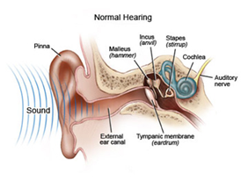  Picture 2  The plot of equation (2), measuring the displacement of a point in space (y-axis) due to a travelling wave versus time (x-axis), is called the waveform. Waveforms can be displayed through an oscilloscope.  Observe the waveform of a pure sine wave as described in equation 2. Familiarize yourselves with it.  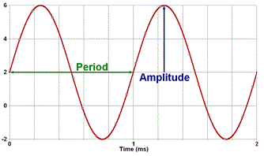  Picture 3  Does a monochromatic wave like the one described here have a single frequency?  Use the iMuSciCA tones synthesizer to find out: https://workbench.imuscica.eu/release/v3  You can set the amplitude to 1 and vary the frequency between 0 and 880 Hz. Use the tools on the left hand side to verify that the frequency of the produced sound is equal to the detected frequency.  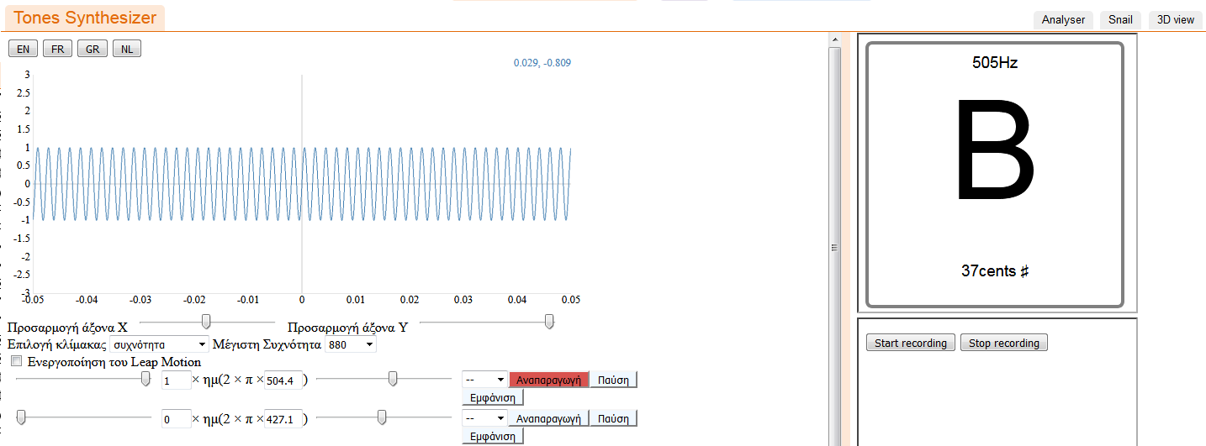  Picture 4  Imagine that you place two sources of monochromatic sine waves with different frequencies at a distance from a microphone. The first source produces a sound of frequency f₁ and the second produces a sound of frequency f₃ = 3f₁, its third harmonic. The microphone utilizes a membrane which is forced to oscillate as the sound waves interact with it. This oscillation is transformed into an electric signal which can be sent to an oscilloscope for waveform visualization.  The equation displaying the displacement of the microphone with respect to time will be:  y = y₁+y₃  y = A₁sin[2π(t/T₁)-φ₁]+ A₃sin[2π(t/T₃)-φ₃]  y: total displacement  y1: displacement due to wave 1.  Y3: displacement due to wave 3.  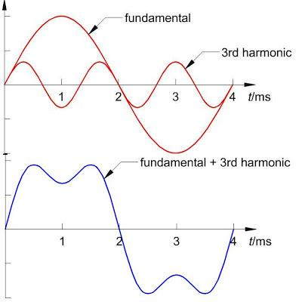  Picture 5  Experiment with the tones synthesizer of the iMuSciCA workbench and synthesize different sine-waves:  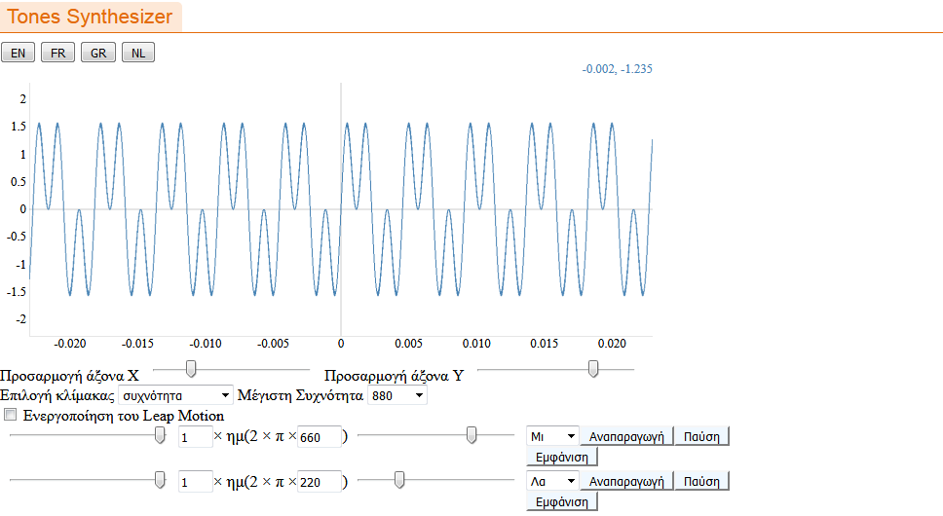  Picture 6  What do you observe?  Can complex sounds result from the admixture of pure monochromatic sine waves? Can you use the iMuSciCA tones synthesizer to reproduce the complex waveform presented in picture 5?  We conclude that: Any periodic wave with some frequency f can be synthesized from sine waves with the frequency f and its harmonics with amplitudes and phases determined by the shape of the complex wave. This statement is known as Fourier’s theorem.  - The power spectrum  A histogram called: “Frequency Spectrum”, “Power Spectrum” or “Fourier Spectrum” is useful in order to display the harmonic component of a complex wave. The wave shape determines the power spectrum, but due to lack of phase information, the power spectrum cannot be used to synthesize the original wave shape.  The y-axis of the frequency spectrum can demonstrate the amplitude, the power, the pressure and other relevant variables whereas the x-axis displays the frequency.  In the following picture, you can see the frequency spectra of two sine waves with frequencies equal to 1 and 3 Hz.  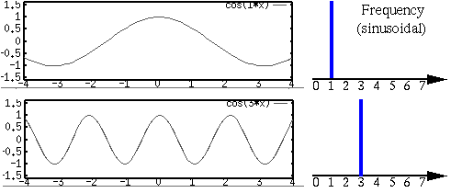  Picture 7  Observe picture 8 to see the power spectrum of a more complex waveform:  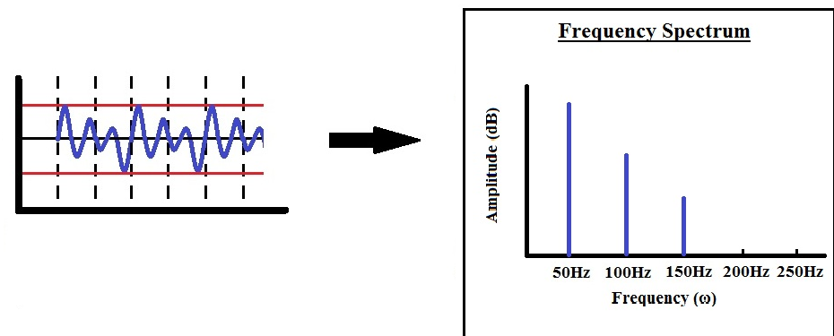  Picture 8  The spectra of real world everyday sounds can be analyzed in thousands of waves of different amplitudes, frequencies and phases. As a result, the power spectrum will be continuous with distinct peaks featuring the most prominent frequencies of the sound. You can see such a spectrum for the sound produced by a flute in picture 9.  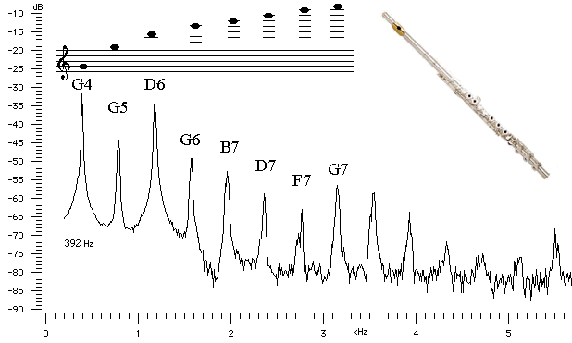  Picture 9  Can you compare the frequencies of the D6 and D7 notes? What do you observe?  Connect to prior knowledge. Do the notes demonstrated here correspond to the correct frequencies?  - The spectrogram  Assume that you observe a complex waveform, such as the waveform of an earthquake.  The frequencies of which the waveform consists may contribute in different proportions over time. In order to visualize this attribute, we use the spectrogram. The spectrogram shows both frequency and amplitude with respect to time. A spectrogram is essentially a 3D plot:  It is a graph with x-axis representing time, y-axis representing frequency and the z-axis representing amplitude. Usually, the z-axis is replaced by a color code.  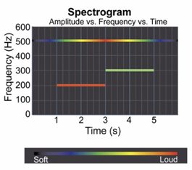  Picture 10  Picture 10 shows the spectrogram of a sound consisting of three frequencies. Can you say which frequency sounds the loudest at t=2s? At which time does frequency equal to 500 Hz sound louder than the others?  A spectrogram can be produced not only for sound waves, but by any kind of vibration. Such vibrations could be for example the oscillations of the ground resulting from an earthquake, a nuclear explosion or a meteor impact.  Observe picture 11 and see the waveforms and the spectrograms of these three events. What are your comments?  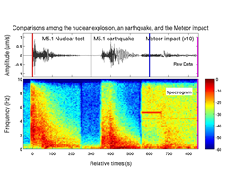  Picture 11  The color code shows the power in dB. The negative values are not to be confused with negative amplitudes. The topmost color (magenta) represents the highest amplitude of ground oscillation, whereas the bottom (cyan) represents the lowest amplitude.
Use your imagination and make hypothesis – Choose potential solution | E, S |  |  |  | 0.5 hrs |  |  | Using the knowledge you obtained on the use of the: waveform, the power spectrum and the spectrogram, brainstorm on how you could use these tools to answer our initial question: Why do different people’s voices sound differently? Why do different musical instruments sound differently?  Work in groups and propose your methods of investigation. |  |  |  | .
CREATE  (Investigate / Design)  Plan the Investigation / Design the Prototype | M, S |  |  |  | 2 hrs |  |  | Sine-wave investigation  - Use the iMuSciCA tones synthesizer to create sine waves of a pre-defined frequency. Define the amplitude and the frequency and select: “Play”.  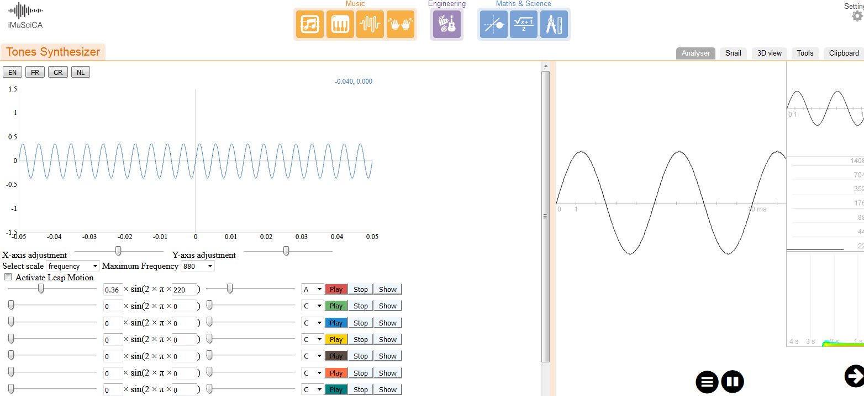  Picture 12  - Select the Analyzer tool and observe the three options: The Waveform, the Frequency Spectrum and the Spectrogram. Click on the frequency spectrum and observe the shape of the spectrum. Do you observe a peak at a frequency value equal to the frequency you pre-defined in the tones synthesizer?  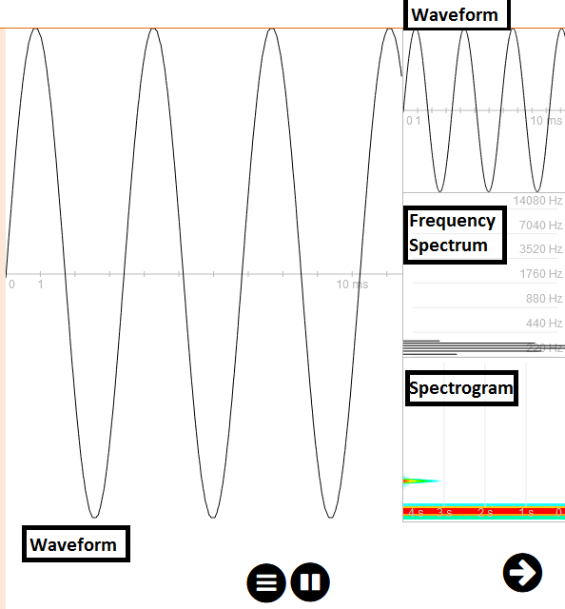  Picture 13  - Using the tones synthesizer, keep the amplitude constant and vary the frequency in steps of 80Hz. What happens in the waveform and in the frequency spectrum? Is the value of the peak in the frequency spectrum equal to the frequency you set every time?  - Fix a value for the frequency and alter the amplitude in steps of 0.1. What do you observe?  - For a selected frequency and amplitude click on the spectrogram option. Observe the shape of the spectrogram. What would be your comments?  Combination of two sine-waves  - Use the tones synthesizer and activate a second sine-wave. Adjust the amplitudes of the two sine-waves to be equal and fix the frequency of the first wave at 600 Hz. For the second sine wave, fix the frequency at a value equal to 300 Hz. Observe the frequency spectrum and the spectrogram. Write down your comments at your notebook.  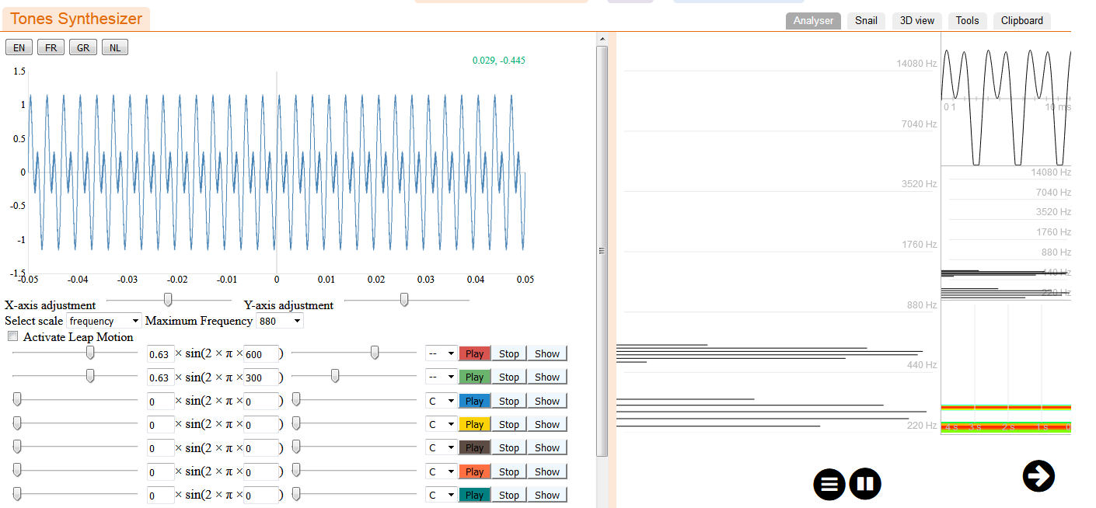  Picture 14  - Alter the frequency of the second sine wave. Observe the shape of the waveform in the tones synthesizer. Adjust the frequency so that it approaches the frequency of the first sine wave, until the shape of the waveform looks like a candy. Congratulations! You have just produced a beat!  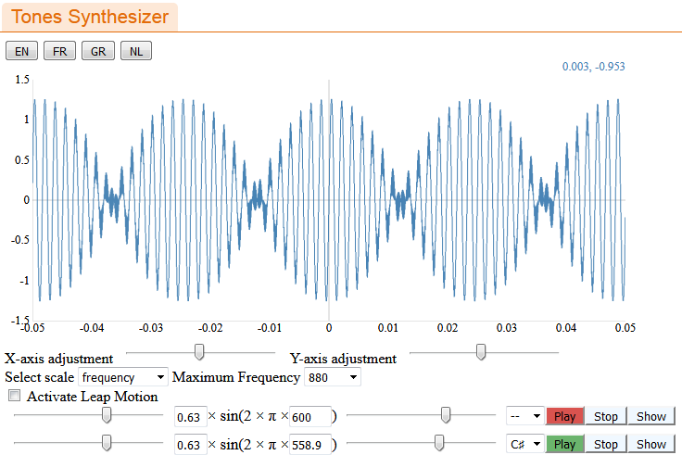  Picture 15  You can repeat the same procedure using two or more sine waves with other frequencies. Remember: In order to produce a beat, the frequencies must have values very close to each other.  Analyzing a natural sound  So far we generated sine waves and measured their frequency component. Everyday sounds, however, have more complex frequency spectra.    Picture 16  - Use the iMuSciCA analyzer and choose the “microphone” option. Plug a microphone in your computer and produce different sounds close to it. Using the iMuSciCA analyzer in the frequency spectrum option you can observe the frequency spectrum of the sound you produced. You can repeat this procedure for sounds of different sources such as musical instruments and observe their frequency spectra. Locate the frequency values which correspond to peak amplitudes.  Analyzing your voice  Now is the time to combine the knowledge we acquired regarding the use of a frequency spectrum in order to find the harmonic content – i.e the frequencies prevalent – of a sound and the use of the Snail tool to find the notes of a sound.  - Record your voice singing a note (for example note B). You could use the PitchA tool of the iMuSciCA workbench to help you tune your voice to the specific note.  - Use the iMuSciCA recorder and record your voice for 10 seconds.  - Use a media player device to play the recording.  - Open the iMuSciCA SNAIL tool and play the recording. Take a snapshot of your monitor at a specific time.  - Open the iMuSciCA analyzer. Take a snapshot of the Analyzer Monitor at the same time that you did it for the Snail.  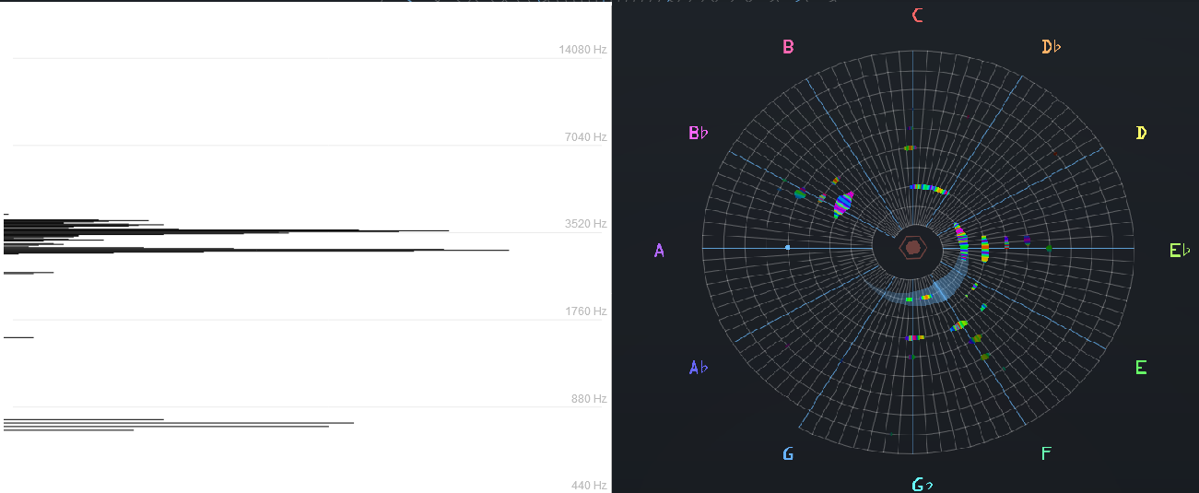  Picture 17  - Compare the two pictures and discuss your results.
Analyze  Analyze Data from Investigations and Draw Conclusions/ Evaluate the Prototype. | S |  |  |  | 1 hr |  |  | Using the data you obtained, find the characteristic peaks of your voice in the frequency spectrum and write down their frequencies in increasing order. Using the SNAIL tool find the characteristic notes of your voice in increasing order.  Compare the two. Can you assign the frequencies you measured to the notes you observed?  Are the values correct?  You can use the chromatic scale to cross check your results:
Explain by Relating to Background Knowledge/ Optimize the prototype | S, M |  |  |  | 0.5 hrs |  |  | What are the sources of error in your frequency measurement?  Cross check your results using an external tool to measure the frequency spectrum.  (For example the Visual Analyzer: http://www.sillanumsoft.org/download.htm).  Compare the frequency spectra and the notes produced by different people. Can you understand why this happens? How would you demonstrate the differences between two human voices speaking the same phrase or singing the same note in terms of Physics and Music?
Describe and explain the results in the different STEAM-fields and the connections between them. | S, E, M |  |  |  | 0.5 hrs |  |  | Understanding voice production needs a combination of knowledge in Physics, Biology and Music. Biology explains the voice generation mechanism in terms of the human organs, physics provides insight in the wave nature and the harmonic content of sound and music describes the output of sound organized in time. In this activity we learned about the human voice generation mechanism, we investigated its harmonic content and we connected it with the music notes produced when we speak.
Communicate/  Reflect  Communicate Results and Conclusions/ Communicate the Product, perform | S, E, M |  |  |  | 1 hrs |  |  | Students should make a short presentation in the classroom displaying the results of their investigation.  They need to demonstrate the connection between science and music in terms of mapping notes and frequencies and should compare the voice output of different students.  Discuss the results in the classroom.
Reflect on Feedback and incorporate in further process | S, E, M |  |  |  | 0.5 hrs |  |  | Reflect and incorporate the feedback you obtained and refine your results trying to reduce potential sources of uncertainty.  Consider the following question with your classmates: Can we emulate human voice using musical instruments? Perform a web-search and discuss possible ways of investigating the possibility of this. |  |  |  | Here, students should be guided to use their newly acquired knowledge. Using tools such as the frequency spectrum, they could compare the spectrum of a human voice playing a note and that of a simple instrument such as a monochord. This is what the final goal of this investigation will be.

Title: Lesson Plan 3: Learning about monochords
Description:
In this lesson plan, students will be introduced to the science behind the sound of the monochord. The lesson plan is addressed to High School Students (Age 14-16).
The proposed duration of this lesson plan is 2.5hrs.
E: Engineering/Technology, S: Science/Mathematics, M: Music
Phases | Field | Time | Description | Activity | Remarks
Engage  Wonder, Ask Questions, Explore, Observe– Identify Problems, questions and chances | M | 0.5 hrs | Have you ever wondered..  - How do musical instruments sound?  - Have you ever wondered why they produce the sounds they produce?  - Does the sound produced depend on parameters of the musical instruments? Discuss.  This is the image of the largest guitar ever manufactured and achieved the 2017 Guinness Record: It is almost 4m long!  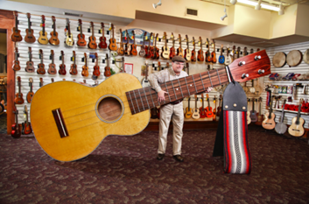  Image.1: Guinness record winning guitar!  - Likewise, listen to the sound produced by a mini-guitar: https://www.youtube.com/watch?v=cvfu5O1lqpU  Is the tuning the same with this of a normal guitar? Once again assume that the strings are similar to those of a normal guitar. Let’s investigate the science behind these instruments and perhaps we’ll break the World Guinness Record! |  | Now that students have learned about waveforms, frequency spectra and the connection between notes and frequencies, they start investigating virtual musical instruments in order to produce simple notes wit hthem and then use them to try to emulate human voice.
Relate to Background Knowledge | S | 1 hr | Let’s remember some things about sound:  1. What are the fundamental properties of waves?  Let’s watch the following video and remember  https://www.youtube.com/watch?v=TfYCnOvNnFU  Discuss:  - How are the wavelength, the frequency and the velocity of a wave related?  - What is the amplitude of a wave and how does it relate to its energy?  - On what does the velocity of a wave depend?  - On what does the frequency of a wave depend?  - What kinds of waves exist if we take into account the motion of a molecule of the medium compared to the direction of the propagation of the wave?  - What happens when two waves meet?  2. Let’s remember some key features of sound:  https://www.youtube.com/watch?v=qV4lR9EWGlY  Discuss:  - What are the sources of sound?  - What is pitch and what is loudness?  - Is sound a transverse or a longitudinal wave?  - Which are the frequencies that humans can hear?  - How does the mechanism of hearing compare to the mechanism of a microphone?  - Does the loudness of a sound depend on the distance from the source of it?  Now that we have reviewed our Physics of Waves and Sound, let’s see how we can understand the mystery of instrument making!
Imagine  Identify relevant variables to investigate – Identify Relevant Solutions to use  Use your imagination and make hypothesis – Choose potential solution | E, S  E, S | 0.5 hrs  0.5 hrs | The monochord is a string plucked on both of its sides and can be considered as the progenitor of the guitar. It consists of two parts: the body and the string.  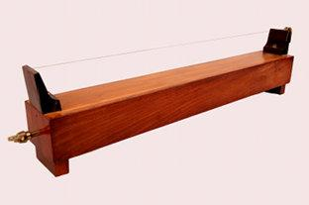  Image 2: The monochord  As happens with the guitar, likewise, when the monochord is triggered, the string oscillates and produces sound. The frequency of the sound produced is equal to the oscillation frequency of the string.  You will be able to interact with the monochord through Leap Motion tools.  Different ways of triggering the string of the monochord will be available, for example, through a bow or a hammer, whereas, the parameters relevant to the interaction of the user with the monochord will be the interaction point, the distance of the interaction tool to the string etc.  Listen to the tuning frequencies of different instruments on the link below:  http://onlinetonegenerator.com/tuning.html  It seems that different instruments can be tuned to different frequencies. Why is that?  Brainstorm and discuss the parameters that you believe are important to determine the frequency of a sound produced by a stringed instrument. You can also perform a literature search. Among the parameters of interest, you should discuss: the length of the string, the string tension, the material of the string and the monochord and the thickness of the string.  After you narrow down the most important parameters, write them down on your notebook.  Create a hypothesis on how you could investigate the dependency of the sound produced by a simple monochord with the parameters you chose at the previous step of your investigation.  Assume that you are musical instrument manufacturers. You can divide in groups and “draw” your solution, highlighting the steps you wish to follow.  Present your solution in the classroom and discuss.

Title: Lesson Plan 4: Design your own monochord
Description: In this lesson plan, students will use the iMuSciCA workbench to create a simple monochord which will be able to play note “A”. They will choose the parameters needed (string length, tension) to create a monochord that plays the requested note. The lesson plan is addressed to High School Students (Age 14-16).
The proposed duration of this lesson plan is 4.5 hrs.
E: Engineering/Technology, S: Science/Mathematics, M: Music
Phase | Field | Time | Description | Activity | Remarks
CREATE  (Investigate / Design)  Plan the Investigation / Design the Prototype | E, S | 1 hr | Let's create  In this activity, you will use the iMuSciCA workbench to try different string lengths and tensions in order to investigate the laws behind the sound produced by the monochord.  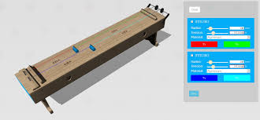  Image.3: iMuScICA's monochord  - Enter the iMuSciCA workbench and choose the 3D design environment https://workbench.imuscica.eu/release/v3  - Choose: “Monochord”  - Get Familiar with the different string parameters and the way to handle the monochord in the3D design environment.  - Choose the material of the string (e.g steel). Set tension at 60N.  - Fix the length of the monochord at a value of your liking.  - Write down the values of length, tension, material, string radius at your notebook.  - “Pluck” and listen to the sound produced by the monochord.  - Now choose the tuner tool. Pluck again and listen to the fundamental frequency of the sound. Can you find it out?  - Brainstorm and discuss the parameters of the instrument that might affect the sound you produced. Write down your hypotheses.
Carry out Investigation / Build the Prototype |  | 1 hr | Now it's time to investigate  Keep tension constant at 60N and measure the frequency for different string lengths: 0.25 m, 0.5m, 0.75m, 1m, 1.25 m, 1.5m. Find the fundamental frequency for each value of length.  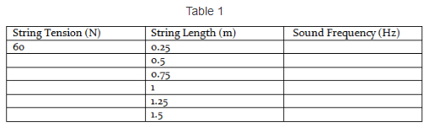  Now reverse the procedure. Fix the length of the string at 1m and start altering tension. You can begin from the value of 20N and alter it by 20N in each step. Fill the next table in your notebook.  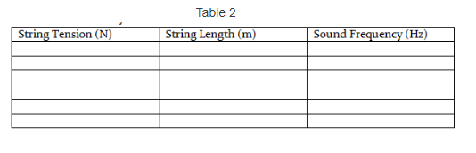
Analyze  Analyze Data from Investigations and Draw Conclusions/ Evaluate the Prototype. | S | 1 hr | Let's Analyze  - Using the data of the two tables you produced, plot the sound fundamental tone frequency with respect to: Tension and length of the string.  - Fit the data points with an appropriate function  - Make sure that your results are clearly noted and that the axes are appropriately labeled with the correct variable names and units.  - Write the dependency of the sound frequency to tension and string length.
Explain by Relating to Background Knowledge/ Optimize the prototype | S, M | 0.5 hrs | Explain your results following the following points:  - First watch this video and consider the following questions  https://www.youtube.com/watch?v=XDsk6tZX55g  - What is a standing wave?  - How do musical notes correspond to the frequencies of standing waves?  - What are the three categories of musical instruments?  - What is the fundamental frequency and what are the upper harmonics?  - What is the connection between the sound frequency and the vibration frequency of the string.  - You see that sound frequency is inversely proportional to the length of the string. Why is that?  - You see that the sound frequency is proportional to the square root of tension of the string. Why is that?  In a stringed instrument like a monochord, both ends are plucked. Neither of them can move. As a result, when the string is triggered, a standing wave will be produced.  The number of nodes on the string depends on the excitation energy. The lowest energy configuration is this with no node between its ends.  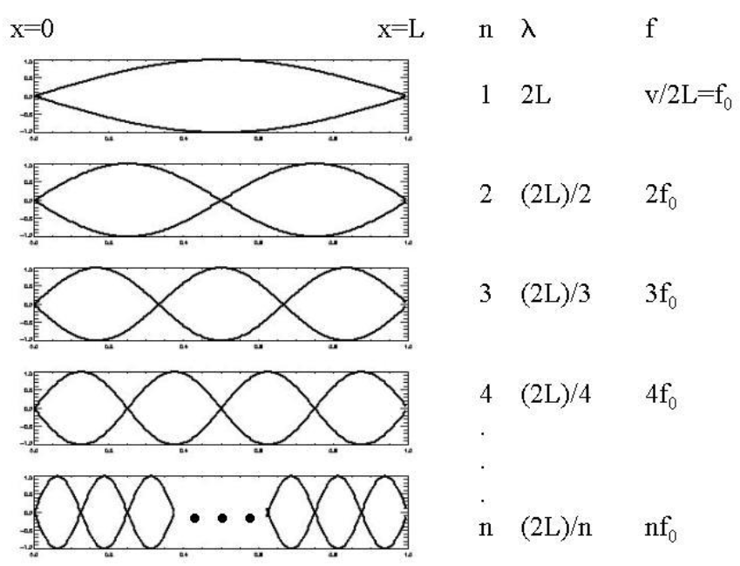  Image . 4: The fundamental frequency and the upper harmonics for a string plucked at both ends.  In this exercise, you investigated the parameters affecting the sound of a monochord. The parameters of interest were: String Length “L” (m), String Tension “T” (N) , String linear density “μ” (kg/m).  For the first harmonic, L = λ/2. The equation connecting frequency, wavelength and wave velocity is:  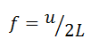 (1)  The velocity of a wave propagating on a string is  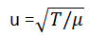 (2).  Thus, the frequency of the sound produced is:  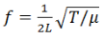 (3)  Equation (3) describes Mersenne’s law on the sound frequency produced by a monochord.  Let’s do a short exercise  Assume that you have a monochord with steel string (density equal to 7700 kg/m3 ). Its length is equal to L = 0.5m. Its string radius is R=0.235mm.  Find the value of the tension needed to produce note A (440 Hz) as a fundamental frequency solving equation (3).  Note! Linear density is not the same as volume density. To go from linear density μ to density ρ, you have to use the relationship:  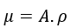
Describe and explain the results in the different STEAM-fields and the connections between them. | S, E, M | 0.5 hrs | Connecting Science, Technology, Mathematics, Engineering and the Arts  - How would the monochord sound if you progressively increased the length of the string? Would the pitch increase or decrease?  - If your monochord had note A as a fundamental and you wanted to play note G, would you have to increase or decrease the length of the string while keeping the tension constant?  - Is the use of weights efficient in terms of a playable musical instrument?  - Propose other ways to vary the tension of the string.  - You are asked to create an orthogonal harp with 4 similar strings with equal length: the first string should have note A as fundamental, the second should be an octave higher, the third two octaves higher and the fourth five octaves higher. Which parameter would you vary and how?
Communicate/  Reflect  Communicate Results and Conclusions/ Communicate the Product, perform | S, E, M | 0.5 hrs | Communicate your findings  - Make a short power point presentation using screenshots of the instrument you designed, the waveforms produced and the frequency-tension and frequency-string length plots you created.  - Present your findings to your teacher and classmates. Accompany the plots with the saved records of the sounds you produced.  - Discuss with your classmates and ask for their feedback.
Reflect on Feedback and incorporate in further process | S, E, M | 0.5 hrs | Reflect  - Reflect on the feedback you obtained.  - Watch this video of a monochord sonometer and compare with the process you followed: https://www.youtube.com/watch?v=IPH4W3n0t4o  - Run through your experiment again. Compare the procedure you followed with the procedure you designed during your “Imagine” phase. Determine the steps you need to take in order to create different monochords with the following frequencies as their fundamental harmonics: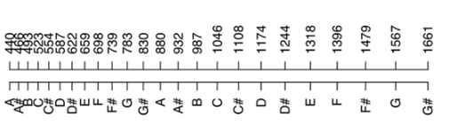  Image 5: Notes and frequencies  - What is more time consuming, changing the length or the tension of the strings? Relate your opinion to the real-world monochords and other stringed instruments.

Title: Lesson Plan 5: Investigating the frequency content of a monochord’s sound
Description: In this lesson plan, students will analyze the sounds of everyday life as well as the sound of a virtual monochord and investigate its harmonic content. The lesson plan is addressed to upper high school students.
The proposed duration of this lesson plan is 8hrs.
E: Engineering/Technology, S: Science/Mathematics, M: Music
Phase | Field | Time | Description | Activity | Remarks
CREATE  (Investigate / Design)  Plan the Investigation / Design the Prototype | S,E,M | 1 hr | In part 1 you will use the iMuSciCA audio canvas analyzer in order to listen to different external sounds and observe their harmonic content, using the knowledge you obtained on the previous lesson concerning the waveform, the power spectrum and the spectrogram.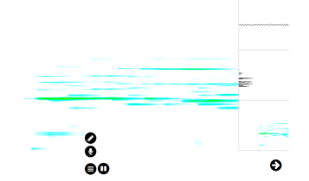  Picture 1  The iMuSciCA audio canvas analyzer imports the sound of your PC’s microphone. The three windows on the right display the waveform, the power spectrum and the spectrogram of the sound.  Part 2  In part 2 you will create a monochord playing note A and vary its parameters of interest as well as the way you interact with it in order to investigate which monochord attributes effect the timbre of the sound it produces.  In order to create the monochord, follow the guidelines of lesson plan 4: “Design your monochord”. If you have already completed this lesson plan, open the saved instrument you have created and work with it.
Carry out Investigation / Build the Prototype | S, E, M | 3 hrs | Part 1:  - Plug a microphone in your PC.  - Choose the microphone option of the analyzer.  - Use different sound sources to produce sound. Listen to the sound and using the iMuSciCA analyzer observe its frequency content. You can use a whistle, clap your hands, have two people speak the same word, sing the same note in different octaves, trigger a tuning fork etc.  -Open a word document in which you will write the name of the source you used and place below the screenshot of the waveform, the power spectrum and the spectrogram.  - Click on this link: https://www.ee.columbia.edu/~dpwe/sounds/instruments/ and listen to the same note played by different instruments. For each instrument, note its name to your word document and take a screenshot of the waveform, the power spectrum and the spectrogram. You can do the same by choosing the “DrawMe” tool of the iMuSciCA workbench and drawing the same line with different colors.  - Now, play a song using two or more different musical instruments. If you don’t have access to musical instruments, search youtube in order to find a song that you prefer and listen to it being played by different instruments. As an example you can see this video: https://www.youtube.com/watch?v=VRAXK4QKJ1Q  As before, write the title of the song, the instrument you used and sample some screenshots.  Part2:  - Using the monochord playing note A you created, let it sound.  - Use the iMuSciCA analyzer to listen to the sound and observe the frequency contents of it. Take a screenshot of the power spectrum. What do you observe? Does the monochord play a single frequency or do we have overtones?  - Keeping the tension of the string constant, vary the length starting from 0,5m until 2m in steps of 0,25m. For each step, calculate the fundamental frequency. Let it sound and take a screenshot of the various power spectra. What do you observe?  - Now, use the leap motion tool in order to change the way you interact with the monochord using the available options. Keep the fundamental tone constant at 440Hz. For different options, observe and take screenshots of the waveform and the power spectrum.  - Alter the shape of the monochord keeping all other configurations constant and observe the power spectrum.
Analyze  Analyze Data from Investigations and Draw Conclusions/ Evaluate the Prototype. | S | 1.5 hrs | Part 1  - Using the results you documented from Part 1, study the power spectra of the different sound sources you used. What are your observations concerning the frequency content of each sound? Write down your comments.  - Using the results you documented on the same note being played by different instruments, note the differences between the different power spectra. Locate and estimate the frequencies occurring with highest intensity.  Do different instruments have the same harmonic content?  - Compare the power spectra you sampled from the same song with two different instruments. Note your observations.  Part 2  - Observe the harmonic component of the sound produced by the monochord for each fundamental tone you have played. You will see that the overtones are different.  - For each fundamental harmonic, find the frequencies which have the highest amplitude and divide them with the fundamental harmonic . Are the ratios constant?  - Compare the waveforms and the power spectra of note A for different interaction configurations with the monochord. Does the harmonic content of the monochord’s sound change with respect to the interaction method?  With this comparison in mind, draw your conclusions. Why do different instruments of the same family sound differently?
Explain by Relating to Background Knowledge/ Optimize the prototype | S,M | 1 hr | - Match the following instrument waveforms with the correct power spectra  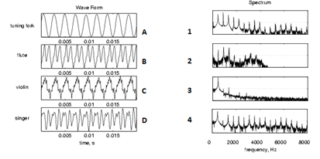  - Explain how you utilized the spectrogram, the power spectrum and the waveform in order to answer the question: “Why do different instruments sound differently”.  - Which instrument of the three has a more “clean” power spectrum: The violin, the cello or the guitar?  - Is the sound produced by a tuning fork strictly monochromatic?  - When we use a monochord, what are the frequencies of the overtones we observe? Are they integer multiples of the fundamental frequency?  - Make a short presentation with the instruments you employed and their power spectra.
Describe and explain the results in the different STEAM-fields and the connections between them. | S, E , M | 0.5 hrs | Discuss the design options of the monochord that contribute to the frequency content of the produced sound. Expand the discussion in other string instruments and discuss the design and the interaction parameters that may affect the sound output. You can use this link as reference: https://www.thoughtco.com/images-of-string-musical-instruments-4122917
Communicate/Reflect  Communicate Results and Conclusions/ Communicate the Product, perform | M, S, E | 1 hr | - Present your results in a powerpoint format and explain the reason why different musical instruments sound differently.  - You can work in groups and make a live demonstration of the waveform, power spectrum and spectrogram tools employing different sounds, the same notes or sounds played with different musical instruments or a music performance of your own.  - Make sure that you highlight the interconnections between the design of the instrument (engineering component), the sound timbre (music component) and the harmonics content of the sound (physics component).
Reflect on Feedback and incorporate in further process |  |  | - Discuss: What have you learned during this investigation.  - Assume that you are an instrument maker. Would you take into account the harmonic content of your instrument while creating it? Would you listen to it and empirically try to figure out the best design parameters, or would you employ scientific reasoning and tools in order to produce the optimal output?  In this context, you could get in touch with instrument makers and interview them on the design considerations they have in order to produce high quality string instruments.  - Review the design of your monochord and evaluate which parameters were more important concerning the timbre of the instrument.

Title: Lesson Plan 5: Let’s emulate our voice
Description: In this lesson plan, students will use virtual monochords of their own design in order to try to reproduce aspects of the human voice.
The proposed duration of this lesson plan is 9hrs.
E: Engineering/Technology, S: Science/Mathematics, M: Music
Phase | Field | Time | Description | Activity | Remarks

Engage  Wonder, Ask Questions, Explore, Observe– Identify Problems, questions and chances | M | 0.5 hrs | Do you believe that we could reproduce human voice using musical instruments?  Many performers have worked the other way around and tried to emulate the sound of musical instruments with their voices:  https://www.youtube.com/watch?v=8_F_aygM-8s  while other artists have claimed that they can replicate human voice with their instruments:  https://www.youtube.com/watch?v=Mo_roYa3RDY&t=22s  Discuss your views. | The teacher can refer to this paper:  https://newt.phys.unsw.edu.au/jw/reprints/Voicelikeness.pdf
Relate to Background Knowledge | S | 0.5 hr | Throughout the previous lessons, we have learned how to obtain the frequency spectrum of a sound and what the corresponding notes are.  Observe the following spectrograms:    Fig.1 : Monochord with fo=440Hz  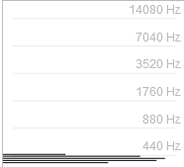  Fig.2: Tone synthesizer for a sine wave with f=440Hz  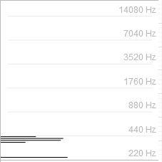  Fig.3: Human voice in tune with a tones synthesizer, producing note “A” at 440 Hz.  - Observe that three different sources of sound: a tone generator, a virtual musical instrument and the human voice, may produce the same fundamental harmonic, but the power of the sound is divided differently between different frequencies, resulting in a different frequency spectrum and finally different sound timbre.  - Use the iMuSciCA workbench to reproduce such graphs yourself: https://workbench.imuscica.eu/release/v3  - Why does the monochord have distinct peaks at 880 Hz and 1760 Hz?
Imagine  Identify relevant variables to investigate – Identify Relevant Solutions to use  Use your imagination and make hypothesis – Choose potential solution | M, S | 1 hrs | Divide in groups and discuss how you would try to emulate human voice using virtual musical instruments of your creation with the use of the iMuSciCA workbench. How would you design your investigation? What tools would you use?  Utilize the knowledge you acquired and come to a decision among you.  Let the following questions guide your discussion:  - What do I want to achieve?  - What are the variables I would use?  - How will I measure them?  - How will I present them?  - How will I compare human voice with the sound of musical instruments?  - Will it be meaningful to compare the frequency spectrum of human voice with that of one or more monochords (or other instruments?)  - Will it be meaningful to compare the notes of the human voice singing a specific tone with those produced when a virtual musical instrument performs the same tone?  - Do I need to start simple – for example trying to play single note with my voice and a virtual instrument – or complex?  - What virtual musical instruments do I need to design in order to emulate human voice?  Make sure that you include at least the following tools of the iMuSciCA Workbench in your investigation:  - The SNAIL  - The visual analyzer  - The LEOPOLY 3D design environment  - The tone generator | This is an open inquiry activity. One potential way to investigate the correspondence between monochords and human voice would be to try to emulate a voice frequency spectrum using monochords with the correct parameters.
CREATE  (Investigate / Design)  Plan the Investigation / Design the Prototype | E, S | 0.5 hr | Divide in groups and use the outcomes of your brainstorming in order to plan your investigation. Make sure that you keep a logbook (a google doc could be used) in which you describe the steps that you follow and provide links and pictures. | The safest option would be to have students first reproduce a note (as was presented in figures 1-3) and then have them modify a monochord so that it will sound closer to human voice.  The comparison can be made in two ways. Superimpose the frequency spectra of their voice and the musical instrument and compare them, or do the same with SNAIL.  Another way forward would be to start with their voice and then use the iMuSciCA tone generator to try to replicate the frequency spectrum of their voice by adding sinewaves with different amplitudes and frequencies. Once they have done that, they can build monochords (or use a polychord) with lengths and tensions representing these specific frequencies and let them sound.
Carry out Investigation / Build the Prototype |  | 3 hr | Carry out your investigation. Make sure that you update your logbook with your results. | The teacher is to encourage and facilitate students’ investigation. By the end of the investigation phase, students should have at least two frequency spectra: one with their voice and one with the sound of the musical instrument to compare.
Analyze  Analyze Data from Investigations and Draw Conclusions/ Evaluate the Prototype. | S | 1 hr | Compare the outputs you have produced: These could be the frequency spectra or the SNAIL output for the virtual musical instruments you used and your voices. Repeat the procedure until you are satisfied with your results.
Communicate/  Reflect  Communicate Results and Conclusions/ Communicate the Product, perform | S, E, M | 2 hrs | Write a group presentation in powerpoint and present it to the rest of your classroom. In this presentation you will explain the steps you followed in your investigation. Incorporate the feedback of your fellow students and teachers and try to answer this question. Can we emulate human speech with musical instruments?  Discuss with your teacher the bibliographical information about the connection of human voice with musical instruments.  Make sure that you keep minutes of the discussion. | The teacher discusses with the students the aspect of voicelikeness of musical instruments referring to this paper: https://newt.phys.unsw.edu.au/jw/reprints/Voicelikeness.pdf
Reflect on Feedback and incorporate in further process | S, E, M | 0.5 hrs | After concluding the investigation reflect on the feedback you received and on the procedure you carried out and make recommendations for further research.

