Guidelines
Dear iMuSciCA teachers: It is time to put our knowledge into action. Let’s try to create together an iMuSciCA educational scenario. An educational scenario consists of one or more lesson plans. Many educational scenarios can be incorporated to a big iMuSciCA project. An iMuSciCA scenario includes all inquiry phases (Engage, Imagine, Create, Analyze, Communicate/Reflect) and all STEAM Fields (E: Engineering/Technology, S: Science/Mathematics, M: Music) at least once.
- The inquiry phases can be rearranged following the sequence that you prefer. If you have the “Engage” Phase 2 times, you can copy and paste the “Engage” page (and the same goes for the rest inquiry phases).
- Make sure that each educational scenario: includes all inquiry phases, addresses all STEAM fields at least once and utilizes the iMuSciCA workbench tools.
- Your educational scenarios can include text, external URLs, images, videos and other media. Make sure that you add a description above each table you create or below each image that you insert.
- Each inquiry phase may include one or more STEAM fields.
- Each lesson plan may or may not include all inquiry phases.
- The end users of your designed educational scenarios are your students. Make sure that the metadata table on top of the scenario provides students and other interested parties with the information needed.
- Once you finalize your scenario take some time to fill the Educational Scenario Synopsis which provides a short overview of the contents of the scenario. The synopsis doesn’t refer to the lesson plans but on the contents of each inquiry phase. However, you may add the lesson plan name in the remarks.
- Once your scenario is finalized please upload it to the iMuSciCA Summer School 2018 online community. If you face any difficulty, don’t hesitate to ask the course organizers for help, or email the scenario to echaniot@ea.gr

iMuSciCA educational Scenario Metdata

Title: | Scenario: Make your own personalized ringtone.
Keywords: | Sound – analogue listening – digital processing – creative process – humour
Short Description: | The student creates his / her own ringtone
Lesson Plans included: | Lesson plan = project | Date: today – tomorrow - now | 05-08/07/2018
Educational Objectives: | Objective = there IS a ringtone | Estimated Duration: | 14 hours
Author(s): | Dominiek De Decker | Age Group: | 12-14 y/o
Contributor(s): | Ron, iMuscica | Language: | English
Status: | Draft | Difficulty Level: | Medium
Dissemination level: | Public/ Private | Special Needs Addressed: | Yes ; multi – media equipment
iMuSciCA educational Scenario Synopsis
Scenario Title: Make your ringtone
Scenario Description: Self – educating project
E: Engineering/Technology, S: Science/Mathematics, M: Music
Phases | Field | Time | Description | Activity | Remarks
several | steam | 14 h | sound-art-tech | Group of 2 students | Sound - engineering

Lesson Plan 1: Make your ringtone
Description: in 14 hours you have a personalized ringtone on your cellphone

Inquiry Phase: Engage

STEAM Field: E, S, M

Wonder, Ask Questions, Explore, Observe– Identify Problems, questions and chances

The teacher has a question; Does anyone have a cellphone? Unlike the school-protocol they can get out their mobile and run the ringtone! Don’t mind your neighbour! Who has the same ringtone? Why?
Who has a special ringtone? Why? How did you do that?
Wouldn’t it be nice if you could make your own? One that expresses your feelings when a person you know calls you? Your mother e.g.?
Can you have different ringtones for different people calling you?
Do you know how a ringtone is made?
???...!!!

Relate to Background Knowledge
Lessons physics? (vibrations – speed of sound…)
Lessons biology? (the anatomy of the ear?)
Inquiry Phase: Imagine

STEAM Field: E, S, M

Identify relevant variables to investigate – Identify Relevant Solutions to use

Engineering; how do we reproduce music? (in – ears, digital audio processing, induction…)
- Science; history of reproduction of music – waveforms

Use your imagination and make hypothesis – Choose potential solution
- Just record you voice on your cellphone – done!!?
- Think! Make fun, be creative, use good software and hardware, give this idea what it deserves!!
- Record your parents and use that! Make advantage of that!
- Import your favourite song and work with it!

Inquiry Phase: CREATE (Investigate / Design)

STEAM Field: E, S, M

Plan the Investigation / Design the Prototype
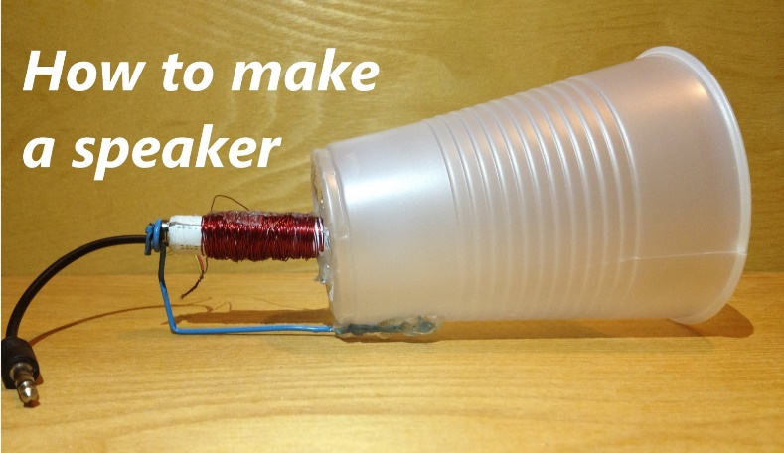
- Make a speaker; what is induction, magnetism,…
How do we reproduce recorded sounds?
What are in-ears?
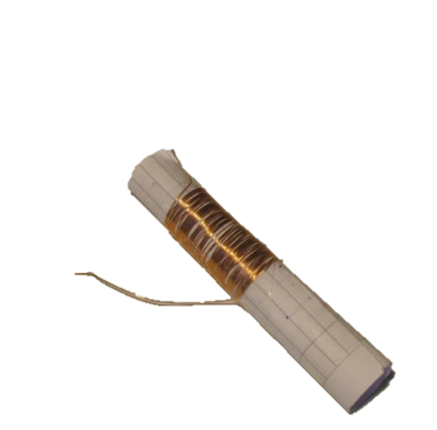
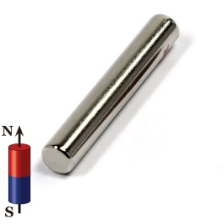

- Music software – outboard soundcard;
How did you experience this experiment?
Are you satisfied with the result?
- What with conversion? Is your file on your cellphone not too big? I.a.w. is it an MP3 – file?
- Did you personalize it?
- …

Inquiry Phase: Analyze

STEAM Field: E, S, M

Analyze Data from Investigations and Draw Conclusions/ Evaluate the Prototype.
- Measure tones that come from your new speaker (?)
- Music software – outboard soundcard;
How did you experience this experiment?
Are you satisfied with the result?

Explain by Relating to Background Knowledge/ Optimize the prototype
What did you expect? Did you know about induction? Did you know that you daily make use of your induction-in-ears

Describe and explain the results in the different STEAM-fields and the connections between them.

- Science; Sound Waves - Axes - Bits - Sampling frequency
- Maths;
- Physics; induction, sound, …
- Music; creative playing, singing…
- Technology

Inquiry Phase: Communicate/Reflect

STEAM Field: E, S, M

Communicate Results and Conclusions/ Communicate the Product, perform

Did you succeed in making a speaker? Or did you have problems?

Did you succeed in loading a self-made ringtone on your phone?

Reflect on Feedback and incorporate in further process
What could be done better?
Did you have enough time?
…

Lesson Plan 2: Title
Description:

Inquiry Phase: Engage

STEAM Field: E, S, M

Wonder, Ask Questions, Explore, Observe– Identify Problems, questions and chances

Relate to Background Knowledge

Inquiry Phase: Imagine

STEAM Field: E, S, M

Identify relevant variables to investigate – Identify Relevant Solutions to use

Use your imagination and make hypothesis – Choose potential solution

Inquiry Phase: CREATE (Investigate / Design)

STEAM Field: E, S, M

Plan the Investigation / Design the Prototype

Carry out Investigation / Build the Prototype

Inquiry Phase: Analyze

STEAM Field: E, S, M

Analyze Data from Investigations and Draw Conclusions/ Evaluate the Prototype.

Explain by Relating to Background Knowledge/ Optimize the prototype

Describe and explain the results in the different STEAM-fields and the connections between them.

Inquiry Phase: Communicate/Reflect

STEAM Field: E, S, M

Communicate Results and Conclusions/ Communicate the Product, perform

Reflect on Feedback and incorporate in further process

