Guidelines
Dear iMuSciCA teachers: It is time to put our knowledge into action. Let’s try to create together an iMuSciCA educational scenario. An educational scenario consists of one or more lesson plans. Many educational scenarios can be incorporated to a big iMuSciCA project. An iMuSciCA scenario includes all inquiry phases (Engage, Imagine, Create, Analyze, Communicate/Reflect) and all STEAM Fields (E: Engineering/Technology, S: Science/Mathematics, M: Music) at least once.
- The inquiry phases can be rearranged following the sequence that you prefer. If you have the “Engage” Phase 2 times, you can copy and paste the “Engage” page (and the same goes for the rest inquiry phases).
- Make sure that each educational scenario: includes all inquiry phases, addresses all STEAM fields at least once and utilizes the iMuSciCA workbench tools.
- Your educational scenarios can include text, external URLs, images, videos and other media. Make sure that you add a description above each table you create or below each image that you insert.
- Each inquiry phase may include one or more STEAM fields.
- Each lesson plan may or may not include all inquiry phases.
- The end users of your designed educational scenarios are your students. Make sure that the metadata table on top of the scenario provides students and other interested parties with the information needed.
- Once you finalize your scenario take some time to fill the Educational Scenario Synopsis which provides a short overview of the contents of the scenario. The synopsis doesn’t refer to the lesson plans but on the contents of each inquiry phase. However, you may add the lesson plan name in the remarks.
- Once your scenario is finalized please upload it to the iMuSciCA Summer School 2018 online community. If you face any difficulty, don’t hesitate to ask the course organizers for help, or email the scenario to echaniot@ea.gr

iMuSciCA educational Scenario Metdata

Title: | Scenario: Speech and Song
Keywords:
Short Description: | In this scenario the students will explore how speech is created. Afterwards the students will research and measure different vowels and consonants. We will use are findings to create music and tools to help the human voice.
Lesson Plans included: | Lesson Plan 1: Forming of vowels  Lesson Plan 2: Forming of consonants  Lesson Plan 3: Harmonizing with different vowels and consonants  Lesson Plan 4: Extending the voice | Date: | 05/07/2018
Educational Objectives: | Objective 1, Objective 2 | Estimated Duration:
Author(s): | Reinout Vaes | Age Group: | 14-16
Contributor(s): | Contributor 1, Contributor 2 | Language: | English
Status: | Draft/ Final | Difficulty Level: | Medium
Dissemination level: | Public/ Private | Special Needs Addressed: | Yes/No
iMuSciCA educational Scenario Synopsis
Scenario Title:
Scenario Description:
E: Engineering/Technology, S: Science/Mathematics, M: Music
Phases | Field | Time | Description | Activity | Remarks

Lesson Plan 1: Forming of vowels
Description:

Inquiry Phase: Engage

STEAM Field: S, A

Wonder, Ask Questions, Explore, Observe– Identify Problems, questions and chances
The students listen to a musical piece of an opera singer trying to sing very loudly. The singer has to try to be comprehensible despite the loud background music.
https://www.youtube.com/watch?v=lJ8cVDPfRdk
Questions:
Can the students hear the singer?
Can they understand what the singer is singing?
What techniques is the singer using to sing louder?
How is the mouth of the singer moving? Why does the singer do that? Amplitude

The louder the singer is singing, the wider the singer opens their mouth and the harder it becomes to understand the singer. How is this possible? Is there a way to make this situation better?
How are different vowels formed?
Relate to Background Knowledge

Inquiry Phase: Imagine

STEAM Field: A, S

Identify relevant variables to investigate – Identify Relevant Solutions to use

How do we pronounce different vowels and consonants?

- Measure different vowels

The pitch of your vowels must remain the same so our measurements can be compared.

- Think about how your mouth and tongue move when you pronounce different vowels

Look in a mirror to see how your lips move when singing the vowels.

Feel what parts of your tongue move up and down when singing the vowels.

Use your imagination and make hypothesis – Choose potential solution

Inquiry Phase: CREATE (Investigate / Design)

STEAM Field: S, A

Plan the Investigation / Design the Prototype

- Using the 2D Visualization tool in the workbench you can look at the frequency spectrum of the vowels. You can also look at the waveforms.

Compare them.

What are the differences and the similarities?

- Sketch the different mouth cavities.

What are the differences and the similarities?

Carry out Investigation / Build the Prototype

A
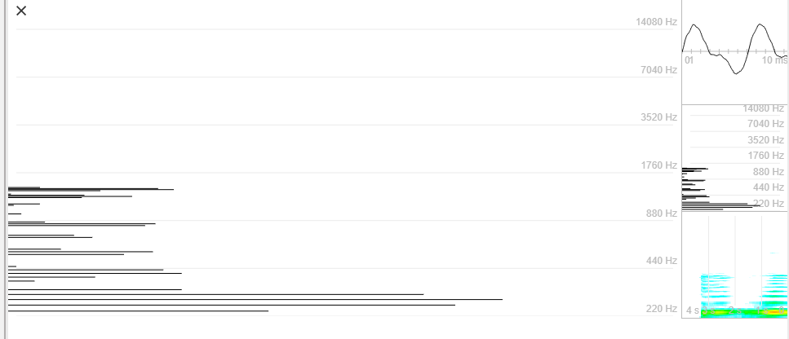

O

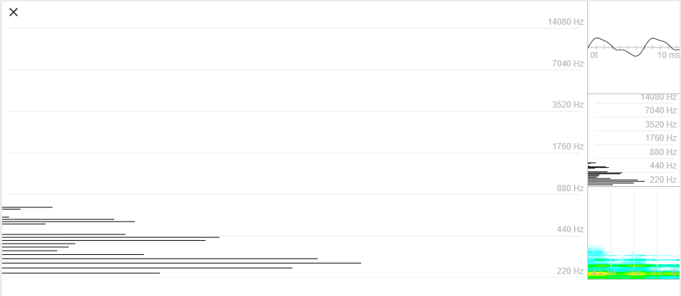

I

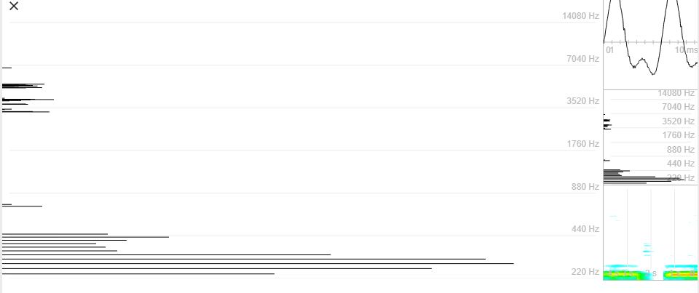

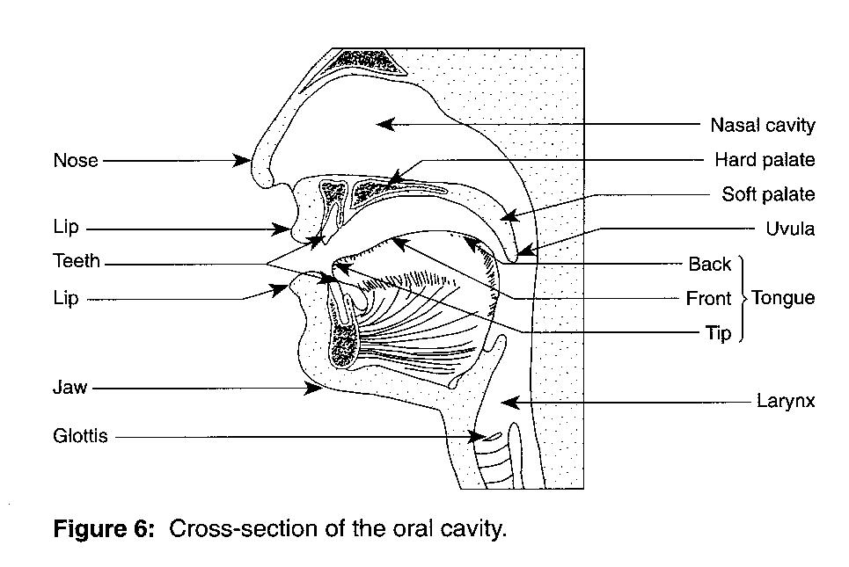

Inquiry Phase: Analyze

STEAM Field: S, A

Analyze Data from Investigations and Draw Conclusions/ Evaluate the Prototype.

Different sounds are created by different combinations and amplitudes of overtones (= timbre). These combinations are formed by manipulating the cavity of the mouth using our lips and tongue.

Explain by Relating to Background Knowledge/ Optimize the prototype

Describe and explain the results in the different STEAM-fields and the connections between them.

Inquiry Phase: Communicate/Reflect

STEAM Field: E, S, A

Communicate Results and Conclusions/ Communicate the Product, perform

How are vowels formed?

Why do vowels get distorted when the singer is singing loudly with his/her mouth wide open?

Reflect on Feedback and incorporate in further process

Lesson Plan 2: Forming of consonants
Description:
Lesson Plan 3: Harmonizing with different vowels and consonants
Description:

Lesson Plan 3: Extending the voice
Description: Creating objects to help or improve the human voice (megaphone)

Inquiry Phase: Engage

STEAM Field: E, S, M

Wonder, Ask Questions, Explore, Observe– Identify Problems, questions and chances

Relate to Background Knowledge

Inquiry Phase: Imagine

STEAM Field: E, S, M

Identify relevant variables to investigate – Identify Relevant Solutions to use

Use your imagination and make hypothesis – Choose potential solution

Inquiry Phase: CREATE (Investigate / Design)

STEAM Field: E, S, M

Plan the Investigation / Design the Prototype

Carry out Investigation / Build the Prototype

Inquiry Phase: Analyze

STEAM Field: E, S, M

Analyze Data from Investigations and Draw Conclusions/ Evaluate the Prototype.

Explain by Relating to Background Knowledge/ Optimize the prototype

Describe and explain the results in the different STEAM-fields and the connections between them.

Inquiry Phase: Communicate/Reflect

STEAM Field: E, S, M

Communicate Results and Conclusions/ Communicate the Product, perform

Reflect on Feedback and incorporate in further process

