iMuSciCA educational Scenario Metdata
Title: | Scenario: Senses - The Human Ear
Keywords: | cochlea ear - soundwaves - philosophy - drawing - listing - ossicles/ear bones - eardrum - ear canal - ear cup - semicircular canals - oval and round window
Short Description: | How is the human ear build, how can we use it? Thinking further than science and how drawings can become musical pieces?
Lesson Plans included: | Lesson Plan 1: The Anatomy of the human ear (2h)  Lesson Plan 2: The Function of the human ear (1h)  Lesson Plan 3: When a tree falls in an empty forest, does it make a sound? - Philosophical Questions (1h)  Lesson Plan 4: When drawings becomes music (3h)  Lesson Plan 5: Making a pen who can draw music (3h) | Date: | 05/07/2018
Educational Objectives: | - To know the different parts of the human ear  - To recognise that the human ear has a special build to transport sound  - To think farther than scientific facts  - To explore if certain drawings can evoke music + the function of the human brain  - To make a tool that can make music | Estimated Duration: | 10 hours
Author(s): | Alexandra Moorkens | Age Group: | 13 - 15 years
Contributor(s): | Alexandra Moorkens | Language: | English
Status: | Draft/ Final | Difficulty Level: | medium
Dissemination level: | Public/ Private | Special Needs Addressed: | Yes/No  - autism  - dysphania

iMuSciCA educational Scenario Synopsis
Scenario Title:
Scenario Description:
E: Engineering/Technology, S: Science/Mathematics, M: Music
Phases | Field | Time | Description | Activity | Remarks

Lesson Plan 4: When drawings becomes music (3h)
Description: The Human brain, reflection/refraction, drawing and music
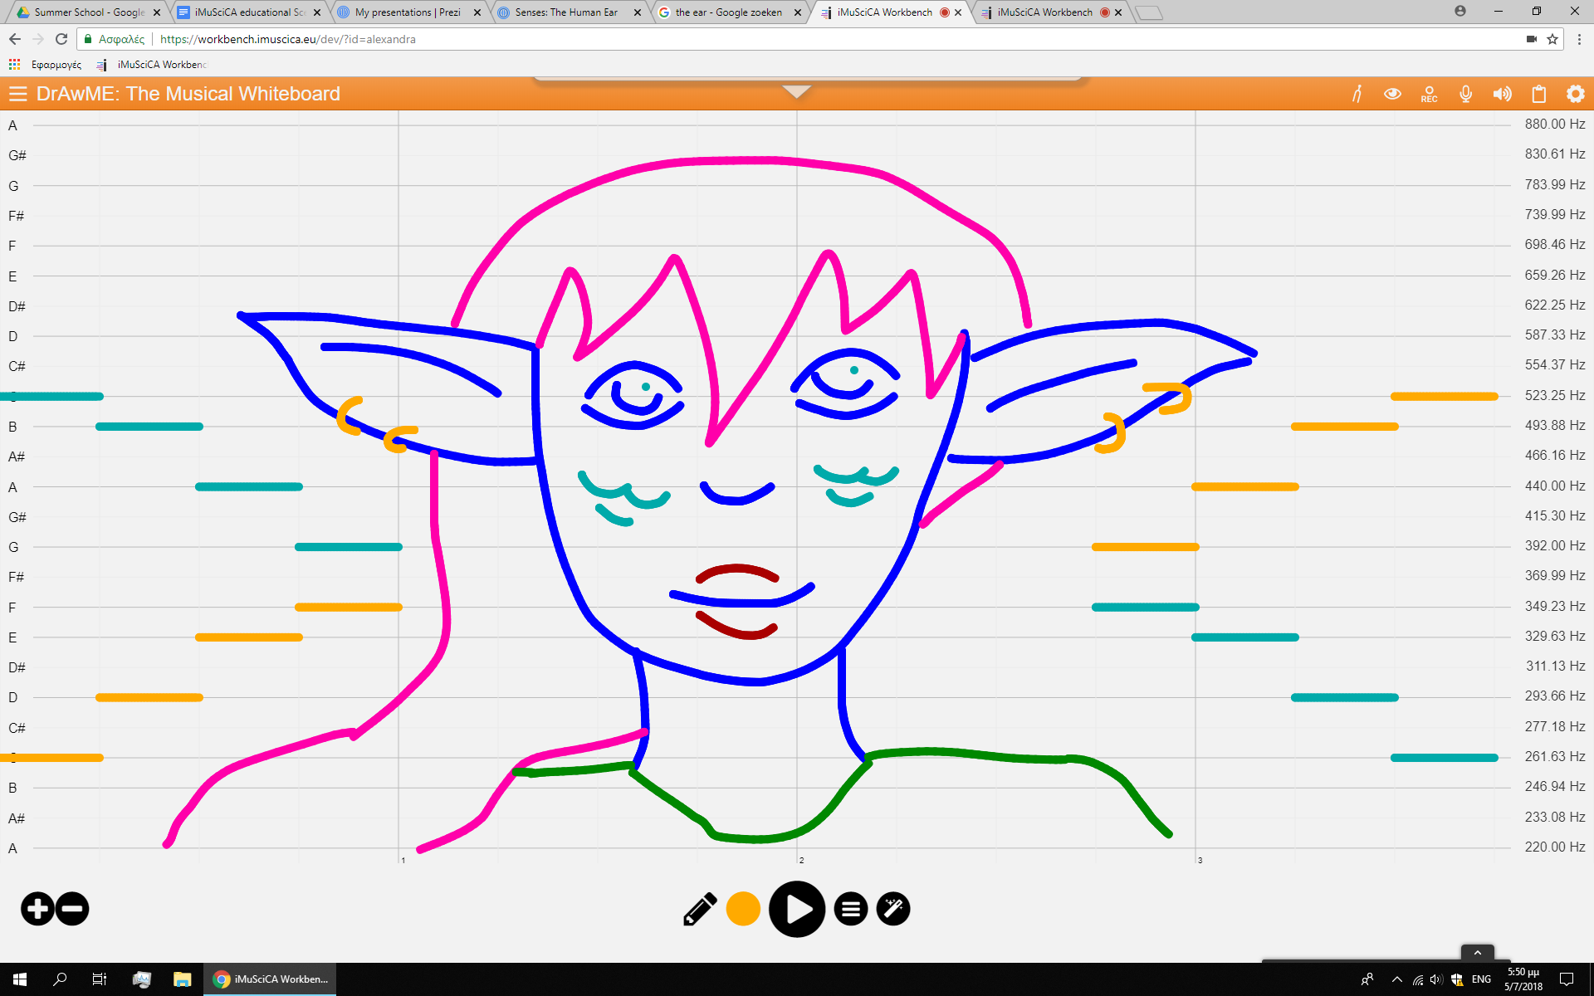
https://workbench.imuscica.eu/dev/?id=alexandra
Previous lessons: Senses: The human Eye - Sight - Refraction

(first hour)Inquiry Phase: Engage

STEAM Field: E, S, M (+ Drawing)

Wonder, Ask Questions, Explore, Observe– Identify Problems, questions and chances

- When you listen to music do you see colors? → making a drawing while listening to Superstition of Stevie Wonder and draw, paint… what you see/hear.
https://www.youtube.com/watch?v=0CFuCYNx-1g
- When you can hear colors, you have synesthesia. We will compare work with that of a synesthesia artist.
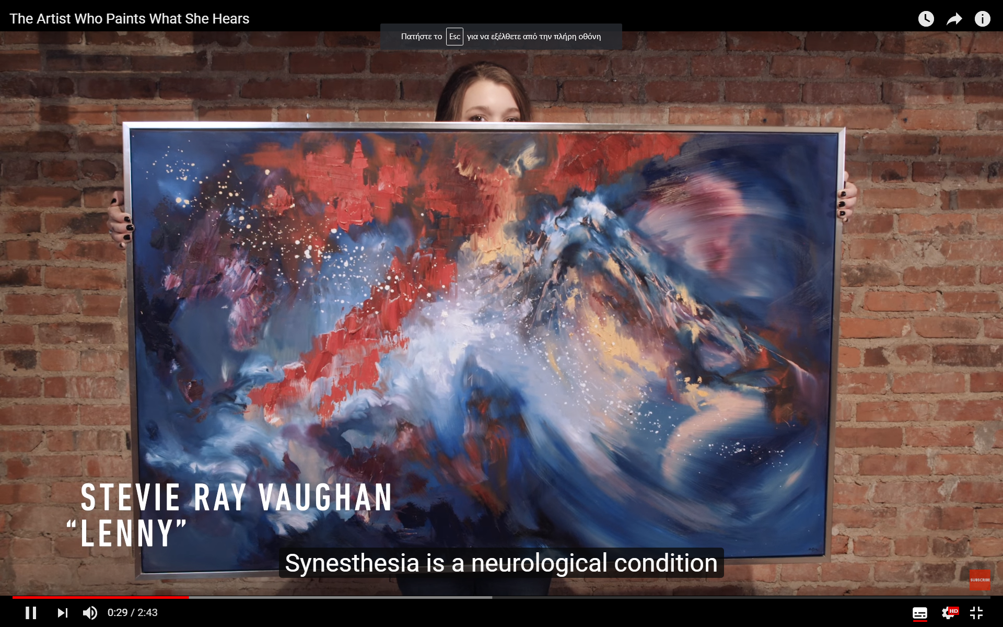https://youtu.be/zbh7tAnwLCY
- How do we hear? What part of the brain helps us to see?
  - seeing = visual cortex
  - hearing = temporal lobe
https://socratic.org/questions/how-many-parts-is-the-human-brain-divided-into-is-one-of-the-parts-the-hind-brai
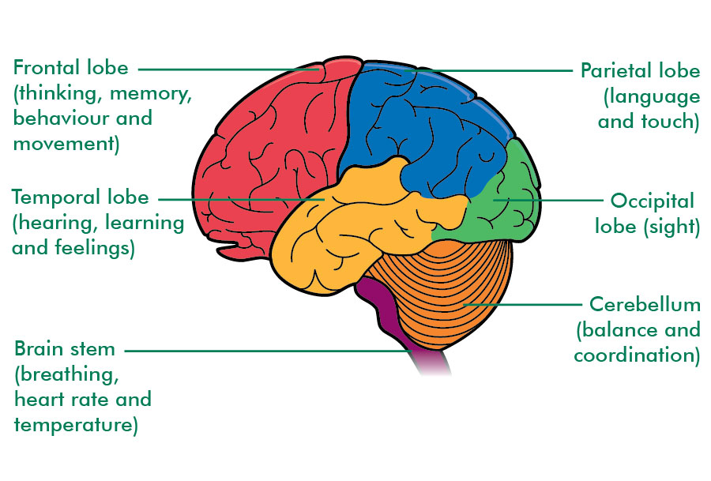
Relate to Background Knowledge
- Synesthesia: https://youtu.be/xj7vukZT9sI
  - There are different kinds of synesthesia. With this video you can test if you have it or not.
  - This can be used for extra information
- The Senses and The Human Brain - Information in their textbook (They learn this during Biology)
Example

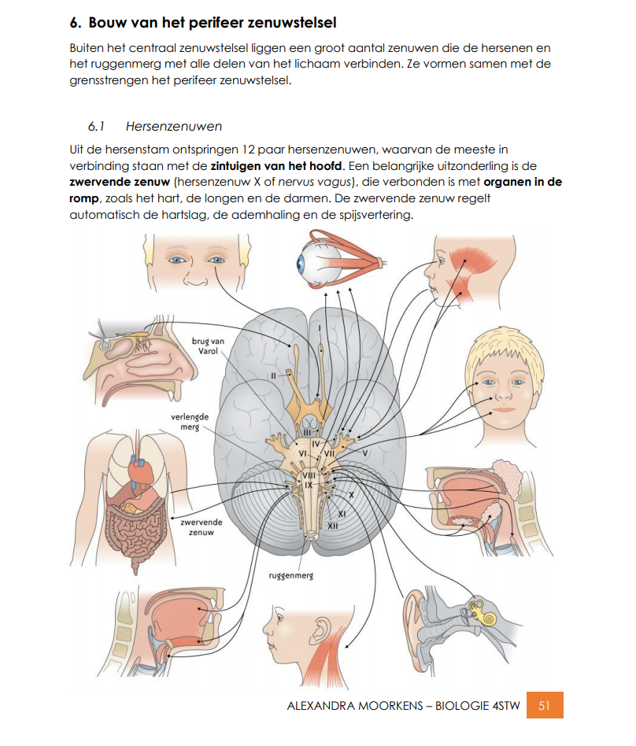 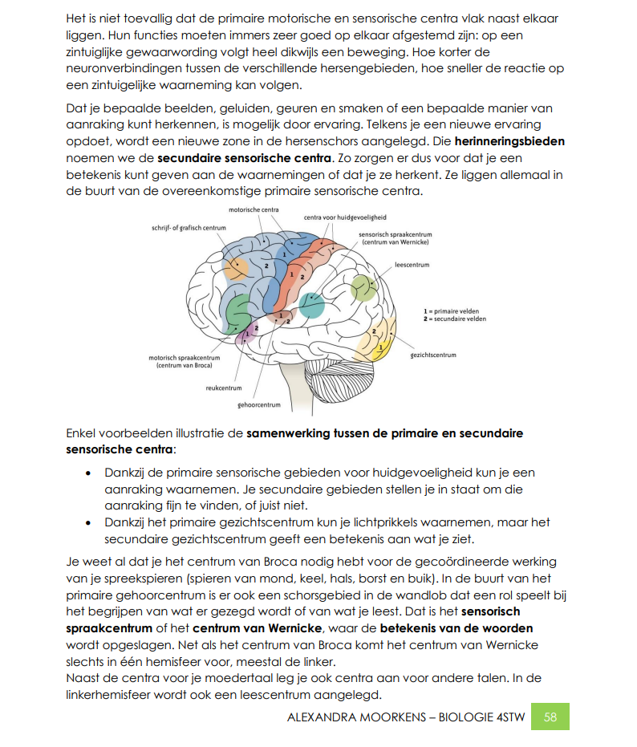
(second hour) Inquiry Phase: Imagine

STEAM Field: E, S, M

Identify relevant variables to investigate – Identify Relevant Solutions to use

Can we do it in reverse and see if a drawing can become music?
- How can we do this?
  - Let the pupils think about it.
    - Let them make a mindmap, flashcarts or brainstorm in groups of 2.
    - They use https://www.goconqr.com/ to present their information
  - They present this to the rest of the class. It only needs to be 1 or 2 minutes long.

Use your imagination and make hypothesis – Choose potential solution

- Research question: How to make music with a drawing?
  - The pupils try to make a hypothesis.
  - They give them to the teacher.
  - The hypotheses are put in a survey on https://www.mentimeter.com/
  - They take their cellphone and vote at: https://www.menti.com/ with the personal code.
  - The one with the most votes is the chosen one for the class

Inquiry Phase: CREATE (Investigate / Design)

STEAM Field: E, S, M (+ Drawing)

Plan the Investigation / Design the Prototype

Material
  - Pc
  - https://workbench.imuscica.eu → Draw me
  - headphones

Method
  - Open the Workbench from Imuscica → https://workbench.imuscica.eu/dev/?id=YOURNAME
  - Open Draw Me
  - Make a drawing in Draw Me. The pupils can already work with Draw Me on the Workbench.
    - Try to bring some reflections in your drawing. Think back to Maths and Refraction
  - Make a copy of your drawing with PRINT SCREEN
  - Save your copy on Smartschool in the Uploadzone: When drawings becomes music
    - Name: Yourname_1
  - Press play and listen to your piece of music
  - Record your piece of music and save it.

Carry out Investigation / Build the Prototype
Example
https://workbench.imuscica.eu/dev/?id=alexandra

(third hour)Inquiry Phase: Analyze

STEAM Field: E, S, M

Analyze Data from Investigations and Draw Conclusions/ Evaluate the Prototype.
- Compare the drawings and music of all the pupils.
Observation/Result
- Why does one piece of music sounds better than another?
- What makes it nicer to listen to it?

They make a resume of the information they need.
- They look up more information about harmonic notes and why they sound good together.
- They write down what they are going to change and why.
- They put their information on a template given by the teacher.
  - They fill it in on the computer.
  - When ready, they upload it on Smartschool in the Uploadzone: When drawings becomes music
    - Name: Yourname_Newdata
What is on the template?
- Name
- Copy of the first drawing
- What was good?
- What do you need to chance and why?
- New information: Music, Science, Maths
- Sources: where did you found that information?

Explain by Relating to Background Knowledge/ Optimize the prototype

Adjustments
- Make your drawing again, but with using to tips and new information you got from your classmates.
  - Open the Workbench from Imuscica → https://workbench.imuscica.eu/dev/?id=YOURNAME
  - Open Draw Me
  - Make a drawing in Draw Me. The pupils can already work with Draw Me on the Workbench.
    - Try to bring some reflections in your drawing. Think back to Maths and Refraction
  - Make a copy of your drawing with PRINT SCREEN
  - Save your copy on Smartschool in the Uploadzone: When drawings becomes music
    - Name: Yourname_2
  - Press play and listen to your piece of music
  - Record your piece of music and save it.

Describe and explain the results in the different STEAM-fields and the connections between them.
Science
- Scientific method, searching information, refraction
Math
- Reflection
Art
- Music: harmonic notes, rhythm, frequency
- Drawing: color theory

Inquiry Phase: Communicate/Reflect

STEAM Field: E, S, M (+ Drawing)

Communicate Results and Conclusions/ Communicate the Product, perform
- Compare the drawings and music of all the pupils again.
Observation/Result
- Does the music sounds better?
- What did you change?

Conclusion
- Research question: How to make music with a drawing?
  - You can do it with Draw Me
  - But can you do it with something you build yourself?

They put their information on a template given by the teacher.
- They fill it in on the computer.
- When ready, they upload it on Smartschool in the Uploadzone: When drawings becomes music
  - Name: Yourname_Newdata
What is on the template?
- Name
- Copy of the second drawing
- What went better?
- If you need to make changes, what are they?
- How can you build/make another tool to turn a drawing into music?
- New information: Music, Science, Maths
- Sources: Where did you found that information?

Reflect on Feedback and incorporate in further process
- Make a pen that makes music
  - What do you need:
    - materials
    - information
    - math calculations
- The ideas of the pupils will be evaluated and improved with feedback of the teacher

