iMuSciCA educational Scenario Metdata

Title: | Scenario: draw the music you hear
Keywords: | Drawing, graph,
Short Description: | Students explore the musical whiteboard at the workbench and draw the mathematical graphs from the pieces of music they listen to. Afterwards they check if there graph sounds the same as the piece of music
Lesson Plans included: | Lesson Plan: discovering the Musical Whiteboard at the workbench and searching a connection between a graph and music | Date: | 05/07/2018
Educational Objectives: | Explore the connection between music and graphs | Estimated Duration: | 1hr
Author(s): | Nele Denayer | Age Group: | 12-13 (students who know nothing about functions)
Contributor(s): | Renaat Frans, Manolis Chaniotakis | Language: | English
Status: | Draft | Difficulty Level: | Easy
Dissemination level: | Public/ Private | Special Needs Addressed: | No
iMuSciCA educational Scenario Synopsis
Scenario Title: draw the music you hear
Scenario Description: exploring the musical whiteboard at the workbench, drawing the mathematical graphs from the pieces of music they listen to, checking the result
E: Engineering/Technology, S: Science/Mathematics, M: Music
Phases | Field | Time | Description | Activity | Remarks
Engage/imagine | E, M | 20’ | Discovering the Musical Whiteboard at the workbench  Did you know you can draw the music you hear?  Did you know you can listen to your drawing?  Someone any idea how you can do that? (computer / program/ workbench)  If you hear music, do you hear always the same sound?  What can be different?  How will you make this visual in the drawing? (=> you draw a graph)  When you draw a graph you have to label the axes.  What means the x axis/horizontal axis?  What means the y axis/vertical axis?  Let’s discover the workbench!  Enter the iMuscica musical whiteboard    Take the pencil and draw a line.  - the minus sign is green => you draw a horizontal line  the minus sign is black => you can draw all kind of curves  - On the left side you can see the notes, on the right side the frequenties who correspond with that notes.  - the numbers below show the length of each note (1 = 1 second)  Listen to the graph with the play-button (triangle)  - other color => other sound  - the gum = delete the whole drawing  if you first select the hand and click on one line, you can erase only that line with the gum  - if you select a line with , you can displace that line  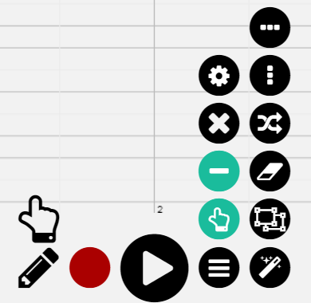  With the buttons , you can zoom in and out to get more or less notes.  Now you are going to experiment with the musical whiteboard:  Suggestions:  => experiment with horizontal lines and with other curves  => experiment with different colors  => experiment with the gum  => experiment with lines going up and going dawn  => experiment with shorter and longer lines
Create + analyse | M, E, S | 30’ | Trying to draw the music you hear + Checking if the drawing is right  - Listen to following pieces of music and try to draw them.  => here the teacher can put links to pieces of music  It’s more easy if you give the students the first note of each piece of music.  - Check immediately if your sound is correct => listen to your draw (play-button).  - If you’re sure you are correct, take a printscreen and give it following name e.g. GraphA-name.  - Send it to your teacher and try to draw the following piece of music.  - Ready? You still have time? Make a special drawing, listen to it  => does it sounds good?  => maybe you can change things for even better sound

