Guidelines
Dear iMuSciCA teachers: It is time to put our knowledge into action. Let’s try to create together an iMuSciCA educational scenario. An educational scenario consists of one or more lesson plans. Many educational scenarios can be incorporated to a big iMuSciCA project. An iMuSciCA scenario includes all inquiry phases (Engage, Imagine, Create, Analyze, Communicate/Reflect) and all STEAM Fields (E: Engineering/Technology, S: Science/Mathematics, M: Music) at least once.
- The inquiry phases can be rearranged following the sequence that you prefer. If you have the “Engage” Phase 2 times, you can copy and paste the “Engage” page (and the same goes for the rest inquiry phases).
- Make sure that each educational scenario: includes all inquiry phases, addresses all STEAM fields at least once and utilizes the iMuSciCA workbench tools.
- Your educational scenarios can include text, external URLs, images, videos and other media. Make sure that you add a description above each table you create or below each image that you insert.
- Each inquiry phase may include one or more STEAM fields.
- Each lesson plan may or may not include all inquiry phases.
- The end users of your designed educational scenarios are your students. Make sure that the metadata table on top of the scenario provides students and other interested parties with the information needed.
- Once you finalize your scenario take some time to fill the Educational Scenario Synopsis which provides a short overview of the contents of the scenario. The synopsis doesn’t refer to the lesson plans but on the contents of each inquiry phase. However, you may add the lesson plan name in the remarks.
- Once your scenario is finalized please upload it to the iMuSciCA Summer School 2018 online community. If you face any difficulty, don’t hesitate to ask the course organizers for help, or email the scenario to echaniot@ea.gr

iMuSciCA educational Scenario Metdata

Title: | Scenario: Sound, tone & silence
Keywords: | Sound, silence, tone, listening, musical creation, drawme-tool, wave-function
Short Description: | Students discover the difference between sound, tone and silence in a musical and scientific way.
Lesson Plans included: | Lesson Plan 1:  Lesson Plan 2:  Lesson Plan 3: | Date: | 05/07/2018
Educational Objectives: | Distinguishing the difference between Sound & Tone. | Estimated Duration:
Author(s): | Lander Frans, Liesel Frans | Age Group: | 12 – 16
Contributor(s): |  | Language: | English
Status: | Draft | Difficulty Level: | Medium
Dissemination level: | Public/ Private | Special Needs Addressed: | Yes/No
iMuSciCA educational Scenario Synopsis
Scenario Title: Sound, tone & silence
Scenario Description:
E: Engineering/Technology, S: Science/Mathematics, M: Music
Phases | Field | Time | Description | Activity | Remarks

Lesson Plan 1: Sound, tone & silence
Description: The students open their ears to all different kind of sounds of the environment. They reflect upon sound and silence in a experiential and scientific way. Then they try to produce different kind of sounds theirselves and we make a musical composition with all the sounds. Now we do the same exercise, but this time we use tones of the Drawme-tool in the iMuSciCa workbench to create music. After having the experience of creating both music with sounds and tones we investigate the two in a scientific way by measuring the waveforms of both sounds and tones. We conclude by measuring examples of a lot of different examples and put them in one of the two categories.

Inquiry Phase: Engage

STEAM Field: A

Wonder, Ask Questions, Explore, Observe– Identify Problems, questions and chances
Relate to Background Knowledge

Listening to sounds
The students go outside to listen to all the different sounds.
They listen for sounds that are closeby and sounds that are further away.
While listening they close their eyes.
(Tip for the teacher: use a musical instrument to mark the beginning and end of the listening with closed eyes)
Drawing what they just heard
After listening carefully for a few minutes, the student take a piece of paper to draw the sounds they just heard.
They make a distinction between sounds closeby and further away by drawing a horizon line on the paper first.
The sounds closeby are drawed close to the horizon line, sounds further from the horizon line sounded further away.

Reflection phase in Group
We put all the drawings in the middle and we take place around them to reflect.
Students that want to can take the opportunity to explain their drawing for the group.
The others can react if they had the same experience.
The teacher can ask questions to help the process of reflecting:
What kind of sound did you hear?
Where did the sound came from?
Did you expect to hear so much sounds beforehand? Etc.

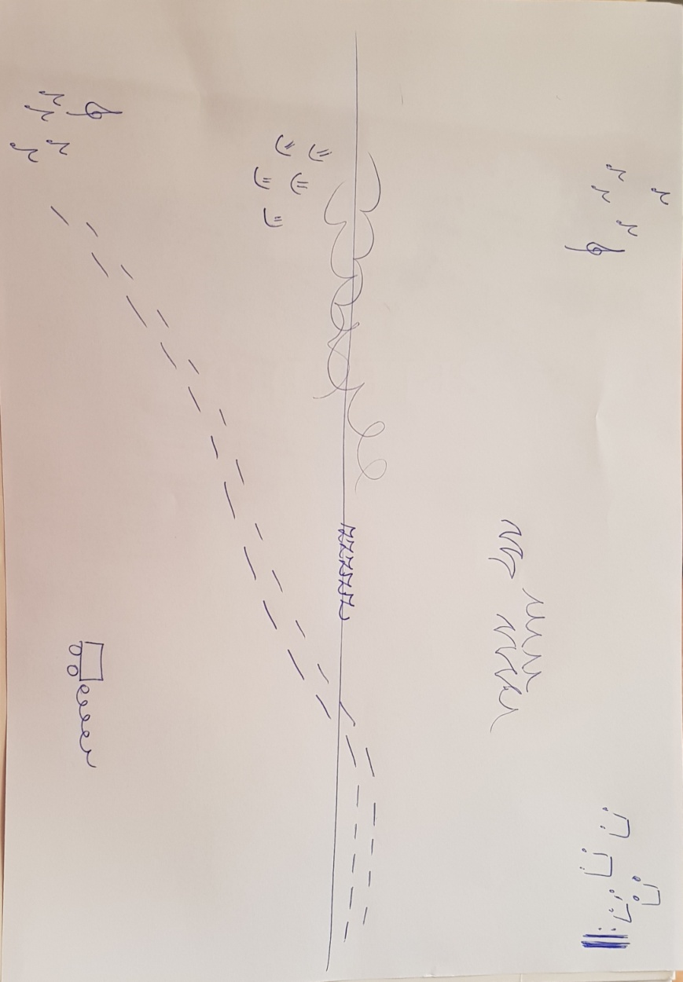

Inquiry Phase: Imagine

STEAM Field: S

Identify relevant variables to investigate – Identify Relevant Solutions to use

Use your imagination and make hypothesis – Choose potential solution

The sound of sound & the sound of silence
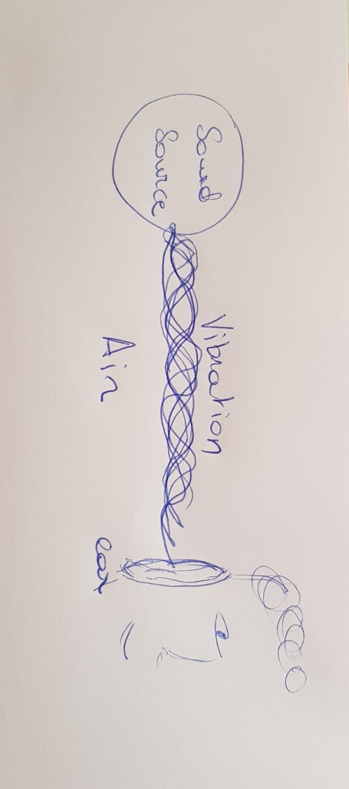
Now we look at our listening experience with scientific eyes:
We ask ourselves the following questions:
Why do we hear these sounds that we drew in the exercise?
How do those sounds reach us?

What is the opposite of sound? => silence
Exercise: Can we make silence with the group?
=> Everyone keeps silent and we have the impression that there is silence.
Now we do the same exercise, but we close our eyes and listen very carefully to the silence.
What have you heard? Was there real silence? Is it even possible to have real silence?
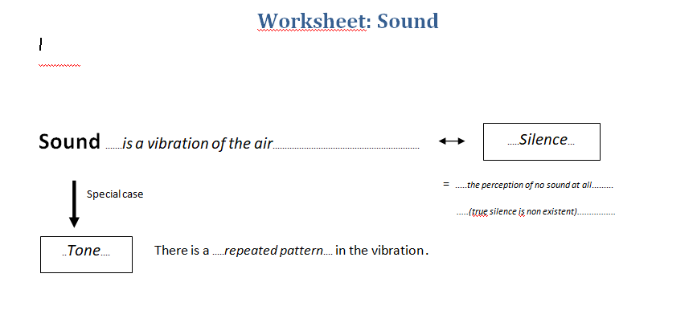

Inquiry Phase: CREATE (Investigate / Design)

STEAM Field: A

Plan the Investigation / Design the Prototype

Carry out Investigation / Build the Prototype

Musical creation with sounds
The students sit in pairs of two.
Exercise 1
Search for an interesting sound in the room. You can use everything you find.
(e.g.: the zipper of your pencil case, pressing a plastic cup, your own body, strike the radiotor…)
The students present their sounds to eachother.
Exercise 2
Search for a rythm with the sound you found. You have to be able to maintain this rythm during the whole groove!
The students choose a rythm, practise the performance of the rythm and present them for the class.
Exercise 3
Now we form an orchestra with all the rythms. The conductor (the teacher at first) chooses when someone can start or stop playing their rythm. This way we create a groove all together.
We try to make a real music piece by adding and stopping musical elements. Students can alternately be the conducter.
Alternatively we can work without a conducter: the students have to feel when it is appropriate for the music to play.

Creation with tone:
Draw me-tool from the iMuSciCa workbench.
Phase 1: Investigation of the tool
Push on the button “straight lines” first.
Now the students can create a musical piece individually or in small groups by drawing lines.
Draw from left to right on the thick lines by changing the hight of the line.
You can add a second voice by using a different color (this will sound like you use another instrument).
Phase 2: Create
When you are satisfied with your composition, you can save it in the environment.
Make 3 different compositions. Then choose your favourite one.
Phase 3: Presentation
The students present their compositions.
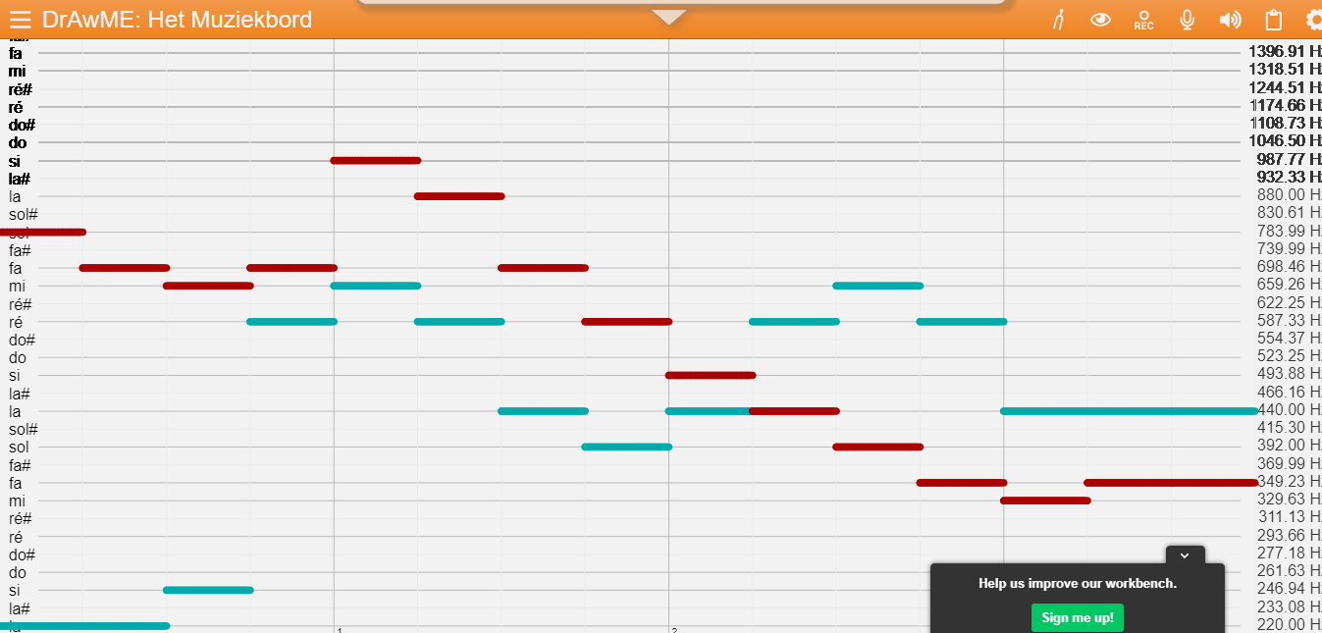

Inquiry Phase: Analyze & Reflect

STEAM Field: S

Analyze Data from Investigations and Draw Conclusions/ Evaluate the Prototype

Explain by Relating to Background Knowledge/ Optimize the prototype

Describe and explain the results in the different STEAM-fields and the connections between them.

Now it is time to reflect on the two different ways of making a musical composition.
What is the difference between the two ways of working?
Why are they different? (different reasons)
Which composition did you like the most?
What kind of music came out of the First one, what kind of music came out of the second?
- Composition with things we found in the classroom=> SOUNDS
- Composition with the software: low and high lines, musical notes, melodies => TONES
We can measure sound sources from the first and second excersice to see their waveform by using the visualisation tool from the workbench.
What do we see? Is there a difference?
=> In the waveform of tone we recognise a repeated pattern!

Now that we understand what sound is and what tone is, the students can give examples of different sounds and tones.
They write them down in a scheme. To be sure which one is a sound and which one is a tone, we can check the waveform in the visualisation tool.

.
Sound  (no pattern in the vibration) | Tone  (pattern in the vibration)
Sound of a plastic cup  The sea  Talking  Footstep  Drums  Shaker  Djembe  … | Whistling  Violin  Singing  Guitar  Piano  …

Lesson Plan 2: Title
Description:

Inquiry Phase: Engage

STEAM Field: E, S, M

Wonder, Ask Questions, Explore, Observe– Identify Problems, questions and chances

Relate to Background Knowledge

Inquiry Phase: Imagine

STEAM Field: E, S, M

Identify relevant variables to investigate – Identify Relevant Solutions to use

Use your imagination and make hypothesis – Choose potential solution

Inquiry Phase: CREATE (Investigate / Design)

STEAM Field: E, S, M

Plan the Investigation / Design the Prototype

Carry out Investigation / Build the Prototype

Inquiry Phase: Analyze

STEAM Field: E, S, M

Analyze Data from Investigations and Draw Conclusions/ Evaluate the Prototype.

Explain by Relating to Background Knowledge/ Optimize the prototype

Describe and explain the results in the different STEAM-fields and the connections between them.

Inquiry Phase: Communicate/Reflect

STEAM Field: E, S, M

Communicate Results and Conclusions/ Communicate the Product, perform

Reflect on Feedback and incorporate in further process

