Guidelines
Dear iMuSciCA teachers: It is time to put our knowledge into action. Let’s try to create together an iMuSciCA educational scenario. An educational scenario consists of one or more lesson plans. Many educational scenarios can be incorporated to a big iMuSciCA project. An iMuSciCA scenario includes all inquiry phases (Engage, Imagine, Create, Analyze, Communicate/Reflect) and all STEAM Fields (E: Engineering/Technology, S: Science/Mathematics, M: Music) at least once.
- The inquiry phases can be rearranged following the sequence that you prefer. If you have the “Engage” Phase 2 times, you can copy and paste the “Engage” page (and the same goes for the rest inquiry phases).
- Make sure that each educational scenario: includes all inquiry phases, addresses all STEAM fields at least once and utilizes the iMuSciCA workbench tools.
- Your educational scenarios can include text, external URLs, images, videos and other media. Make sure that you add a description above each table you create or below each image that you insert.
- Each inquiry phase may include one or more STEAM fields.
- Each lesson plan may or may not include all inquiry phases.
- The end users of your designed educational scenarios are your students. Make sure that the metadata table on top of the scenario provides students and other interested parties with the information needed.
- Once you finalize your scenario take some time to fill the Educational Scenario Synopsis which provides a short overview of the contents of the scenario. The synopsis doesn’t refer to the lesson plans but on the contents of each inquiry phase. However, you may add the lesson plan name in the remarks.
- Once your scenario is finalized please upload it to the iMuSciCA Summer School 2018 online community. If you face any difficulty, don’t hesitate to ask the course organizers for help, or email the scenario to echaniot@ea.gr

iMuSciCA educational Scenario Metdata

Title: | Scenario: Pentatonic
Keywords:
Short Description:
Lesson Plans included: | Lesson Plan 1:  Lesson Plan 2:  Lesson Plan 3: | Date: | DD/MM/YYYY
Educational Objectives: | Objective 1, Objective 2 | Estimated Duration:
Author(s): | Natacha Gesquière | Age Group: | 12-14
Contributor(s): | Contributor 1, Contributor 2 | Language: | English
Status: | Draft/ Final | Difficulty Level: | Medium
Dissemination level: | Public/ Private | Special Needs Addressed: | Yes/No
iMuSciCA educational Scenario Synopsis
Scenario Title: Pentatonic
Scenario Description: Students play a piece of Grieg with a self-engineered monochord and bichord
E: Engineering/Technology, S: Science, M: Mathematics, A: Music
Phases | Field | Time | Description | Activity | Remarks

Lesson Plan 1: Title
Description:

Inquiry Phase: Engage

STEAM Field: E, S, M

Wonder, Ask Questions, Explore, Observe– Identify Problems, questions and chances

A lot of music is based on a pentatonic, a sequence of 5 tones. With those 5 tones one composes a little piece of music.

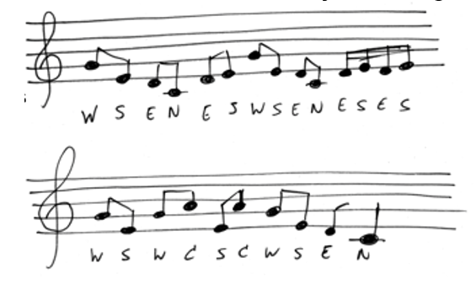

Relate to Background Knowledge

Inquiry Phase: Imagine

STEAM Field: E, S, M

Identify relevant variables to investigate – Identify Relevant Solutions to use

Make it possible to play 5 pitches on the monochords.

How can you do that if you are only able to divide a string in two? (It is not so that if you made one pith possible, that you automatically have another one on the other part of the string.)

You have to investigate:

the number of pitches you need
- which pitches you need
- the length of the strings
- the measure of the monochord
- the tension on the strings (only if necessary)

Use your imagination and make hypothesis – Choose potential solution

Inquiry Phase: CREATE (Investigate / Design)

STEAM Field: E, S, M

Plan the Investigation / Design the Prototype

Investigate using the monochord and the tuner:

Design the monochord to produce the lowest pitch you need.
Calculate the length of the other strings you need.
Change the length of the bichord so you can produce two of the needed pitches with one string divides in two.
Do the same with the monochord. Now you already have four pitches.
Use the second string on the bichord to produce the fifth pitch.
Change the tension on the strings when needed.

Carry out Investigation / Build the Prototype

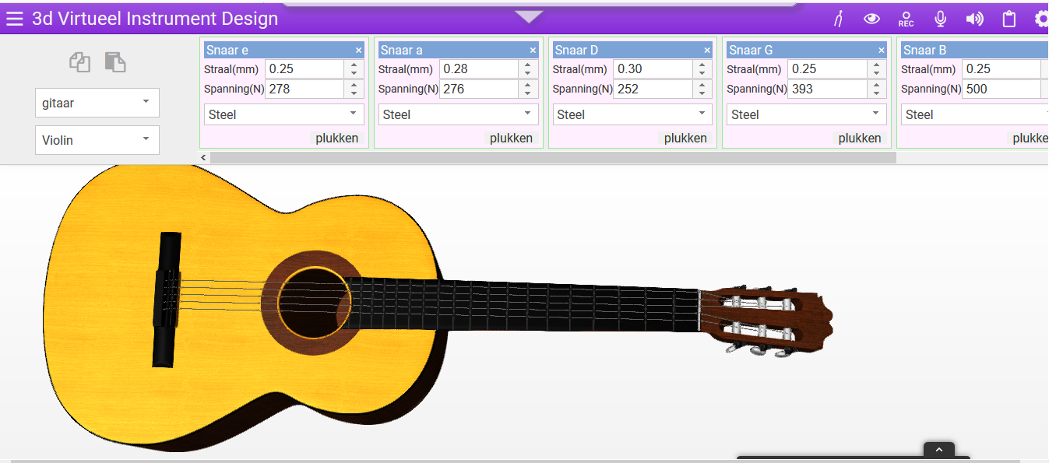

Inquiry Phase: Analyze

STEAM Field: E, S, M

Analyze Data from Investigations and Draw Conclusions/ Evaluate the Prototype.

Explain by Relating to Background Knowledge/ Optimize the prototype

Describe and explain the results in the different STEAM-fields and the connections between them.

A: the pitches you need to play the music

S: the relationship between the length of the string and the pitch
M: the calculation you do to decide upon the length of the monochord and the calculations for the length of the strings
E: make the monochord with and divide the strings in the right way
T: using the workbench 3D-instrument and a calculator

Inquiry Phase: Communicate/Reflect

STEAM Field: E, S, M

Communicate Results and Conclusions/ Communicate the Product, perform

Reflect on Feedback and incorporate in further process

Lesson Plan 2: Title
Description:

Inquiry Phase: Engage

STEAM Field: E, S, M

Wonder, Ask Questions, Explore, Observe– Identify Problems, questions and chances

Relate to Background Knowledge

Inquiry Phase: Imagine

STEAM Field: E, S, M

Identify relevant variables to investigate – Identify Relevant Solutions to use

Use your imagination and make hypothesis – Choose potential solution

Inquiry Phase: CREATE (Investigate / Design)

STEAM Field: E, S, M

Plan the Investigation / Design the Prototype

Carry out Investigation / Build the Prototype

Inquiry Phase: Analyze

STEAM Field: E, S, M

Analyze Data from Investigations and Draw Conclusions/ Evaluate the Prototype.

Explain by Relating to Background Knowledge/ Optimize the prototype

Describe and explain the results in the different STEAM-fields and the connections between them.

Inquiry Phase: Communicate/Reflect

STEAM Field: E, S, M

Communicate Results and Conclusions/ Communicate the Product, perform

Reflect on Feedback and incorporate in further process

