פעילות בנושא "גם אני יכול" I Can Too Program
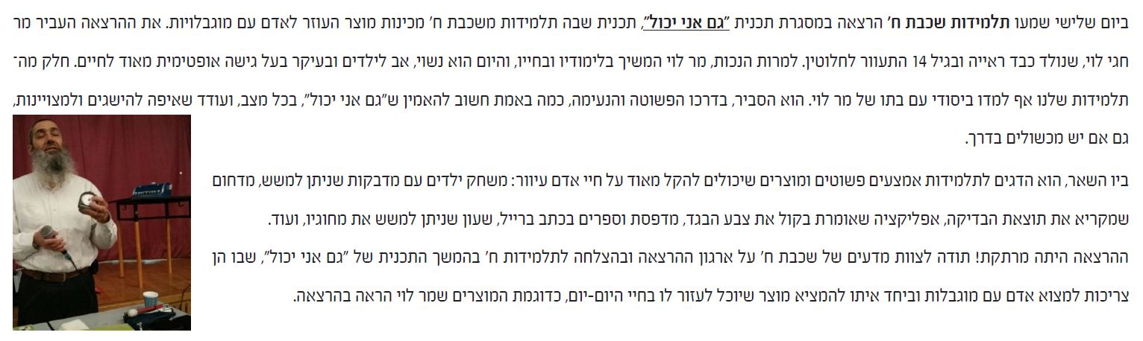
21 נובמבר 2017- OSOS
Chagay Levi, a blind man, came to our school and explained how different products can make a huge different in the life of a handicapped person. He gave the students examples of different games and new applications that make his life easier.

