Hands –on-Astronomy Cardiff 13th – 14th April 2015
Report on New activities tried out so far by George Buick

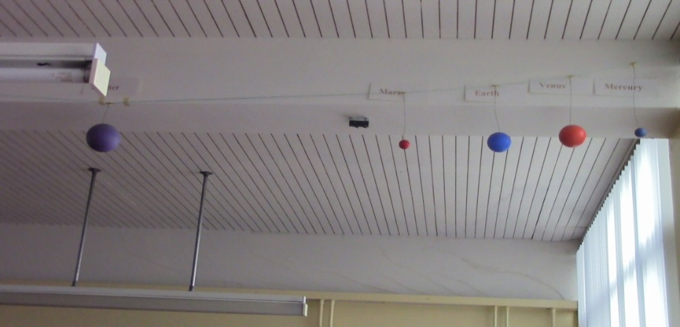
Solar System
Previously:
Static model of planets attached to ceiling of lab, which gave pupils a reminder of the names of the planets in the correct order, but was not scaled accurately.
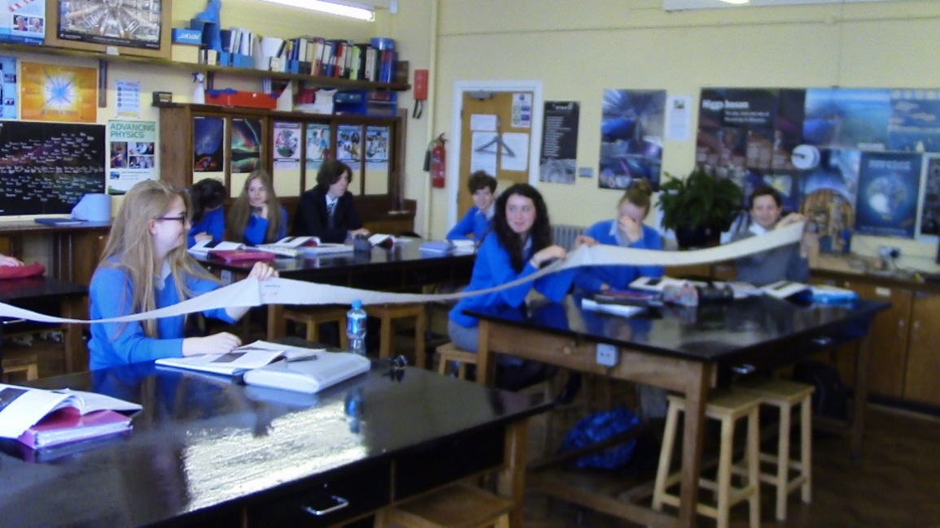
Tried out:
I liked the hands-on activity using a toilet roll (demonstrated by Paul Hill) to model the scale of the planets in the solar system in terms of 1 AU = 1 sheet of toilet roll. The photo shows that some of my pupils enjoyed it too!

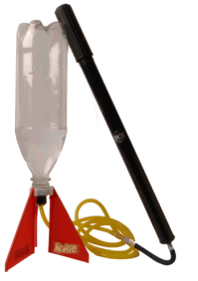
Rockets
Previously:
Demonstrated basic principle of rockets using a water rocket www.rokit.com (similar to the Whoosh bottle demonstration by Paul Hill). Pupils enjoy watching the demonstration outdoors, and are surprised by the sudden whoosh as the rocket takes off, and the height reached but don’t actually handle a rocket themselves.
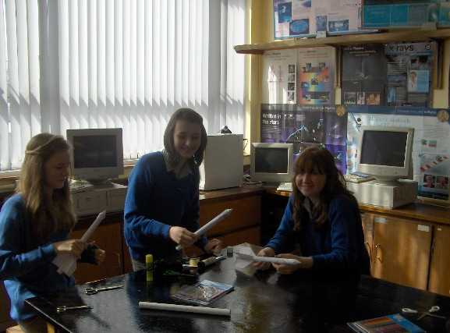
Tried out:
Hands-on activity originating from institute of Physics. Rockets – Make and Take
http://www.iop.org/education/teacher/support/network/cpd-sessions/page_44093.html
Pupils make a paper rocket from a template, and use a simple compressed air launcher to see whose rocket goes furthest. This prompts lots of discussion about the physics involved and they really enjoy the hands-on activity!

Exoplanets
Previously:
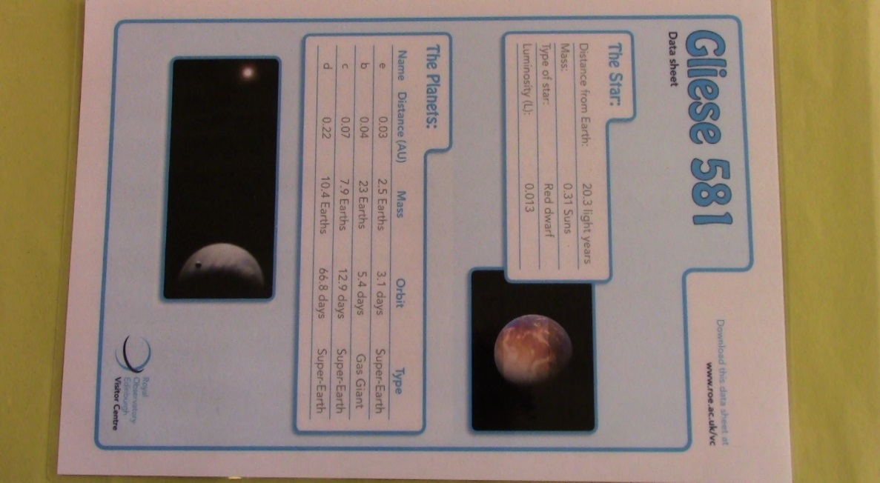
Used ideas from Royal Observatory Edinburgh http://www.roe.ac.uk/vc/education/secondary/exoplanets.html This involved showing the class a short video introducing them to the idea of Exoplanets, followed by a group activity using data supplied to identify possible habitable zones.
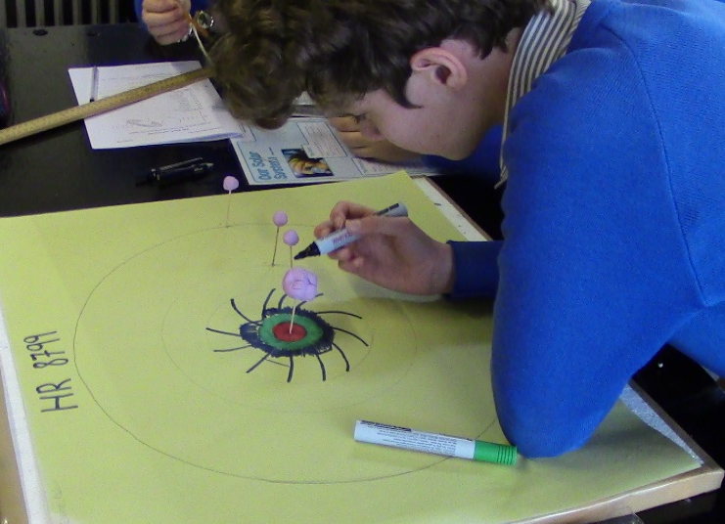


Tried out:
Agent Exoplanet http://lcogt.net/agentexoplanet/
Unlike the other activities above, this involved taking the class to the ICT room so that they could use a computer terminal each.
The task was introduced with the help of an excellent short video “Mission Briefing” then pupils used the techniques which had been explained in order to try to produce a light curve. In the lesson time available (50 minutes) there was only enough time to try out the beginner activity (CoRoT-2b) which involved analysing 13 images. Everyone in the class was able to complete the activity and gained useful insight into one method of identifying an exoplanet.
Unfortunately the light curve obtained at the end of the process didn’t show as convincing a dip as in the mission briefing video!
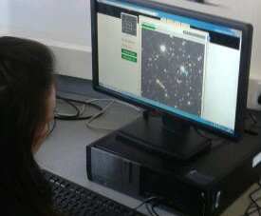
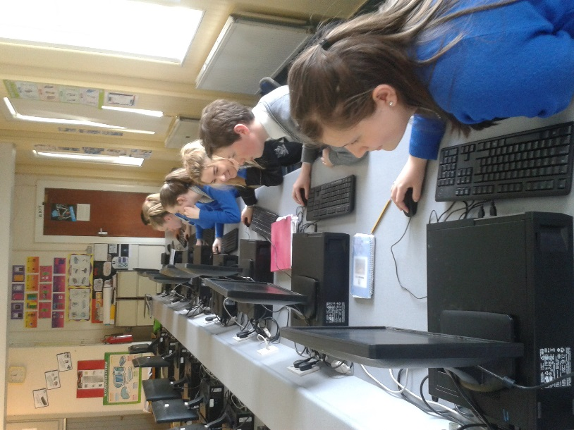
While in ICT room gave pupils an opportunity to browse in the N.S.O. website.

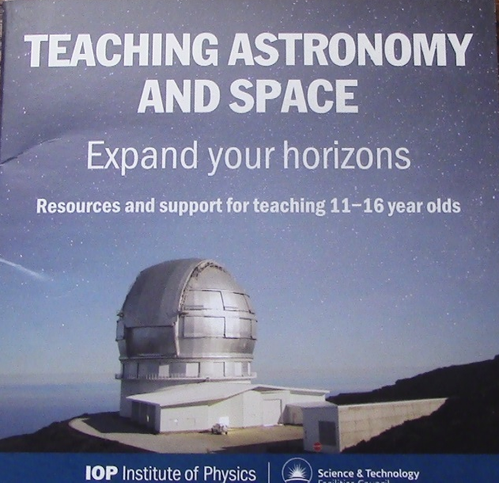
Also made extensive use of a resource provided by the Institute of Physics. This has several short videos (one of which features a younger Chris North) which are excellent support for activities on planets, exoplanets and more…
Had a browse through the Nebraska Astronomy Applet Project which I found to have many useful looking ideas, and may use some of them in the future.
Particularly liked the Faulkes Educational resources e.g. “Distant Light in the Universe” which I hope to explore further in the coming months.
Looked briefly at GoLab portal, but will need to take more time to explore it more thoroughly. Made use of the introductory tutorial material to see how GoLab might be used.

Major challenges faced:
Most of my timetable involves exam classes (A2, AS, GCSE) so there was unrelenting pressure after Easter to complete the syllabus and concentrate on exam technique by going over past paper questions. This made it very difficult to incorporate any new astronomy related teaching ideas until the exams were out of the way.
Enquiry based learning was unfamiliar to me before attending this course so I will need to take more time to reflect on the ideas presented.
The use of GRAASP was also unfamiliar to me so I found it difficult to get the hang of it as Rosa went over it very quickly. I would have needed more help in the initial stages, but might be able to take it further with the help of on line tutorials.

Summary
It has been very worthwhile to have had the opportunity to get 2 days completely away from the routine demands of the school classroom, mix with fellow teachers from other schools in UK and Europe, and be made aware of the extensive range of resources available to enrich and enhance the teaching of aspects of astronomy at GCSE and A-level. It has given a boost to my own confidence in teaching the relevant concepts enthusiastically.

Many thanks to all those involved in organising and delivering the course in sunny Cardiff.

Best wishes from (a sometimes sunny) Dominican College Portstewart, N. Ireland
