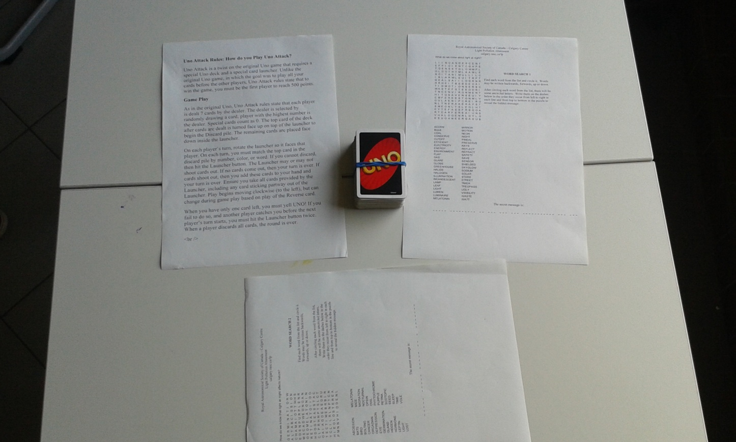

The game is actually UNO, but there has something to do with the winners and the losers. The winners, gets a piece of candy, the losers, must solve a crossword puzzle. The one who then lose, is the big loser.
- The game you can play with 4 people.

- From the game you can learn different words about light pollution.
Have fun!

