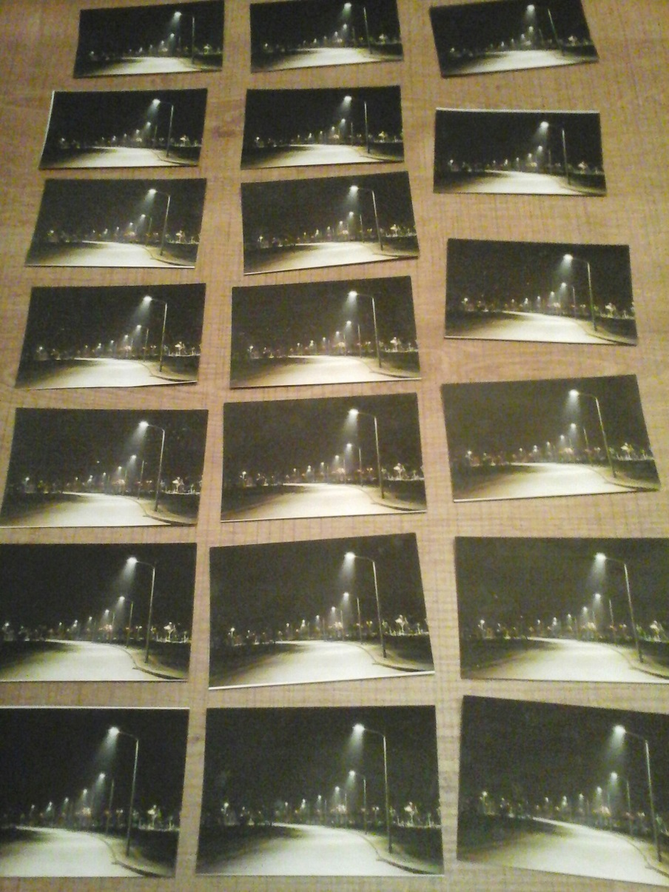
Game light pollution
(memory)

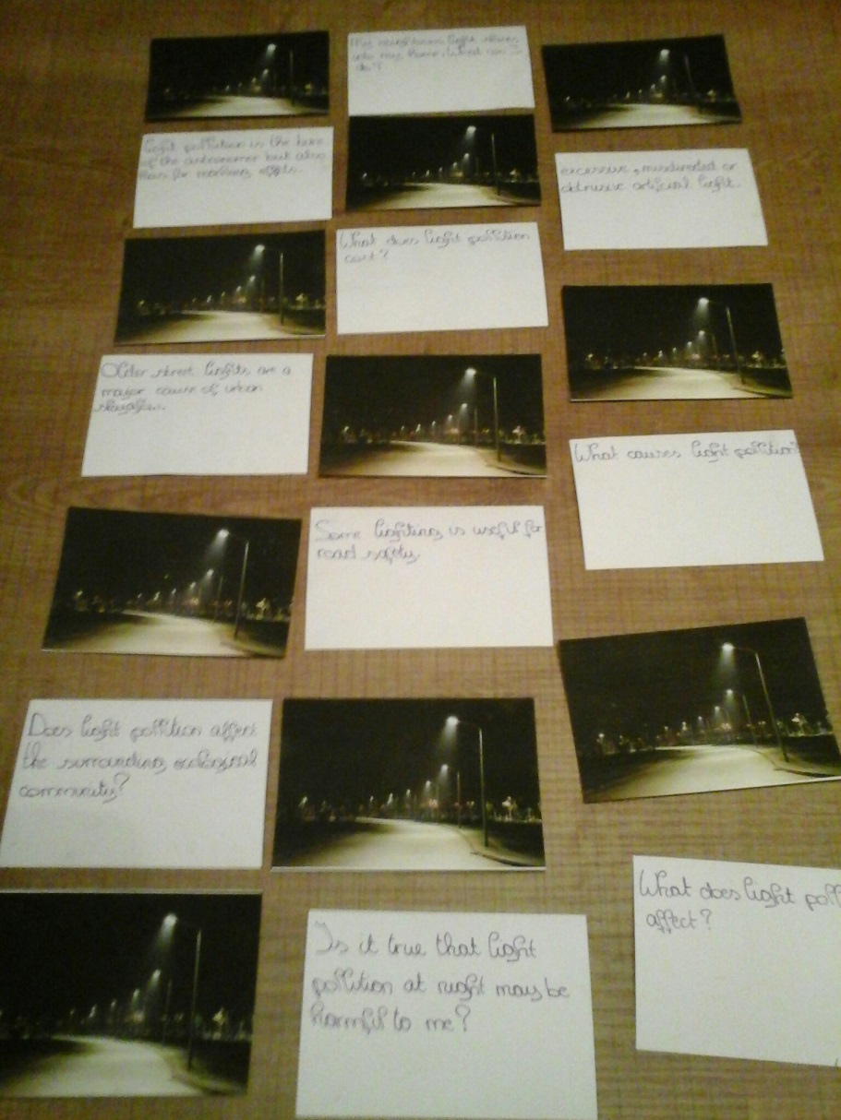

THE RULES FOR PLAYING MEMORY
- Mix up the cards.
- Lay them in rows, face down.
- Turn over any two cards.
- If the two cards match, keep them.
- If they don't match, turn them back over.
- Remember what was on each card and where it was.
- Watch and remember during the other player's turn.
- The game is over when all the cards have been matched.
- The player with the most matches wins.

