The LHC Tunnel
Project Reference: | 665917 |  | Author: | Emmanuel Chaniotakis (EA)
Code: | D 3.1. |  | Contributors: | Giannis Alexopoulos (EA)
Version & Date: v1. 24/5/2017 |  |  | Approved by:

Table of Contents
1 Introduction / Demonstrator Identity 6
1.1 Subject Domain 6
1.2 Type of Activity 6
1.3 Duration 6
1.4 Setting (formal / informal learning) 6
1.5 Effective Learning Environment 6
2 Rational of the Activity / Educational Approach 7
2.1 Challenge 7
2.2 Added Value 7
3 Learning Objectives 8
3.1 Domain specific objectives 8
3.2 General skills objectives 8
4 Demonstrator characteristics and Needs of Students 9
4.1 Aim of the demonstrator 9
4.2 Student needs addressed 9
5 Learning Activities & Effective Learning Environments 10
6 Additional Information 15
7 Assessment 16
8 Possible Extension 17
9 References 18

Introduction / Demonstrator Identity

Subject Domain
High Energy Physics at CERN

Type of Activity
This is a student activity taking place in both formal and informal settings, promoting the connection of school and research center. Through this activity students learn about CERN through an interactive exhibition, the “Interactive LHC tunnel” and investigate: i) the physics of high energy proton collisions and their detection in a playful fashion; ii) the Higgs mechanism through an interactive experience. Activity can take place both in local and in national level.
Duration
2 hours

Setting (formal / informal learning)
Formal (classroom) and informal (research center).

Effective Learning Environment
- Simulations aiming to enable the visualization of theoretical models and facilitate inquiry-based experimentation
- Dialogic space / argumentation aiming to engage students in argumentation and dialogic processes for a better insight into the nature of scientific enquiry and the ways in which scientists work
- Arts based.

Rational of the Activity / Educational Approach

Challenge

- Understanding advanced scientific topics beyond the reach of school curricula in a playful and engaging fashion

In order to understand Nature and the Laws governing our Universe, Modern Science has developed tools and techniques of sophistication far beyond the reach of school curricula. Modern discoveries are able to answer questions such as “What are we made of?”, “What is the nature of mass?”, “How did the Universe look like during its infancy”, which were once in the realm of Philosophy and speculation. Today, these questions can be quantified and answered in cutting edge experiments, thus expanding the boundaries of human comprehension far beyond our everyday practice. In order to organize and conduct the experiments needed to verify such hypotheses, scientists form international collaborations consisting of thousands of scientists and engineers and build gigantic research infrastructures dedicated to the pursuit of fundamental knowledge. Such an international, multicultural research infrastructure is CERN, with experiments ran by thousands of scientists aiming to discover the most fundamental laws of the Universe with unprecedented accuracy.
Students are exposed to these scientific breakthroughs through media such as TV, newspapers, blogs or social media. However, the knowledge and skills needed to be able to comprehend the science behind these discoveries, are far beyond the reach of the school curricula. As a result, dedicated outreach activities have been developed by leading organizations involved in scientific research, science education and outreach, in order to bring students in touch with modern scientific research culture, demonstrate to them cutting edge scientific achievements and cultivate the skills needed in order the students to become ‘little researchers’ and explore on their own the fascinating world of modern science.
In this framework, the “LHC tunnel” demonstrator employs an interactive ICT-enhanced exhibit created by CERN’s media-lab in order to bring students closer to the scientific endeavours taking place at the world’s largest particle physics laboratory. By having students to “kick” protons in order to produce simulated high energy proton collisions and observe the products of them and by having students experiment and perform in a visualization of a world with and without the Higgs boson, their interest in science is sparked and the complex subatomic phenomena are addressed in a fashion understandable by them.

Added Value
- Students learn about cutting edge research at CERN in a hands-on and minds-on fashion.
- Students divide in small groups and investigate the physics of the proton-football they conduct.
- Students learn Physics within and beyond their school curricula and thus get inspired on science in general.
- Development of analytical thinking.

Learning Objectives

Domain specific objectives

Concepts like “the influence of Higgs Field on matter” and “particle acceleration and collision” can lead to explanations which are quite often hard to understand and even harder to retain. By immersing students in a fully interactive gaming experience, the Interactive LHC Tunnel touring exhibition manages to bridge the gaps between science education, interactive media and information visualization, creating an entertaining and memorable tool for learning.
Using Kinects to detect users, and projecting images on the floor and on a video wall, we can create different learning experiences in a variety of subjects.
The learning objectives of this demonstrator are:
- The students to understand the principles of particle acceleration, collision and detection at CERN. This is achieved through a gaming experience called “Proton Football”: Students become particle accelerators themselves by kicking protons. By varying the force of their “kick” they vary the energy offered to a proton and thus the collision energy of the protons. The collision energy in turn defines the multiplicity of particles produced in a particle collision. Furthermore, students learn about Einstein’s famous E=mc² equation and learn that higher collision energies can result in the production of heavy particles. Finally, students learn about components of a modern particle detector including the tracker and the calorimeter and learn how these detectors can provide us with information regarding the collision process and products.
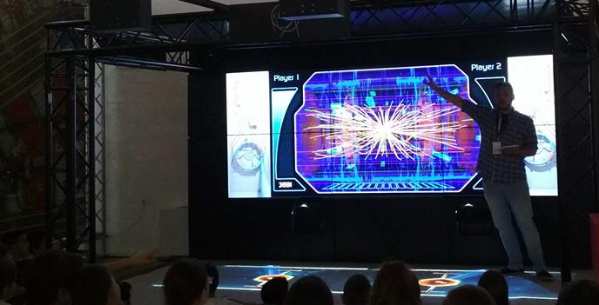

- The Higgs Boson, discovered by scientists at CERN, is one of the keys to understand why the universe is the way it is. In Higgnite, a kinect-based mixed environment, the user becomes a particle, which can hop between an area where the Higgs Field is absent, and another where it will interact with the Higgs Field, thus gaining mass.
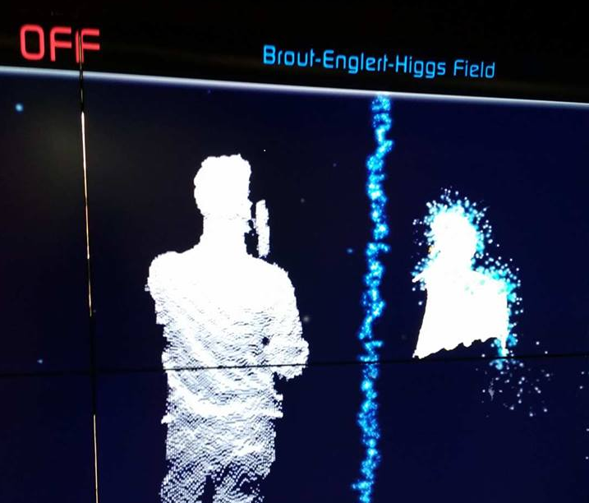

General skills objectives
- Students learn to apply teamwork and analytical thinking in order to connect the results of their game with the scientific output of their achievements.
- Students learn to control variables and observe the results.

Demonstrator characteristics and Needs of Students

Aim of the demonstrator
This demonstrator is a hands-on activity aiming to introduce the scientific culture of large research infrastructures such as CERN to students in a playful and engaging fashion.

Student needs addressed
In this activity, students develop their knowledge on scientific issues beyond the reach of their school curricula. They develop creative skills, critical thinking and learn how a scientist thinks by doing their own inquiries based on the IBSE model.

Learning Activities & Effective Learning Environments

- Question-eliciting activities
- Introductory material addressing the basic needs of the exercise will be offered to the students to explore before the beginning of the exercise.
- Lecture about elementary particles, CERN, LHC will be delivered by experts.
- Discussion/question/answer session with the students and teachers and experts.

- Active investigation
- Introduction to the features of the LHC Tunnel exhibition.
- Introductory lecture about CERN, LHC and its experiments.
- Proton football and introduction to aspects of particle acceleration, collision and detection.
- Introduction to the Higgs boson through the artistic impression of Higgnite
- Students choose one fundamental physics property (electric charge, mass, spin) and create an artwork inspired by Higgnite to demonstrate how they believe the world would be without these properties.

Science topic: High Energy Physics.  Class information  Year Group: Sixth year of Primary school to Third year of Senior High School.  Age range: 12-18  Sex: both  Pupil Ability: Team work, analytical thinking |  |  | Materials and Resources: The setup of the LHC tunnel interactive exhibition needs to be available for the implementation of this demonstrator.  Where will the learning take place? On site or off site? In several spaces? (e.g. science laboratory, drama space etc), or one? In informal settings (such as science festivals) or formal settings (schools).  Health and Safety implications? None  Technology?  - Teacher support?. The relevant material can be found in this online virtual community: http://portal.opendiscoveryspace.eu/en/community/lets-explore-lhc-tunnel-849923
Prior pupil knowledge:
The students involved in this activity need to have basic knowledge of the principle of conservation of energy and momentum and its applications in collisions. Basic knowledge of phenomena related to special relativity as well as the structure of matter are desired.
Individual session project objectives (What do you want pupils to know and understand by the end of the lesson?)
Using Kinects to detect users, and projecting images on the floor and on a video wall, we can create different learning experiences in a variety of subjects. By the end of the lesson, the students should be able to understand the mission of CERN, the principles of particle acceleration, collision and detection as well as the influence of the Higgs field on matter.

Assessment  Content knowledge is assessed through specific questions and exercises throughout the in-class activity and creativity as well as science motivation are assessed through pre-post questionnaires. |  | Differentiation  The activities described in this demonstrator refer to very advanced scientific concepts and the attempt to bring them in the classroom. As a result they have specific content knowledge requirements. Variants of these activities including a presentation and creative expression of students combined with a virtual visit can be performed by more students without tight content knowledge restrictions. |  |  | Key Concepts and Terminology  Proton football, higgnite, Kinect, angry birds, augmented reality.  Science terminology:  Proton, quark, Higgs, CERN, LHC, particle Collision, particle detection, mass, energy, particle multiplicity, cosmic ray, speed of light  Arts terminology:  Graphic display of particle collisions, Artistic impression of Higgs field
Session Objectives:
Concepts like “the influence of Higgs Field on matter” and “particle acceleration and collision” can lead to explanations which are quite often hard to understand and even harder to retain. By immersing students in a fully interactive gaming experience, the Interactive LHC Tunnel touring exhibition manages to bridge the gaps between science education, interactive media and information visualization, creating an entertaining and memorable tool for learning.
In the end of the activity, students will create a their own artwork- based on the Higgnite example- demonstrating how they believe
that the Universe would be like if one of the following fundamental particle properties didn’t exist (electric charge, mass, spin).
For a demonstration of the LHC interactive tunnel exhibition, please see the following link: http://portal.opendiscoveryspace.eu/en/community/lets-explore-lhc-tunnel-849923
Learning activities in terms of CREATIONS Approach
IBSE Activity | Interaction with CREATIONs Features |  |  | Student |  | Teacher | Potential arts activity
Phase 1:  QUESTION: students investigate a scientifically oriented question | Students pose, select, or are given a scientifically oriented question to investigate. Balance and navigation through dialogue aids teachers and students in creatively navigating educational tensions, including between open and structured approaches to IBSE. Questions may arise through dialogue between students’ scientific knowledge and the scientific knowledge of professional scientists and science educators, or through dialogue with different ways of knowledge inspired by interdisciplinarity and personal, embodied learning. Ethics and trusteeship is an important consideration in experimental design and collaborative work, as well as in the initial choice of question |  |  | Students get introduced to key concepts and ideas in elementary particle physics and particle collisions. They observe the introductory video of CERN and discuss about the size, the mission and the components of the great particle physics laboratory.  They wonder:  - why do we need such a big experimental facility to measure the very small?  - how can we extract, bunch and accelerate such small particles at speeds close to the speed of light and then have them collide?  - what is the benefit of research at CERN? Why is it important to study particle collisions? |  | The teacher introduces students to the mission and vision of CERN. The teacher can consult this video: https://www.youtube.com/watch?v=328pw5Taeg0  Furthermore, they can visit:  https://home.cern/about for extra details.  Students should also have a prior knowledge regarding the constituents of matter at an introductory level  https://www.youtube.com/watch?v=7WhRJV_bAiE  In order to be able to discuss the impact of CERN to society, the teacher  could visit this link for preparatory material:  https://kt.cern/funding/kt-fund
Phase 2:  EVIDENCE: students give priority to evidence | Students determine or are guided to evidence/data, which may come from individual, collaborative and communal activity such as practical work, or from sources such as data from professional scientific activity or from other contexts. Risk, immersion and play is crucial in empowering pupils to generate, question and discuss evidence. |  |  | The students divide in groups of two and play “proton football”: a Kinect based interactive activity in which the students can kick a proton emulating the procedure of proton acceleration. When the “protons” of the two students collide, they observe the results of a simulated collision in a monitor next to them.  The students explore the relationship between the force of their kick and the energy of the simulated protons and observe the output in the simulated detector. |  | The teacher describes the path of a proton beam towards its collision and briefly introduces students to the concept of particle detectors. Then the teacher launches the proton football game.  To introduce students to particle collisions and detectors, the teacher can prepare using this introductory material: http://www.particleadventure.org/accelerators-and-detectors.html  The teacher acts as a mentor and explains to the students the components of a modern particle detector. They draw the students’ attention to the fact that as they kick harder, the proton energy increases and thus the collision energy increases.
Phase 3:  ANALYSE: students analyse evidence | Students analyse evidence, using active investigation and dialogue with each other and the teacher to support their developing understanding. |  |  | The students measure the number of particles produced with respect to the sum of proton energies.  To count particles more easily, students can use the “Angry Birds” visualization option. |  | The teacher asks the students what happens when collision energy increases. The students need to observe the monitor and see for themselves that the number of produced particles increases as the proton energy increases.  http://www.particleadventure.org/colliding_beam.html  The teacher asks the students the question: “Since we collide two particles, why do we observe way more after the collision?”  This will trigger a discussion regarding the famous mass-energy relationship of Einstein: The energy produced by the particle collision becomes mass and therefore more particles can be produced during the collision.  For further information on this, the teacher can visit this link: http://portal.opendiscoveryspace.eu/sites/default/files/emc2_proof.pdf  and the orientation section of this educational scenario: http://tools.inspiringscience.eu/delivery/view/index.html?id=b751e977827743e390c2fd4df0ef46af&t=p
Phase 4:  EXPLAIN: students formulate an explanation based on evidence | Students use evidence they have generated and analysed to consider possibilities for explanations that are original to them. They use argumentation and dialogue to decide on the relative merits of the explanations they formulate, playing with ideas. |  |  | Part 1:The students make a brief presentation regarding their explanation of the proton-proton collision based on the evidence they collected.  Part 2:  Students discuss with their teacher about how they could detect a new particle using a particle detector like those of CERN. They discuss the difficulties of detecting a rare Physics process taking place during a particle collision, such as the production of a Higgs boson.  Part 3:  The students wonder what is the importance of observing a new particle such as the Higgs boson. |  | Part 1: the teacher encourages the students to make a short presentation in the class explaining what they have learned so far.  Part 2:  The teacher explains to the students that the LHC produces about 100.000.000 proton collisions per second. These collisions produce particles that may be more massive than the proton, if the energy produced by the collision is enough to create a particle of their mass.  The Standard Model of Particle Physics ( http://www.particleadventure.org/standard-model.html ) provides the “selection rules” that determine whether a new particle will be produced, how it will be produced, how often it will be produced and how it decays. Of course we believe that there is Physics beyond the Standard Model which may result in new observable phenomena that we can tackle in the LHC.  The production of the Higgs particle (https://archive.nytimes.com/www.nytimes.com/interactive/2013/10/08/science/the-higgs-boson.html?WT.z_sma=SC_WIT_20131008&_r=3&smid=fb-nytimes#/?g=true&higgs2_slide=4  , https://www.youtube.com/watch?v=joTKd5j3mzk ), a particle that was searched for almost 50 years before it was detected at CERN in 2012 is an example of a very rare process. For every 10¹³ protons that collide, 1 Higgs particle is created and spontaneously decays to pairs of photons ( https://www.youtube.com/watch?v=51XK4YeNEn8) , or to 4 leptons (μ-μ+e-e+, μ-μ+μ-μ+, e-e+e-e+) or other signatures.  Observing it will be like searching for a needle in a haystack! To observe the decay pattern of the Higgs, scientists need very powerful selection algorithms which will be able to transform an event display looking like this:  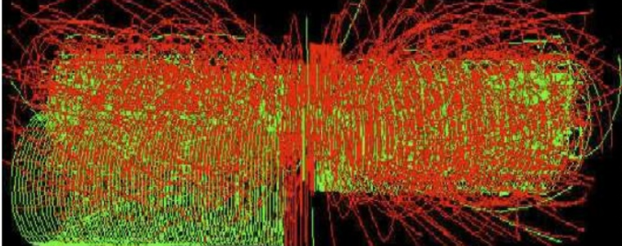 to something like this:  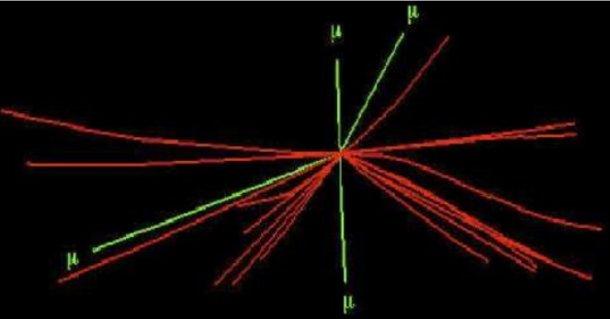  Part 3: The teacher explains to the students that the Higgs particle is responsible for the property of mass. The teacher can show this video to the students:  https://www.youtube.com/watch?v=joTKd5j3mzk in order to understand the concept of interaction with the Higgs field to produce mass.
Phase 5:  CONNECT: students connect explanations to scientific knowledge | Students connect their explanations with scientific knowledge, using different ways of thinking and knowing (‘knowing that’, ‘knowing how’, and ‘knowing this’) to relate their ideas to both disciplinary knowledge and to interdisciplinary knowledge to understand the origin of their ideas and reflect on the strength of their evidence and explanations in relation to the original question. |  |  | The students wonder how our world would be without the property of mass – thus, without the existence of the Higgs boson.  They use Higgnite in order to experiment and perform in an artistically presented environment displaying the world without the property of inertia (Higgs field off) and with inertia (Higgs field on). |  | The teacher introduces students to the Higgnite mode of the LHC Tunnel, making sure that no more than 4 students at a time visit it. The teacher should explain to the students that in a world without a Higgs field, no particle would have mass, therefore everything would move with the speed of light and no stable structures could be made (such as atoms). Even the elementary particles themselves would be fundamentally different than those we observe.  The on-off version of the Higgnite mode displays what a particle would “feel” in an abstract and artistic way in a world with inertia and without. The projection of the student on the monitor through the Kinect detectors represents a particle. | The artistic analogy of a student to a particle through the Higgnite mode of the LHC tunnel.
Phase 6:  COMMUNICATE: students communicate and justify explanation | Communication of possibilities, ideas and justifications through dialogue with other students, with science educators, and with professional scientists offer students the chance to test their new thinking and experience and be immersed in a key part of the scientific process. Such communication is crucial to an ethical approach to working scientifically. |  |  | Part 1: Students make a short video of their experience and present it to their school.  Part 2: Inspired by the way that Higgnite metaphorically explains how the world would be with or without the property of mass, they create their own artworks to express how they feel the world would be like if there were no other fundamental physics properties such as electric charge or spin.  Students present their videos and artworks in a dedicated “LHC day” at their school. |  | Teachers help students employ their creativity and summarize their results in a motivational video in which they speak of their experience and convey their excitement to the viewer.  With the help of an arts teacher, the students are guided to create an artwork which would describe abstractly how the world might be like if properties such as the electric charge didn’t exist. | Video presentation.  Creation of artwork
Phase 7:  REFLECT: students reflect on the inquiry process and their learning | Individual, collaborative and community-based reflective activity for change both consolidates learning and enables students and teachers to balance educational tensions such as that between open-ended inquiry learning and the curriculum and assessment requirements of education. |  |  | Students discuss among themselves and with the teacher and reflect on the feedback they obtained during the communication phase. |  | Teachers facilitate the procedure of learning data acquisition from the students’ discussions.

Additional Information

All relevant companion resources and activities can be found in the dedicated online community of the CREATIONS portal http://portal.opendiscoveryspace.eu/en/community/lets-explore-lhc-tunnel-849923

Assessment

The student motivation and creativity will be monitored using dedicated evaluation questionnaires developed by the CREATIONS consortium before and after the completion of the activity The content knowledge will be monitored throughout the lesson through dedicated questions and exercises which are done in a hands-on fashion.

Possible Extension
This activity can be coupled with an artistic intervention as described in the Cultural Collisions community (http://portal.opendiscoveryspace.eu/node/848012) or the Art@CMS community (http://portal.opendiscoveryspace.eu/node/846962 ). Having obtained a sound introduction regarding physics at CERN, students can perform mini-masterclasses as described by the HYPATIA demonstrator (http://portal.opendiscoveryspace.eu/node/847063).

References
- http://portal.opendiscoveryspace.eu/en/community/lets-explore-lhc-tunnel-849923
- http://cern.ea.gr
- http://medialab.web.cern.ch/content/lhc-interactive-tunnel

