ESTEP Trainers’ Guide
Session Plan

Module | 2
Unit | 1
Activity Title | Understanding and agreeing purpose
Teaching and Learning mode (face to face, online etc.) | This unit can be done either face-to-face or online, although appropriate adaptations would need to be made.
Session objectives | - To explore and identify purposes and priorities for parental engagement.  - To agree a timeframe for change and development.  - To consider the roles of stakeholders in school development processes.
Session outcomes | - A shared understanding of purposes and priorities for parental engagement.  - Identification of a timeframe for change and the roles of stakeholders.
Resources required | - Accompanying slides.  - Large A3 printouts of slides 5, 6, 7 and 8.  - Paper, post-its, whiteboard, flipchart or screen.  - If unit is taking place online, appropriate conferencing or discussion tools.
Session Outline

A ‘roadmap’ for parental engagement? (Slide 3)

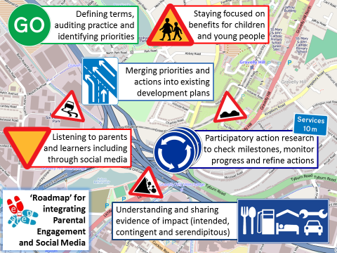
The metaphor of a ‘journey’ with a ‘roadmap’, first introduced in Module 1 Unit 3, is offered again to support teachers and parents exploring and developing parental engagement in their own context. There are four main stages of the journey and two main ‘warning’ signs or reminders along the way.

This slide could, of course, be adapted to provide different metaphors or stages in the process

Activity – setting priorities (Slides 4 & 5)

This two-stage activity supports participants in identifying purposes for parental engagement in terms of priorities for learners’ experiences and outcomes. The latter may come from existing priorities, already identified through school self-evaluation processes. However, the activity provides an opportunity to articulate and share these within this particular group, formed to develop parental engagement.

The following prompts are offered to guide the first part of the activity:
- What are the current priorities for developing learners’ experiences and outcomes within your context?
- Be as specific as you can.
- ‘Post-it’ them.

The second part of the activity involves placing these priority ‘Post-its’ on the map below. The aims are:
- to prioritise those that have high impact on learner experiences/outcomes;
- to identify those where the school’s ability to influence is low as potentially fruitful for parental engagement.

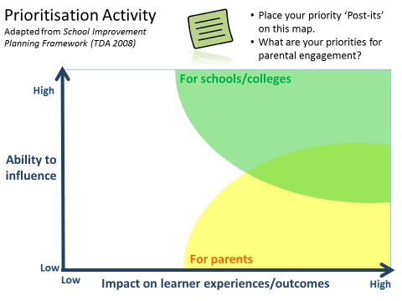

From priorities to strategic actions (Slide 6)

A ‘fan plan’ model is presented to guide a discussion on how the priorities identified in the previous activity can be translated into strategic actions over a three-year time-frame. This is simply an example, although has the advantage of a being a simple and visual framework. Of course, it could be replaced by a different planning model/time-frame according to established school practices and preferences. The discussion could consider:
- What would be appropriate strategic (i.e. high-level) actions to take in pursuing the agreed priorities?
- What is the school like now in relation to these priorities?
- What will the school be like in three years?

These questions are posed:
- How will parents be engaged in strategic actions?
- How can social media be used to support strategic actions?

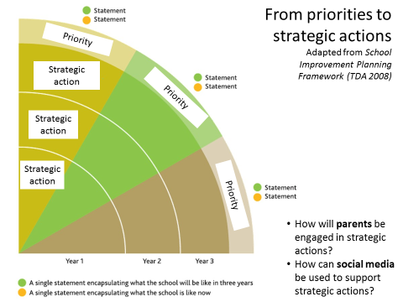

From strategic actions to key activities and milestones (Slide 7)

A further step in the planning process is offered in the form of ‘swim lane’ plan (similar to a Gantt chart), to guide discussion over month-by-month operational activities for each strategic action. Milestones are also proposed as opportunities to check progress, which may also relate to points of reflection within a participatory action research cycle. Again, this is simply an example of an operational planning framework, which may be replaced with established school planning models.

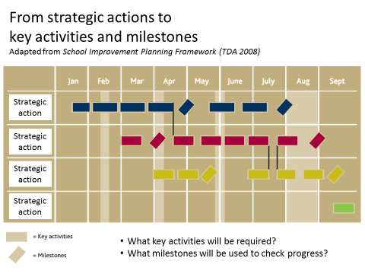

Stakeholder activity (Slide 8)

This final activity is designed to challenge any pre-conceptions about the roles of stakeholders in school development planning and action. There are three stages to the activity:
- Identify who the stakeholders are (some are already included) – they could be written on ‘Post-its’ or cards.
- Position each stakeholder on the map according to whether they should be actively involved, consulted, or informed.
- Re-position each stakeholder on the map according to what actually happens in your school.

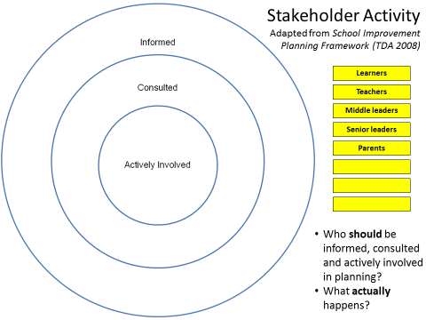

Possible follow-up activities:

- Produce a visual representation of a strategic and/or operational plan for development incorporating parental engagement and:
  - display it in a prominent place in the school;
  - upload it to a social media site where stakeholders can view it;
  - encourage stakeholders to comment, contribute and become actively involved.

References:

TDA (2008) School Improvement Planning Framework. Training and Development Agency for Schools.

