ESTEP Project Framework
Supporting effective parental engagement through social media
Birmingham City University
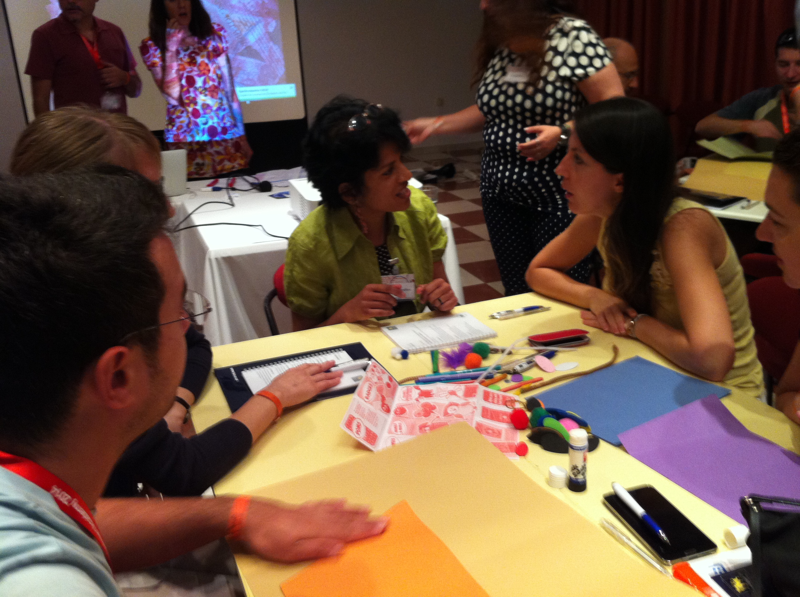

D2.1 Training Framework Design

Project Number | N°. 539498-LLP-1-2013-1-GR-COMENIUS-CMP
Work package | 2
Partner | BCU
Authors | Alex Kendall, Eleni Kanira, Phil Taylor
Document Type | Report
Distribution | Public
Status | Final
Document file | E-STEP_D2.1_TrainingFrameworkDesign.docx
Version | 4
Date | 2/12/2014
Number of pages | 16

Acknowledgement:
This work has been partly funded by the European Commission through E-STEP project (Grant Agreement N° 2013-3698/001-001, Project Number 539498-LLP-1-2013-1-GR-COMENIUS-CMP 2013-3698). The authors wish to acknowledge the Commission for their support.

Versions of the Document

Version | Date | Contributor | Summary of Changes
1 | 04.07.2014 |  | 1st draft
2 | 28.10.2014 |  | Updated in response to feedback from Greece
3 | 8.11.2014 |  | Pre-final version after partners’ comments
4 | 02.12.2014 |  | Final version after quality review

TABLE OF CONTENTS
1. Introduction 5
4. Overview of Framework 7
3. Module 1: Understanding Parental Engagement in Context 10
3.1. Module Aims 10
3.2. Learning Objectives 10
4. Module 2: Working towards change: planning and implementing context specific parental engagement 13
4.1. Module Aims 13
4.2. Learning Objectives 13
4.3. Skills Development 13
4.4. Module Content 14
4.5. Module Outcomes 14
5. Module 3: Parental Engagement in practice: understanding outcomes, impact and influence 15
5.1. Module Aims 15
5.2. Learning Objectives 15
5.3. Module Content 15
5.4. Module Outcomes 16

Introduction
E-STEP aims to develop, implement and evaluate a training programme for school education staff in order to prepare them to effectively engage parents in schooling, through social networking technologies. The aim of WP2 is to design a training framework that draws on the findings and recommendations of work undertaken in WP1: D1.1 the state of the art review; and D1.2 needs analysis. The framework is derived from the following principles about meanings, contexts, values and forms of parental engagement that have emerged from this work.

Meanings and value of parental engagement
- ‘Parental engagement’ is a contested concept;
- Conceptualisations of the meanings of school, learning and childhood are implicit in all forms of PE;
- PE that engages parents in their children’s learning has been shown to contribute to beneficial outcomes (social, developmental, academic) for young people;
Contexts for parental engagement:
- Many parents value opportunities to engage with schools and teachers although needs and wants may evolve and change as the child progresses through their school career;
- Schools and colleges work with diverse communities of young people and parents and a parental engagement strategy must be responsive to the complexity and plurality of the particular local context;
- The engagement of senior leaders is crucial to effective forms of PE;
- Highly valued parental engagement is characterised by a range of interactions for a variety of purposes and is likely to make use of a range of communication modes including social media;
Forms of Parental Engagement
- Participation in social media is a social practice and requires digital literacy knowledge, expertise and confidence from all participant;
- Teachers’ and parents’ (and young peoples’) knowledge, awareness, understanding and experiences of social media (and other forms of ICT) vary substantially and impact on their attitudes to social media use in school;
- Teachers and parents attitudes towards social media are informed by wider discourses and these might be especially influential where individuals lack direct experience;

- Initial teacher education does not necessarily teach either PE or digital literacy, teachers knowledge and expertise is likely to be tacit and gained through experience and participation;
- The use of technology to support PE is in its infancy and the body of evidence that might inform practice is very much emergent;
- Communication between parents and schools that is mediated by technology will be framed by the existing attitudes, values and cultures of the school or institution;
- Attitudes and values of leaders, teachers, parents and children are crucial in determining the success or otherwise of both a parental engagement strategy and implementation of a work in digital modes.

Overview of Framework
The training framework will enable trainees to:

- explore key issues and debates in parental engagement;
- engage with the wider school community to better understand parental engagement and the existing and potential roles of social media in their own context;
- create new meanings, identities and roles in relation to parental engagement;
- experiment with social media as a tool to support effective parental engagement;
- collaborate with parents, teachers and the wider school community;
- drive innovation and implement change.
The framework design is underpinned by an enquiry-based approach, participatory action research (PAR), that encourages inclusive, collaborative and co-constructionist approaches to institutional growth and development. PAR is process orientated and starts with reflexive engagement with the everyday experiences of participants in the school/college community enabling trainees to develop, in collaboration with others, grounded descriptions of how parental engagement ‘currently works’ in their particular context. This then allows the community to ‘work towards change’, the next stage of the PAR process, that is distinctive, highly differentiated and tailored very particularly to the needs and aspirations of the institution and the community it serves.

This generative approach, where course participants are most often in production rather than consumption mode, will ensure that the framework generates outcomes that meet the needs of a broad spectrum of institutions and promotes trainee learning that is responsive to the diverse student, parent and community groups that schools and colleges work with. As such it is ‘future-proof’, sustainable and highly relevant to a wide range of institutions across Europe that are concerned with young people’s learning.

Throughout their learning participants will explore social media in two ways; as a context for stimulating and sharing their own thinking, learning and collaboration; and as potential tools to support and facilitate new ways of working and interacting with parents. As such they will be immersed in an experiential learning programme through which they will learn about the potential of social media through ‘real-life’ engagement and participation in a learning context.

The framework comprises three modules that, taken together, train participants to work competently and confidently with the PAR learning cycle, each module representing a stage in the classic PAR process: documenting and contextualising the current situation; working towards change; and understanding impact, affect and influence.

Module one, ‘Understanding Parental Engagement in Context’, will introduce action research methodologies, modes and strategies and open up exploration of key concepts and definitions. Participants will be encouraged to experiment with social media (mainly using MyODS communities) and engage in reflexive evaluation of existing practice, cultures, attitudes and values. These will include collection of pre-existing empirical material as well as generation of new data through implementation of more creative, experimental approaches such as story-telling and artefact production. A range of conceptual lenses will then be used to critique, analyse and make sense of this material so as to establish starting points for working towards change.

Module two, ‘Working towards change: planning and implementing context specific parental engagement’, will facilitate a series of interventions derived directly from the close examination of the school/college context undertaken in module one. Participants will agree strategic priorities for their own institution alongside a bespoke, context specific, ‘road map’ for change that will identify the key actions and dependencies (resources, roles, responsibilities, training needs) that will be required to realise the aspirations articulated in module one.

Module three, ‘Parental Engagement in practice: understanding outcomes, impact and influence’, will explore a range of strategies for documenting, describing and evaluating the outcomes of parental engagement in practice. It will support design, development and implementation of robust and rigorous evaluation tools that draw on a range of qualitative and quantitative traditions. This will enable institutions and communities to understand the outcomes, impact and influence of their parental engagement work through a range of lenses and to pay attention to anticipated, as well as the contingent and serendipitous, change and or development. This module will also explore strategies for sustaining momentum and enthusiasm for ongoing collaborative development in this key area of work.

Through participation in the ESTEP programme trainees will develop, extend and practice a range of skills in relation to:

- use of digital and social media
- communication skills
- community engagement
- project management
- reflective practice

- enquiry and research
- project management, planning and target setting
- data collection
- team working
- collaborating with others

The programme of study will engage participants in the following modes of study:

- face to face, synchronous and asynchronous online activity;
- analysis and synthesis of a range of texts in different formats;
- participation in a range of learning activities including mini-lectures (synchronous, asynchronous or both) and workshops;
- participate in digitally mediated interaction and learning;
- research and data collection;
- discussion and debate with peers;
- discussion and debate with a wider range of stakeholders in the school community including trainees, young people, parents, other teacher and wider representatives of the local community that the school/college serves;
- elicitation and analysis of quantitative and qualitative data.

Module 1: Understanding Parental Engagement in Context

3.1. Module Aims

This module will facilitate exploration and analysis of parental engagement and use of social media in your context. You will discuss key contemporary concepts, issues and debates in the field and develop a working definition of parental engagement for your institution. You will make use of enquiry orientated practitioner researcher approaches to explore existing attitudes, values and cultures to parental engagement in your setting and, to understand the role and potential role of social media in developing practice. You will begin to agree priorities and aspirations for the future development of practice.

3.2. Learning Objectives
Through participation in this module trainees will:

- describe and synthesise existing debates, concepts and research evidence in relation to parental engagement and social media;
- use participatory action research techniques to plan strategies for change;
- make effective use of a range of investigative tools to explore current practice and stake-holder perspectives (including their own) on parental engagement and use of social media;
- evaluate the potential value of social media to support and sustain parental engagement in your own context;

  - Module Content

Unit Code. | Unit Name | Description
M1U1 | Introduction – exploring definitions, values and attitudes | In this unit trainees will engage in a range of creative methods to explore and describe their personal attitudes, values to, and perceptions of, parental engagement. See suggested session plan MU1U  Introduction to and exploration of key theories and concepts in parental engagement for example Price-Mitchell, Epstein (see M1U1 sample session plans). Generate working definition relevant to own context  Review personal definitions and share a revised personal definition with wider group through appropriate social media tool (for example definition in 140 characters via Twitter) in the session.  Share a follow-up reflective ‘think piece’ through example through Storify post session.
M1U2 | Exploring own context | Introduction to modes of practitioner research and the action research cycle.  Plan an action research ‘audit’ to produce a baseline against which to measure development.  Determine what data already exists to inform the review and what new data will need to be collected.  Explore a range of techniques and strategies collecting data e.g. map, box etc  Consider ethical issues and e-security  Review a range of social media tools and select an appropriate social platform through which to document and share the review process e.g. Facebook or Storify.
M1U3 | Analysis and Review | Produce baseline analysis – ‘where are we now’ in relation to parental engagement and social media and make available for dissemination.  Identify key priorities of a ‘road map’ for change – what does the school want to do differently?

  - Module Outcomes

At the end of this module trainees will have:

- agreed a working definition for parental engagement that is meaningful in their own context;
- designed and planned a participatory action research process to implement in their school/college;
- engaged the wider school community in a study of current practice;
- used social media to support and facilitate the above.

Module 2: Working towards change: planning and implementing context specific parental engagement

4.1. Module Aims
This module will provide a step-by-step approach to planning for change using a range of modes and mediums. You will generate a context specific ‘road map’ that responds to the strategic priorities identified in module one and define targets, milestones, key dependencies and success criteria.

4.2. Learning Objectives
Through participation in this module trainees will:

- analyse existing school development processes and cycles and potential spaces and places for embedding development work on parental engagement;
- re-conceptualise boundaries between home, school, community and identities of key stake-holders including young people, teachers, leaders and parents;
- identify the key components necessary to facilitate cultural change within the local context;
- identify, describe and attribute key roles and responsibilities in cultural change processes for different groups of stake-holders within the community;
- plan the stages and processes of a parental engagement intervention/s within their local context and the evidence base that will help to document the communities experience of participating in the intervention;
- explore strategies for winning support and commitment from the wider school community for new ways of working in relation to parental engagement.

4.3. Skills Development
Through participation in this module trainees will develop, expand and practice their skills:
- as communicators - influencers, persuaders, brokers of change;
- as analysts of qualitative and quantitative data

4.4. Module Content

Unit Code | Unit Name | Description
M2U1 | Understanding and agreeing purpose | Reviewing existing school development processes and understanding how this work will complement. Key questions:  - How does my school develop?  - What existing cycles and processes could this work fit in to?  Identifying actions for change  Identifying stake-holders. Key questions:  - Who needs to be involved in the process? How? and why?  Agreeing time-frame for implementation of Road Map
M2U2 | Building stories of success | Agreeing what the school wants to achieve through the intervention and describing in detail what success might look like for different groups of stakeholders and beneficiaries.  Identifying interim milestones – what will the stepping stones towards success look like?
M2U3 | Designing and planning change | Construction and dissemination of plan.  Key activities:  Agreeing deadlines  Identifying dependencies and resources.  Clarifying roles, responsibility and expectations.

4.5. Module Outcomes
At the end of this module participants will have:

- clearly articulated strategic priorities and aspirations for both parental engagement and the use of digitally mediated environments to support parental engagement in their context;
- constructed a co-produced and community owned ‘road map’ for change

Module 3: Parental Engagement in practice: understanding outcomes, impact and influence

5.1. Module Aims
This module will provide a step-by-step approach to evaluating the processes, experience and impacts (planned and unexpected) of the ‘road-map’ proposed in module 2. It will explore approaches to designing impact and strategies for effective sharing, dissemination and sustainability of outcomes.

5.2. Learning Objectives
Through participation in this module trainees will:
- Explore and evaluate a range of pathways for achieving maximum impact and determine what most preferred approach in their context;
- Plan how they will track and monitor the progression of their intervention and document and share, via social media, ‘change in action’;
- Construct a dissemination plan that makes effective use of social media to ensure that the process and outcomes of change are shared with local, regional audiences as well as those further afield;
- Determine how change will be sustained over the longer term

5.3. Module Content
Unit Code | Title | Description
M3U1 | Understanding & Maximizing Impact | Explore a range of potential approaches to achieving maximum impact for a wide range of stake-holders and beneficiaries.  Ensure that strategies for achieving high impact are ‘designed-in’ to Road Map from the outset.
M3U2 | Build an evidence base | Evaluate a range of ways of capturing and evaluating outcomes (both planned and serendipitous) using social media.  Determine:  - Where to look  - Who to ask  - What to collect  - How to collect it  - How best to share with other  - Who you want to share with
M3U3 | Dissemination and Sustainability | Create a social media dissemination plan that identifies:  - key stories  - audiences  - best social media platforms and tools to utilize  Review whole action research cycle and determine Where next?

5.4. Module Outcomes
At the end of this module participants will produce:

- An impact strategy
- a plan for generating evidence (pictures, stories, case studies as well as more traditional forms of data) to document the process of implementing a change ‘road map’
- A dissemination and sustainability strategy

