D3.1.x SCIENCE PANTOMIME

Project Reference: | H2020-SEAC-2014-2015/H2020-SEAC-2014-1 , 665917 |  | Author: Sanja Bulat (Primary school “Branislav Nusic”)
Code: | D 3.1.x |  | Contributors:
Version & Date: | v1.0  August 17th 2017. |  | Approved by:

Table of Contents
1 Introduction / Demonstrator Identity 3
1.1 Subject Domain 3
1.2 Type of Activity 3
1.3 Duration 3
1.4 Setting (formal / informal learning) 3
1.5 Effective Learning Environment 3
2 Rational of the Activity / Educational Approach 4
2.1 Challenge 4
2.2 Added Value 4
3 Learning Objectives 5
3.1 Domain specific objectives 5
3.2 General skills objectives 5
4 Demonstrator characteristics and Needs of Students 6
4.1 Aim of the demonstrator 6
4.2 Student needs addressed 6
5 Learning Activities & Effective Learning Environments 7
6 Additional Information 15
7 Assessment 16
8 Possible Extension 17
9 References 18

Introduction / Demonstrator Identity

Subject Domain
Physics, Mathematics, Chemistry, Biology, Geography… applicable to all natural sciences

Type of Activity
Educational activity based on creativity – enriches Inquiry Based Approaches, school based. Activity allows students to acquire knowledge in the field of natural sciences through pantomime performance

Duration
Overall duration: 2 months
- 5 weeks activities in school – 2nd week is planned for research, and 7th for event marketing

Setting (formal / informal learning)
Formal – activities and preparation are done in a classroom

Effective Learning Environment
- Communities of practice
- Dialogic Space / argumentation
- Art-based
- Experimentation (Science laboratories and eScience applications)
- Communication of scientific ideas to audience

Rational of the Activity / Educational Approach

Challenge
School program doesn’t allow much time for informal learning science topics or other science contents that aren’t a part of a curriculum provided by the Ministry of education.
Students are burdened with a large number of obligations, so finding their free time for realizing this kind of activity poses a challenge.
Another challenge for student was finding a right way to connect science with the art of movement, because natural sciences a re rarely connected with art in that way.

Added Value
This kind of approach allows students to perceive topics from natural sciences from different angles. Through acting and humor students are:
- More motivated to gain knowledge
- Students are encouraged for a large personal engagement during the learning process
- Knowledge gained in informal ways is more likely to be applicable and long lasting
This king of activities also brings:
- IBSE learning, which is not used in school program in a sufficient percentage
- Student encouragement to defend their attitude with argumentation and to respect their interlocutor
- New visual association and movement, symbols that will help students in the continuing learning process
- Ability for students with special need which are working with inclusive curriculum to acquire more easily science knowledge that was presented and to be a part of these activities
- More strength in students to present their knowledge in public
And finally, moving away from written and oral ways of presenting topics from school curriculum and liberating students to try a new creative way was slowing activity flow, but it was overcome with carefully planned creative activities.
Science pantomime is conducted like regular pantomime, but with science, and not movies, tv shows, cartoons, books etc. Like in regular pantomime, when student start to explain their term, they first have to show a sign which represents is it a topic, definition, unit, physical quantity etc. The signs are agreed in the begging of the project between students and teachers.
Working on this project allows students and teachers to verify the level of their knowledge. It takes understanding of the science topic for them to properly show and explain something to their peers. Also, it was shown that negative points for explaining the wrong kind of term motivated students to participate more seriously, and to re-examine learned knowledge.
Science topics presented by a specific movement can create different associations which will in students’ knowledge system connect new contents more permanently and more applicable.
Activities in this project can be used for qualification of students knowledge, and can be graded, via sum total or a formal grade.

Learning Objectives

Domain specific objectives
Students are familiar with basics of a science topic they are learning through these activities, and a goal is to look and recognize topic, its properties and values in real life.
With guidance from the teacher, students will:
- Research and enumerate terms necessary for describing basic parts of natural science topic processed by these activities, going more and more in details during activities
- Define and select proper ways to represent these terms through pantomime
- Analyze their everyday surroundings and connect with the science topic
- Explore movement ideas for representation
- Empower their capability for representation
- Learn about different possibilities and different points of view
- Practice their marketing capabilities during the promotion of the event

General skills objectives
- Empowering students in seeking different learning approaches
- Developing independence during research
- Developing competence in representation of gained knowledge
- Engaging in multidisciplinary approach in teaching
- Developing cooperative skills
- Empowering students in public performance

Demonstrator characteristics and Needs of Students

Aim of the demonstrator
Primary aim of this demonstrator is to explain how SCIENCE PANTOMIME was prepared and realized, so that teachers and science communicators that are interested in similar activities can have some guidance through the process.
This demonstrator explains the pedagogical framework that SCIENCE PANTOMIME was based on, and steps toward implementation of embodied learning of natural sciences, through movement and public performance.
Primary aim of the demonstrator is to explain the methodology for the implementation of SCIENCE PANTOMIME, and to give schools the opportunity to engage in art-based science performance.

Student needs addressed
Through various student interview, teachers noticed their need for a change in methods in acquiring and defining knowledge from natural sciences curriculum. Through experience with other activities that form a bond between natural sciences and art, it was concluded that merging science and art is something that motivates students in engagement during the process of gaining knowledge, in the process of research, in analysing and presenting personal knowledge to others.
Through team work students have the opportunity to individually choose the way they wish to participate in realizing tasks given during the project. Also, student with difficulty during individual learning can be more motivated and successful in acquiring knowledge through peer learning.
Student with hyperactivity issues can, following tasks through activities, we more engaged and successful and carriers of science class – which is for them much more motivational.

Learning Activities & Effective Learning Environments

Science topic: Physics  Relevance to national curriculum: natural sciences primary and secondary school curriculum  Class information  Year Group: 5th – 8th grade primary school, 1st – 4th grade secondary school  Age range: 12- 15, 15 - 19  Sex: both  Pupil Ability: All pupils could participate |  |  | Materials and Resources  What do you need? (eg.printed questionnaires, teleconference, etc.)  Printed pre and post questionaires, printed science terms  Where will the learning take place? On site or off site? In several spaces? (e.g. science laboratory, drama space etc), or one?  Project is relized in school – classroom, schoolyard, summer classroom and in school hall  Health and Safety implications? None  Technology?  Teacher support? Teacher is guiding students through the process of exploration during the classes, on out-of-school activities, via social networks and via email correspondance. Art teacher is guiving instructions regarding performance, shows various techniques which students can use, and provides useful online tutorials and links where students can find examples of good practices. During rehearsals both teachers are correcting and suggesting, and after each session they are encouraging and directing disscussion between students.
Prior pupil knowledge
- Basic knowledge about science phenomena
Individual session objectives (What do you want pupils to know and understand by the end of the lesson?)

SCIENCE PANTOMIME can be realized through couple of workshops with different activities.

Workshop 1: Students are familiarizing themselves with the concept of pantomimical learning
1st activity – Determing a number of science term from school curriculum, all connected to one subject
2nd activity – Students are divided in paires or groups, and are demonstrating each other how could a term be explained and shown
3rd activity – Defining terms which are most suitable for pantomimical representation
Workshop 2: Students focus on body movement and empowering themselves for representation
1st activity – Defining the rules for pantomimical realization (for ex. Sign for physics, sign for measurement unit etc.)
2nd activity – Acting education for students
Workshop 3: Students are gaining more detailed knowledge about scientific topic
1st activity – Students are divided in groups, they are choosing in interesting question within the scientific topic
2nd activity – By rotating student groups students are answering questions from other groups
3rd activity – Coming up with a way to represent given question and answer through pantomime
Workshop 4: Students are becoming experts in visual representation with body movement
Activity – Practicing techiques and pantomimical ways with mutural correction
Workshop 5: Students gain ownership of the learning process by evaluting themselves before the final event
Activity – In class, presenting each other and grading (students who are presenting and student with answers)
Workshop 6: Students gain even more sence of ownership by organizing big event of science pantomime in their school
Organization of activities in school during a particular school event, or as a separate event in schol hall (informing other students, parents etc.)
Assessment  Evaluation is done trough  informal students’ feedback and  via formal assessment made by  teacher |  | Differentiation  How can the activities be adapted to the needs of individual pupils?  Students who show bigger interest for research will be leaders in that segment of activities, those who are more eloquent will be dealing with the organization, and those prone to public performance will demonstrate terms |  | Key Concepts and Terminology  Science terminology: natural sciences, research, exploring  Arts terminology: scenery, costumes, script, body movement, performance
Session Objectives:
During this scenario, students will deepen their understanding on scientific concepts and phenomena, using their creativity and imagination
Learning activities in terms of CREATIONS Approach
IBSE Activity | Interaction with CREATIONs Features |  |  | Student | Teacher | Potential arts activity
Phase 1:  QUESTION: students investigate a scientifically oriented question | Dialogue, Balance and navigation  Through the storm of ideas, students and the teacher will define terms and topics from school curriculum.  They are exploring with firm steps which of the topics or terms is more appealing for pantomimical representation.  They select the topic for the activities. |  |  | Students are playing with words and terms form natural sciences.  They write ideas on the board, discuss and choose a couple of appropriate topics. | Teacher guides students or suggests topics from school curriculum. | During this word play, students also play with body movement and drawings.
Phase 2:  EVIDENCE: students give priority to evidence | Individual, collaborative and communal activities for change  Based on a science topic, students are conducting a research, gathering all potential information. |  |  | Students are conducting research in groups, they singly determine who will do which task of research within the group | Teacher is giving guidance for research – safe web addresses, encyclopedias, ideas for visit to research facilities…  Teacher also suggests possible ways for representation, guide activities of individuals and groups | Students express pantomimical ideas, and analize different types of performance  /appearance
Phase 3:  ANALYSE: students analyse evidence | Individual, collaborative and communal activities for change  Students analyze gathered information, selecting certain information that they think is important for presentation. |  |  | Students decide on their own the way of selection and storing gathered information. They decide about with research institution/center to visit.  Students decide do they want and to what level engagement of parents in realization of activities. | Teacher provides guidance and suggests different (web) tools and techniques for storing information. | Watching and evaluating different performances, stand-ups, street artists
Phase 4:  EXPLAIN: students formulate an explanation based on evidence | Possibilities  Students are coming to a conclusion about their research and effects of the science topic to their surroundings.  Students are thinking about ways to represent their assumptions about scientific phenomenon. |  |  | Students are connecting and applying gathered information | Teacher reminds students of examples about different scientific topic, conclusions and IBSE steps | Imitation of different forms of acting and pantomime
Phase 5:  CONNECT: students connect explanations to scientific knowledge | Balance and navigation  Students analyze additional contents and consult with teacher to check if their conclusions are correct and in accordance with latest scientific achievements. |  |  | Students connect personal conclusions with scientific facts.  They demonstrate results of their research through some sort of an experiment.  Students present evidence for the results of their research – some other research, textbook…  Students can connect with high school students and have discussions with them – in person or online | Teacher reminds students about previously gained knowledge, as from that particular subject as from other subject in school.  Teacher shows them other researches.  Teacher can guide them to some other experimental techniques and allows them means for realizing them.
Phase 6:  COMMUNICATE: students communicate and justify explanation | Dialogue, Possibilities, Ethics and trusteeship  Students are discussing within the group and with the teacher about ways of research and exploring, relevant sources of information (online safety), ways of most adequate representations…  Students are discussing within the group and with art teacher – proper ways of representation of evidence with body movement.  Groups discuss between them and add suggestions. |  |  | Students present information, make conclusions, make arguments, contradict non-consensual facts, analyze engagement of all participants, make suggestions for improvement od representations. | Teacher coordinates discussion, reminding everyone about the rules of debates
Phase 7:  REFLECT: students reflect on the inquiry process and their learning | Empowerment and agency  Individual and group analysis of acquired content.  Suggestions for improvement of activities, realization and presentations |  |  | Discussion between students | Guidance and support  Dialog with students  Dialog with public of the event

Additional Information

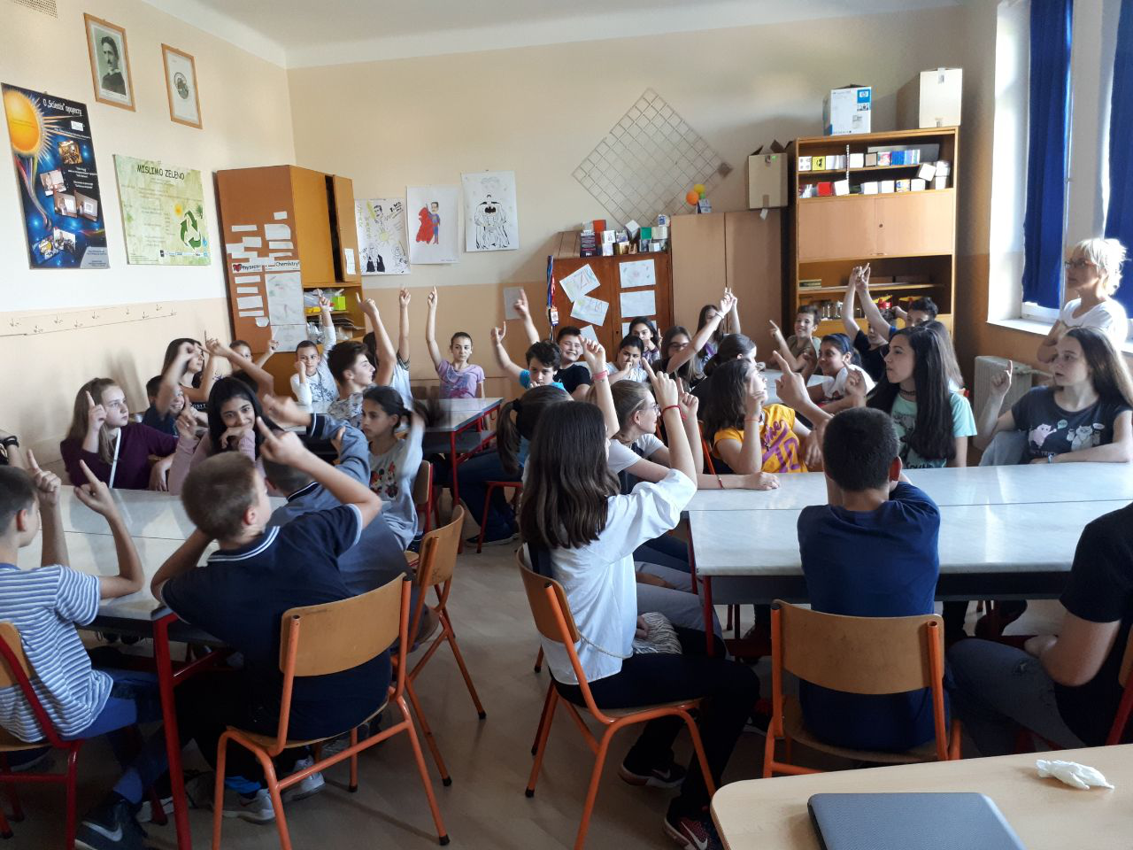
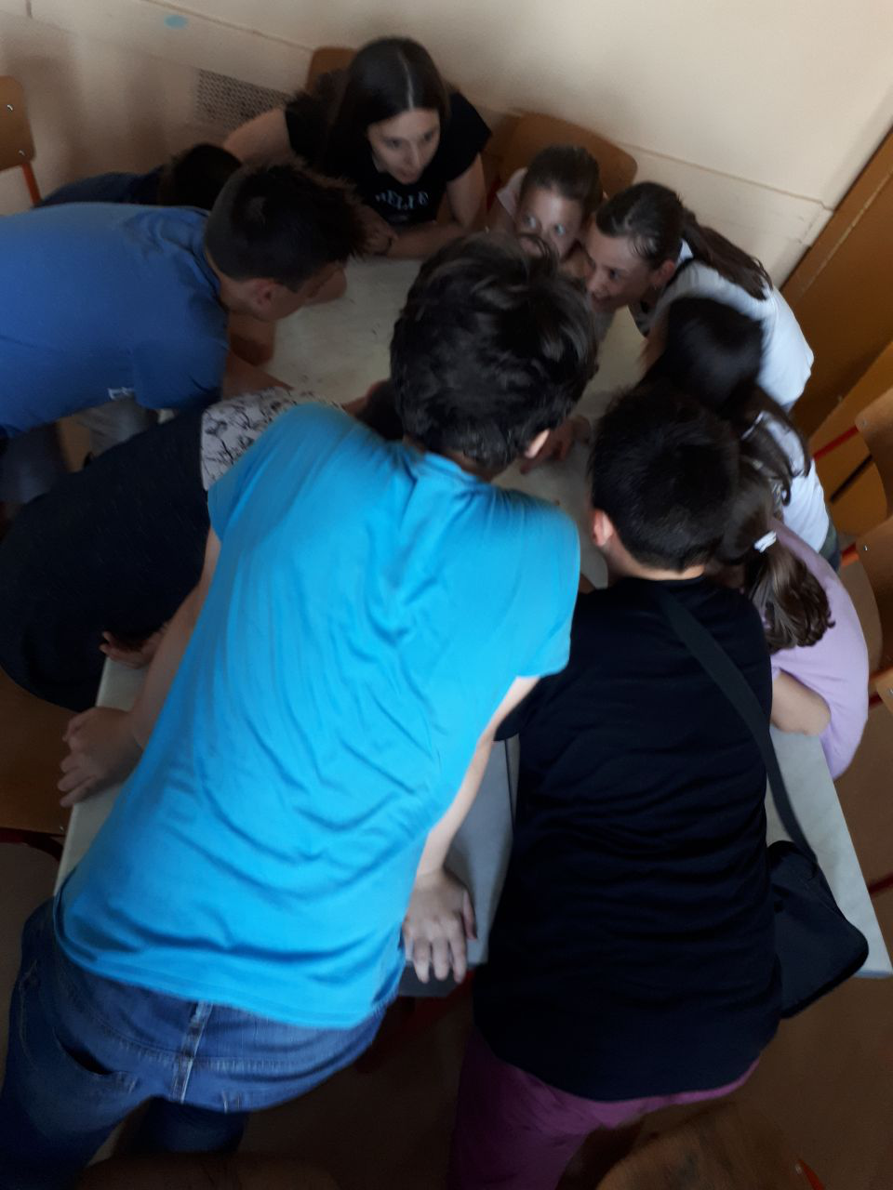

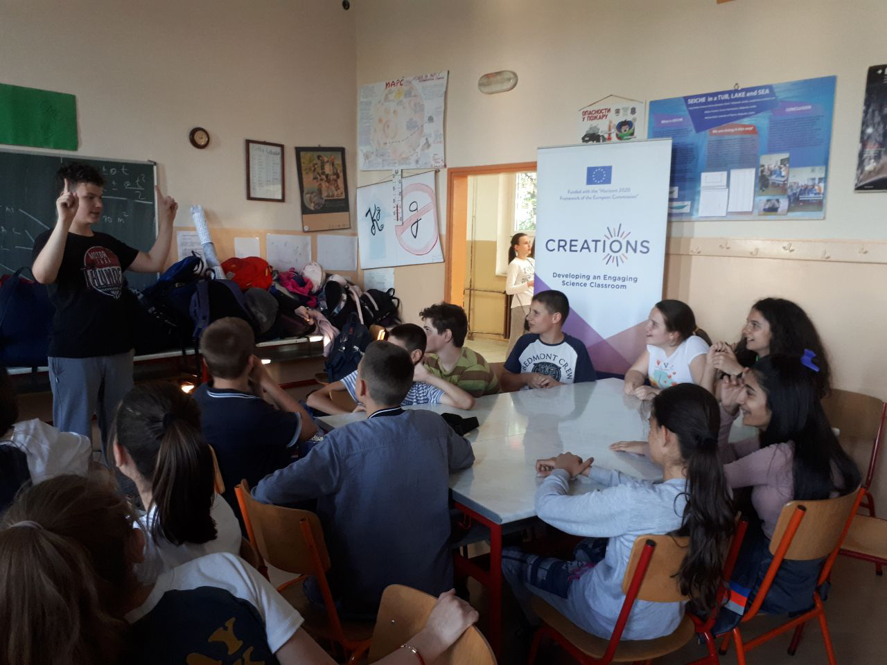

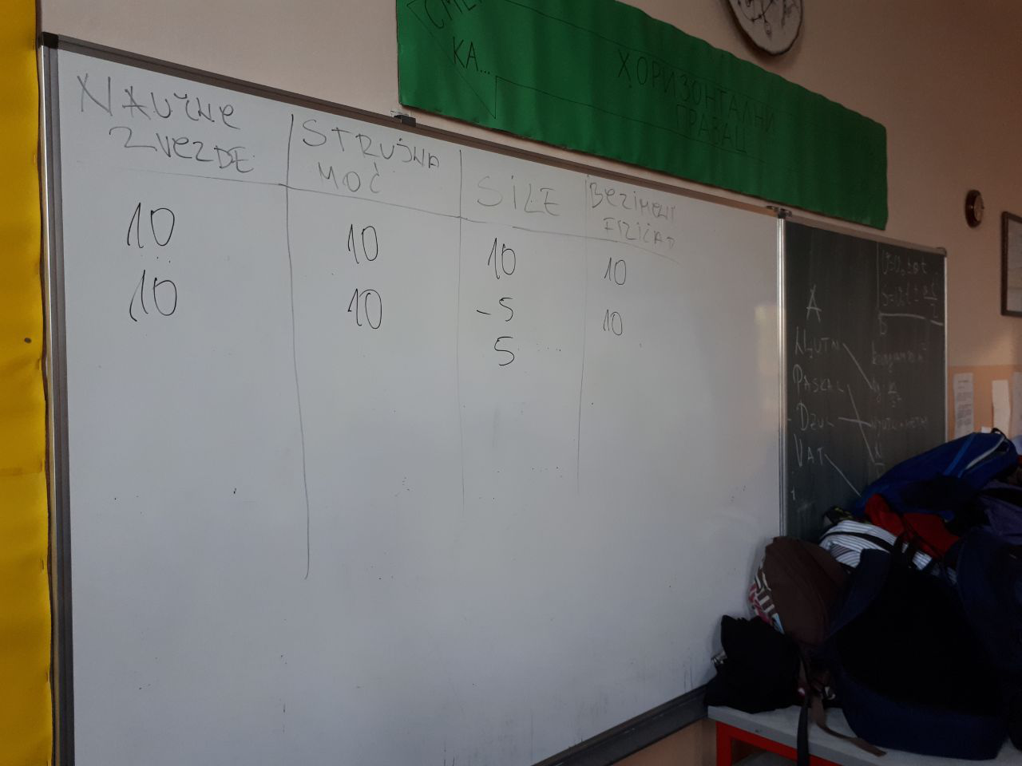

Assessment
Assessment should be conducted via standardized Creations questionnaires for students’ evaluation
Students fill out pre-questionnaires before starting the project, and post-questionnaires after the project end. Teacher fills out teachers’ questionnaire at the end of the project.

Possible Extension

This project can be realized to be in a form of a school manifestation, or in a local level (municipality). That manifestation can be in a form of a competition, between classes and schools.
It would be good to ask for a support from the local community and media.

References

