Science fiction - STEAM motivation

Project Reference: | H2020-SEAC-2014-2015/H2020-SEAC-2014-1 , 665917 |  | Author: Milena Mladenović
Code: | D 3.1.x |  | Contributors: Aleksandar Gjorgijev
Version & Date: |  |  | Approved by:

Table of Contents
1 Introduction / Demonstrator Identity 6
1.1 Subject Domain 6
1.2 Type of Activity 6
1.3 Duration 6
1.4 Setting (formal / informal learning) 6
1.5 Effective Learning Environment 6
2 Rational of the Activity / Educational Approach 7
2.1 Challenge 7
2.2 Added Value 7
3 Learning Objectives 8
3.1 Domain specific objectives 8
3.2 General skills objectives 8
4 Demonstrator characteristics and Needs of Students 9
4.1 Aim of the demonstrator 9
4.2 Student needs addressed 9
5 Learning Activities & Effective Learning Environments 10
6 Additional Information 15
7 Assessment 16
8 Possible Extension 17
9 References 18

Introduction / Demonstrator Identity

Subject Domain
“Science fiction – STEAM motivation” project is applicable to natural sciences such as chemistry, physics, electronics, engineering, but depending on individual products during project phases, any science can be represented

Type of Activity
Educational Activities based on Creativity- enriched Inquiry Based Approaches (school based).
It is can be local, national or international activity.

Duration
The project is conducted through four stages, where each one has a certain number of sub phases.
Introduction phase: around 90 min - two school classes in 6 days period (45min + 45min)
Next phase: up to 7 days
Students are creating proper settings for the problem and its solutions
Some phases students can realize in their homes – phase of reading literature, phase of developing pictures of future visions, developing movie scenarios…
Creating scenarios: 6 days
Preparation phase for film shooting: around 90 min – two school classes in 6 days period (45min + 45 min)
Film shooting (and framing): depending of the script, this can vary from 5 to 15 days.
Post-production phase: up to 7 days
Reflection phase: around 90 min – two school classes
Overall duration of the project can vary from 1 to 2 months, depending on students’ work and objective work and life circumstances.

Setting (formal / informal learning)
Settings of the activities is formal.
Formal activities were performed in the school in language classes, art classes, computer classes, after class activities.
The demonstrator is designed to be applicable to all the needs and wishes of the teachers and students, so with the few modifications it can have formal and informal activities, e.g. if the shooting of the movie takes part outside of school, or there can be institutional cooperation, and it all depends on the age of the students, project’s needs, teachers etc.

Effective Learning Environment
- Simulations
- Arts-based
- Dialogic Space / argumentation
- Experimentation in safe learning environment
- Communication of scientific ideas to audience

Rational of the Activity / Educational Approach

Challenge
School programme doesn’t allow much time and space for informal learning of science disciplines/contents that are outside official school curriculum.
Target participants for the realization of this project are elementary school students, and also groups of older students - middle school and high school, whose work is based on school curriculum. Depending on this, challenges during the realization process can vary.
Challenge lays also in groups of younger students – low levels of knowledge and understanding of the scientific principles, as well as smaller science fiction domain appropriate and adjusted for younger age. This can be tricky especially in the argumentation phase of the project. This phase expects students to connect their scientific predictions in created scenario with scientific discoveries present today.
In groups of younger students, they will have to rely on teachers’ guidance and assistance during realization of science experiments, which will create visual effects during film shooting. This can also be the case during post-production phase of movie montage, due to lack od knowledge in this area. All of this lead to a condition that teacher realizing the project must know how to use some of the programs for editing and montage of video materials.
For the older groups of students challenge may lie in the fact that this project is supposed to be interdisciplinary, meaning more teachers from different areas can be included in the project, but that entails their additional preparation and engagement, something for what some of the teachers are not prepared for.

Added Value
This project allows opportunities for developing interest to few STEM fields or individual science problems. Depending on the script that students develop for the movie, and also with which science problems and science fields will they deal with during the project.
This wide diazepam of topics which students can process during the realization of the projects gives possibilities to every individual student to focus their interests on specific science field or a topic, which can later guide them to a certain carrier choice.
Possibility to learn about the process of creation of the movie story and the freedom to be creative given to them by the field of science fiction, can guide some students towards creating science fiction contents in the future, which can ask new questions and open new challenges.
Aside from this, added value also lies in the following:
- Students are dealing with science from the future perspective – with prediction, which has a goal to motivate students to realize their predictions in the future.
- Students are dealing with ethics in science, analysing the consequences of technology development
- Students are dealing with sustainable development form the domain of science and technology
- Students are dealing with science from the perspective of movie scenes and effects (chemistry, electronics, engineering, physics…)
Their creative engagement students are exploring through the creation of literal work – script for the movie, drama elements – acting, they are learning about directing and framing the scenes, learning about scenography and photography.

Learning Objectives

Domain specific objectives
The aim of this project is to motivate students to continue working with STEM problems from different science fields, but also, movie alone can help promote STEM classes to a wider audience.
Another objective of this project is to give students a chance to express their visions of future using theatrical play and to push them further in to becoming a part of positive change by using science – as motivators, as well as future scientists.
With guidance from the teacher pupils will:
- Research terms necessary for describing scientific problems that they will represent in the movie
- Explore through tasks about certain topics (individual and group effort)
- Conduct scientific experiments that will enrich theatrical play
- Experience the process of creating a theater-like performance, writing a script, preparing the costumes, scenography, behaving on the stage and understanding a process of making movies
- Experience the process of being taught and evaluated by students
- Bring school closer to local community

General skills objectives

- Engaging in interdisciplinary: connecting STEM classroom with art
- Developing creative and critical skills
- Developing better cooperation and teamwork skills
- Improving communication skills
- Developing independence during research
- Developing competence in representation of gained knowledge
- Empowering students in public performance

Demonstrator characteristics and Needs of Students

Aim of the demonstrator

The aim of this demonstrator is to show how creating a science fiction movie can have multiple benefits in the learning process. In perspective, it can build student’s attitude towards ongoing scientific and civilizational challenges, like over-usage of planet’s resources, exploration of space or interpretation of certain natural phenomenon. It then questions students’ affiliations towards certain field of science (chemistry, physics, biology, ecology, engineering) and deepens their knowledge and interests in that direction. Then it connects all scientific knowledge into art form through the creation of the movie script, creation of the scenography and effects (which partially rely on science experiments) and creation of a movie while becoming familiar with public performance, photography and framing.
Project is conceived for students ages 10-18 years. Although during project realization it is possible for a lot of teachers to be included, it is advised for only two teachers to be responsible for the project realization – one teacher from the arts field (literature or fine arts) and the other from natural sciences or engineering and informatics.

Student needs addressed

It was shown that students have more motivation during the learning process when they get the chance to explore their interests through the process of creation. In this specific case of creating a science fiction movie, students are incorporating their scientific knowledge with imagination and innovation and with theoretical background bordering fantasy. In this manner they are freeing their scientific potential, deepening their interests linked to a certain scientific field, questioning their curiosity which is the base of a well-motivated scientist.

Learning Activities & Effective Learning Environments

Science topic: Physics, Informatics, Chemistry, Biology…  Relevance to national curriculum: Physics, Informatics, Chemistry, Biology, Literacy and Art curriculum.  Class information  Year Group: Primary school from 4th to 8th grade, Secondary school from 1st till 3rd grade  Age range: 10 -18  Sex: both  Pupil Ability: There are many activities and roles in this demonstrator, so various students can participate in various activities having in mind their abilities. |  |  | Materials and Resources  What do you need? (eg. printed questionnaires, teleconference, etc.)  - Short movie on subject of sci-fi predictions  - Printed or digital card game  - Material for drawing pictures  - Laboratory equipment (Physics, Chemistry, Biology, Physics), or kitchen equipment, as well as home tools  - Costumes  Where will the learning take place? On site or off site? In several spaces? (e.g. science laboratory, drama space etc), or one?  Learning will take place in several spaces. Preparation will take place in school premises. Movie making, scene shooting will take place in places that students think are most suitable. Post-production phase will take place in school media (IT) classroom.  Health and Safety implications?  All science experiments conducted by students must be conducted with the presence and supervision of a teacher, to ensure that the risk of injuries can be avoided.  Technology?  - Projector  - Camera (mini camcorder or mobile phone camera)  - Computers with internet access  Teacher support?  Teacher is there to introduce impact of sf movies on development of science, to steer a debate on important ethical issues in science, to guide students trough process of discovering solutions for science problem of their choice. Important teacher support role is also in helping students to conduct experiments and to synthetize knowledge they have gained from science and film making in to final product – sf movie. In younger groups of students teacher is the one that is doing post-production phase.
Prior pupil knowledge
- Basic knowledge about making video clips using mobile phone
- Internet research methodology
- Basic, role play script whitening
- Cardboard modeling
Individual session project objectives (What do you want pupils to know and understand by the end of the lesson?)
Project can be realized through following stages:
- Stage: Students will understand how science is used in science fiction contents, as well as how SF content can influence development of science.
- Stage: Students recognizing and acknowledging scientific challenges of our time, discuss and criticize importance of future scientific discoveries.
- Stage: Students explore and engage the science problem of their choice, find evidence, analyze it and explain it.
- Stage: Students create a solution for the scientific challenge presented through SF scenario for the movie.
- Stage: Students gain basic training in movie making and photography.
- Stage: Student make special effect for movie using science knowledge and experiments.
- Stage: Students preparing scenography, costumes and stage performance.
- Stage: Student observe and learn post-productive process.
- Stage: Promotion of movies.
Assessment  Evaluation is done through informal students’ feedback and via formal assessment of teacher.  One other informal feedback will be gained from general public audience. |  | Differentiation  How can the activities be adapted to the needs of individual pupils?  Project includes variety of activities, and many of them can be adopted for student’s individual needs. We have science experiments, art expression trough script writing, acting, drawing, modeling, then we have video recording, directing and producing. With this number of activities first level of adaptation can be that students can find their interest in different science subjects (Physics, IT, Chemistry, Biology, Robotics…). The second level of adaptation can be for those who do not find much interest in practical science to find their interests in artistic expression trough idea development for scripts, drawing and modeling, acting, video recording, directing, costume and scenography making. The third level of adaptation would be that we can adapt single activities to individual abilities. |  | Key Concepts and Terminology  Science terminology: Physics, Chemistry, Biology, IT, robotics.  Arts terminology: scenery, costumes, script, performance/acting, photography, shooting movie, production
Session Objectives:
During this project students will get deeper understanding of specific scientific challenges that are ahead of us and will try to think about solving them by using fiction and science at the same time. In this proses they will acquire knowledge about how to address scientific problem by using IBSE methodology, and how to promote possible solution to wider audience.

Learning activities in terms of CREATIONS Approach
IBSE Activity | Interaction with CREATIONs Features |  |  |  | Student | Teacher | Potential arts activity
Phase 1:  QUESTION: students investigate a scientifically oriented question | Students pose a scientifically oriented question to investigate. Balance and navigation through dialogue are accomplished with pre-designed questions. Questions are aroused through dialogue between students’ scientific knowledge and the scientific information gain from Science-fiction video. While individual activity leads to greater sense of empowerment and agency, collaborative activities create trusteeship among group. |  |  |  | Students watch specific video with SF content that teacher prepared.  Students play association based card game.  Students are given to choose one from three given scientific breakthrough that they would like to see first discovered (ethical debate).  Students discuss about scientific problems that are jet to be solved, and are/could be presented in SF movies.  Students chose one problem and transform it in to scientific question. | Will use challenging questions and the web videos to attract the students’ interest in scientific problems that are not jet solved or are neglected.
Phase 2:  EVIDENCE: students give priority to evidence | Students individually collect data from internet that describe chosen scientific problem. In other collaborative activity they gather data and make presentation of evidence.  Risk, immersion and play is crucial in empowering pupils to generate, question and discuss evidence. |  |  |  | Students are divided in groups based on their domain of interest. They gather and exchange information, while trying to organize and prioritize findings. | Teacher helps organize division of students in groups, and then acts as support.  Teacher is here to help and guide through the process if necessary.  The role of the teacher is also to answer concrete doubts that may occur during the gathering of information. | Photos, graphics, illustrations, video material.
Phase 3:  ANALYSE: students analyse evidence | In collaborative activity Students analyze gathered information in groups that are formed, shaping gathered evidence into science-fiction prediction.  Students analyze what part of question they have been answered with evidence they have gathered, and what part of question remained still unanswered - Risk, immersion and play |  |  |  | Students are using gathered data to explain idea behind the script they are developing, but in the same time present what part of question they will have to fill out with fiction part. | Teacher gives students form with pre-defined questions so they can easer categories and analyze gathered information.
Phase 4:  EXPLAIN: students formulate an explanation based on evidence | Students are working on explaining scientific phenomenon or solving scientific problem using gathered data and implementing / transforming that data in to simulation/presentation - Risk, immersion and play, Collaborative and individual activities. |  |  |  | Students are making simulation of scientific solution for chosen problem.  After each simulation presented to rest of the group there will be a discussion with questions. | Teacher acts as guidance.  Its role is point out possible misunderstanding of the interpretation of presented scientific evidence.  Teacher shows them other relevant researches. | Simulation can be experiment, but can be artistic model, or graphic.
Phase 5:  CONNECT: students connect explanations to scientific knowledge | In this phase, the main feature is Interdisciplinary, because students connect their explanations of the scientific phenomenon with vision of solution for defined scientific problem/challenge.  They will combine gathered evidence, personal theories and fiction so they can shape a story for a movie script. |  |  |  | Students are implementing gathered data (evidence and theories) in to movie script in which they have to explain how they have solved scientific problem. | . | literary work, movie script
 | The Interdisciplinary comes out from the transforming movie script in to movie. Students need to understand how to emphasize relevant findings, theories and solutions in the form of movie. |  |  |  | Participate in theoretical and practical short course for movie making. | Teacher organize course for movie making. | Photograhy
 | In to the process of shooting a movie, students and teachers will have to combine their scientific knowledge and use it for creating a scenography and special effects - Risk, immersion and play |  |  |  | Students will conduct the research and experiments to obtain visual effects for their movie.  Students are shooting movie scenes. | Teacher will observe, monitor and give support in making visual effects for the movie using scientific knowledge. | Movie making
 | Students and/or teacher are share their knowledge about applications for movie making in the post-production process. |  |  |  | Student are editing movie. | Teacher is giving the support in the movie editing process. The support can differ depending on students age. | Movie making
Phase 6:  COMMUNICATE: students communicate and justify explanation | Students communicate with the audience with their vision of a future, presenting their solution for defined scientific problem or challenge. They justify their idea through dialogue with other students or science educators, and with professional scientists. In that way they can test their theories and their new way of thinking. |  |  |  | Students answer questions, give additional explanation about idea and process. | Teacher facilitates discussion that will emerge after movie presentation. | Movie presentation
Phase 7:  REFLECT: students reflect on the inquiry process and their learning | Empowerment and agency  Individual and group analysis of acquired content.  Suggestions for improvement of activities, realization and presentations |  |  |  | Discussion between students. | Guidance and support  Dialog with students  Dialog with public of the event

Additional Information
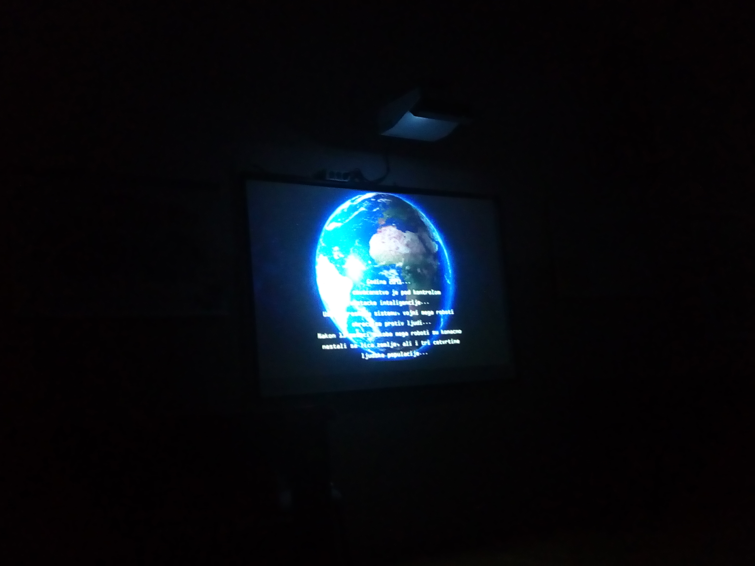
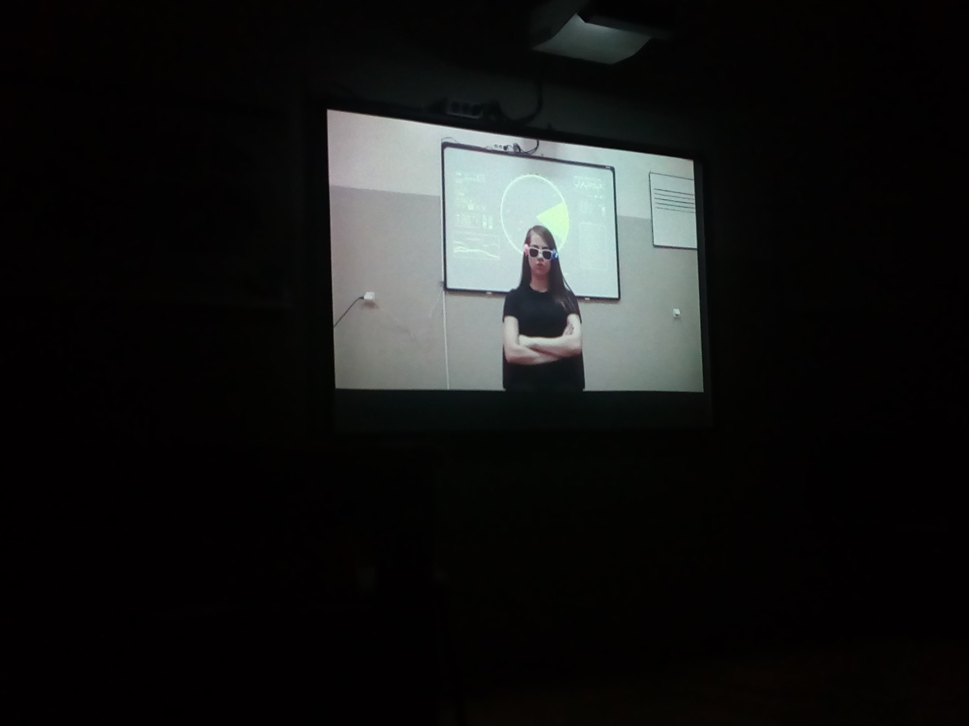

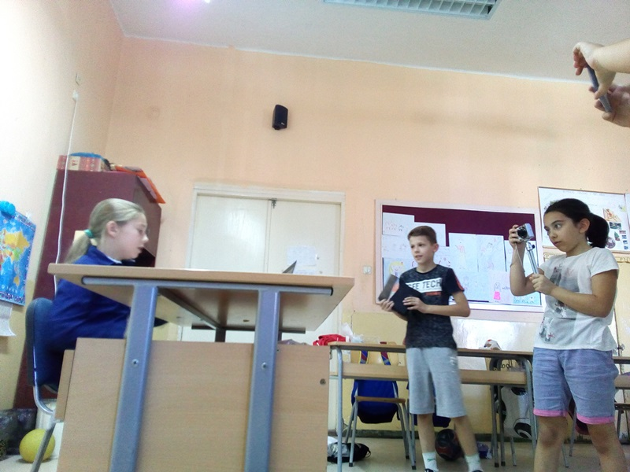
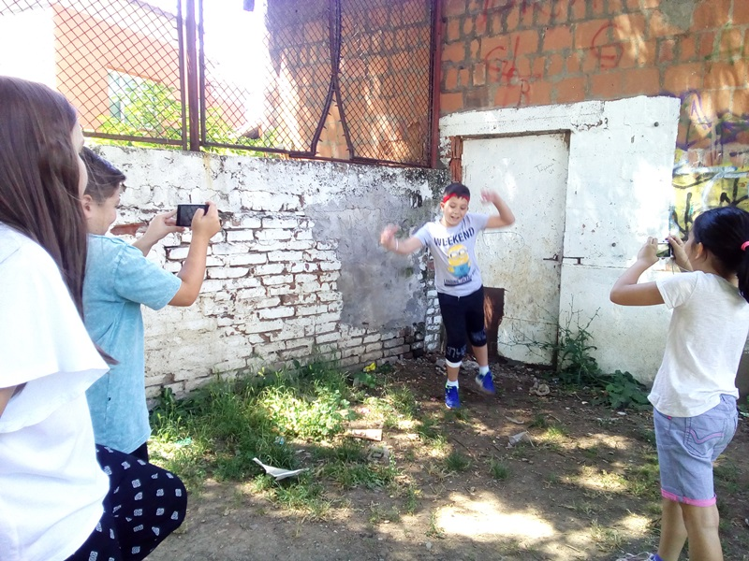
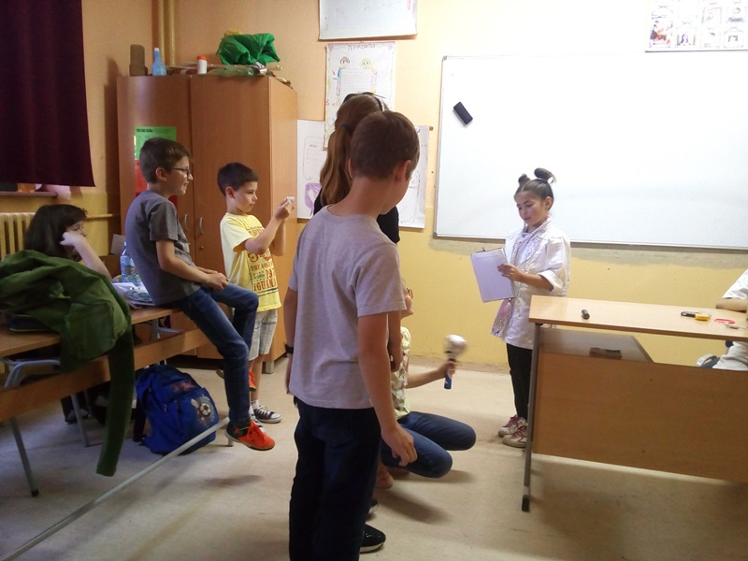
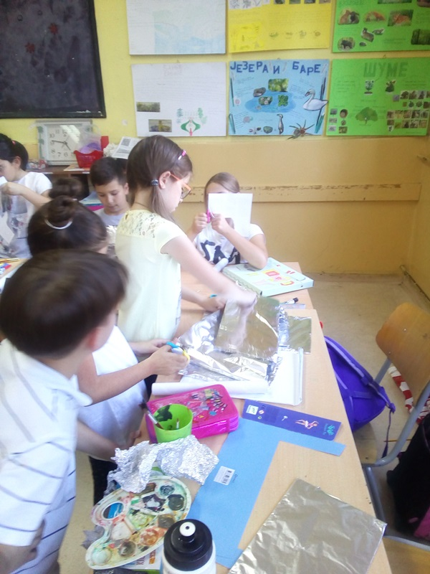
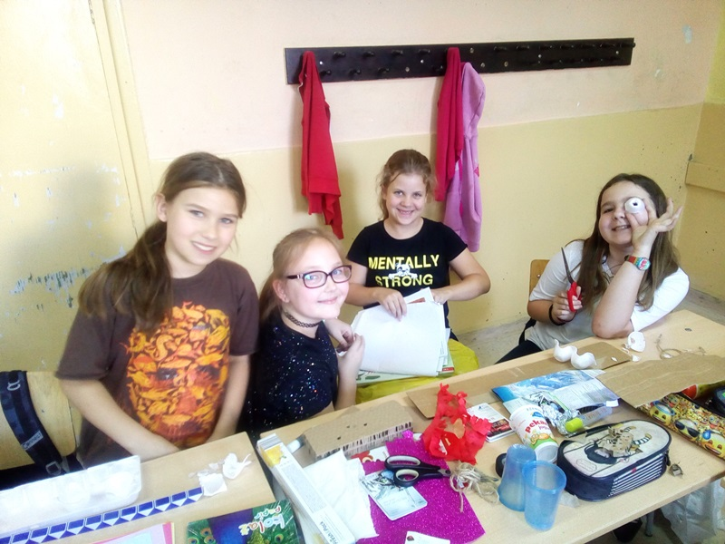

Assessment
Assessment should be conducted via standardized Creations questionnaires for students’ evaluation
Students fill out pre-questionnaires before starting the project, and post-questionnaires after the project end. Teacher fills out teachers’ questionnaire at the end of the project.

Possible Extension

Future development according to the subject and potentials of project could be organization of local, national or international film and short SF story festival. The aim of this activity can be sharing experiences and ideas, as well as opening debate on responsible research and science ideas development path. Film festival can be with competitive character or just promotional character.
Students could make a step-by-step guide -Student handbook- on how they made the movie, so other students and teachers could easily jump into the movie-making.

References

On line references

Articles:

Biography of Jules Vern
- on English https://en.wikipedia.org/wiki/Jules_Verne
- on Serbian https://sr.wikipedia.org/sr-el/Жил_Верн

National Geographic, February 8, 2011 - 8 Jules Verne Inventions That Came True (Pictures): https://news.nationalgeographic.com/news/2011/02/pictures/110208-jules-verne-google-doodle-183rd-birthday-anniversary/

NASA, July 20, 2016 - The Science of Star Trek: https://www.nasa.gov/topics/technology/features/star_trek.html

Videos:

Trekspertise, October 09, 2014 - The Game of Technology Prediction :
https://www.youtube.com/watch?v=4Q8JUrPANbY

Public Domain Footage, March 01, 2011 - Jules Verne Predictions and Prophecies Newsreel:
https://www.youtube.com/watch?v=trtiiFvtg2Q

Buzz Feed Celeb, February 03, 2014 - Real Life Technology Predicted by Star Trek
https://www.youtube.com/watch?v=lKH0Ipcc87E

Shereece Perry, October 10, 2016 - The 5 Elements of Drama :
https://www.youtube.com/watch?v=LGG4jxvc_ps

Printed books
Andrić, R. (2008). Kako snimiti film, Kreativni centar, ISBN-10: 8677815538, Serbia

