DRAGON CURVE - connecting math and art in classroom by teaching fractals

Project Reference: | H2020-SEAC-2014-2015/H2020-SEAC-2014-1 , 665917 |  | Author: Natalija Budinski
Code: | D3.1.9 |  | Contributors:
Version & Date: |  |  | Approved by:

1. Introduction / Demonstrator’s Identity

1.1 Subject Domain
Fractals, Mathematics

1.2 Type of Activity
- Educational activity based on Creativity - enriched Inquiry Based Approaches (school based)
- Both, in-school activity (workshops with students during the mathematics class) and out of school activities (students giving workshops to other students on a science fair or similar events; public exhibition of fractal origami pieces made by students)

1.3 Duration
It consists of:
- two workshops in school,
- one public workshop (e.g. in Science Center or Science Museum)
- one evaluation workshop in the school (e.g. evaluating learning objectives and each phase of the process)
Each activity lasts 90 minutes. Preparation for each activity lasts 180 minutes.

1.4 Setting (formal / informal learning)
Settings of the activities were both formal and informal.
Formal activities were performed in the school, in the classroom equipped with computers, where students learned about fractals and their mathematical properties. Also, evaluating activities were taken in school setting.
Informal activities were based on the public workshops presented by the students to other students in institutions that support science promotion and education (e.g. in Serbia, the students' led workshop was held in the Centre for the Promotion of Science in Belgrade).

1.5 Effective Learning Environment
- Communities of practice
- Art-based
- Dialogic space/argumentation
- Visits to research center
- Communication of scientific ideas to audience

2. Rationale of the Activity / Educational Approach

2.1 Challenge
Fractals are usually connected with modern and advanced mathematics. The father of fractals, Mandelbrot, described them as: "beautiful, damn hard, and increasingly useful". What is more interesting, they can be found everywhere in nature, which is practically full of fractal patterns. Fractals have become an inspiration for mathematical art, so the topic of fractals is not strictly connected with mathematics and science.
Fractal geometry is getting significant attention in the scientific world, but these types of lessons are not recognized in the curriculums of most schools in the countries worldwide.
Even though many educational researches are providing evidence of benefits of teaching science trough art, this practice is uncommon in the classroom. On one hand, it is understandable, because teachers are reluctant to work beyond the curriculum and without official support, but on the other hand, only a small artistic content in the mathematical lesson can make huge and beneficial impact on the educational process, especially in terms of increasing motivation among students for engaging in science.

2.2 Added Value
Bringing fractal geometry into the classroom can be done by expanding some usual activities and lessons in the schools. Morover, by teaching fractals, new directions in education might appear. Fractals connect mathematics, art and science, and therefore their application in teaching and learning could contribute to develop different aspects of competences. Students may gain interest in mathematics via art, and vice versa which may direct their future carriers.
The visual expression of fractals can convey mathematical concepts, such as geometric shapes and structures, symmetry, iterative and recursive forms, structures or changes can be taught with modeling and explaining fractals. Also, fractals have eye appealing forms, which can inspire students in art exploration. Although fractals are very complex, they are easy to make with a repetition of forms, and hands-on activities could improve manual abilities of students, which are highly neglected due to increased use of technology.
During the in-school workshops students, who were without previous mathematical knowledge of fractals, were introduced to their definition and properties. Good results could be accomplished by using hand-on activities and paper folding, connecting esthetical and mathematical aspects of fractals. The out of school workshop was based on the fact that the visual representation and hands-on activities can aid the participants in discovering fractals without formal definitions and concepts. For that purpose, the participants were given paper to fold the dragon curve. Their work was exposed in Centre for science promotion during their public workshop. During the workshop, students have taught other present about fractals and how to fold one from paper strips.

3. Learning Objectives

3.1 Domain specific objectives
This workshop describes how to investigate fractals with the help of hand-on activities and paper folding. Described activities can be used for exploring the fractal phenomena and connections between mathematics and art. The workshops could be implemented in regular school lessons as an alternative to classical geometry.
The domain specific objectives are:
- To explore and understand fractal phenomena
- To learn about contemporary mathematical achievements
- To revise their previous mathematical knowledge in new and different context
- To explore and understand application of mathematics in practice, not just theory, through hands-on activities
- To explore bridges between mathematics and art
- Offer students possibility to present their work and teach others trough public activities

3.2 General skills objectives
The general skills objectives are:
- To develop interdisciplinary thinking and understanding among students and teachers and to help integration of conflicting insights from alternative disciplines such as arts and mathematics
- To develop scientific inquiry skills applying their knowledge in new situation and learning about advanced mathematical concepts
- To develop communication and social skills by learning how to interact and dialogue with others during the public workshop
- To practice learning science trough IBSE steps

4. Demonstrator characteristics and Needs of Students

4.1 Aim of the demonstrator
The aim of the demonstrator is to enable students to explore and develop different aspects of competences by using art to understand scientific phenomena like fractals. Also, the aim is to provide teachers with an interactive, open educational and outreach platform for inspiring and engaging young students with the mathematics and art.
We achieve this aim through:
- Exploration of mathematical properties of fractals
- Hands-on activities
- Exploration of aesthetical properties of fractals
- Complementing other educational activities for students such as public workshop

4.2 Student needs addressed
Based on quantitative and qualitative feedback from teachers and student, workshops address adequately the following students’ needs:
- Interest in mathematics and art
- Curiosity about contemporary mathematical achievements
- Sense of the fact that mathematics belongs to the scientific enterprise
- Evidence that mathematics is useful and applicable
- Exploration of different competences, talents and aspects of intelligence

5. Learning Activities & Effective Learning Environments
Science topic: Mathematics  Relevance to the national curriculum:  Fractals are not on the national curricula as a separate lesson, but the topic and activities are related with mathematical contents in the curriculum, such as: Pythagoras theorem, logarithms, symmetry, etc.  Class information  Year Group: High school students  Age range: 14-18  The scenario allows adjustments  so the students with various abilities can participate |  |  | Materials and Resources  What do you need  - Computer with access to the internet, projector, paper, scissors, glue, pencils  Where will the learning take place? On site or off site? In several spaces?  - School classroom  - Science centres and museums  - Science festivals or similar events  Health and Safety implications? None  Technology? Computers with internet access and video-conferencing equipment  Teacher support? Guiding the process; Preparation and Scaffolding
Prior knowledge
While there is no prior knowledge of fractals needed, the activities are organized from simple to more complicated tasks in order to help students follow the topic.
In the introduction session, the teacher should arouse students’ interest to explore the topic. The prepared materials would be in both, electronic and paper format.

Individual session project objectives (What do you want students to know and understand by the end of the lesson?)
The workshops have three segments: introduction to fractals, researching their mathematical properties and discovering their universal natural and artistic beauty. For that purpose, we have based hands-on activities on one particular fractal called the dragon curve fractal.
Besides the definition of the fractals, students should learn other mathematical features. During that process they could revise Pythagoras theorem, logarithms, symmetry etc., which they have previously learned in math classes.
Assessment  Evaluation is done trough informal students’ feedback and via formal assessment made by teacher |  | Differentiation  How can the activities be adapted to the needs of individual pupils?  Learning about fractals could be adjusted to the students’ needs according their age, interest, previous knowledge and students personal strengths and competences |  | Key Concepts and Terminology  Science terminology: fractals, symmetry, dragon curves, self-similarity, dimension, paper folding, valley folding, mountain folding  Arts terminology: craftwork, art inspired with fractals and self-similar forms, modern art,
Session Objectives:
During this scenario, students will explore:
- fractals which are advanced mathematical concept
- mathematical properties of fractals and connect to previously gained math knowledge
- aesthetical properties of fractals and discover its artistic features
- hands on activities which help students in profound understanding of fractals
- about the science, engineering and technology involved in fractals
- about how science inspire art and if it is possible to do vice versa
- embark on dialogue and discussion with people who are not involved in learning process and share gained knowledge and experience

Learning activities in terms of CREATIONS Approach
IBSE Activity | Interaction with CREATIONS Features |  |  | Students | Teacher | Potential Arts Activity
Phase 1  QUESTION: students investigate a scientifically oriented question | Balance and navigation is achieved trough teachers' mentorship and guidance with focus on dialog among students. While individual activity leads to greater sense of empowerment and agency, collaborative activities create trusteeship among group. Possibilities are being explored trough interdisciplinary of the approach. |  |  | Students engage in a dialog with a teacher and each other about application of previously learnt mathematics phenomena in understanding fractals. | Engage students with questions and tasks that will motivate them to explore this topic more and beyond the classroom by asking them to search for and recognize fractals around them.  Provide additional materials and links for students who want to investigate topic by themselves.  Tackle students with the questions and problems that illustrate fractals, both in scientific and artistic side of fractals. | Introducing students with art pieces inspired with fractals. Showing the real life examples that fractals occurred in nature.
Phase 2  EVIDENCE: students give priority to evidence | Students are exploring evidences and data coming from individual and collaborative activities such as practical work, calculations or research.  Risk, immersion and play are the most important in empowering pupils to look for evidences. |  |  | Students take part in workshops and learn about mathematical properties of fractals. | Organizing workshops, providing materials that will enable students to investigate and look for evidence. | Mathematical properties of fractals such as self-symmetry has also an aesthetical component and artistic value.
Phase 3  ANALYSE: students analyze evidence | While analyzing facts received in the workshops students engage in dialog with each other in order to make plan for further work which would be their future task. Empowerment and agency come from having control of the learning process - from the first phase which is asking questions to analyzing evidence. |  |  | Students analyze evidences trough learning about mathematical features of fractals. Students should notice that they can use much of knowledge previously learned. | Monitoring students work and providing help for the further tasks.
Phase 4  EXPLAIN: students formulate an explanation based on evidence | The main idea is to play with possibilities in order to get new solutions and product of work. |  |  | Students are given a task to apply their knowledge about fractals. They need to consider different possibilities for explanation of fractals. Depending on students’ preferences they can explore mathematical or artistic way of presenting fractals.  Students use their knowledge of fractals in order to use it in hands-on activities and present this topic later on at a public event. | Assist students in the process of their organization. | Hands-on activities that will lead to physical models of fractals.
Phase 5  CONNECT: students connect explanations to scientific knowledge | Usage of miscellaneous ways of thinking, combining theoretical knowledge, hands-on activities, art background clearly illustrate how is interdisciplinary knowledge gained in school. Making models of dragon curves, based on the previously gained knowledge about fractals leads to sense of empowerment and agency. Connecting explanations to scientific knowledge implies individual, collaborative and communal activities for a change. |  |  | Students make models of dragon curves. They work in the pair. Hands-on activities need to be followed with the theoretical knowledge of fractals. | Helps if there are some problems in the process. | Models of dragon curves should be done aesthetically appealing, in different colors or techniques.
Phase 6  COMMUNICATE: students communicate and justify explanation | The way that the scientific knowledge acquired is communicated in this phase based on dialog and interdisciplinary approach. Both students giving workshop and those who participate are immersed in the activity, taking risk and being ready to play with all possibilities that cooperation of art and science can bring. |  |  | Student holds a public workshop, teaching other students about fractals. | Teacher helps during the process of workshop organization. | Results of a workshop on fractals are displayed in different colors and shapes.
Phase 7  REFLECT: students reflect on the inquiry process and their learning | Activities dedicated to the reflection of the whole process trough individual and collaborative task that lead to the open-ended questions and possibilities for further exploration. Reflection leads to new dialog, new risks, opening new possibilities. |  |  | Students make proposals of further investigation of the topic. | Teacher summarizes results and make plans for the future. | Public performance of students' work.

6. Additional Information

The activities related to teaching students about fractals has been extended and connected with other scientific fields such as programming. Lessons and tasks related to fractals were adjusted to the learning programming in Scratch. That is why we have collaborated with The Faculty of Electrical engineering at The University of Belgrade. During the visit, students who have previously took part in math-art activities, have a chance to talk to scientist, researches and students at this faculty and found out where they can use their high school knowledge. Also, this approach was presented at the 22nd Asian Technology Conference in Mathematics (ATCM 2017).

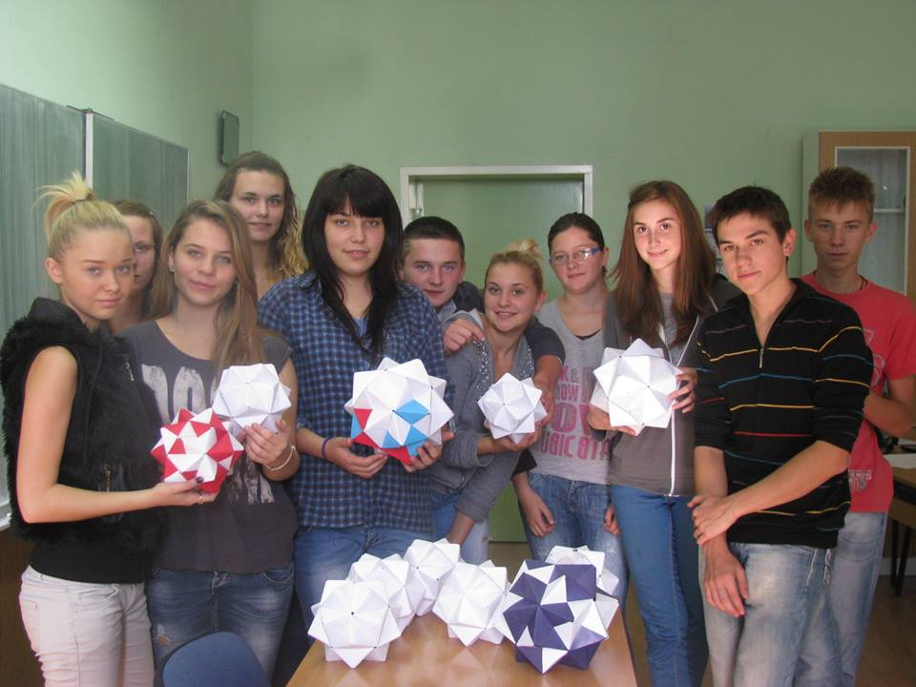

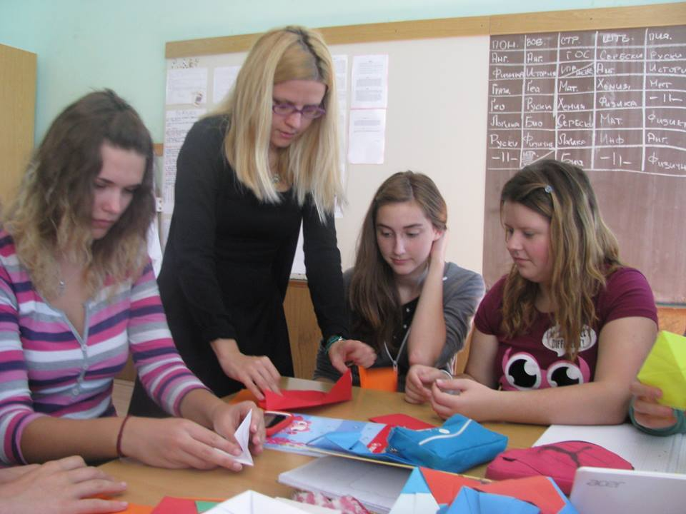

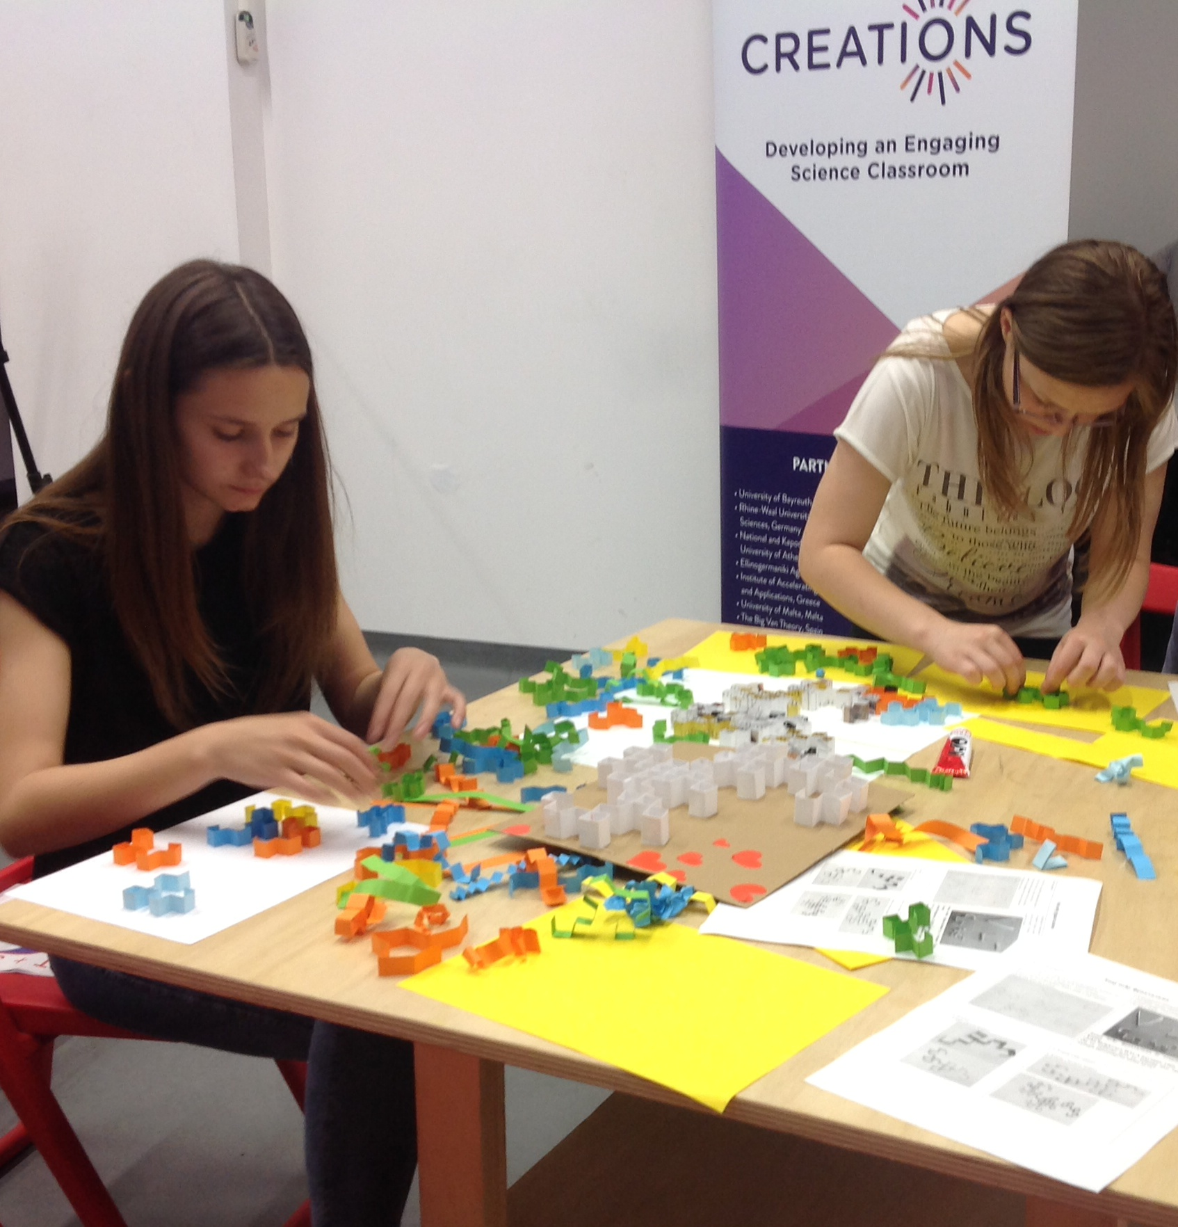

7. Assessment

Assessment should be conducted via standardized Creations questionnaires for students’ evaluation
Students fill out pre-questionnaires before starting the project, and post-questionnaires after the project end. Teacher fills out teachers’ questionnaire at the end of the project.
8. Possible extension

This kind of activities can be applied to teaching students about other fractals and its properties such as Koch snowflake or Mandelbrot's fractal.
Also, it can be adjusted to teaching students about basics of programming. For that purpose, Scratch can be used as a suitable computer language.
It can be worked on teaching students how to code but include different art activities such as paper folding or dancing.
9. References

B. Mandelbrot. The Fractal Geometry of Nature. W.H. Freeman and Company, San Francisco. 1983.
B. Mandelbrot. 24/7 Lecture on Fractals. Ig Nobel Awards. Improbable Research. 2006.
D. Hilbert and S. Cohn-Voss, Geometry and the imagination. AMS Chelsea Publishing. 1999.
G. Irving and H. Segerman. Developing fractal curves. Journal of Mathematics and Arts, 7(3-4), pages 103-121. 2013.
L. Debnath. A brief historical introduction to fractals and fractal geometry. International Journal of Mathematical Education in Science and Technology, 37, pages 29-50. 2006.
M. Fraboni and T. Moller. Fractals in the classroom. National Council of Teachers of Mathematics, 102(3), pages 197-199. 2008.
N. Budinski and M. Novta. Folding the Dragon Curve Fractal, Bridges 2017, in print.
R. Siegrist, R. Dover and A. Piccplino. Inquiry into fractals. The Mathematics Teacher, 103, pages 206-212. 2009.
S. Chen. Assessing Awareness, Interest, and Knowledge of Fractal Geometry among Secondary Mathematics teachers in the United States and China. University of Southern Mississippi, The Aquila Digital Community. Dissertations, 129. 2015.
S. Tabachnikov. Dragon curves revisited. The Mathematical Intelligencer, 36(1), pages 1-13. 2014.
www.cutoutfoldup.com
http://vihart.com/doodling-dragon-dungeons/

Other references and links

http://math4all4math.blogspot.rs/2017/08/dragon-curve.html

http://www.ruskeslovo.com/2017/05/22/59775/%D0%9A%D0%B5%D1%80%D0%B5%D1%81%D1%82%D1%83%D1%80%D1%81%D0%BA%D0%B8-%D1%88%D0%BA%D0%BE%D0%BB%D1%8F%D1%80%D0%B5-%D1%83-%D0%91%D0%B5%D0%BE%D2%91%D1%80%D0%B0%D0%B4%D0%B7%D0%B5-%D0%BE%D1%82%D1%80%D0%B8/

https://www.youtube.com/watch?v=c-XxSfUzHGY

