Agent Exoplanet
Student worksheet

Planet transits
- Open your web browser and search for http://astro.unl.edu/naap/esp/animations/transitSimulator.html
- Select “Option A” and click “Set”. This configures the simulator for Jupiter in a circular orbit at (1AU) the distance of the Earth from the Sun, with an inclination of 90o (i.e. edge-on to the line of sight.
- Determine how increasing each of the following variables would affect the depth and duration of the eclipse (Note that the duration of the transit is shown underneath the flux plot)
The radius of the planet:
The orbital distance of the planet (semi-major axis):
Mass (and therefore temperature and radius) of the Star:

Agent Exoplanet
- Open your web browser and search for http://lcogt.agentexoplanet
- Log-in or register at the top right hand corner
- From this page read the mission brief, and if you’re ready press start the mission on the banner above the mission brief.
- Pick a planet that you would like to measure from the six on the subsequent page.
- Once you have picked a planet, read the introduction and then press ‘Analyze images for this exoplanet’ further down the page.
- The first step in analysing the image is to move the marker around the target star; the star in question will have cross hairs around it.
- The next step is to add another marker in order to measure a value of the sky (as not to add the unwanted value of the sky brightness to our data which will corrupt our measurements for the planet later on), when choosing a target for the sky aim to avoid the stars.
- Next we will pick 3 calibrator stars, these are needed as the brightness of the star won’t just vary due to the transit of the planet in front of it, but also from fluctuations in the atmosphere from day to day. The brightness of the target star will be divided by the brightness of the calibrator stars to account for these fluctuations in the atmosphere, so now our data will only show a change in brightness due to the transit of the planet in front of our target star. When choosing a calibrator star, aim for a star of a similar brightness to the target star. Once you have appropriately placed your markers, press analyse image from the left hand side of the page, and then select next image.
- As you can see from the next image, the stars may have moved around a little, tweak the position of your markers to fit the stars and the sky and press analyse the image, repeat this for all of the images.
- Once you have completed analysing all of the images you will be taken to page showing the light curves of the star just measured. The page contains information about the planet orbiting the star you’ve just analysed and gives information on how some of these characteristics were measured or calculated.

Questions
At the end of Agent Exoplanet, you will be told the values for your exoplanet which were calculated from combining your analysis with others.
- Which planet are you analysing observations of?

- Write down the values here, we will need these later:
% dip
Duration of transit (in days)
Period (in days)
Orbital radius (AU)
Radius of planet (in km)

- How does the radius of this planet compare with those in our Solar System?

Radial Velocities
- Enter the radial velocity measurements for your star into either Excel or Logger Pro
- Read off the mass of the star from the summary page of Agent Exoplanet.
- If you are using Excel:
  - Make a scatter plot of the radial velocity versus the phase of the orbit
  - The graph shows the wobble of the star due to the planet.
  - The maximum value of the radial velocity shows the maximum speed as the star moves away from the Earth, while the minimum value shows the maximum speed as the moves away from you. The average of these two speeds gives the orbital speed of the star
- If you are using Logger Pro:
  - Fit a sine wave onto your plot using the ‘curve fit’ tool from the icons above the plot (curve fit is the icon second from the right). From the window that appears, select the sine wave from the list of fits, then select ‘Try Fit’, and then ‘Ok’ if the curve fits.
  - The graph shows the wobble of the star due to the planet. The box attached to the curve reads out the values of the curve, including the amplitude. The amplitude is the orbital speed of the star.

- The orbital speed of the star is

The mass of the planet is calculated using the following formula:
$$M_{\text{planet}}= \frac{\text{Radial velocity} ×M_{\text{star}}^{2/3}×{\text{Period}}^{1/3}}{{\left(2 π G\right)}^{1/3}}$$
Where G is Newton’s gravitational constant (6.67 x 10⁻¹¹ N m^2/km^2). The mass of a planet is often given in terms of the mass of the Earth (6 x 10²⁴ kg).

- Calculate the mass of your planet:

Mass of planet: x M_{Earth}

Planet properties
For planets which have a known mass and size, we can calculate their average density. The densities of some common materials and some of the planets in our Solar System are given below.
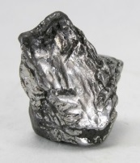 | Iron  Density: 7874 kg/m³ | 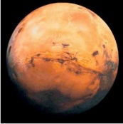 | Mars  Average density: 3940 kg/m³
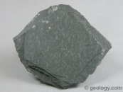 | Metamorphic rock  Density: 2650 kg/m³ | 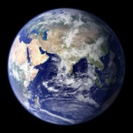 | Earth  Average density: 5155 kg/m³
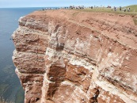 | Sedimentary Rock  Density: 2500 kg/m³ | 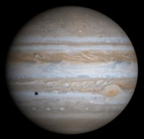 | Jupiter  Average density: 1330 kg/m³
 | Ice  Density: 917 kg/m³ | 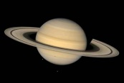 | Saturn  Average density: 700 kg/m³

- Calculate the average density of your planet:

Average density of planet: kg/m³
- Can you speculate what your planet might be made of, and what it might be like on its surface?

