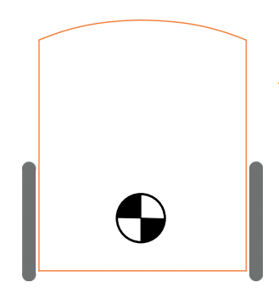
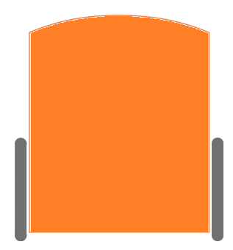

Place the colorless Edison robot between the two colorful Edison robots
NAME :______________________________________________________

ACTIVITY SHEET - parking

