«A small exemplary hydroponic school garden»

Hydroponics is a new exciting educational tool to demonstrate plant growth to learners. The term ‘hydroponic’ is used to describe plant cultivation in a water solution of soluble fertilizers or in an inert growing media. The creation of an educational hydroponic unit provides a visible insight to the process of plant growth to school kids under real growing conditions. A closed-loop hydroponic unit will be created, which enables recycling of fertilizers and water, thereby minimizing environmental impacts and saving natural resources. Thus, getting familiar with plant cultivation in a hydroponic situation is anticipated to motivate school kids to become more conscious of the need to preserve the environment. Students are challenged by the prospect of growing plants without soil. Combining theoretical teaching with a paradigm of practical application makes it much more interesting for the pupils to participate.

Aims
Students are becoming familiar with environment-friendly practices of plant cultivation and environmental factors involved in plant growth. The proposed case would provide insight to the full life cycle of plants through hands-on experience. The learners will acquire the basic understanding on how plants are grown hydroponically and how input of natural resources in agriculture can be minimized through recycling. Thus, learners will be educated to think more environment-friendly and search for more rational utilization of natural resources in the production process, including agricultural and food production.

Main activities
Learners will set up a closed-loop hydroponic unit in which plants will be growing in recirculating nutrient solution without the use of any solid medium for rooting. Thus, learners will have the opportunity to monitor and document plant growth in a controlled environment. They will make observations, record data under different physiological plant stages, environmental conditions and study the impact of light, temperature, water, and nutrients on plant growth. Thus, learners are anticipated to draw conclusions and make observations that will raise scientific questions and stimulate scientific discussions.

Involved actors
Τhe involved actors are teachers and researchers.

Location
This environmental practice can be easily used at school or even at home at a smaller scale.
Connection with the curriculum
The proposed Best Practice is an interesting way for students to learn practical application of subjects of their school curriculum such as biology, botany, chemistry, business administration, math, and project.
Languages available English, Greek
Where to find the application or case
Useful information can be found in our Lab website, Laboratory of Vegetable Crops of Agricultural University of Athens.

Content
Hydroponics is defined as “any method of growing plants without the use of soil as a rooting medium, in which all inorganic elements that are required for plant nutrition (except carbon which is fixed in the leaves through the process of photosynthesis) are supplied to the root system via the irrigation water”. The fertilizers used as sources of the nutrients to be supplied to the crop are dissolved to the irrigation water at proper concentrations and the resultant solution is termed “nutrient solution”. The proposed Best Practice involves a closed-cycle hydroponic cultivation system, which involves re-use of the drainage solution. The cultivation of plants in closed hydroponic systems can substantially reduce the pollution of water resources by nitrates and phosphates originating from fertilizer residues, while contributing to an appreciable reduction in water and fertilizer consumption.
The hydroponic school garden proposed as one of the Best Practices will be a simple closed-loop hydroponic unit, consisted of:
- A trough continuously supplied with flowing nutrient solution that will be used to accommodate the plant roots,
- A supply tank that will serve both as a reservoir of nutrient solution to be supplied to the plants and as catchment tank of the returning solution to be reused,
- A replenishment tank that will be used to automatically replenish the consumed nutrient solution in the supply tank via a floating valve,
- A small pump that will be used to supply nutrient solution to the plants
- Irrigation pipes to supply nutrient solution to the upper edge of the trough and collect the remainder solution after flowing through the plant roots at the lower edge of the trough.
The supply of nutrient solution to the plants and its recirculation in the unit will be continuous. No water or nutrients will be discharged. Thus, students will obtain a more environmental friendly way of thinking. With the establishment entrance of a hydroponic school garden it is possible to still achieved to introduce school kids to the principles of plant cultivation under real growing conditions. Μοreover, it gives also to students the opportunity to make a comparison between the conventional cultivation in soil and reveal the advantages of hydroponics. At the same time, their experiences and their observations are going to raise a variety of scientific questions that can actually investigate through observations, experiments or even additional research.

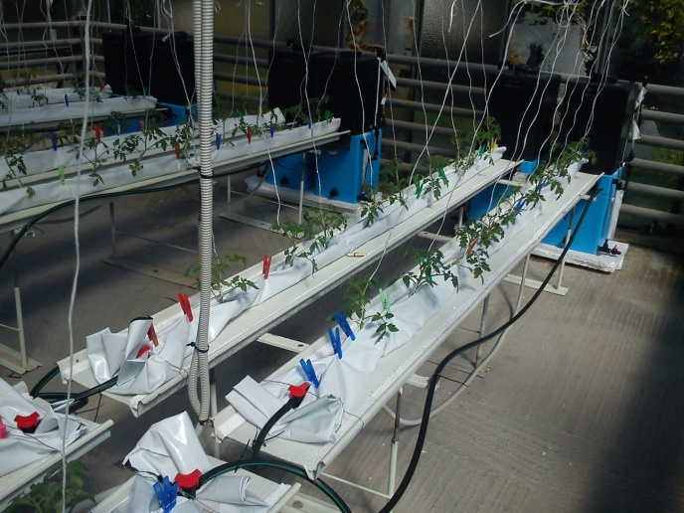
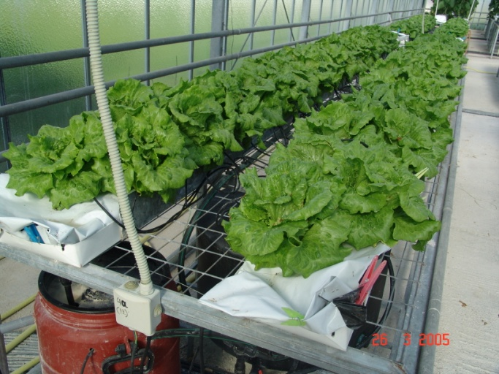
Additional information or resources:

http://www.ekk.aua.gr/index.php?sec=library&lib=1&item=111
D. Savvas, H.C. Passam (Eds). Hydroponic Production of Vegetables and Ornamentals. Embryo Publications, Athens, Greece.
http://www.embryopub.gr/index.php?target=products&product_id=23&sl=EN
Savvas, D. 2012. Soilless Culture. Hydroponics – Substrates. Agrotypos Publishing, Athens, Greece (in Greek).
http://www.agrotypos.gr/eshop/index.asp?mod=eshop_item&cID=87&pID=63565

