Title: | iMuSciCA Summer Camp Scenario
Keywords: | Mersenne’s Law, Pythagoras, Chords, Consonances, Frequency, Period, Sinusoid graph, Amplitude, Musical praxis.
Short Description: | In this scenario students with different backgrounds from Science and Music work together in defining the tube lengths of the 3D printed instruments they produce in order to participate in a final music event. The music arranged for the event corresponds to the properties of the actual 3D printed instruments, the virtual instruments and the physical instruments used to produce it.
Lesson Plans included: | Sources of Sound and Music  What is Tone?  Timbre and Power Spectra  Create a Piece of Music using Geometric Symmetries  Defining the Octave  Investigating the Monochord  Let’s hear Thales’ Theorem  Let’s play Sectio Canonis  (Vol. 2) | Date: | 30/6//2018
Educational Objectives: | Define the formula of frequency and verify its properties through measurements of the actual sound produced on virtual and physical instruments..  Understand Mersenne’s law through the actual investigation of sound experiments that confirm it.  Understand the similarities between the visual representation of a frequencies and the actual sound of a consonance.  Students collaborate in groups in order to produce a music activity based on their findings and the properties of their instruments. | Estimated Duration: | 30 hrs
Author(s): | P. Stergiopoulos, E. Chaniotakis | Age Group: | 15-17  (14-16)
Contributor(s): |  | Language: | English
Status: | Final | Difficulty Level: | Medium
Dissemination level: | Public | Special Needs Addressed: | No

Description: During the scenario students are introduced to a variety of topics covering both the disciplines of acoustics and music. Students are introduced in the theory of frequency and timbre through the measurement of real instruments and come to conclusions about music consonances and vibrating lengths. Musical concepts of consonance such as the “elements of musical praxis” are combined with their conclusions on Mersenne's law in order to produce a unique music-event coming out from both virtual, 3d printed and real instruments. Students experiment with 3d printed tube-instruments and calibrate their performance after defining their lengths according to a musical piece generated on the spot. The scenario finishes with a small live performance of the piece coordinated by the teacher.

E: Engineering/Technology, S: Science/Mathematics, M: Music

Phases | Field | Time | Description | Activity | Remarks
Imagine | S,M | 3 hrs | Students learn about sound. They understand the most fundamental properties of sound and imagine their connections to music. | Learning about sound:  Students are introduced to the Physics of Sound. What is sound? Is it a wave or something else? How does it propagate? Why can we hear it and what does exactly hearing mean? They learn about fundamental observables of sound such as frequency and amplitude and they experiment with them in order to obtain deeper understanding of the science behind it.  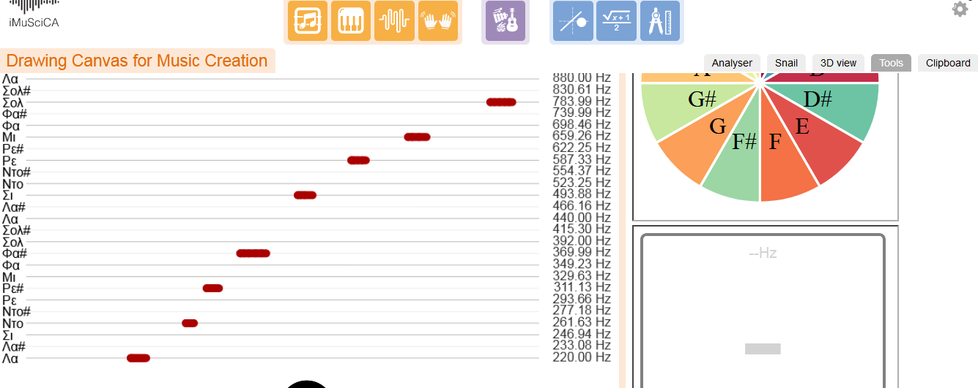  Fig.1: Learning about frequency of sound using the iMuSciCA workbench.  In the next step of their scientific investigation, the students wonder why do different musical instruments sound differently. They experiment with different sounds using the iMuSciCA workbench, sounds generated by them as well as sound produced by real musical instruments and get introduced to the concept of musical timbre. They understand that the differences of the sounding bodies influence the sound produced and get introduced to the Physics of Standing waves. They experiment with different tools and understand how we can analyze sound using powerful visualization and analysis tools such as the waveform, the power spectrum or the spectrogram.  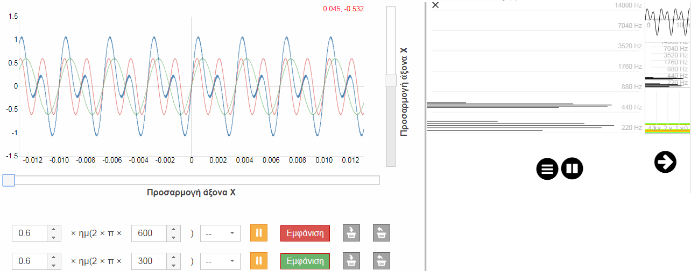  Fig.2: Using innovative visual analysis tools to investigate the harmonic content of sound.  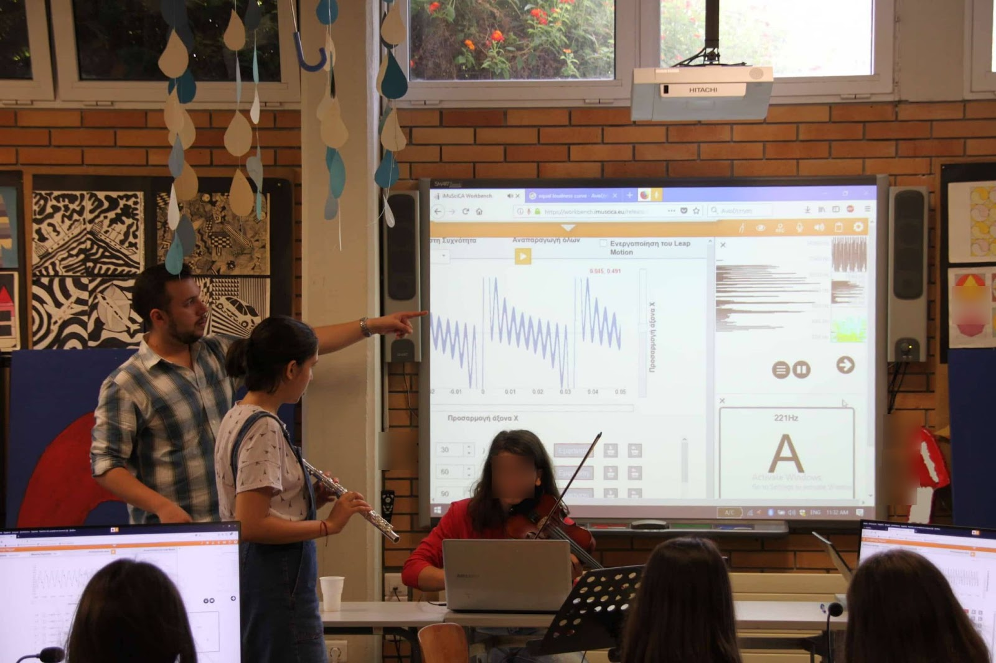  Fig.3: Learning about timbre of sound using different musical instruments and analyzing their sound with the iMuSciCA workbench tools. | The students are introduced to the Physics of Sound and its wave properties adapting material from the scenarios:  Sources of Sound and Music  What is Tone?  Timbre and Power Spectra
Engage | M,S | 3 | Students engage with the connections between music and mathematics/physic s, generating hypotheses and testing them. | About the Music of Physics and Mathematics  Students are introduced in the idea of understanding music as a result of acoustics. Why do we like certain aspects of listening or why do we define others as repellent? Students are introduced into the mechanisms of making consonances pleasant to the ear and the way music is produced using physical instruments. They explore the fundamental steps for defining the notes of the musical scale and experience the logical steps of the Pythagoreans dividing the monochord.  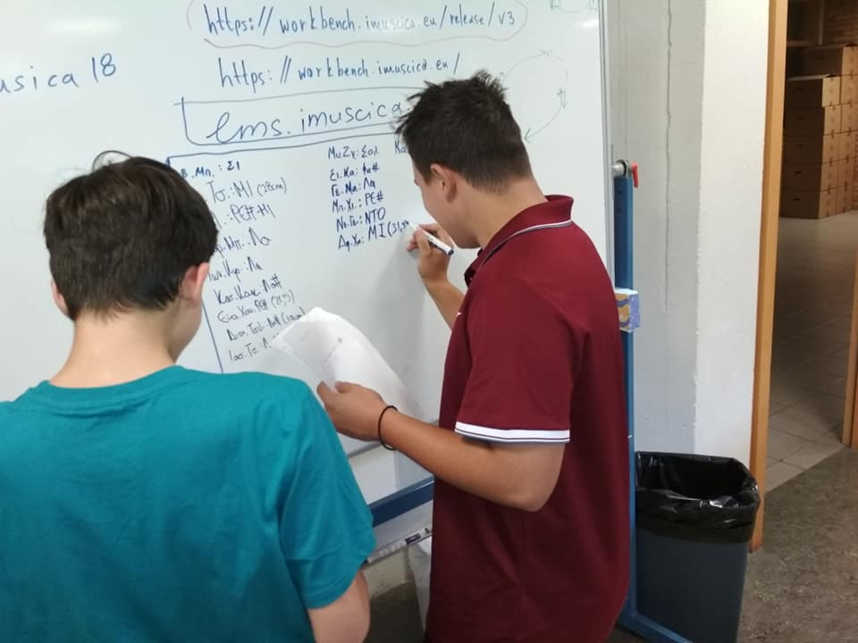  Fig.4: Students prepare their math inspired synthesis | This phase uses reference material from scenarios:  Create a Piece of Music using Geometric Symmetries  Defining the Octave
Create | M | 2 | Students compose their own math inspired synthesis | The most important aspect of a creative activity is collaboration. Musicians understand collaboration as musical “sym-praxis”. By understanding the fundamental aspects of music making through consonance, the iMuSciCA summer camp succeeded in bringing together students with music background along with students that defined themselves as more interested in science. Students were introduced in basic elements of musical praxis which allowed them to form different groups that collaborate together. Writing a melody that comes out of virtual, 3D printed and physical instruments was a challenge that the students had to overcome using the iMuSciCA tools.  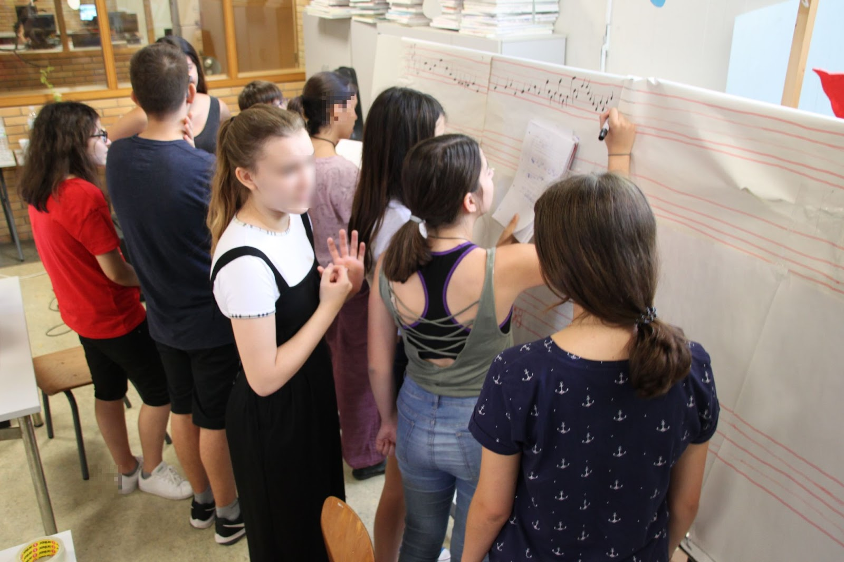  Fig. 5: Students collaborate to create their own math-inspired synthesis
Create/  Analyze | S,E,M | 5 | Students create their own virtual musical instruments and investigate their parameters. They analyze their results and optimize their products. | Create and experiment with your own virtual musical instruments  Students investigate the sound produced by musical instruments. They wonder which parameters influence the sound produced and use the iMuSciCA workbench to experiment with virtual musical instruments such as the monochord. They investigate the influence of string length, tension, radius and material on the sound pitch and experiment to define the mathematical relationship describing the sound frequency as a function of these parameters: Mersenne’s Law.  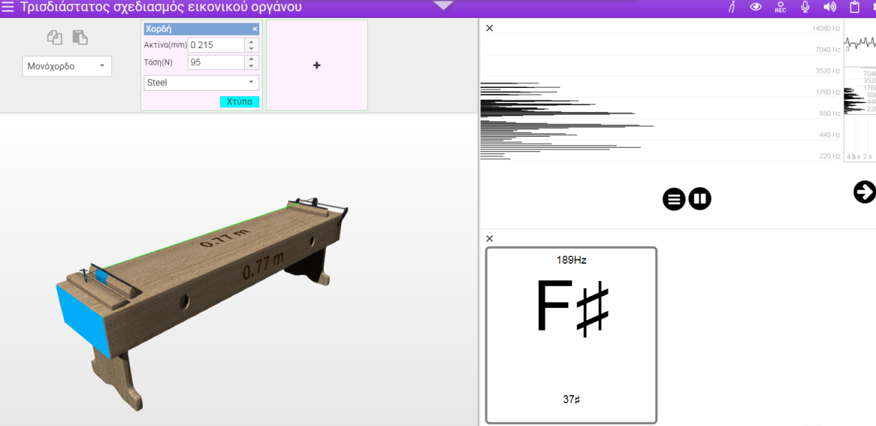  Fig.6: Students investigate the relationship between the frequency of the produced sound, with respect to different parameters, of virtual musical instruments.  They continue their investigation studying the sound pitch of various other musical instruments with respect to their design parameters. But what happens when a string is divided in the fundamental proportions? How Thales’ Intercept Theorem helps students define the ratios of musical notes? These were just a few of the questions that form the core knowledge for musical tuning that kept numerous creative musicians, scientists and music theorists engaged for centuries since even today. Students made the basic steps for understanding Sectio Canonis not only as part of Geometry curriculum but as a living multimodal interactive experiment.  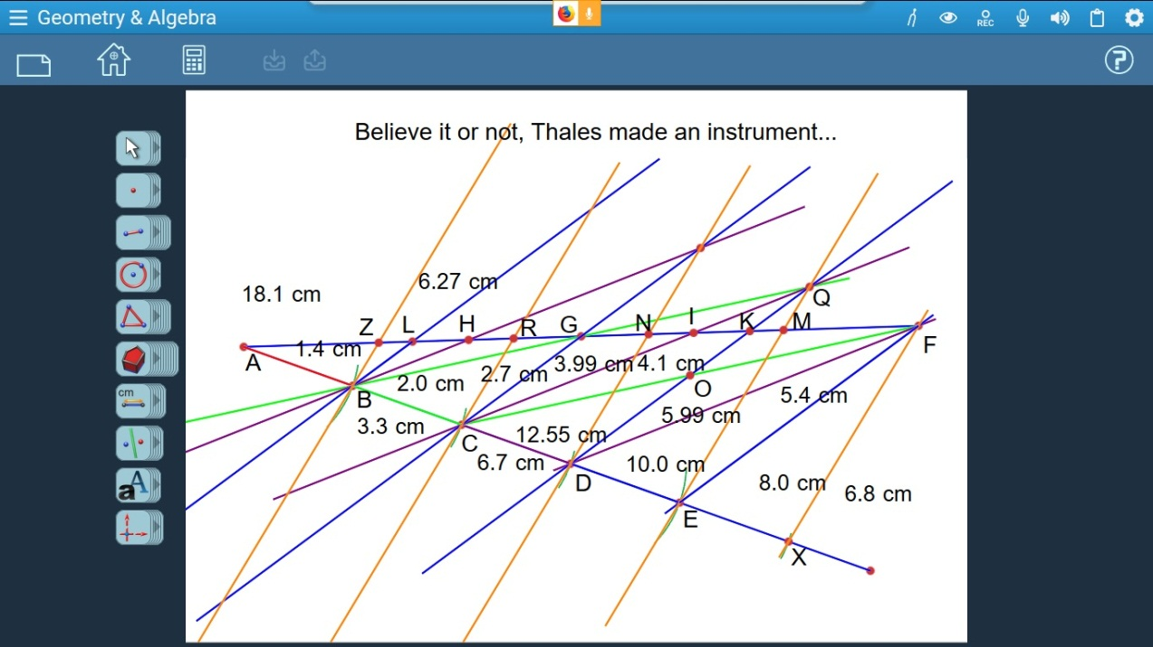  Fig.7: Using the iMuSciCA Geometry and Algebra tools to learn how to divide a string in equal proportions using Thales’ Theorem. | This phase uses material from the following scenarios:  Investigating the Monochord  Let’s hear Thales’ Theorem  Let’s play Sectio Canonis  (Vol. 2)
Create | E | 3 | Students 3D print a virtual musical instrument. | 3D print your virtual musical instrument  Students experiment with 3D printed replicas of a flute a bec without toneholes but with moveable parts. They define their different acoustical aspects by measuring their behaviour and then they printed their own versions according to their own analysis. The instruments selected were printed out during the summer camp and they became part of the final musical performance.  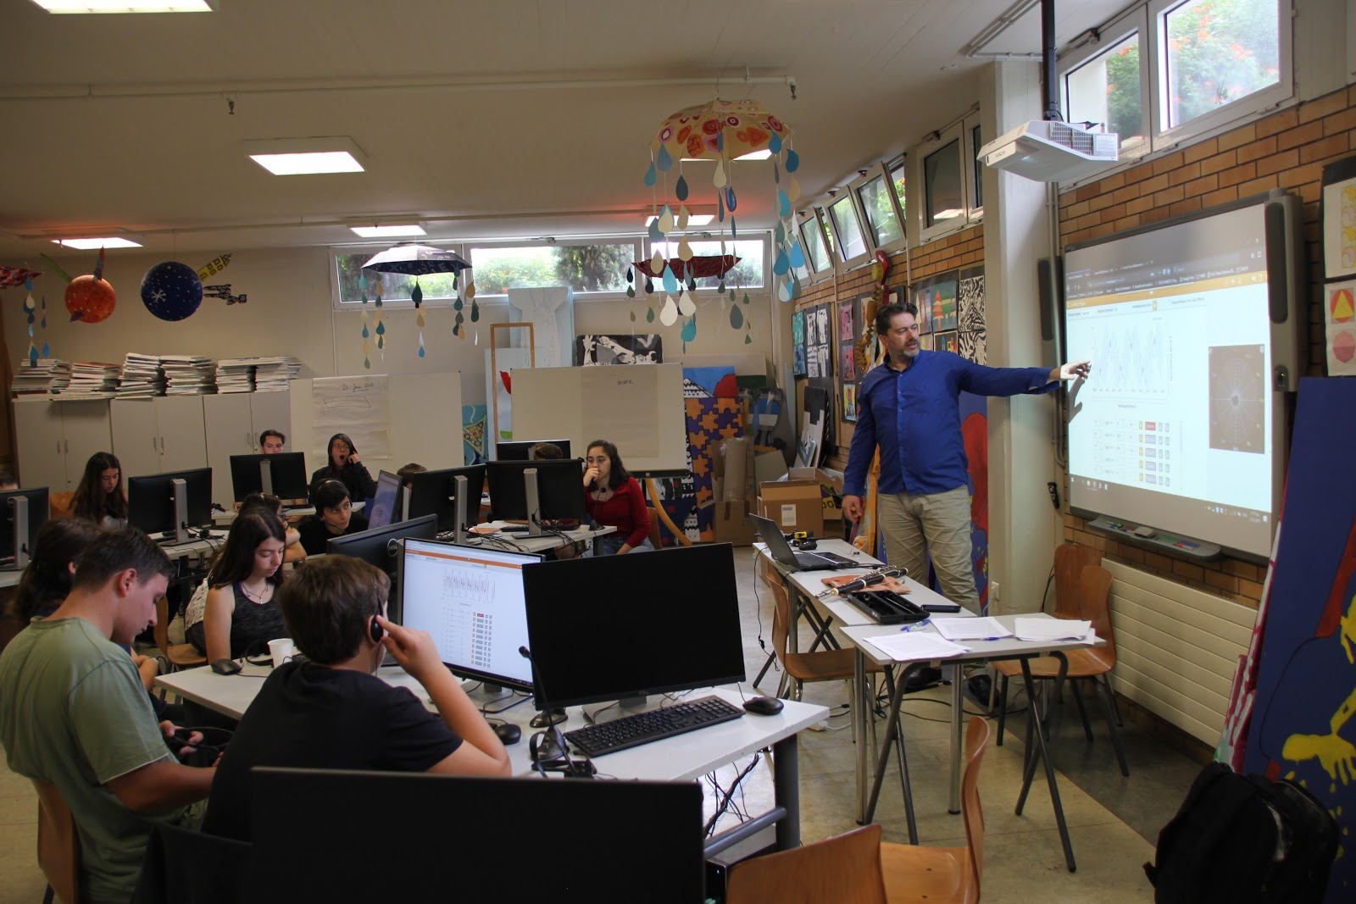  Fig. 8 Students prepare and design their virtual musical instruments which will be 3D printed.  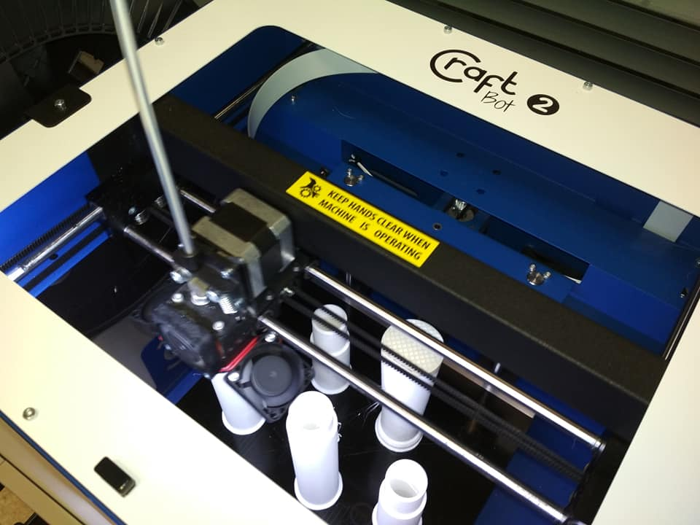  Fig.9: 3D printing student- designed musical instruments. | Students get introduced to 3D printing and get hands-on experience using a 3D printer and the corresponding Leopoly 3D design software.
Communicate | M | 3 | Students combine virtual, real and 3D printed instruments to perform their science inspired synthesis. | Perform using virtual, 3D printed virtual and real musical instruments  Students divide in groups and define a sequence of notes with equal duration forming musical motives as cluster of notes. Performed by all kinds of instruments: virtual, 3D printed, physical, the piece was directed by the music teacher as a result of group effort.  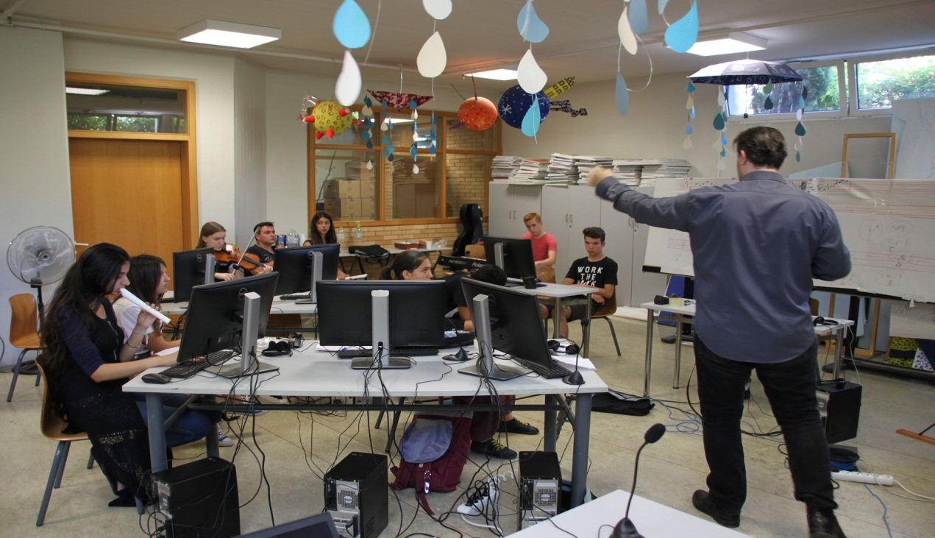  Fig.10: Students rehearse their final musical synthesis.
Communicate | M |  |  | 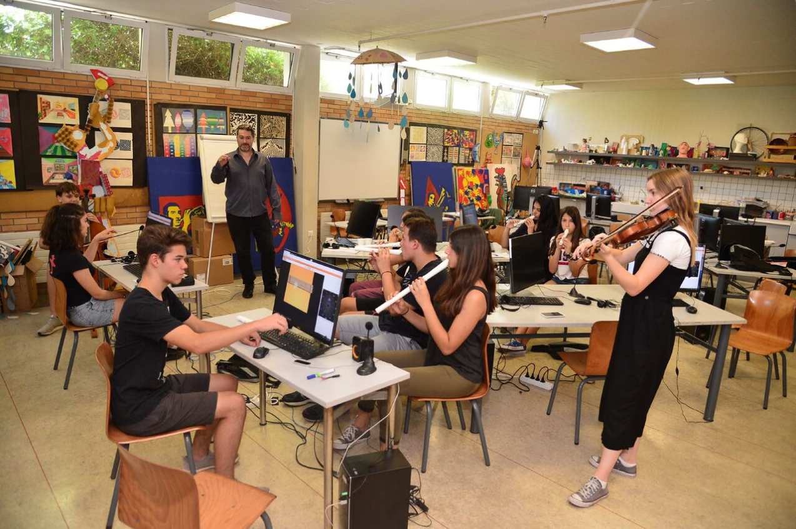  Fig.11: Students perform their final musical synthesis with virtual musical instruments (left) using the iMuSciCA virtual instrument performance environment, 3D printed musical instruments (center) and real musical instruments (right).
Reflect | S,E,M | 1 | Students reflect on the iMuSciCA summer camp experience | Students reflect on the summer camp experience and are interviewed both as a group and individually to discuss their impressions and to assess their knowledge gain throughout this process.

