Hartop Secondary School studies earthquakes
coordinators: Gradinariu Ionela, Onofrei Nadia

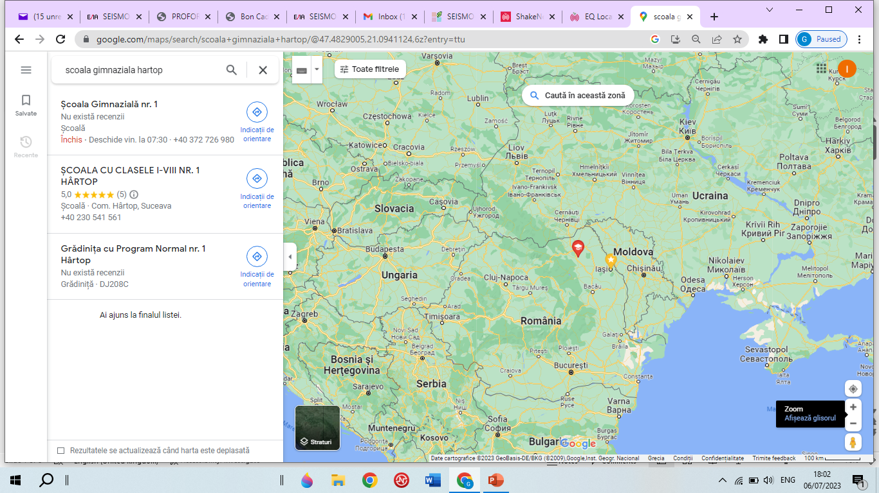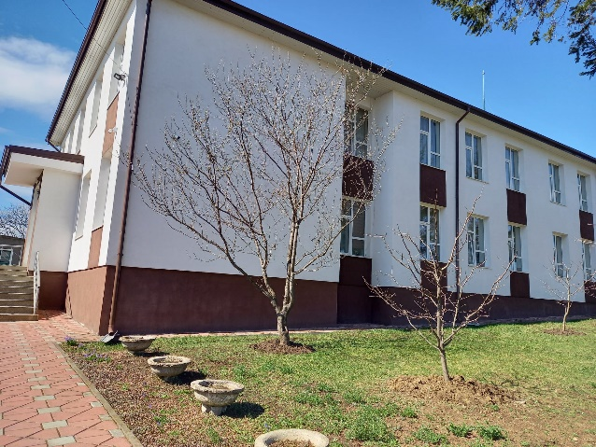

Seismology in school education can promote scientific literacy at all levels but its benefits go far wider than simply providing scientific knowledge about this natural phenomenon. It provides the basis for informed action to protect lives and property on local, regional and national levels.

Purchase of Rassberry Shake Educational Seismometer
With the help of the funding provided by LfE, we have acquired a seismometer that the students found to be a very fascinating instrument. They now have the tool needed to research and monitor the seismicity characteristics of the local area and its surroundings and the tool needed to identify S and P waves.
With LfE funding we have also procured tablets. These are used by students to explore and research various theoretical seismology aspects like: what is an earthquake, why do earthquakes occur, the composition and structure of Earth, the main tectonic plates on the globe, etc. The tablets are further used by students to verify acquired knowledge by solving various interactive tasks in digital format, mainly using game-based learning platform Kahoot.
The proposed activity uses equipment purchased with funding from the LfE being in the same time supported by NIEP researchers who came to our school to install, configure and train the teachers involved in the project. This has added value to our school both at local level (our school becoming some sort of interest point for other schools) and educational level (as we have enhanced school’s offer for students).

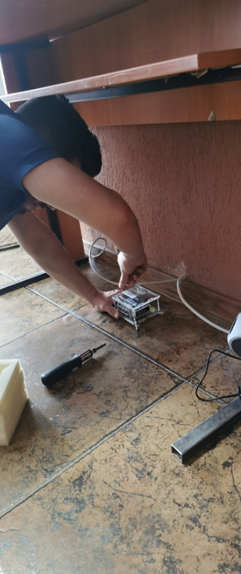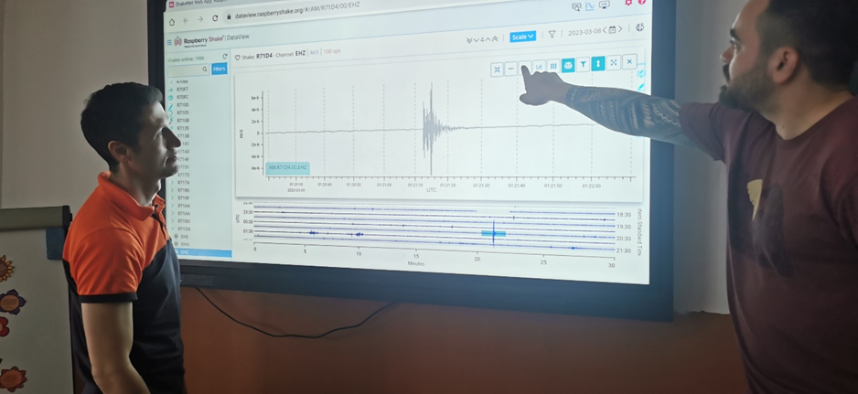
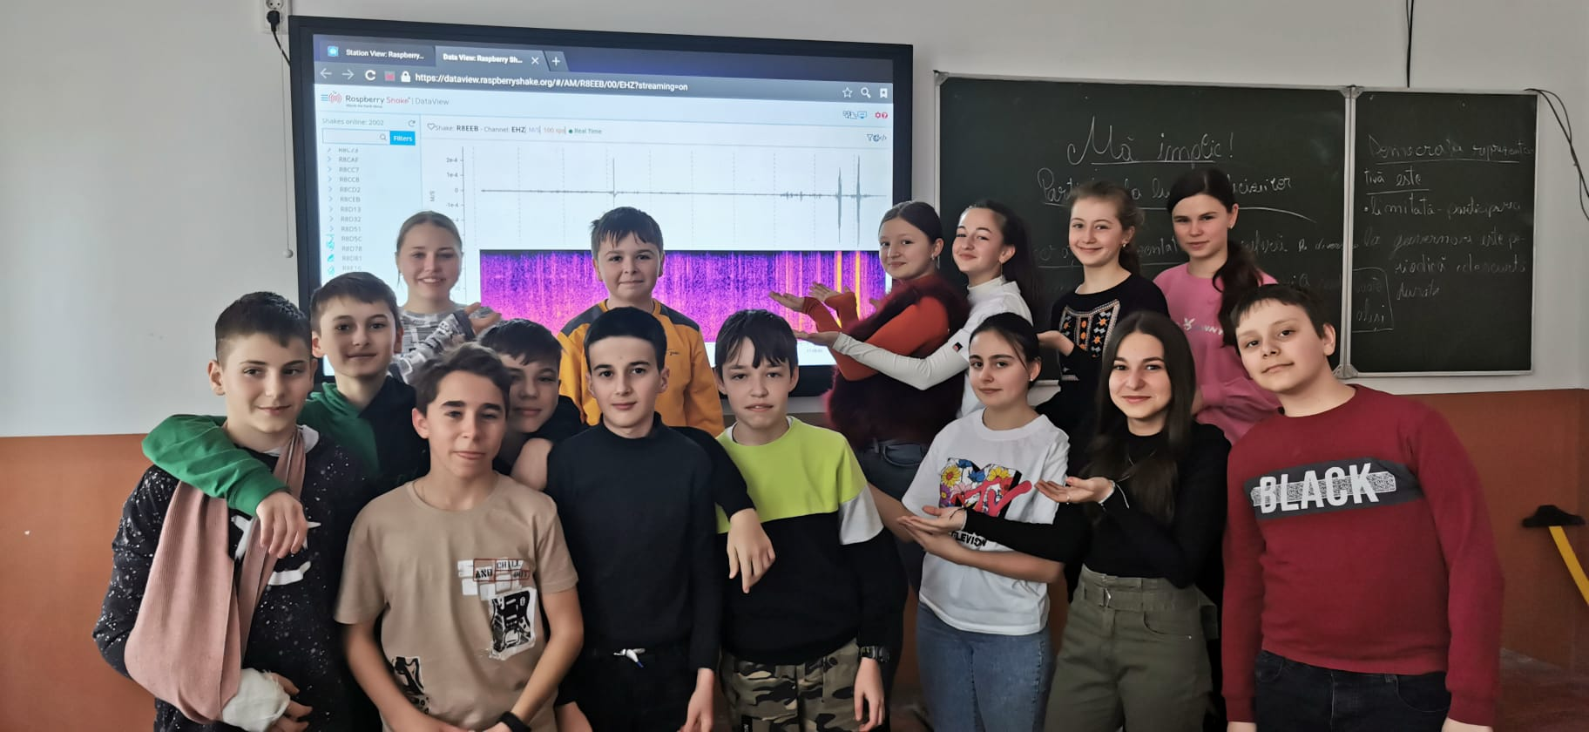
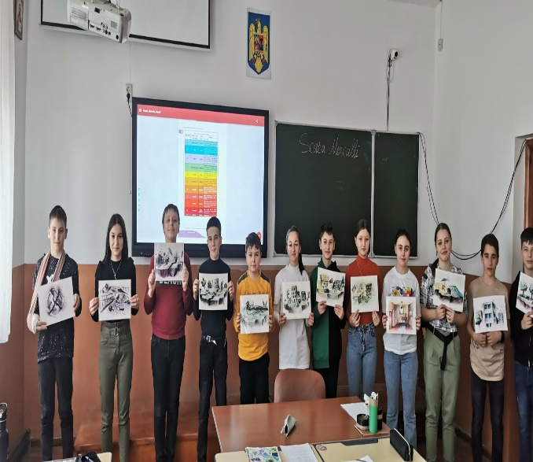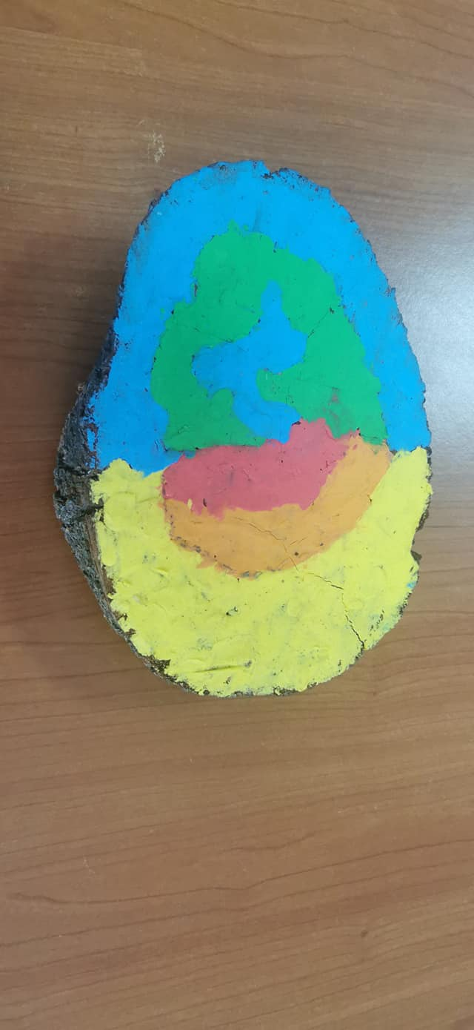
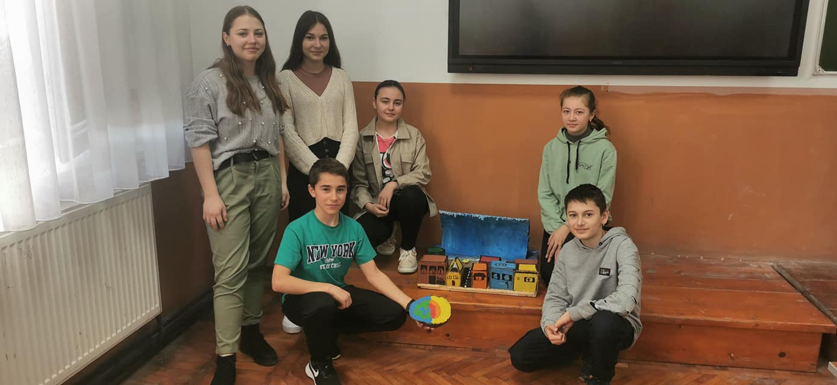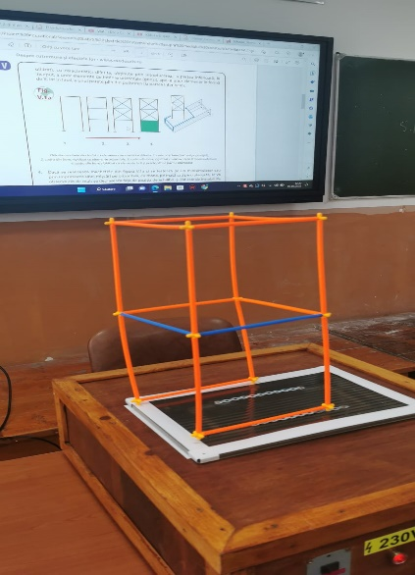

The students involved in the project are first of all grateful for the opportunity given; they are also excited to be able to learn through practical activities about the phenomena that occur in day to day life. They have been given tasks, like monitoring of the earthquakes recorded by the seismometer and have now the necessary tools to document themselves with ease, using the recently acquired tablets. They are now our relay points, disseminating the information gained to the other colleagues during various activities like e.g. ‘’Alternative Week’’.

Using Hartop STEAM CLUB social media page, students also keep the local community informed on the extracurricular activities carried out, on the small earthquakes that take place and are recorded by the school's seismometer, etc. Local community has also controlled access on request or during school’s ‘’Open Doors’’ day.

The activity proposed by our school was disseminated so far as follows:
- locally, within the periodic governmental organized pedagogical meetings
- at national level, within the Summer School held in Măgurele, Ilfov
- at international level, within the European Geoscience Union at the GIFT section (Geoscience Information for Teachers).
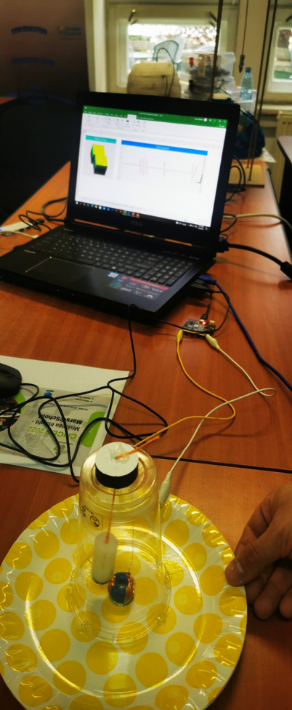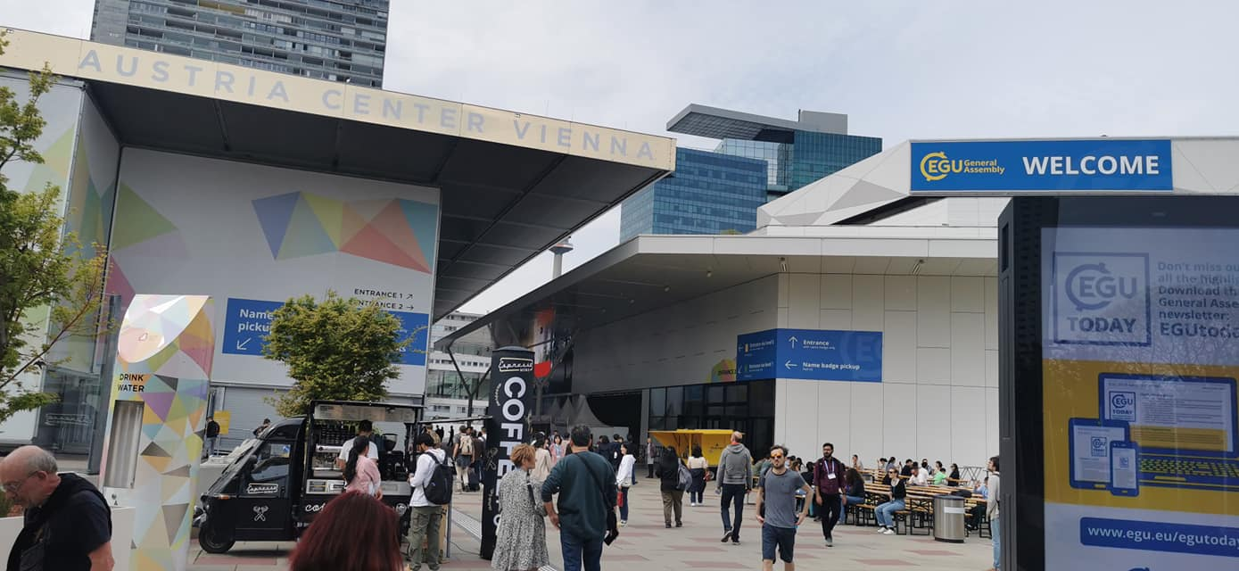
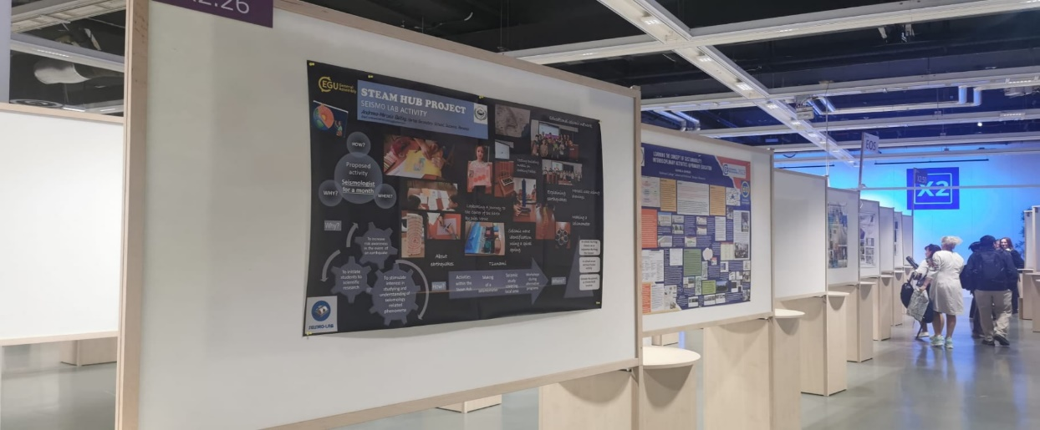

What activities do we intend to do next…
To continue the development of our students, the next activities that we intend to implement are:
- Apply different Seismo-Lab scenarios to find velocities of P waves ;
- Determinate the earthquake epicenter;
- Build the seismometer with children;
- Simulating earthquakes using theatre demonstrations;
- working with seismic data;
- Convert the seismic data into music;
- Continue disseminate the information using Hartop STEAM CLUB social media page, to keep the local community informed on the extracurricular activities carried out, on the small earthquakes that take place and are recorded by the school's seismometer.
- Partnership with nearby schools during the Summer school.

